**Working together to create a stronger city we can all be proud of**

**Stronger Together & Room to Grow**

**Supervision Practice Guidance**

|  |  |
| --- | --- |
| Version | 1 |
| Approved by | Principal Social Worker |
| Publication Date | July 2022 |
| Review Date | July 2023 |
| PH No. |  |



**Contents**

Introduction 2

To be a good Supervisor you need to 2

Practice Focused Supervision Practice 3

Common Barriers to the Delivery of Effective Supervision 4

# Introduction

A person offering supervision should have all the capabilities needed to maintain this role or relationship successfully. This will allow them to speak with authority, both within their professional range and in their functional role on behalf of the organisation, and suggests that they will have the strength of character to carry out all of the supervisory tasks, including those that are more challenging – for example, those relating to performance, behaviours or emotional stress.

A key component of leadership in any environment is to be an exemplar to others in the workplace. If supervision is to be properly embedded in an organisation’s culture and practice, it will first be practised by its leaders

A feature of a positive culture is having the opportunity to make an evaluative comment at any time in the supervision process. This is desirable because it can have a direct impact on the service being delivered. It is also an essential feature of the supervisor/supervisee relationship that gives a worker the right at any time to raise concerns promptly.

Checking with the supervisee at the end of each session that they are happy with the process they have been part of and have left nothing unsaid that they wanted to say is good practice. It is also sensible to share the notes from each session and agree the content and actions soon afterwards.

# To be a good Supervisor you need to

These guidance notes may be used as a checklist to help you audit your supervision practice and help you to get the best out of the session, both as a supervisor and a supervisee.

* Plan a co constructed agenda (e.g. review previous supervision notes before meeting and make a note of issues you wish to raise);
* Clarify tasks and areas of work that the manager expects of the staff member;
* Encourage honest and open discussion of real issues;
* Hold regular sessions at agreed dates and times and be “on time”;
* Ensure the session is uninterrupted or any interruptions are unavoidable;
* The venue is comfortable;
* Praise work done well;
* Listen, summarise and check out;
* Be constructive and offer balanced feedback, focusing on the positives first;
* Support staff and build on existing skills and knowledge (refer to standards appropriate to the post);
* Set clear targets with actions and timescales and write these down;
* Anticipate problems and issues before they get serious, e.g. in relation to potentially violent service users;
* Do what you say you will do;
* Be specific in any comments you make relating to supervisee's performance;
* Whatever the supervisee's present levels of capability/competence, convey confidence that he/she can reach new levels. Try to stretch him/her towards them;
* Write down actions for either supervisor or supervisee;
* Record any disagreements;
* Make your own experience, knowledge and skills available to help the supervisee;
* Set the supervisee's work in the context of legislative and agency requirements, signposting to relevant statute, regulations and agency policy/procedure as appropriate (e.g. Social Work England, [**Stoke on Trent Safeguarding Children Partnership Procedures**](http://rotherhamscb.proceduresonline.com/chapters/contents.html));
* Acknowledge conflict and tensions openly, e.g. as between 'ideal case' interventions and resource or budget constraints;
* Acknowledge that you do not have 'all the answers';
* Think who else can help with the issue;
* Give yourself time to seek further information or seek advice, if you are not sure;
* Help staff to reflect on their practice, e.g. what worked, did not work, why and lessons for the future;
* Give space and permission for the supervisee to express their feelings.

# Practice Focused Supervision Practice

Practice focused supervision will broadly aim to answer three questions:

* What is the worker going to do next?
* Why is the worker going to do ‘those things’?
* How is the worker going to do ‘those things’?

The supervisor and supervisee should discuss clearly why they are going to do ‘these’ things and consider how best to share the rationale with the family.

The discussion should also include exploration of how to complete those tasks and how best to achieve them.

It will be important that the supervisee understands why the actions are important and how they might be completed in the family’s best interests.

Achieving more practice focused supervision is not as simple as asking more what, why and how questions.

The way in which the questions are asked and the context of the supervisory relationship is key (restorative).

Practice-focused supervision that provides high support for practice will have the following characteristics:

* Respectful curiosity-genuine desire to understand
* Child and family focus-consideration of what life is like for children and families
* Clarity about risk and or need-explicit discussion

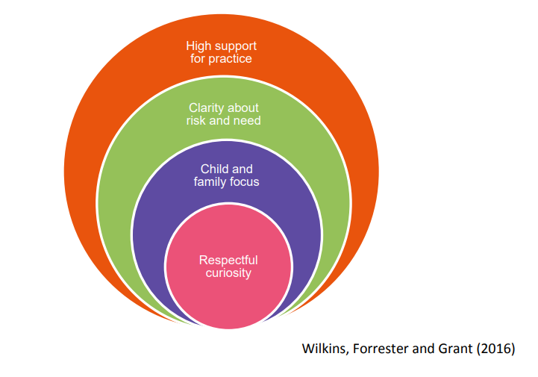

# Common Barriers to the Delivery of Effective Supervision

* 'Dumping' - saving up criticisms and discussing them all at once;
* Unplanned, rushed agenda and unfocussed sessions;
* Inadequate preparation by supervisor or supervisee;
* Unclear or unrealistic goals for staff members;
* Telling rather than listening;
* Failure to offer constructive commentary on performance;
* Misuse of power, e.g. bullying, harassment, victimisation;
* Allowing avoidable interruptions;
* Running out of time;
* Poor recording of supervision;
* Emotional issues unaddressed;
* Case management to the exclusion of reflective discussion