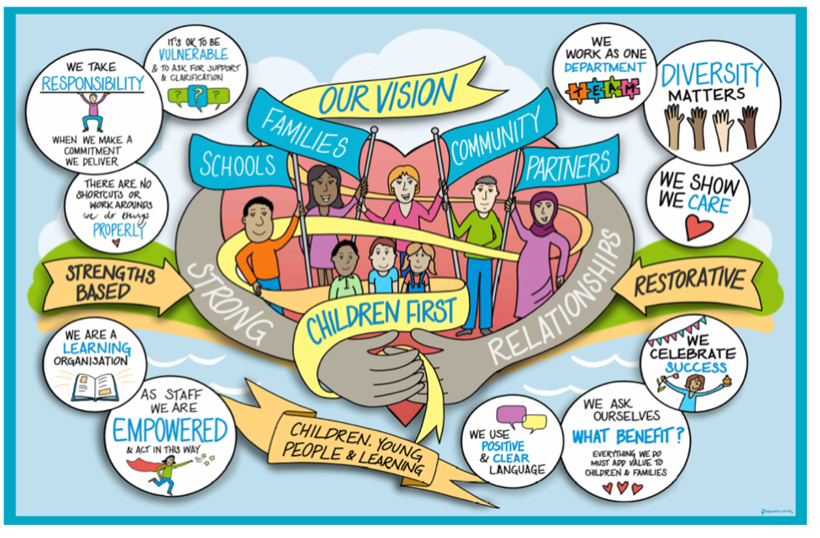

Practice Alert Guidance

Introduction and Background
The aim of this document is to provide practitioners and managers with guidance and a shared understanding about the value and purpose of practice alerts in our collective role of improving the lives of children through our intervention.

Practice alerts are a way of recording constructive challenge, curiosity and collaboration. They support and drive best practice and as such, best outcomes for children and young people. They are an important part of our ongoing improvement journey.

Every child or young person that We Care For or who are subject to a Child Protection Plan has a Conference and Reviewing Officer (CRO) allocated to them, which will be recorded on mosaic. CRO’s oversee and review their plans to ensure that they are outcome and impact focused, reflect each child’s needs, ensure that their wishes and feelings are given full consideration, and are consistent with the Local Authorities legal responsibilities.

Roles and Responsibilities of CRO
An important part of the CRO’s role is to ensure that Children We Care For and children on Child Protection Plans are not negatively impacted on by poor practice, drift, or delay. The CRO has a responsibility to challenge any areas of poor practice and to do so by way of a collaborative discussion and/or a practice alert raised at the appropriate stage.

The CRO’s responsibility is set out in Chapter 6 of the IRO Handbook, which says that “one of the key functions of the Independent Reviewing Officer (CRO) is to resolve problems arising out of the care planning process; for example in relation to care planning, the implementation of the care plan or decisions relating to it, resources or poor practice”. Furthermore, that “it is the responsibility of each local authority to put in place a formal process for the IRO to raise concerns and to ensure that this process is respected and prioritised by managers”; and that the practice alert process “should have timescales in total of no more than 20 working days”.

Social Workers are responsible for writing the outcome focused plan prior to conference, alongside the children, family, and multi-agency network. The CRO will chair Child Protection Conferences and further develop the plan to ensure it is outcome and impact focused, with the family and multi-agency network. The CRO has a responsibility outside of that meeting to maintain regular oversight and scrutiny of the progress. CROs will invite Social Workers to be part of midway review meetings. These will take place in between Review Conferences and Children We Care For Reviews to ensure the plan is updated and progressing and will ensure that any concerns are raised in a timely way.

Child’s Voice

It is important that the child’s voice is recorded throughout our involvement, and this should be included in practice alerts. The CRO will ensure any impact that poor practice or delay has had on the child or young person, is clearly recorded as part of the practice alert.

Where a young person has raised concerns with the CRO, it may be appropriate to actively seek their views to include within the practice alert. The CRO in these circumstances may share feedback around resolution and the actions agreed by the relevant manager.

Practice Alerts
Where appropriate, the CRO will endeavour to resolve any practice concerns for a child or young person through discussion with the relevant manager. Actions with clear timescales will be agreed with the CRO and relevant manager as part of this discussion and will be recorded in in the Mosaic Collaborative Discussion case note.

However, where we are unable to achieve timely, improved outcomes for a child through this process, a practice alert will be raised on Mosaic at the relevant level. In addition, if significant issues of concern are identified, the CRO will initiate a practice alert without a Collaborative Discussion. This practice alert will escalate up the management tiers until resolution is achieved. The CRO can choose to bypass any level if they consider it proportionate and expedient to do so (6.2 IRO Handbook).

Process
The CRO will inform the relevant manager that a formal practice alert has been raised on Mosaic. This will be via a telephone call where possible, or an e-mail can be used if the manager is not available at the time that contact has been attempted.

The practice alert will clearly outline the issues of concern and the impact on the child and will be tasked to the relevant manager for completion. A response must be recorded in the management section of the Mosaic document within 5 working days. Outcome focused actions with clear timescales to ensure a resolution in a timely way, will be added by the relevant CSC manager, however, the CRO can ask for additional actions to be considered.

If the relevant manager does not respond and complete their part within 5 working days, the CRO will escalate the Practice alert to the next stage.

In addition to this, if the relevant manager responds, but it is determined by the CRO that the issues raised remain on-going and the response does not adequately address them, then the CRO will escalate the Practice alert to the next stage.

As well as escalating, the CRO can choose the option to close the practice alert as ‘resolved’ and this will end the process. However, the CRO may choose to outcome it to ‘Practice Alert Action Review’. This will open a review form that the CRO will complete at a time when they can review the file and be assured that the agreed actions have happened. If the CRO is of the view that the practice hasn’t improved, they may consider it appropriate to re-start the practice alert at an escalated stage to ensure that practice alerts are meaningful and achieve change for children and young people.

The CRO is responsible for closing the practice alert once they are satisfied that a resolution has been achieved, and actions are in place that address the practice concerns identified.

Practice Alert Resolution
There are five stages to the practice alert resolution process. The CRO has the discretion to proceed directly to stages 2, 3 and 4 in more serious or urgent issues. A response is required within 5 working days. Where this is not achieved, the practice alert will be escalated to the next stage.

Stage 1  Stage 2  Stage 3  Stage 4 | CRO and Team Manager – Issue to be resolved or sufficiently progressed within 5 days of initiation.
 | CRO and Service Manager – Issue to be resolved or sufficiently progressed within 5 days of escalation to Stage 2. CRO’s Service Manager (SM) to be notified.
 | CRO and Head of Service – Issue to be resolved or sufficiently progressed within 5 days of escalation to Stage 3. CRO’s SM & Head of Service to be notified.
 | CRO and relevant Assistant Director - Issue to be resolved within 5 days of escalation to stage 4. CRO’s SM, HoS & Assistant Director SQP to be informed. Assistant Director SQP to notify DCS.

The IRO has the power to refer the matter to Cafcass at any point in the dispute resolution process [regulation45] and may consider it necessary to make a concurrent referral to Cafcass at the same time that s/he instigates the dispute resolution process. (IRO handbook 6:3).

Complaints and the Resolutions Process
Complaints operate independently of the practice alert process. A complaint made by a child or their advocate that is being addressed within the Local Authority’s Corporate Complaints Procedure should not prevent the CRO from working to resolve the issues raised within the practice alert process.
An CRO has a responsibility to ensure, where appropriate, that the child understands his or her right to make a complaint to the Local Authority and to have an Advocate to provide support with the complaint, should the child so wish. In circumstances where the child does not have the ability or understanding to instigate a complaint, consideration will need to be given to who is best able to do so on behalf of the child. This could be the CRO.
The Local Authority’s Complaints Manager should advise the CRO of any complaint brought by or on behalf of the child and may enlist the help of the CRO to resolve the problem.

For Children We Care For, the CRO will need to make a judgement about whether a problem raised as a complaint is sufficiently serious to make a referral to CAFCASS.

Quality Assurance
All recorded formal practice alerts will be reviewed and monitored so that the themes can be captured. Quarterly practice alert reports will be completed by the CRO service managers, the learning from which will be presented to Departmental Leadership Team and disseminated within the practice forums.

Legislation and Standards
- Adoption and Children Act 2002
- The Review of Children’s Cases (Amendment)(England) Regulations 2004
- Independent Reviewing Officers Guidance, June 2004
- The Adoption Agencies Regulations 2005
- The Children and Family Court Advisory and Support Service Regulations 2004
- IRO Handbook: Statutory Guidance DfE 2011
- The Children Act 1989 Guidance and Regulations Volume 2 Care Planning, Placement and Case Review June 2015

Appendix 1
Reasons for practice alerts will always link back to practice that negatively impacts achieving best outcomes for a child/ren and may include:

General issues (CRO)
- Report not prepared for children we care for reviews/ child protection conferences
- Report and plan not shared with parents within timescales (5 days RCPC & 3 days ICPC/ 3 days for CWCF reports and plans)
- Report and plan not shared with children we care for review attendees
- Insufficient evidence of the child’s voice and inclusion within the assessment, planning and review process
- Non completion of actions/ failure to meet timescales
- Assessments not completed in a timely manner/poor quality
- Unsuitable/inadequate contact arrangements
- Child not being provided with a good service e.g. multiple social workers visiting
- CRO not notified of significant event in the child’s life
- CRO not in agreement with the care plan
- Delay in life story work

Failure to Meet Statutory Requirements
- No allocated social worker
- No up to date/poor quality assessment/ care plan/ pathway plan/ adoption plan
- No up to date/poor quality safety plan
- Statutory visits not being completed, or children not being seen alone, where appropriate, by the social worker
- No up to date/inadequate personal education plan, health assessment
- No up to date/poor quality placement plan.
- Failure to consult CRO before final care plan is submitted to court

Care plan implementation
- Delay in progressing a child protection plan
- Delay in progressing a child’s permanence plan (second review onwards)
- Failure to implement a significant element of the child’s care plan
- Failure to notify the CRO of potential significant changes to the child’s care plan
- Failure to complete the neglect tool kit in advance of an ICPC or for it to be updated again by the second RCPC.
- Delay in holding and progressing a Family and Friend Network meeting

Provision of Service
- Concern around the suitability and sufficiency of the placement choice/ standard of care or support to meet the child’s needs
- Family finding / placement search
- Concern around professional practice.
- Where the relevant manager does not agree with the recommended actions arising from a review
- There is limited evidence that parents/primary carers have a clear understanding of what needs to continue/change/improve as part of ‘next steps’
- There is limited evidence of contingency planning in cases where the CP Plan is not resulting in reduced risk to the children

These will be captured on Mosaic under the following headings

- Safeguarding issues that have not been satisfactorily addressed
- Child’s voice/views not ascertained and considered
- Child/family not included/invited to meeting
- Report not completed for conference/CLA review
- Care/CPP plan not updated/progressed in a timely and outcome focused way
- Statutory visit not undertaken within required timescale
- Life story work /direct work not completed
- Assessments not completed within required timescales (parenting/prebirth/CSE/risk/domestic abuse)
- Missing protocol not followed
- CRO not informed of significant event
- Pathway Planning not completed within required timescales
- Family and Friend Network meeting not completed
- Other

Review / Contacts / References
Document title: | Practice Alert Process
Date approved: | October 2022
Approving body: | Policy and Practice Steering Group
Last review date: | March 2021
Revision history: | November 2022
Next review date: | October 2024
Document owner: | Simone McCarthy – Interim Head of Service
Lead contact / author: | Amanda Cole- Practice Development & Improvement Lead

Independent Reviewing Officer Handbook - Statutory guidance for independent reviewing officers and local authorities on their functions in relation to case management and review for looked after children (2010) ² https://sussexchildprotection.procedures.org.uk/ ³ Section 5.12

