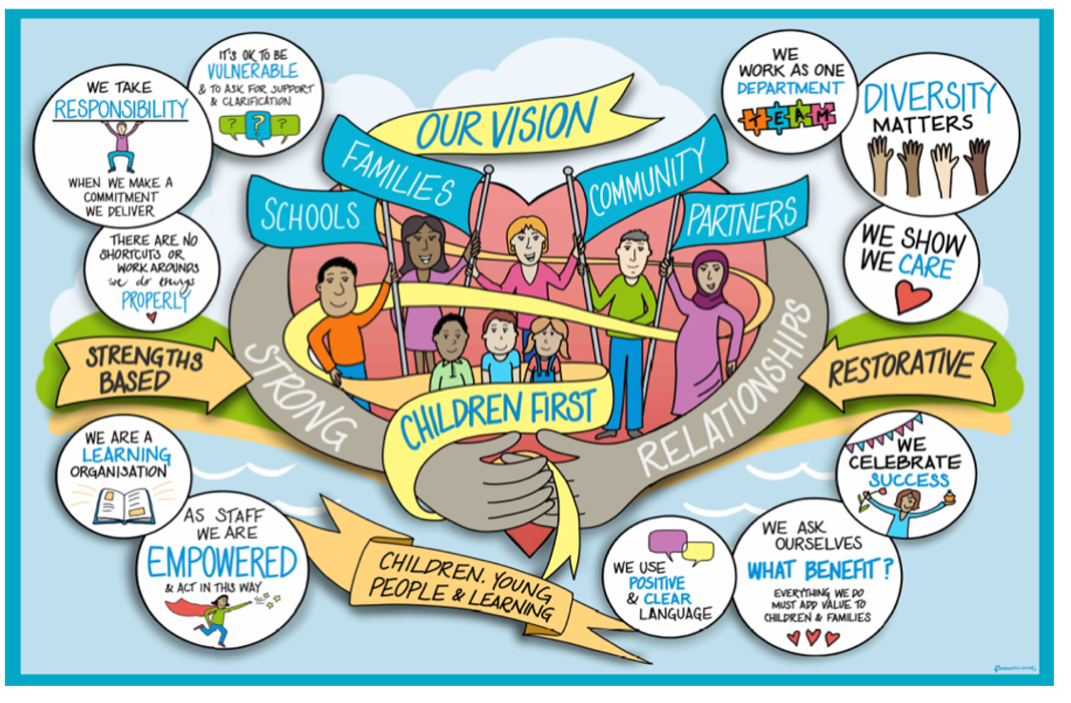

Family Time Contact and Contact within the Home

Index | Subject | Page
 | Contents
1. | Introduction | 3
2. | Family Time Team | 3
3. | Referring to the Family Time Team | 3
4. | Virtual Contact | 3
5. | Family Time in the Community | 3
6. | Family Time in our Family Hubs | 4
7. | Family Time within the Home | 4
8. | Family Time following the conclusion of Care Proceedings | 4

- Introduction

The aim of this practice guidance is to assist the Children's Social Care teams with arranging Family Time Contact for children and to understand when Family Time Contact can be undertaken in the family home.

- Family Time Team
As a service we need to put the child/ren at the centre of this and ensure that contact is in their best interests. The purpose of Family Time Contact for children and young people is to promote and maintain meaningful relationships and attachments with significant family members who contribute towards identity and a child’s sense of knowing who they are.

The Family Time Team offer contacts:
- Virtual via skype
- In the community, this could be in a park, café, or other appropriate venue.
- In one of our 3 centres
  - Bluebell Lodge Family Hub, Bognor
  - East Preston Family Hub
  - Teasel close, Crawly Family Hub

- Referring to the Family Time Team
All referrals are received via Mosaic and then allocated to the relevant area. If you require contact for more than 3 times per week and for more than 1.5 hours per contact, we would ask that you have a discussion with either one of the Family Support Leads - Sarah A Jones, Jessika Watling and Nicola Falvey, or the Team Manager Madeline Hartley.

- Virtual Family Time
We offer virtual/skype calls to parents who are in prison and if the child/ren are placed out of county and cannot easily get to one of our centres. Virtual/skype calls were set up at the beginning of the Covid Pandemic to ensure children could still talk to their families. Following pandemic restriction changes we have now returned to face-to-face contact and although we continue to supervise virtual/skype calls we do have limited capacity as face-to-face family time takes priority.

- Family Time in the Community
We offer contacts in the community for families that have been assessed to be low risk using the risk assessment tool. These can be in places such as parks, cafés, restaurants etc. We do sometimes offer contact in venues such as “Out of bounds” but this would only be if the social worker agrees as the worker may not always be able to see and hear what is happening during contact.

- Family Time in our Family Hubs
We offer contacts in our 3 buildings for families that are deemed not to be low risk and also for new families using our service that need to be more closely supervised. There is the option for contact to move into the community once social workers assessment and evidence is completed and subject to revision of the risk assessment.

- Family Time within a Family Home
As a service we do not offer contacts within the family home unless the care plan for the child/ren is for them to return home on a “reunification plan” and that this is the care plan before the Court.
The reasons are:
- Being in the home can influence the child/ren’s behaviour as they may have experienced a trauma when residing there.
- Having family time contact in the home may give the child/ren false hope and if the Judge then does not agree to the child returning home it could have a negative impact on them.
- There are a lot of distractions in the home such as playing consoles, watching tv etc.
- Parents need to be able to demonstrate they can meet the needs of their child/ren by arriving to contact on time and spending the time they have focused on that child/ren.
- Our workers cannot control who may attend the home during this would present us with a higher level of unknown risk.

If the care plan is for the child/ren to be reunified home, contact can only be completed within the family home following completion of a risk assessment and with a working agreement completed by the social worker, with the family time team and with the parent/s around expectations during the contact.
Any recommendation for the contact within the family home must be discussed by the social worker with the family time team prior to any care plan being submitted to the Court.

- Family Time following the conclusion of Care Proceedings
Following the conclusion of care proceedings, the Family Time Team will be available to facilitate contact, where required for children we care for. These will be children who are subject to a Care Order or are cared for under Section 20 arrangements, with a clear care plan for contact.

For children whose care proceedings conclude with orders such as a Supervision Order, Child Arrangement Order or Special Guardianship Order, there needs to be clear contact plans in place to enable contact to move away from being supervised by the Family Time Team prior to or at the end of proceedings. This may be, for example, supervision by family members/friends or within a local community contact centre and should be detailed in the final care plan submitted to the Court.

To enable transition of contact from The Family Time Team are able to provide the following support:
- Supporting transition to family/friend supervised contact (maximum of 6 weeks)
- Providing a room for contact (no supervisor)
- Providing information on contact services available in the community.

Should support be required at the conclusion of care proceedings by the Family Time Team it is important that this is discussed directly with the team before the final care plan is submitted to Court to ensure availability.

Review / Contacts / References
Document title: | West Sussex Practice Guidance – Family Time Contact and Contact within the home
Date approved: | 1.12.2022
Approving body: | Policy & Practice Steering Group
Last review date:
Revision history:
Next review date: | 1.12.2024
Document owner: | Linda Steele Assistant Director Safeguarding and QA
Lead contact / author: | Madeline Hartley, Team Manager, Family Time Team

