**Guidance for**

**Life Story Work**

**in**

**Redcar & Cleveland**

*As for the search for truth, I know from my own painful searching, with its many blind alleys, how hard it is to take a reliable step, be it ever so small, towards the understanding of that which is truly important*.

***-Albert Einstein***

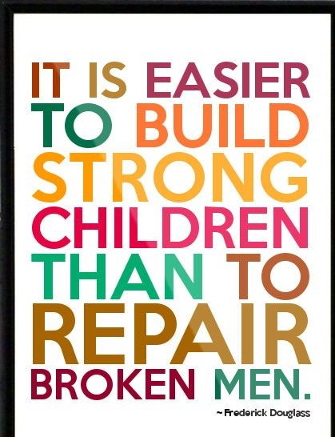

# **What is Life Story Work?**

Life story work is much more than just completing a book that outlines events in the life of a child or young person.

Life Story Work should support the child’s understanding of their life story, one way in which we do life story work is the process by which a life story book can be produced. It is a long-established social work tool used with children who are generally separated from their birth family and most commonly used with children who are or will be placed for adoption.

Life Story work can be an essential part of the recovery process for ALL traumatised children. Children as young as 2 or 3 can be given simple explanations which will help them understand why a professional is involved with them and their family and should support those children who have been removed from their parent’s or carers care to make sense of what has happened.

Redcar & Cleveland Children’s Services believe that Life Story Work is vital for the children and young people that we work with. Therefore, it is expected that each child / young person has the following:

* All Children and Young People who have an allocated Social Worker should have a Words and Pictures explanation available to them. This should be updated throughout our involvement and a final updated copy provided to the child at the point of case closure
* All Children who are subject to a Care Order and have a plan which means they do not return to their birth family should have: Words and Pictures and a life story book. (Please see appendix one)
* All children who have a plan of adoption should have: Words and Pictures, A Life Story Book, Later Life Letter, and memory box (see guidance and appendix two/appendix three).

Every child in our care who has a permanency plan other than a return to live with their birth parents should have life story work undertaken. Life story work is a therapeutic process which allows a child or young person to:

* Have details and understanding of their history
* Build a sense of identity
* Share their past with others
* Have a realistic account of their early events and dispel fantasies about their birth family
* Link the past to the present and to help both the child and adopter or alternative carer to understand how earlier life events continue to impact on behaviour
* Acknowledge issues of separation and loss
* Enable adoptive parents/carers or alternative carers to understand and develop empathy for the child
* Enhance the child’s self-esteem and self-worth
* Help the child to develop a sense of security and permanency
* Promote attunement and attachment

(Joy Rees, 2009)

# **Life Story Work vs. A Life Story Book**

**A life story book** concentrates on the child and building self-esteem. It has an important place and can help build a positive sense of identity, primarily using photographs, details of the child’s present, past, present, and future life in a scrap book style.

**Life story work** is a therapeutic process that includes all information and multiple truths in a child’s life. The child is not the author of their book but ideally actively participates in preparation for it. It is about answering what, why, when and where questions most children may have, but may be reluctant to ask.

Life story work absolutely depends on gathering full and accurate information and that information being correctly recorded (the information spine) – this process should not just begin once a decision has been taken to place a child in an alternative permanent family – this is too late. Life Story work should start with building the child’s narrative from the first point of contact and should always be in place and continuing at the point a child comes into our care therefore, Words and Pictures are a valuable tool to use.

# **Where to begin**

Life Story work should follow the 6 key steps outlined below to work with the child and their family/carers to support and deal with the child’s inner world and promote the recovery process (Wrench and Naylor, 2013):

(Please see the tools available to support you in life story work)

**Building a sense of safety**: This means beginning the life story work by helping the child regulate and lower arousal levels. Once improvements are made in this area then it is possible to move towards using more creative interventions. Often the carer/s need to be involved in this as they can learn to help the child regulate – it brings containment and a sense of safety through their relationships.

Why do we start with building safety? -

* Any adverse event be that neglect or trauma will affect the area of the brain that was most actively developing at the time of the event
* The younger the child was at the time, the more profound the impact on the developing brain (please see appendix four in relation to brain development and trauma)

**Building emotional literacy**: It is important to establish whether the child has words for feelings and can match them to events and that they know it is safe to talk about the good and the bad feelings they may have.

What is emotional literacy?

* At the beginning of life story work it is important to establish whether the child has words for feelings and can match them to events
* Traumatic memory is stored in the lower brain in non-verbal fragments – smells, taste, touch, sounds, images etc – The traumatic memory does not need verbal memories or consciousness to be expressed. A child might not be able to talk about the memories but may experience emotional responses to sometimes unidentified triggers in their environment
* Helping a child put words onto these fragments allows him to develop a verbal story thereby transferring the memory to the left hemisphere of the brain where it can be discussed, examined, and made sense of. The child then has the opportunity to gain some control over these memories (Appendix 4)

**Building Resilience and self-esteem**: Celebrating the strengths and achievements of the child and showing high expectations for them. Showing and providing evidence of their strengths and the importance of their relationship with their carer who will provide the safe base from which to explore their life story.

**Building a sense of identity**: Identity is who the child believes themselves to be, based on their experiences, their interpretation of those experiences, and the reactions of others to them and of the significant adults with whom the child identifies. As a result of experiences in their birth families and the care system, looked after children often have a negative sense of self and damaged sense of belonging. This will focus on identity in the past and in the future, promoting a positive sense of self.

**Information sharing and integration**: This is a process of information- sharing through which the child develops an understanding of their life history and that they are not responsible for the trauma they have experienced. As the child begins to have a clearer understanding of the past, present and future and a clearer understanding of their position in the world.

**Looking to the future**: This is a celebration of the child, packed with hope and optimism for the future. It is about reinforcing their position in their current placement, adoptive family, or permanent alternative– ‘a passport to the future’. The child’s carer/parent should also have a clearer understanding of the child’s history and what to expect from behaviour, which should help stabilise the placement. The child should have less guilt about what happened in the past and a stronger sense that they are deserving of love and care.

Life story work should be completed by a social worker. Sessions should be recorded on Protocol in case notes.

# **What is a Life Story Book and when do you need to complete one?**

First and foremost a Life Story Book must contain a coherent, narrative account of the child / young person’s story. You should seek to gather as much information as possible including their birth certificate, a genogram, photographs, video’s, information from places they may have visited or been and as much information about their birth family as possible.

All Children who are subject to a Care Order and have a plan which means they will not return to their birth family should have Words and Pictures and a Life Story Book. The Life Story Book contents should be agreed through discussion with the child / young person. Below is a table of suggested content:

|  |
| --- |
| Suggested Content for a Life Story Book with a Child or Young Person who is subject to a Care Order and is in foster care or in a Children’s home |
| Introduction to Life Story Work – what do you want to gain out of this |
| About you and your story so far- focus on the present and then move to the past before coming back to the present again |
| Your favourite things |
| Your birth family |
| When you lived with your birth family – what were your memories and stories of this time |
| What carers do (foster carers / residential staff) |
| Your Carers |
| Where you have lived |
| Finish in the present: What are your hopes and dreams for the future |
| Remember leave space so their story can be added to |

If a child is to be placed for adoption and the decision has been taken that no alternative care will do it is likely that all ties with their birth family will be severed, then the following is required.

|  |
| --- |
| **Content for a Life Story Book where adoption is the plan** |
| Introduction |
| About You – birth certificate, genogram, eco map etc |
| Your Story so far – Present moving to past (Your Early life) – starting with the present where they are currently and moving to their past to include things such as maternity hospital including weight, length & head circumference. Any items from hospital such as identity tag. |
| Your firsts – first smile, first tooth, first steps |
| Your Birth Family – photos of birth parents, aunts, uncles, grandparents, brothers and sisters and friends |
| Where you lived – including photos and maps |
| Things children need and making best decisions – how did they come in to care and how were decisions made. This should be a very child friendly explanation; more detail or distressing information should be in the later life letter. |
| When you lived with your foster family – photos, stories, and information |
| Family Stories unique to them about their birth family or while in foster care |
| How decisions are made – explanation of the Court process and a Judge |
| What does adoption mean |
| Information about your adoptive Family |
| Remember leave space so their story can be added to |

Making a Life Story Book is more than creating a photograph album with identifying sentences giving dates, places, and names. It is an account of a child's life in words, pictures, and documents, and provides an opportunity for the child to explore and understand their early history and life before their adoption.

A Life Story Book should:

* Keep as full a chronological record as possible of a child's life
* Integrate the past into the future so that childhood makes sense
* Provide a basis on which a continuing Life Story can be added to
* Be something the child can return to when they need to deal with old feelings and clarify and/or accept the past
* Increase a child's sense of self and self-worth
* Provide a structure for talking to children about painful issues.

The progress of a Life Story Book and Life Story Work should be discussed within the Social Workers supervision and within the child in our care review. It is essential that Life Story Books are completed and presented to the adoptive family and child by the time the Adoption Order is granted.

# **The Life Story Book – A new approach**

Traditionally life story books would look at the past and progress to the future. However more recent approaches promote the narrative of the child’s story starting with the present, moving to the past, back to the present before ending with the future:

* **Present**: Concentrates on facilitating stronger attachments to carers, reinforcing a sense of security and permanency
* **Past**: History to be contained in the middle which is symbolically significant
* **Present**: As above
* **Future**: A bright positive future

Clear messages of permanency, love, trust, and belonging should be threaded throughout every book.

# **How is it put together?**

* The child’s social worker should write it up in the third person (He/she NOT you/I) and put it together. Get a colleague and then the child’s parent/carer to review it before you share with the child.
* Individualise the book so it reflects the child’s personality – there is no right or wrong way to do this.
* Loose leaf binding is best so the child can edit information as they grow and can choose what to share with others and when. You should leave room to add new stories.
* Use clipart or scanned photographs to bring it alive.
* Use PowerPoint not word … much easier to work with.
* Ensure the text reflects the child’s emotional, social, and cognitive stages.
* Keep a second copy – books get destroyed or lost!

REMEMBER A LIFESTORY BOOK SHOULD BE A BACKPACK NOT A BURDEN

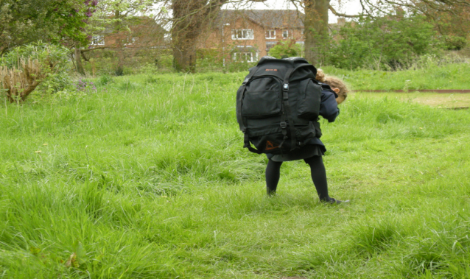 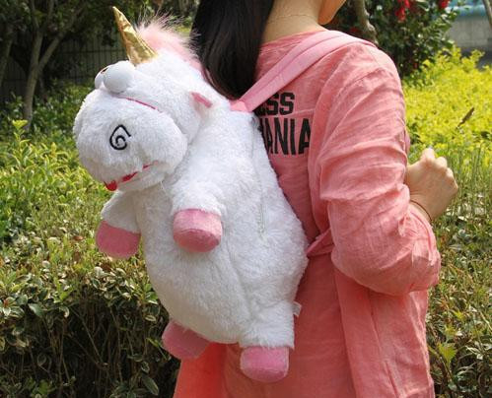

**GUIDANCE FOR LIFE STORY WORK IN REDCAR & CLEVELAND**

Appendix 1 – Words and Pictures

Every child that Redcar & Cleveland Children’s Services work with should have Words and Pictures completed and stored on their electronic case file in Documents. This is part of their narrative, part of their life story and part of the work to help them make sense of the journey to date.

Words and pictures are a simple and creative way to explain to a child what has happened in their lives and within their family’s lives. It can be used to explain why services are involved now and what their role is.

It allows parents / carers to share the same simplified narrative to explain to a child what has happened and what is going to help to keep them safe.

The most critical aspect of Words and Pictures is that the explanation is created with the parents, and they must be happy with the story before the children are given the explanation. Placing parents in the middle of creating the explanation requires significant skill alongside skilful use of authority.

Simple ‘stick’ drawings work best. (It is not a drawing competition, and you should never use ‘clipart’) it is designed to simply tell a story or explain what has happened.

It may be that the parent does not want to tell the story, however this is still an important part for the child and words and pictures should still be undertaken by the social worker or someone else who has knowledge of what has happened. This could be done alongside the child if appropriate and if parents will not complete.



**Mam and Dad were drinking alcohol and using drugs, and everyone was very worried about you and your sisters because sometimes Mam and Dad didn’t have enough food to feed you all and you were only a baby and needed special milk.**

**Sometimes Man and Dad didn’t have any of the special milk to feed you. Because of Mam and Dad’s drinking and drug use it was decided that it wasn’t safe for you and your sisters to live with your Mam and Dad, but you would still get to see them**.

**GUIDANCE FOR LIFE STORY WORK IN REDCAR & CLEVELAND**

Appendix 2 – Later Life Letters

The Later Life Letter should explain the child's history from birth and provide an explanation of why they were adopted, including the reasons why they could not live with their birth family.

The child is the focus of the letter, and it must be remembered when writing the letter that the child has a need to know why they were placed for adoption. The letter should be able to give the child a personal sense of their own history and a sense of their value and worth, something that a court report or the Child's Permanence Report (CPR) cannot provide.

The letter should, whenever possible, include the views of all the people involved in the adoption process, including the birth family.

Remember that every child will see the letter at a different age, and so the letter, whilst being truthful, must be written so that a child can understand it.

Our expectation would be that the child sees the letter when they are around 10-12 years, but the final decision on timing is at the discretion of the adoptive parents. In very difficult situations (e.g., incest, mental health problems, abuse) it may be better to write two letters. The second one for when the child is in their mid-teens, and better able to understand their history.

The letter is in addition to the child's Life Story Book and should never be a substitute for the book. The main difference between the Later Life Letter and the Life Story Book lies in the depth of the detail being shared with the child. Thus, more detailed, and sensitive information should be included in the Later Life letter as the letter will be shared with the child at a later age when they are emotionally able to understand and deal with the information.

**What Information Should be Included?**

In any letters the birth parents should be called by their first names, and the adopters described as "your parents".

**Beginning the letter -** Begin by introducing yourself and acknowledging that some time will have passed before the letter is read and that the child may not remember you. Talk about your role in relation to the child, the length of your involvement, and the reason for writing the letter, you should also mention other previous significant social workers who were involved (if that is the case) - give their names, and when and why they were involved.

Acknowledge that it might be difficult for the young person to read the letter and that they can ask for help from their adoptive parents while reading it.

**Write about their birth mother's pregnancy and their birth**

It is important to include as much information as possible about their mother's pregnancy and their birth. This is often the information that children would like to know. Think about things such as Date and time of birth; Name of the hospital; Weight; Experience of pregnancy; Length of labour; Type of delivery; Time spent in the hospital with their birth mother; Who was present; What happened next? And who cared for the child after their birth?

**Include Information about the Child's Life Before and After Care**

It is important to include all facts related to where the child lived – include names of caregivers, area where they lived, dates, description of caregivers and their family and talk about why they had to move. Names and descriptions of any nurseries or schools they attended and their developmental milestones, such as when they said their first words, had their first tooth, took their first steps. Think about any particular characteristics that they had at the time or any activities they enjoyed as well as their friends and any pets that were important to them

**Describe their Birth Family**

It is important to include those family members who had significant relationships with the child and who may have influenced their experience. Details of other family members who were not significant could be found in the CPR or in the genogram and the letter can refer to these if needed.

Focus on their birth family's situation at the time, where the children were living (mention the house, surroundings, etc) and the situation of the birth parents and siblings, describe the family members including their first name, their date and place of birth if known, their ages when their child was born, ethnic origin, a physical description, personality and appearance (what did they like to wear). You should try to include as much information as possible about the child’s birth parents thinking about their interests, employment their own upbringing and their relationship with one another:

Use the term 'birth mother/father' this will avoid confusion with their adoptive parents.

Include information about siblings if they were not placed together. Are they adopted? If they live with birth parents, explain why.

The child needs to know what happened to their siblings, who cares for them, and if relevant, why there is no family time. Be careful to give only first names for all birth relatives and do not use addresses or other identifying information. Be mindful about the amount of information you include it should be long enough for the child to know what happened to their siblings but remember that the child is the focus of the letter.

**Detail the reasons for adoption**

There will already be enough information to help describe the events that led to the child being placed for adoption. However, the key thing about the later life letter is that it gives the opportunity to explain these events in a more personal way.

The following explanations are found to be the most common for why the birth parents could not care for their children:

* Your parents were struggling with problems or troubles of their own
* Your parents never learnt how to look after and care for others
* Your parent was too ill
* Your parents were never shown how to look after a small baby

It is important to include clear explanations of when and why the big decisions were made, and who made them. The child needs to know the reason behind these decisions and needs to have an honest and clear explanation as to why this was the best decision for them.

The letter should also include, wherever possible their birth parent's attitude to the adoption and their hope for the child's future.

**Explain how their adoptive family was chosen**

Write about details of their adoptive family, including the process of choosing and the reasons for choosing them. Give details about their introduction to their adoptive family – the process of introductions and reactions, the date they moved, their final visit with birth parents or other birth family members

Talk to the adopters about the letter(s). When telling the child's story, it is important to be positive as well as negative. We rely on the adopters passing on this information, so involve them. Ask if you can talk about their hopes, fears, and feelings at the time of the introductory meetings and placements. Can you include the reason they wanted to adopt?

Give details of how any agreed family time was decided - whether it is "face to face" or Letter Box. The child needs to know that birth parents and other relatives want to hear about their progress, and that their adoptive parents agreed to the family time arrangements prior to placement.

Once the letter is drafted you should link in with the adopters' social worker and together show it to the adopters, they may have extra information that needs to be added. They may also wish to ask for some amendments/different wording. They need to feel comfortable with the content as this will be reflected in the way they help their child later with its contents.

**GUIDANCE FOR LIFE STORY WORK IN REDCAR & CLEVELAND**

Appendix 3 – Memory Boxes

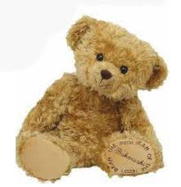

MEMORIES

MATTER

However traumatic a child’s past has been, helping them to understand it can prepare them for the future.

It is an important part of life story work for children who are going to be adopted to have a memory box. This does not have to be an expensive box it can be made from a cardboard box and decorated by the child if they are old enough with help from you if they want this. They should be encouraged and supported to put things in that are special to them.

**What should I put in my memory box?**

* Cards from special occasion from specific important people in their life.
* First tooth / First haircut / lock of hair, negotiate this with the birth parents, explaining the importance. Share if this is possible
* Negotiate with their birth parents for things such as one first bootie out of the two
* Photographs, get these from the birth family, take copies and return them
* Photographs from their foster carers
* Mementos, memories, and photos from any final family time sessions with their birth family
* Tickets to special events.
* Holiday mementos.
* Artwork.
* School books.
* Certificates and Trophies.

This is not an exhaustive list and just gives you an idea of the sort of things you should look to seek from birth family, support a child to keep or request their carer to keep.

**Make a Memory Box**: Get a sturdy cardboard box and some stickers, glitter, pens, or anything that can be personalised and decorate the box together if they are old enough. While you are working together you can discuss the sort of things they would like to keep. The box can then be kept in a safe place to store anything that they feel is special and they will want to remember. Keep a copy: Make copies of everything that can be easily photocopied or stored electronically just in case it gets lost or damaged.

**Think about the future**: Children may not seem so interested in keeping these memories when they are younger, but as they get older, they will want to look back and you play a key role in making sure these memories are not lost forever.

Please note that this does not have to be limited to children who are placed for adoption and any child that we work with can be supported to develop a memory box.

**GUIDANCE FOR LIFE STORY WORK IN REDCAR & CLEVELAND**

Appendix 4 – Brain Development and Trauma

Trauma and neglect at an early age can impair the development of many of the brain functions and affect the development of thinking, relationships memory and health. Exposure to repeated stress means that the structure and function of the brain may not develop properly just as repeated positive experiences help the brain to grow properly. This may mean that some young people who have not received nurturing and safe caring will have difficulty in regulating emotions and impulses. They may also have an excess of the stress hormone cortisol which makes them hyper vigilant and wary even in situations where they are safe. Sometimes they may react to events of situations subconsciously because something has triggered the fight or flight reaction. It is important that we understand and aware of the child or young person’s past experiences and how they might affect their behaviour now.

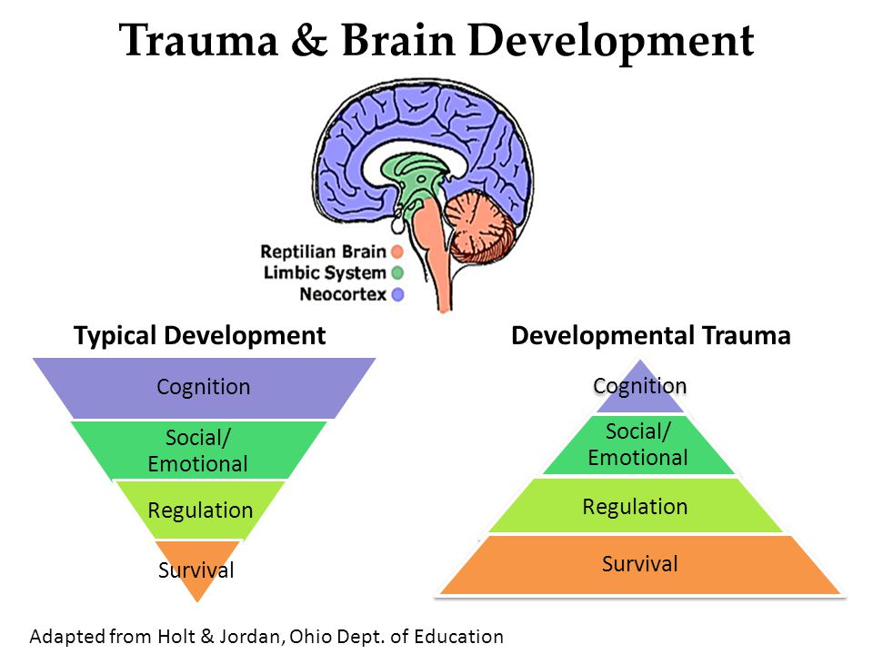

Adapted from Holt & Jordan

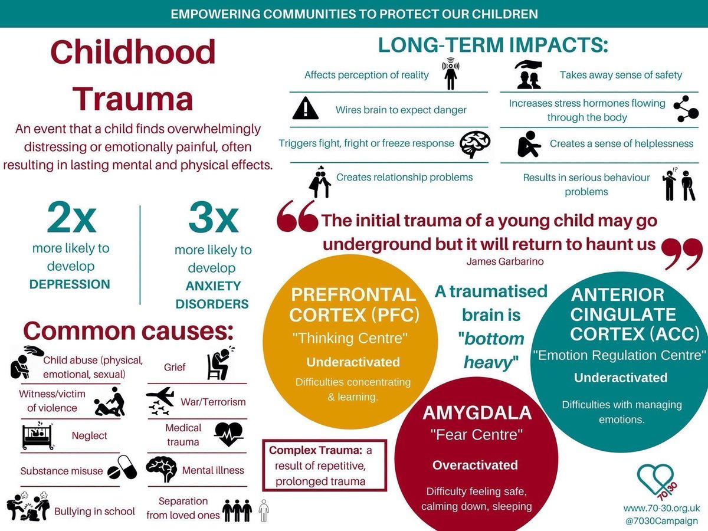

**Unlocking traumatic memories – how life story work might help.**

Traumatic memory is stored in the lower brain in non-verbal fragments such as smells, taste, touch, sounds, images etc

A Traumatic memory does not need verbal memories or consciousness to be expressed. This means that a child might not be able to talk about the memories but may experience emotional responses to sometimes unidentified triggers in their environment.

Life Story work can support a child to understand their narrative and so support them to connect this to their responses / triggers. This can support in unlocking trapped memories and integrating them into their story aiding in their recovery from trauma.

