This document is classified as Unclassified

How to Record a Return Interview on Liquid Logic
Return Interviews should be recorded within 72 hours of the young person being found. Allocated have responsibility to complete the recording of the Return Interview (the conversation can be between the young person and another worker).
The MISP episode are assigned to your work tray by MASH and Police notifications are uploaded to Documents – giving you the seen and report times along with the incident number MP/0001/2020.
- Click into the Missing Person Episode – it looks like this

- Click Update Missing Person Episode

- Click on ‘Found’

- Click ‘Yes’ Return Interview Offered – it is mandatory to offer a return interview unless the Police state the episode was not a Missing Person or the child is too young.

- Click ‘Yes’ if the young person spoke to you – even with partial information. Or ‘No’ if there was a complete refusal to say anything.

- You can input the date of the conversation

- Who spoke with the young person – another worker from another agency?

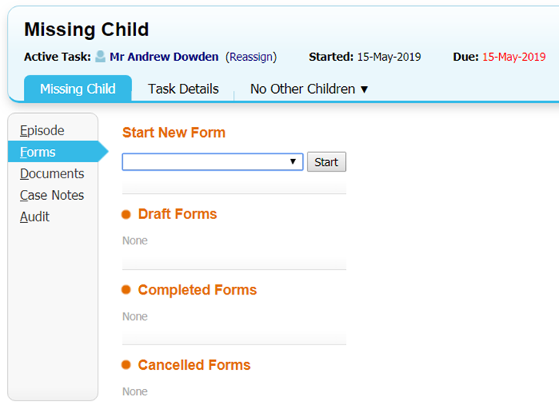
- Optional information for a quick glance….

- Return Interview Form needs to be completed regardless of how little information the young person provides.

- Recording the return conversation is ensuring the voice of the child is where all other [with access to LL] professionals can find it.
Case notes do not replace a Return Interview Form.

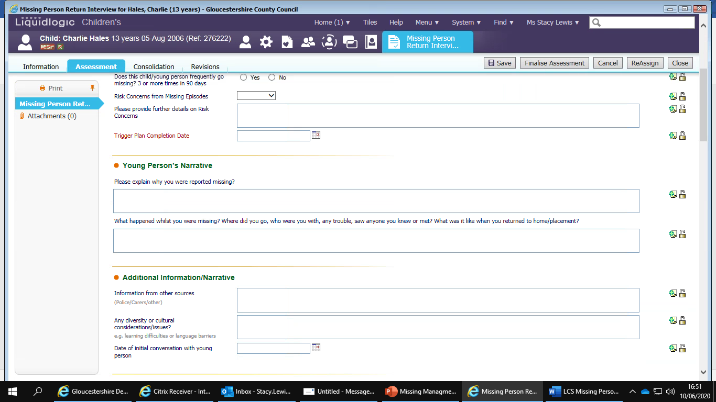
- You need to provide evidence the understanding of the risks. Even if the young person is not sharing information – who else is giving you information (additional information box) Parents/Carers/YST Workers/Placement/Police?

- Answer all questions and have a plan to tackle the reasons for Missing episode.

- The form can only be found in the Missing episode and once an episode is finalized it cannot be accessed.

