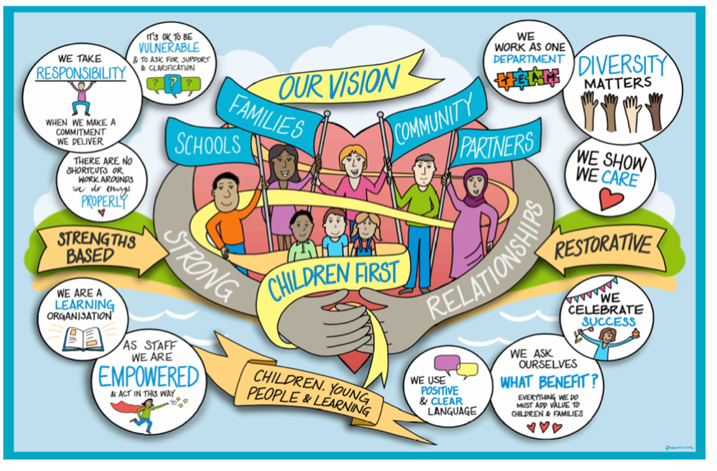

Protocol for urgent connected person viability assessments – for temporary approval under regulation 24

- Reason for this protocol
This process is in place in order to reduce delay to viability assessments being completed of connected persons in urgent situations. (Kinship placements)
This will in turn further reduce unlawful or unregulated placements.
This protocol is only in place for urgent situations (defined below). In non-urgent situations this process will not apply and viability assessments will be allocated to the “viability assessment” social workers in the fostering team to complete in conjunction with the allocated social worker.

- Criteria for children needing an urgent viability assessment
- Already placed with a family member (police protection or section 20 due to immediate safeguarding concerns)
- Child in hospital awaiting discharge
- EPO application
- Short notice ICO
- Child abandonment
- Foster placement have given immediate notice
In all other circumstances a family network meeting must be convened to identify a maximum of two family members and the non urgent process will be followed.

- Process:
First 24 hours:
- Child’s allocated social worker rings fostering duty
- Fostering duty SW takes call & asks key questions to establish urgency and suitability (screening)
- Agree time for fostering social worker to visit with allocated SW within 24 hours
- If a “viability assessment social worker” has availability they would undertake the joint visit with child’s social worker
- If there is no viability assessment social worker available, fostering duty social worker will undertake joint visit with child’s social worker
- Child’s social work team admin completes PNC check (if not already done by police)
- Child’s social worker completes part A viability assessment and sends to fostering team on mosaic
- Agency checks sent by fostering social worker
- Joint visit completed
- Verbal agreement between fostering SW and allocated SW if the arrangement is immediately safe or if management advice needs to be sought.
Within 48 hours of visit:
- Allocated social worker completes part b of viability assessment
- Fostering social worker completes part c of viability assessment
- Fostering social worker sends assessment to fostering TM to sign off
- TM signs off within one working day
Positive viability assessment - progress to ADM for same day sign off
Negative viability assessment – allocated social worker for the child convenes case discussion with the child’s TM and SM regarding next steps. They may still send the viability assessment to the ADM if they wish to have approval considered.
- If the placement is still not approved and the team wish the child to remain in placement, same day meeting to be convened with the head of service for assessment & family safeguarding.

Review / Contacts / References
Document title: | Process for urgent viability assessments
Date approved: | 12/01/2023
Approving body: | Louise Fox/Barry Kirwan
Last review date:
Revision history: | V1
Next review date: | 02/06/2023
Document owner: | Louise Fox
Lead contact / author: | Louise Fox

