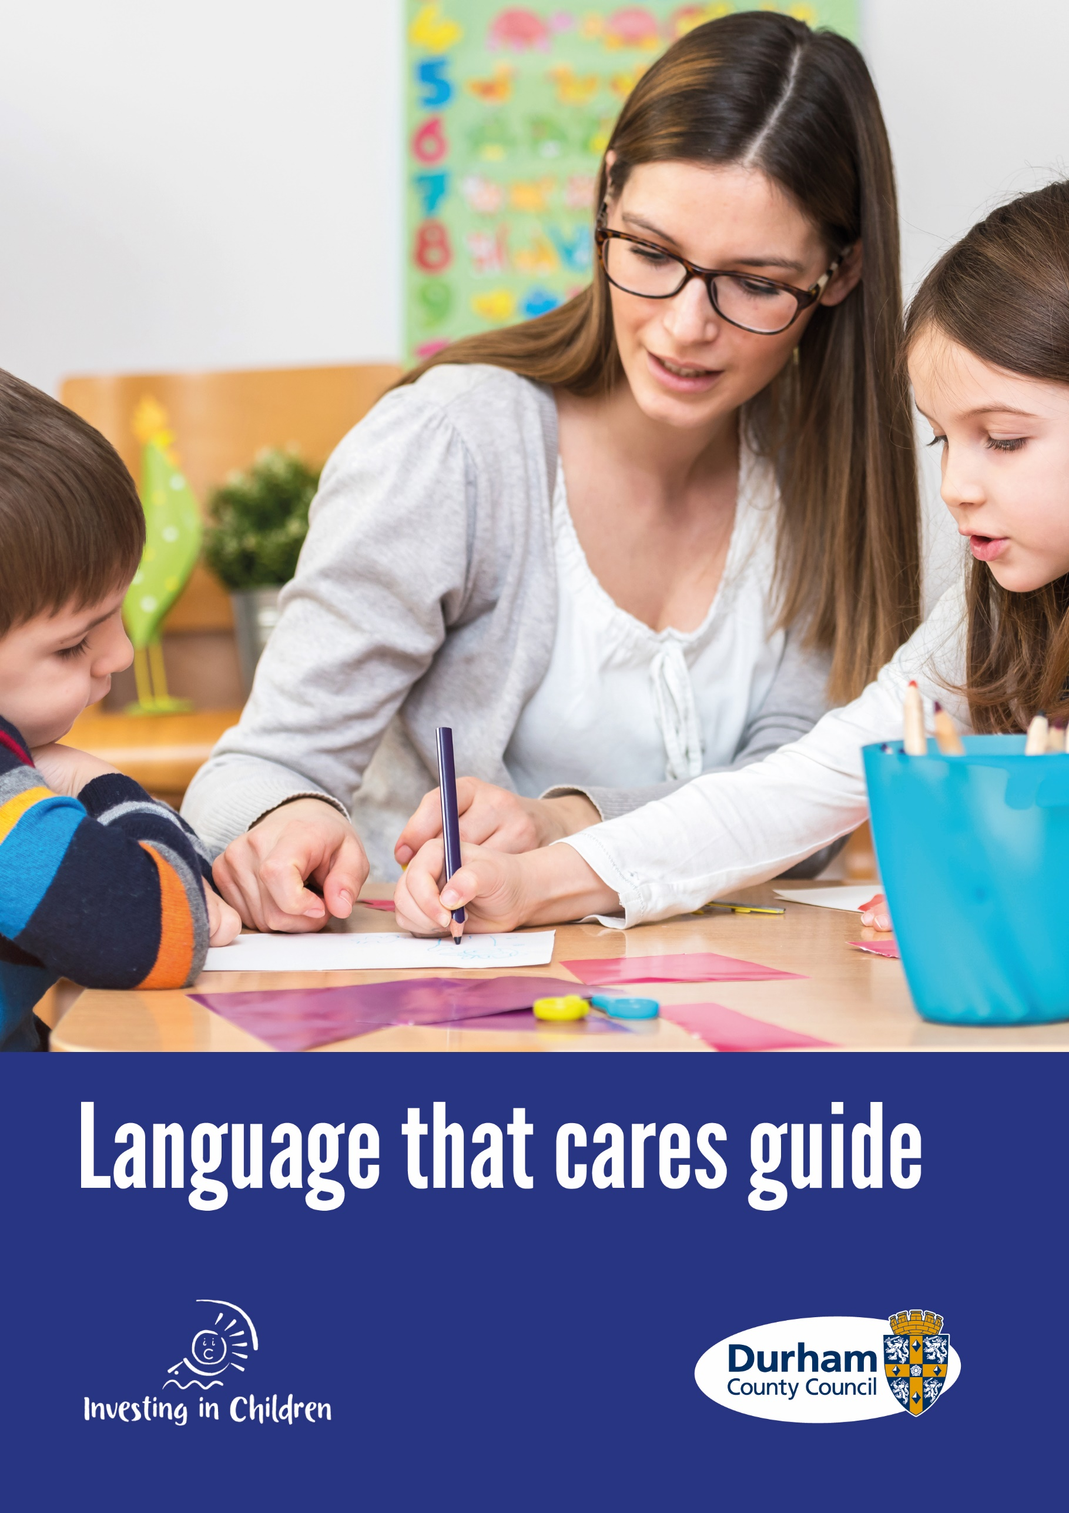
“Our commitment to children, young people and their families is that we will always speak with them and write about them using plain, straightforward and family friendly language that makes sense to them.”
Helen Fergusson, Head of Children’s Social Care

‘No one has ever asked me before how I feel about the words adults use … it’s good to be able to share my ideas!
Durham Young Person

Acknowledgements
Thank you to the children and young people from Durham County Council Children’s Social Care, Children In Care Council and Investing in Children, who led this project following learning from the national TACT ‘Language that cares’ document.
Children and young people with care experience, those working with Families First teams and Children Looked after Teams developed this language guide through various workshops and group activities.

Contents
Chapter 1
Why focus on language? 4
Summary 5

Chapter 2
Language guide developed by children and 6
young people across County Durham

Chapter 3
Not using victim blaming language 15
Summary 16

Chapter 4 17
Useful Links

Chapter 1: Why focus on language?
Changing the Narrative - Language That Cares
Children’s Services are committed to using clear, precise and understandable language so that everyone, especially children, young people and families, understand what we are saying and writing. Not using straightforward and commonly understood language runs the risk of making people feel foolish, inadequate, excluded and powerless when what we want is for them to feel strong, empowered, confident and hopeful.
Sometimes professionals use over complex words, abbreviations and jargon because: it feels quicker; it’s what we are used to; we mistakenly think that improves quality, we see other professional using it or we don’t think, we forget or don’t notice the negative impact this has on the people we are trying to work with and help. At worse, unnecessarily complex language, professional jargon, abbreviations can, consciously or unconsciously, make us seem arrogant, superior, can be something to hide behind or show power in an unhelpful and unskilful way.
We build good, honest and respectful relationships, which fundamentally underpin all our work, through good, clear communication both verbally and non-verbally. We want to be clear and firm in a hugely kind manner.

TACT Fostering and Adoption published ‘Language That Cares: Changing the way professionals talk about Children in Care’

In March 2019 TACT Fostering and Adoption published ‘Language That Cares: Changing the way professionals talk about Children in Care’. This is a useful and practical guide that challenges language that is often used by those who work with children and young people who are looked after and are care experienced. Children’s Services support the use of language that cares:
Click to open the TACT document
As a response to this guide, children and young people across Children’s Social Care and Durham Children in Care Council (CICC) have been discussing a variety of words used by workers across social care. This language guide details suggestions about the words they tend to prefer and would like us to think about when talking with them, in front of them and when writing reports or forms. All children, young people and families should feel comfortable and understand the language we use and we should make sure of this by asking not assuming that they do.
Every child and young person is unique. The way we talk with children, young people and families plays a crucial role in relationship building. We want to show that we value and respect families’ wishes and feelings when it comes to the way we talk with them, in front of them and write about them.
To do this, we need to have conversations about the words and phrases children, young people and their families prefer us to use and what they mean to them. Remember, when you are getting to know and are building a relationship with a child or a young person, check out and understand what words they like to use and those they don’t like. It shows that you are interested and care.
It is recognised that there will still be sometimes when we need to speak or write using more official words or phrases. On these occasions, we will explain meanings to children, young people and their families so they understand them.
When writing reports, we will explain at the start how certain words/phrases will be used so everyone knows who and what we are writing about.
For example: ‘The young person likes to referrer to the time she spends with her parents as ‘family time’ rather than contact so this is how this is referred to within this report.
For example: Joseph prefers to be called Joe, so throughout this report I will refer to him as Joe.

Summary

Clear, straightforward and understandable
Ask the child or young person what words they prefer to be used
Respect what the child or young person says by using their chosen words
Explain official words that need to be used so everyone understands their meaning
Support and challenge other professionals to use language that cares

Chapter 2: Language Guide
The Top Six Words and Phrases that Children and Young People dislike the Most

Words and phrases Durham children and young people tell us they tend to prefer …but, remember to ask the person you are working with what they wish to be used

1.Contact-
We prefer: family time/ seeing people you care about/ meeting family
‘When you tell people, you’re going on contact no-body knows what that means’ Durham young person

2.In care-
We prefer: being cared for
‘When speaking about us why are you labelling us as ‘in care’
Durham Young Person

3.Child in Need-
We prefer: Young person needs extra care / extra support
‘Do not say CIN!!’
Durham Young Person

4.LAC-
We prefer: A person who’s cared for / CLA / YP / called by your name/
‘LAC sounds like there is something wrong with us’
Durham Young Person

5.Care plan-
We prefer: Child and Family Plan/ personal progress plan/ my personal plan / family plan
‘The plan is about our family so say just say that’
‘The plan tells me when I’ll see Mam and Dad’
Young People from Durham

6.Siblings-
We prefer: brother or sister

A-Z List of suggestions developed by Children and Young People:
A
Abscond
We prefer: running away/ disappearing act

Advocate
We prefer: messenger/ talks on your behalf/ a person to represent your feelings/ spokesperson

Assessment
We prefer: Make a plan / look at the information
‘Assessment sounds like a test I have to do at school’
‘I don’t know what is going on when you say an assessment’
Young People from Durham

Asylum seeker-
We prefer: young person/ someone who needs our help/ someone seeking safety/ sanctuary seeker/ safety seeker

B
Birth/ biological parents-
We prefer: real parents/ first parents/ actual parents

C
Care leaver- “fine the way it is!”

Challenging behaviour-
We prefer: take out the word challenging/ distressed feeling/ hard behaviour/ struggling thoughts/ Individual behaviour/circumstances / behaviour

Consistent guide-
We prefer: routine guide/ someone who cares/ consistent support

Contact centre/room-
We prefer: family visitation centre/ place to see people you care about/ place to see family and friends/ Family time centre

Corporate parent-
We prefer: member of the council/ council member/ there to help you/look after you when you’re in care/a councillor who cares/our helper/ community guardian

D
Designated teacher-
We prefer: chosen teacher/ one to one support/ nominated teacher

Difficult to place-
We prefer: failed by the system/ hard to match to a suitable family/ hard to place/ Hard match/ difficulty placing

Drop out–
We prefer: leaves early / leaver/ early leave/ retire

E
Emergency placement-
We prefer: place to stay when it is difficult to find a place at short notice/last minute placement/ emergency home

F
Foster carer-
We prefer: people who look after you while you’re in care/ carer/parent/guardian

Full potential-
We prefer: best/ biggest achievement/ reaching the goals/goals reached

H
High aspirations-
We prefer: high personal goal/ positive high goals/ just aspirations positive personal goals

I
Initial Child Protection Conference-
We prefer: Next steps meeting/Plan meeting

Isolation- We prefer: lonely/ being on your own/alone/loneliness/on own

L
LAC review-
We prefer: meetings/ personal progress plan/your 6-month review

LAC visit-
We prefer: social worker visit/ visit/ Support worker visit
‘There should be more positive stories around LAC, CLA is no better as a suggestion. Maybe just stick to acronym CIC (child in care), and abbreviations need to be explained clearly’
Young People from Durham

Leaving care-
We prefer: leaving / moving out/ leaving home

Long term placements-
We prefer: place to live for a long time/permanent home/long term home
‘Need to remove the word placement entirely!’
Young People from Durham

M
Moving placements-
We prefer: moving house

N
NEET-
We prefer: unemployed and not in education/ out of education and unemployed
‘Nobody knows what NEET means’ Durham young person

Neglect-
We prefer: Not looked after properly/not always cared for
‘They say that to us because Mam doesn’t always do the right thing’
Durham young person

P
PA-

We prefer: someone who advises you/advisor

P
Pathway plan-
We prefer: your plan/ preparing for independence/ future planning

Peers-
We prefer: people you can talk to/ friends

Permanence-
We prefer: being in care until you’re an adult/ forever home/ permanent Home

Placement-
We prefer: family home/ your home/ where you are living/ where you live/ home
‘Placement needs to be removed entirely from vocabulary and any other terms that have placement in. Swap it to the suggested word’
Young People from Durham

R
Respite-
We prefer: to give your carers a break/ holiday just for carers/home away from home/ break

Restrained-
We prefer: protecting someone from harm/stopped from harming anyone or yourself/holding

Reunification-
We prefer: going back home/ reuniting/coming together again

Risk
We prefer: Not safe/Need protecting/help to keep us safe

Risk assessment
We prefer: safety plan/ keep safe plan/ safety care plan

S
Short term placement-
We prefer: place to stay for a little time/ temporary home/ short term home

Sick–
We prefer: poorly/ ill/ not very well

Social worker-
We prefer: worker / one to one worker / helper

‘Social worker has so much stigma associated with it, as soon as you say social you think of social services and being removed’ Durham young person

Special needs-
We prefer: extra support
‘“Special needs” as a term is derogatory and inappropriate, this has been a issue for a long time and should not be used anymore at all!
’Durham young person

Staff/ support staff /unit manager-
We prefer: workers/ names/ person in charge/ carer/ adults in the house

Statutory visit-
We prefer: visits/ check-up visit/ chance to be listened too

Staying put-
We prefer: staying at home/ living with your foster carers when you leave care

Supported lodgings-
We prefer: semi-independent living/ place to help you prepare to live by your self

T
TAF-
We prefer: Family Meeting / Our Meeting
‘It’s about our family so it should be called our meeting’
‘TAF is a nonsense word if you’ve not heard it before’
Young people from Durham

Therapy-

We prefer: help/ sessions/ meetings

Transition-
We prefer: next chapter

Y
YPA
We prefer: advisor, helper
‘No abbreviations’
Durham young person

Chapter 3: Avoiding Victim Blaming Language
When we speak with and about children and young people, parents and carers, we have a responsibility to make sure that the words we use don’t make them feel as if they are being blamed for something, especially when it is not their fault. This can sometimes happen even when we are trying to be careful with our language and without us intending to imply this.
There are many reasons why children and young people who have suffered or who are suffering harm are unable to let us know what has, or what is happening to them and how they feel. Behaviour is communication. This type of communication helps us to recognise that a child or young person is not coping, is distressed, in turmoil and, or suffering and needs our help and support. Our approach should not be ‘Billy is a nightmare’ but rather ‘Billy has lived a nightmare’.
Take time to reflect on the words and phrases we use. For example, think about how a child or young person, who is vulnerable and likely to already be unnecessarily blaming themselves for the situation they are in, would interpret ‘involved in’ child sexual exploitation? Might they feel implicated or complicit, that they are part of the problem? We would never say that a 6-year-old is ‘involved’ in sexual abuse, so why would we say this for an older child or young person? Or calling them ‘difficult to place’, again it is easy to see that this could add or reinforce a child or young person’s miss placed self-blame and further destroy self-esteem and trust in us.
A large amount of blaming language relates to children and young people who are at risk of, or are, being harmed by child sexual and or criminal exploitation. Historically, the words ‘child prostitution’ were commonly used which implied that the child or young person is responsible for the abuse when no child or young person can consent to being abused.
Phrases like ‘lifestyle choices’ and ‘putting themselves at risk’ are now being challenged and are no longer acceptable in our work. Both these terms imply that the child or young person is responsible for the risks presented by the perpetrators of abuse. The child or young person is not able to make a free and informed choice as they are being coerced and controlled is part of the abuse, which they can’t always recognise or communicate. Alternative phrases should be used to explain that the child or young person is at increased risk because of others abusive behaviour.
By slowing down our thinking about language and reflecting on what unintended messages words could be giving to already vulnerable children and young people, supportive and non-blaming language will help us use language which will then become embedded and our culture.

We embrace and adopt the language guidance for professionals created collaboratively by The children’s Society, Victim Support and National Police Chief’s Council: Appropriate Language; Child sexual and/or Criminal Exploitation
Link: click here for Appropriate Language; Child sexual and/or Criminal Exploitation

Summary

- Behaviour is communication

- Billy has lived a nightmare

- A child or young person can’t consent to their own abuse

- Take time to reflect on words and phrases that might sound and feel critical or blaming of the child or young person and use something kinder and accurate

Useful Links
Tact Language that Cares: Changing the way professionals talk about children in care. Alternative words and phrases to use with and about children who are looked after
TACT Language that Cares

Appropriate Language: Child sexual and/or criminal exploitation. Guidance for professionals on changing language to avoid blaming children and young people
Appropriate Language; Child sexual and/or Criminal Exploitation

Glossary: Created by children and young people for children and young people by the Family Justice Young Peoples Board, Children and Family Court Advisory and Support Service (Cafcass)
Cafcass Glossary

