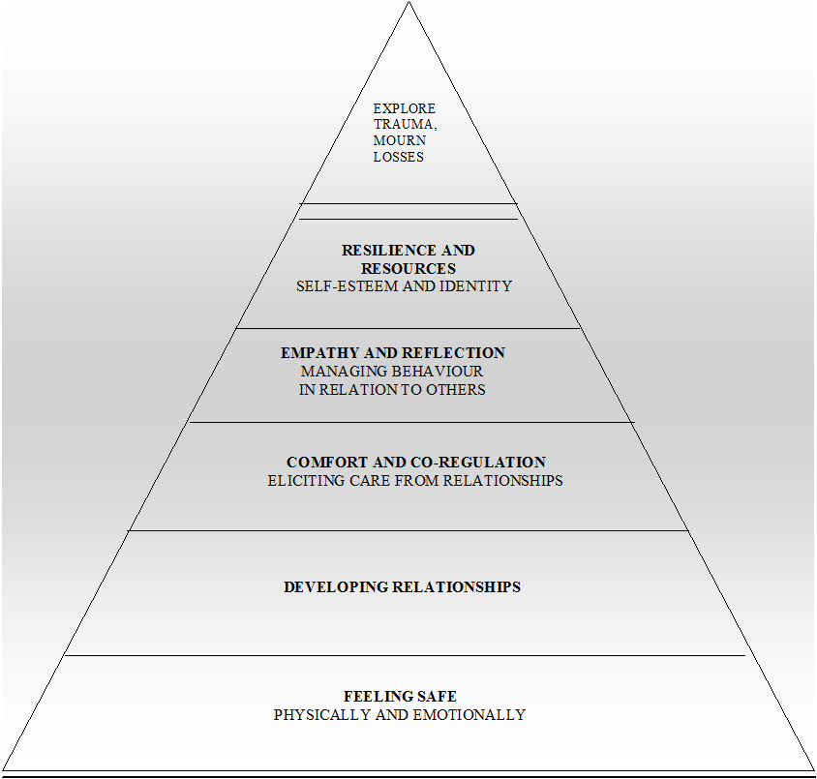
Pyramid of Need – The needs of the traumatised child
- To feel SAFE! Safe, stable environment with a committed carer
- Nurture and trauma informed parenting/care that supports connection
- Opportunity to build healthy, secure relationships
- Support to regulate themselves and their emotions
- Understand their own feelings to support empathy building
- Validation of feelings and experiences
- Structure, predictability and routine e.g. regular meals and bedtimes
- Physical activity, meditation/mindfulness and sleep (healing during REM sleep)
- Support to build self-esteem
- Positive friendships and social ties/ activities
- Opportunities to process their experiences with a trusted person(s) in their network or professionally
- Consistent approach from all agencies

Source: Kim Golding

