The brain
Understanding the way our brains work can help us learn
- Why we get angry
- Why it can be hard to calm down
- Why we can do things that we regret later
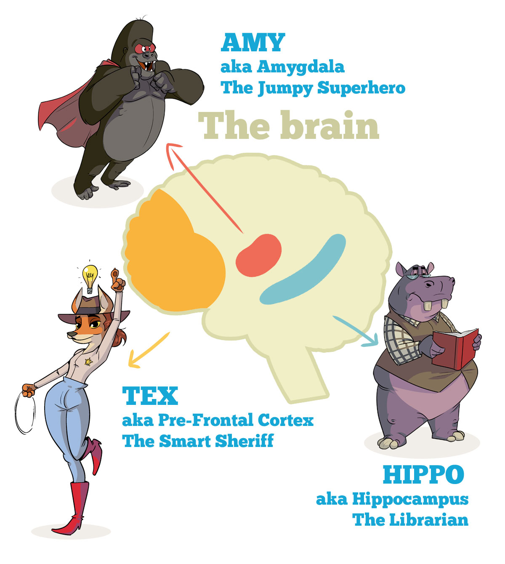

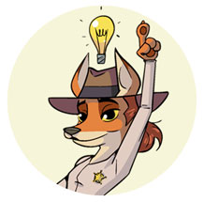Tex –Pre-frontal Cortex
- The Pre-frontal cortex (or TEX for short) is the part of the brain that helps us deal with emotions and making wise decisions.
- She figures out stuff for you and helps you make good choices.
- Tex is like a smart sheriff in your brain.
- And she helps us with impulse control too, to overcome temptations.
How does she help us?
When we experience a thought or an emotion, Tex asks:
“Will this help us to reach our goals?”
If the answer is no … then Tex will stop you from acting.
If the answer is yes (as in this will help you reach your goals) … then Tex will allow you to act.
This is how the prefrontal cortex or Tex does her work. Sort of like a sheriff in your brain.
For example…………..
Have you ever wanted to say something … but you realised that saying it would only make things worse?
If this has happened to you it is likely you will have bit your tongue and managed to not escalate the situation … then Tex was able to help you.
How about this:
Have you ever felt really emotional and said something awful … something you wished you could take back?
Of course you have. We all have.
Okay so … at that time Tex was not able to help you.
But … why not?
This happened most likely because another part of your brain called the Amygdala believed that the stress you were experiencing was a real threat to you.
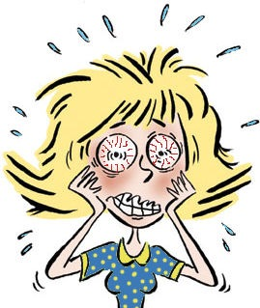

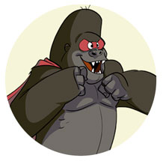Amy-Amygdala

- Amy is like a jumpy superhero who tries to protect you at all costs.
- She often mistakes stress for real threats.
- This can stop Tex from doing her job.
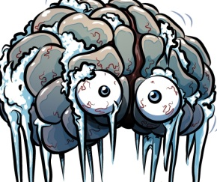
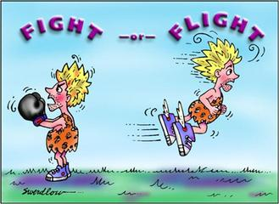

- During a stress response we can experience fight, flight or freeze.
- During this time we lose connection with higher brain functions like empathy, communication skills and memory.
- It becomes really hard to make good choices, remember instructions and control impulses.
- A long time ago when wild animals hunted us, our brains helped us survive by reacting automatically and instantly to danger.
- When we feel we are in danger –we can have a fight, flight or freeze response. When this happens we can experience overwhelming emotions such as anger, sadness or fear.
The real life example
We are generally not hunted by animals anymore! But it could be someone saying something unkind to you (or even you expecting them to be unkind) and this part of your brain thinks you are in danger. You could fight by calling them names and being angry, freeze at school if you are overwhelmed or try to run away.
Hippo-Hippocampus
He is like a librarian, he stores and recalls memories. When Amy is upset Hippo can’t store memories properly or bring them to mind. This means that sometimes when Amy is not working properly it can be really hard to learn, or remember things you have previously learnt.

Source material http://blissfulkids.com/mindfulness-and-the-brain/

