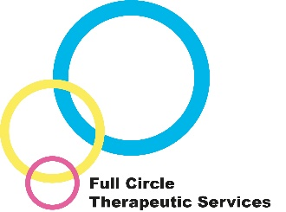
Kinship Carers Therapeutic Parenting Training
This training is available for kinship carers who care for a child looked after or for a child who was previously looked after and they now hold either a Special Guardianship Order, Residence Order or Child Arrangement Order.

The training focusses on the impact of trauma and attachment difficulties on your child/the children you are caring for and how it can affect their behaviour, presentation, and relationships.

The training course takes place over 3 half day sessions. The training course supports understanding around the impact of attachment difficulties and trauma. It also addresses how to parent therapeutically to support your child in their healing from their difficult early life experiences and discusses how you can help strengthen or repair the carer-child relationship.

The Kinship Carers Enhanced Therapeutic Parenting Training is delivered by appropriately qualified and experienced Therapeutic Workers, with input from our Consultant Clinical Psychologist.

Why would this be helpful?
From research and experience we know that parents and carers are key to helping children heal and have positive futures. Part of this is understanding the child’s behaviour through a different framework. Changing how you approach things can make a huge difference to family life.
An additional benefit of the group is meeting others who are in similar situations or who understand your experiences - both the rewarding and the more challenging ones!
Different training methods will be used including a presentation, practical examples, activities and video clips.
What people say about our training:
“An enjoyable time during a delicate and sometimes emotional course when thinking about our loved ones”
“Ladies were really good at explaining everything, it helps me understand my children more”
“I can see where her behaviour comes from and why now”

Contact/access us: Your child’s allocated Social Worker/One Point worker in Durham can contact the Full Circle Business Support on 03000 264730 or via fullcircleadmin@durham.gov.uk and ask to speak to a duty worker to discuss the appropriateness of a referral and/or can complete a referral in the forms section of Liquid Logic.

