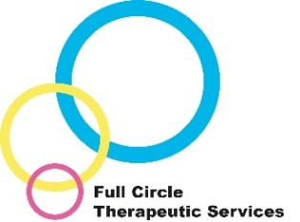
Nurturing Attachments Training
Information leaflet

This training for adoptive parents and foster carers focusses on the impact of trauma and attachment difficulties and how they can affect can your child (or the child in your care), their behaviour, presentation and relationships.

The training course takes place over 7 half day sessions. The training course supports understanding around the impact of attachment difficulties and trauma. It also looks at how to parent therapeutically to support your child in their healing and how you can help strengthen or repair the parent/carer-child relationship. This way of parenting also helps to support re-wiring of the brain, helping the child to recover from their difficult early life experiences.

The Nurturing Attachments Training is delivered by qualified and experienced Therapeutic Social Workers and Fostering Social Workers with input from our Consultant Clinical Psychologist.

Why would this be helpful?

From research and experience we know that parents and carers are key to helping children heal and have positive futures. Part of this is understanding your child’s behaviour through a different framework – an adapted approach can make a huge difference to family life.
An additional benefit of the group is meeting others who are in similar situations or who understand your experiences - both the fantastic and the more challenging ones!
Different training methods will be used including a presentation, practical examples, activities and video clips.

What people say about our training:

“The attachment training was fantastic, without a doubt the best training we have taken in our 10 years as foster carers; a real eye opener”
“Trainers were really good at explaining everything, it helps me understand my children more”
“A lightbulb moment…I can see where her behaviour comes from and why now”
Contact/access us: Your allocated Social Worker or One Point Worker can make a referral to Full Circle on your behalf. For further information, contact Full Circle Business Support on 03000 264730 or via fullcircleadmin@durham.gov.uk.

