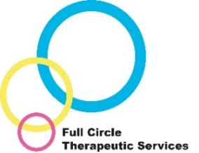
Trauma Informed Approaches Training
Information leaflet

This training is for professionals who provide direct or indirect care to child and young people in the looked after system. It focusses on the impact of trauma and attachment difficulties and how they can affect the child or young person in your care, their behaviour, presentation and relationships.

The training course can be delivered across a full day or a couple of sessions, and we would be happy discuss what will suit your requirements/any alternative needs. The training course supports understanding around the impact of attachment difficulties and trauma. It also looks at how to parent/care for therapeutically to support the child/young person in their healing and how you can help strengthen or repair carer-child relationships. This way of parenting also helps to support re-wiring of the brain, helping the child to recover from their difficult early life experiences.

The Trauma Informed Approaches training is delivered by qualified and experienced Therapeutic Social Workers with input from our Consultant Clinical Psychologist.

Why would this be helpful?
From research and experience we know that parents and carers are key to helping children and young people heal and have positive futures. Part of this is understanding the child’s behaviour through a different framework – an adapted approach can make a huge difference to home life.

Different training methods will be used including a presentation, practical examples, activities and video clips.

What people say about our training:
“The attachment training was fantastic, without a doubt the best training we have taken in our 10 years as foster carers; a real eye opener”
“I really felt they understood what was going on very quickly and provided really helpful advice, guidance, support and practical strategies”
“A lightbulb moment…I can see where her behaviour comes from and why now”

Contact/access us:
For further information about Full Circle and the services we offer, please visit https://www.durham.gov.uk/fullcircle . For further information about this training or any additional training we can provide and to discuss your needs and cost, please contact Full Circle Business Support on 03000 264730 or via fullcircleadmin@durham.gov.uk.

