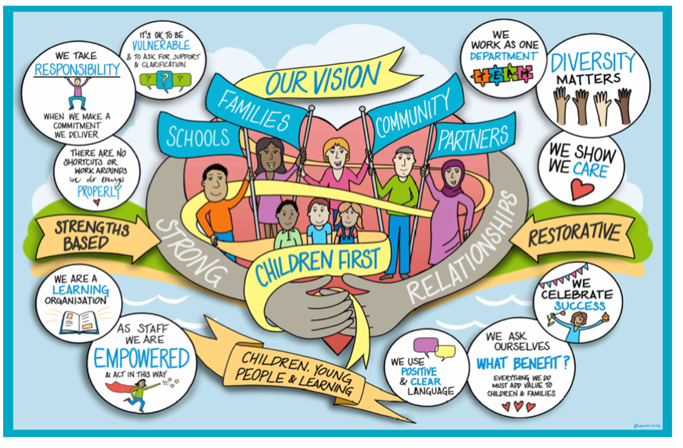

Homeless Young People (16 and 17-year-olds) Practice Guidance

This is a Joint Working Protocol between the Seven District and Borough Councils and West Sussex County Council’s Children & Families Directorate responding to 16/17year olds who are homeless or threatened with homelessness.

The protocol will be framed around the Young Peoples Pathway key functions of homeless prevention, Children and Families assessment and emergency accommodation.

The protocol will set out the requisite action to be taken where a young person approaches either District & Borough Housing services or Children and Families Services for assistance with the aim of preventing rushed and damaging transitions for young people to independence and to minimise the number of young people facing a housing crisis.

Contents

- Fundamental Principle
- Legislation and Statutory Guidance
- Housing Duty
- Children’s Services Duty
- Ordinary Residence
- Procedures for Disputes
- Suitability of Temporary Accommodation
- Monitoring the Protocol and Review

Appendix 1: Definitions

1.Fundamental Principle
This Joint Protocol sets out the mutually agreed commitment between Children’s Social Care, Youth Homelessness Prevention Team and the Seven District and Borough Councils of West Sussex to work in close partnership to prevent young people becoming homeless or entering the care of the Local Authority by supporting them to remain at home with their families wherever possible and if it is safe to do so.

The protocol outlines the agreed roles and responsibilities for all parties involved in assessing and supporting 16/17 year olds who are at risk of homelessness. It provides a series of definitions and procedures to be followed by West Sussex County Council Staff to ensure that the responsibilities for homeless or likely to become homeless 16- and 17-year-olds under Part 7 of the Housing Act 1996 (as amended by the Homeless Act 2002), Part 3 of the Children Act 1989, the Children Act 2004, the Children Leaving Care Act 2000, Recent Case Law: G v LB Southwark are appropriately fulfilled.

The Young Person should remain at the centre of practice, taking into account their wishes and feelings and ensuring that they are made aware of all work that is happening. When considering the Young Person’s needs for support and accommodation, professionals must consider any additional needs they may have, as well as how their ethnicity, culture and heritage may impact upon their required outcomes.

The parents/carers/guardians of young people will be contacted as an essential part of the youth homeless assessment process and family meetings offered unless Children’s Services assess that to do so would place the young person at risk of harm.

Prevention
West Sussex County Council (WSCC) and the District and Borough Housing Authorities believe that, in most circumstances, the interests of young people are best served by living with their parents/carers and that they should move to independent living in a planned way. The initial priority for both WSCC and the District and Borough Housing Authorities will be to identify whether a young person, who approaches an authority for assistance because they are homeless or threatened with homelessness, can safely return to their parent/caregivers home.

If a young person approaches WSCC, the Youth Homelessness Prevention Team’s role is to support a young person to reconcile the differences with their parents/carers so that they can return home on an indefinite basis or return to their parent/caregivers home for a period sufficient to enable them to make a planned move into appropriate supported or independent accommodation.

If a young person approaches a District or Borough Housing Authority, the role of the Housing Options Services is the same; to support the young person to reconcile their differences to return home and make a planned move into appropriate supported or

independent accommodation. However, where this is not possible, they will ensure that the young person understands that a referral will be made to WSCC, how the two authorities will work collaboratively and to ensure the young person understands the help available to them under the different statutory duties.

It is important that whomever the young person presents to holds the initial duty to provide accommodation to the young person as set out in the G v’s Southwark judgement and that the 16/17year-old is not bounced between services. Preventative work should be undertaken alongside the statutory assessment processes and should not delay assessment or the delivery of statutory services to 16- and 17-year-olds who may be homeless or at risk of homelessness.

2. Legislation and Statutory Guidance
The protocol is concerned with the legal duties set out in the 1989 Children Act relating to children in need who require accommodation and Part 7 of the 1996 Housing Act, as amended, relating to people who are homeless or threatened with homelessness who approach either authority requesting housing assistance and reflects the judgement made by the House of Lords in (G) v Southwark and the statutory guidance updated April 2018 issued by the Department for Education and the Ministry of Housing, Communities and Local Government, ‘Prevention of homelessness and provision of accommodation for 16 and 17 year old young people who may be homeless and/or require accommodation’.

The Department for Education’s guidance states;
3.4 - Where a 16 or 17 year old seeks help or is referred, and it appears that they have nowhere safe to stay that night, then children’s services must secure suitable emergency accommodation for them under section 20 of the 1989 Act, whilst their needs, including their need for continuing accommodation and support, are further assessed. If the young person is accommodated for a continuous period of more than 24 hours the young person will become looked after
This statement highlights the importance of all agencies working together from a preventative standpoint, to minimise the need for emergency measures being initiated to minimise negative impact on the Young Person who is at risk of homelessness.

The primary responsibility for a Child in Need who requires accommodation, including a 16 or 17-year-old who is homeless, lies with the relevant children’s services authority. The duty under S20 of the 1989 Children Act takes precedence over duties in the 1996 Housing Act in providing for children in need who require accommodation. However, the majority of young people who present to either Housing Departments or to Children’s Social Care do so when there is a risk of homelessness which can still be prevented.
When working with Young People who are facing homelessness, irrespective of which agency they initially present to, all professionals have a responsibility to provide the Young Person with realistic and full information about the support that they could receive at the start to help them make a fully informed decision. This must include information on S20, S17, Leaving Care and assistance under Part 7 of the 1996 Housing Act, as amended. Staff will be trained to understand the different legislation and how it affects young people. Contact and ideally a home visit must take place as soon as practicable after a young person presents to a service to progress reconnection with immediate or extended family.

When all agencies have worked together to confidently clarify that the Young Person has no alternative living arrangement, and are therefore considered as homeless, a Joint Housing Assessment is required. This is a meeting that includes a representative from the Housing Authority, the Allocated Social Worker, Youth Homelessness Prevention Worker, the Young Person and their family. This meeting is held in order to definitively set out to the Young Person what options they have and to set out a plan for next steps ensuring that they have a safe place to stay.
If emergency accommodation is required, the Youth Homelessness Prevention Team will assist Children’s Social Care by referring to a Temporary Access Bed (TAB). Alternative provision but not B&B, may be offered by the local housing authority or Children’s Social Care following agreement of what is most suitable or available. (See s13 Suitability of Temporary Accommodation). It is essential for the Housing Options Service and Children’s Social Care to communicate on planning and support to continue to reconnect the young person with family or other networks for longer term accommodation to minimise time needed in emergency accommodation.

3. Housing Duty
Where a young person approaches housing services for accommodation, or help with obtaining accommodation, housing services should treat this as an application for assistance under Part 7 of the 1996 Act. Under s184, if housing services have reason to believe the young person may be homeless, or threatened with homelessness, they must make inquiries to determine what duties, if any, are owed to them. The

‘Information on Support for 16 & 17 year olds’ leaflet is to be used by Housing Services to explain the services the young person may be entitled to receive from Children’s Social Care and the District/Borough Housing Authority.
If the young person is eligible and is (or may be) homeless and, by virtue of being 16 or 17 years old may have a priority need, the housing authority will have an immediate duty to secure interim accommodation (s188(1) of the 1996 Act). In considering the suitability of accommodation authorities should bear in mind that 16 and 17 year olds who are homeless and estranged from their family will be particularly vulnerable and in need of support. As such, a referral must be made with the Young Person’s consent, to Children’s Services via the Integrated Front Door.
If the outcome of the initial housing authority assessment is a finding that a young person is homeless but not eligible for housing assistance or is a 'relevant child' owed an accommodation duty under the 1989 Act, immediate arrangements must be made for them to receive assistance from children's services and a referral to West Sussex Integrated Front Door must be made.
After 56 days, if the young person still remains homeless then a final decision will be made as to whether or not the housing authority owes a main housing duty, otherwise no further duty is owed. Where a young person is unwilling to return home this will mean they will not be regarded as homeless under the 1996 Act, however it is at the discretion of Children’s Services to use emergency bed spaces on a case by case basis considering the vulnerability of the individual, and efforts will continue to reconcile the family involving the Housing Service and Children’s Services.

Where children's services have decided that a s20 duty is not owed, or the young person does not wish to be accommodated, housing services duties under Part 7 of the 1996 Act will continue.

4. Children’s Social Care Duty
Given that the 1989 Act takes precedence over the 1996 Act and given their responsibilities for children in need in their areas, Children’s Social Care has lead responsibility with regard to assessing and meeting the needs of 16 and 17-year-olds who seek help because of homelessness under their duties to safeguard and promote the welfare of children under the age of eighteen.
The referral to the Integrated Front Door will be processed by the MASH and passed to the Assessment and Intervention Team to initiate a Child and Family Assessment under s17 of the Children’s Act 1989. At the same time, a referral will be made to the Youth

Homelessness Prevention Team who will work closely between all agencies to ensure the Young Person does not experience imminent homelessness (please see Appendix for process). All professionals will seek to support the Young Person to remain in the care of their family or close family network, but it is the role of the allocated Social Worker to ensure that this is a safe and sustainable arrangement. It is the explicit role of the Allocated Social Worker to set out to the Young Person their housing options and they must be satisfied that these options are understood. This conversation must be documented for future clarity. The Young Person should be given the leaflet “Prevention of Homelessness for Young People” to help assist them with their decision making.
During the assessment where a return home is not immediately viable, a Children’s Social Care Manager will make an interim decision on day one as to whether a duty is owed under s20 and seek agreement from the Head of Service where this is required. There will be young people who state that they don’t want to be ‘looked after’, in which case Children’s Social Care will, taking the person’s wishes into account determine whether the application of s20 is appropriate. Young people who indicate that they do not want to become looked after should also be aware that they can request a re-assessment at a later stage if they revise their decision and decide that they would consider becoming a looked after child.

Youth Homelessness Prevention Team Role;
The Youth Homelessness Prevention worker’s role is to provide realistic support and guidance to the Young Person to ensure that if they cannot remain in the care of their family network, and that they do not want to become a Child We Care For under s.20 of the Children Act 1989, that they are supported into a setting that is appropriate for their need and will assist them with independence. Every 16-17-year-old assessed as being a Child in Need but who does not wish to be accommodated under s20 should have a child in need plan setting out the services that will be provided to meet their needs. If the young person still does not wish to be accommodated under s20 and is judged to have the capacity to make that decision, they should be offered accommodation under s17 with a child in need plan in place, until they no longer require accommodation, or they reach the age of 18. In such cases, children’s services and housing services will need to work together with the young person to ensure that they are not placed at risk of homelessness as they approach age 18.

The Youth Homelessness Prevention team can provide support if a young person decides they do not want a service under S17 or S20 subject to consent.

Should all professionals agree that it is in the Young Person’s best interests to remain in the care of their family network, the Allocated Social Worker can refer to the Solutions Team who specialise in keeping families together safely. At this time the Youth Homelessness Prevention Team’s role will end.

For clarity, the Youth Homelessness Prevention Team (YHPT) will assist in the following;

- Once a YHPT referral for 16 or 17 year old who is at risk of homelessness is received, they will be allocated a YHPT worker within 24 working hours.
- Where the Young Person is immediately homeless the YHPT will assist in referring to a Temporary Assessment Bed (TAB) for up to 28 days.
- The YHPT worker and the allocated Social Worker will complete a joint visit to the Young Person and their family/carers within 5 Working Days.
- If the Young Person is placed in a TAB, or if they are found to be sofa surfing, a Joint Housing Assessment with Social Worker, District and Borough Housing and the Young Person and their family will be arranged. It is the YHPT workers duty to arrange and facilitate the Joint Housing Assessment and record the outcome within 5 working days.
- It is the responsibility of the YHPT worker to facilitate and lead with TAB reviews whilst the Young Person is occupying the TAB, the YHPT worker is also responsible for managing the actions from the reviews.
- The YHPT worker is responsible for the completion of a Support Assessment of the Young Person to consider the young person’s needs and it is done in parallel with the Child and Family Assessment. The YHPT worker and the allocated Social Worker must determine who will deliver what support to ensure there is no overlap of provision.
- Following the Support Assessment the YHPT worker will agree the Support Plan with Young Person and sent out how they will deliver support. The YHPT worker will offer six interventions approximately 1 hour long. These interventions take in a wide range of support needs, such as; accesses to Education Employment or Training, physical help, mental health, benefits/finances, relationship advice and longer term planning for independent living. YHPT worker is also responsible for the longer-term planning if a more specialised intervention is needed and will complete a referral to relevant services.
- YHPT Worker is responsible in completing a transition review when handing the young person over to another service, ensuring the needs and desired outcomes are communicated.

5. Ordinary Residence
16 & 17-year olds from one local authority area that seek assistance from a children’s services in another local authority area should not be returned and Children’s Social Care must consider the young person’s immediate needs. The duty to assess falls on the authority area where the young person is requesting assistance, as set out in R (Stewart) v Hammersmith and Fulham, Wandsworth and Lambeth LBC’s 2001.

If during assessment it becomes clear that young person is ordinarily resident elsewhere, consideration may be made by Children’s Social Care to return the young person to their home area provided that it is safe to do so. Enquiries should be made by Children’s Social Care with the “home authority” for them to take over the assessment of their needs. Homeless young people should not be returned to another area where there is no confirmation that accommodation is available for them. If the young person refuses to return to where they are ordinarily resident, Children’s Social Care must take into account the child’s wishes and feelings and deal with the case as they would if the person was from the local area.

Travel Warrants/Fares. Where needed, travel warrants, or bus fares will be provided by Children’s Social Care.

6. Procedures for disputes
All staff involved in delivering this Protocol are expected to work positively together in the interests of the young person. However, it is recognised that on occasion differences of opinion and assessment will arise. Such differences should, whenever possible, be resolved through discussion between those staff directly involved. If a resolution cannot be agreed, the area and reason for the disagreement should be recorded and staff should meet to discuss the reasons for the disagreement and try to reach an agreement or compromise.

Subject to the paragraph above, if any of the Districts or Boroughs or the County Council cannot agree on any aspect of the joint assessments or provision of services, the case will initially be referred to the appropriate Head of Service in Children’s Social Care and the appropriate Housing Options/ Housing Needs Manager (or equivalent) in the District or Borough for resolution.

If the above officers cannot reach agreement, the case should be referred to Head of Service, Assessment & Intervention Service, Children’s Services, West Sussex the

County Council and the appropriate Head of Housing in the District or Borough for resolution.

A steering group will be established with appropriate representation from Children’s Social Care and each District/Borough Housing Authority. The steering group will be able to discuss and aim to agree on any cases that cannot be resolved by officers referred to above.

If any young person is dissatisfied with the manner or outcome of the joint assessment or services provided, they have the right to complain through existing complaints procedures.

7. Suitability of Temporary Accommodation
Temporary Access Beds (TABs) are the commissioned emergency accommodation. If not available or refused then Local Authority temporary accommodation may be offered if suitable and available, this may include on-site support or an out of hours service. The local authority must give consideration of current tenants and risk factors in deciding to make an offer.

Consideration will be given to the wishes, feelings, education, employment, training and health needs of the young person in offering emergency accommodation. Both the Housing Authorities and WSSC’s Children’s Services will need to consider how a young person’s needs affects the suitability of emergency accommodation offered to them. Location of accommodation, including proximity of support, will be a relevant factor. The

Housing Authorities and WSCC’s Children’s Services will be mindful that the accommodation offered does not expose a young person to harm or social exclusion.

The Housing Authorities and WSCC’s Children’s Services will need to be satisfied that the accommodation offered is safe, secure and affordable. The accommodation must be in a reasonable standard of repair and meet the suitability of accommodation in the Homelessness Code of Guidance.

Bed and Breakfast accommodation, as defined in Homelessness (Suitability of Accommodation) (England) SI 3326 2003, is not deemed to be a suitable temporary accommodation option for 16 and 17 year old even on an emergency basis (Homelessness Code Of Guidance, CH17, 17.39).

Monitoring the Protocol and Review

This protocol will be kept under review at the meetings of the Strategic Homelessness Group and report into the Strategic Housing Group on operation, what is working well and any issues to resolve. The Protocol will be reviewed annually and when changes in legislation determine.

Appendix 1: Definitions

S17 Child in Need Support
Support from a social worker in partnership with the family, who will consider which other professionals will be involved in providing support. This may include education welfare workers, personal advisors and youth workers. Support to take on the responsibilities for living independently, or in returning to live with family (depending on circumstances).

A plan to detail what support will be received and who will be providing that support. Meetings and reviews the young person and any other people who become important in meeting the support needs, which include: housing issues and appointments, education, employment and training, independent living skills, support to claim income and housing benefits, support in keeping up relationships with family members, health and wellbeing, other advice and support as needed, some temporary financial support is available until benefits are received. If this is backdated, some of the money will need to be paid back to Children’s Services. This support is available for as long as it is needed, or until their 18th birthday.

S20 Looked After Child Support
Children’s Social Care look after and support in partnership with the family (if appropriate). A social worker will consider which other professionals will be involved providing support.

A Care Plan will detail what is needed and how different agencies can help. A social worker will coordinate the agencies providing the support. As part of the Care Plan, there will be a more detailed Placement Plan, which will set out what the placement will be provided and what is expected. Help with: housing issues and appointments, education, employment and training, independent living skills, support in keeping up relationships with family members, health and wellbeing.

There will be regular meetings and reviews (known as statutory reviews) involving the young person and the services that are supporting to see if all the help and support is meeting needs. The reviews will be chaired by an Independent Reviewing Officer. Regular

Health checks are offered, including checks on height, weight, a general chat about how the young person is are feeling and any health issues or any worries and help to register with a Doctor and Dentist. Rent will be paid for by Children’s Social Care and a weekly

allowance paid, at the same rate as welfare benefits. Accommodation will be discussed. Benefits can be claimed at the point of leaving care. If looked after for 13 weeks or more a personal adviser will be appointed, and support is available as a care leaver up until at least the age of 25 years.

Care Leaver Support Offer
Entitlements vary depending on whether the young person is Eligible, Relevant or Former Relevant and less support for Qualifying Care Leavers. Broadly support can be available up until the age of 25 with:

A personal adviser allocated. The continuation of the Pathway Plan, including regular reviews. Living expenses associated with living near the place where they work/plan to work. Assistance with education and training needs. Higher Education bursary. Help with accommodation

Homeless or threatened with Homelessness
The principal legislation governing how local authorities assist people who are homeless or threatened with homelessness is;
- The Housing Act 1996 (Pt VII) as amended by,
- The Homelessness Act 2002
- The Homelessness Reduction Act 2017

A person is threatened with homelessness if they are likely to become homelessness within 56 days.

A person is homeless if they have no accommodation that is available for their occupation, in the United Kingdom or elsewhere that they have a right to occupy, and which is reasonable for them to occupy.

Under the above legislation District and Borough Housing Services have a duty to;
- provide information and advice about homelessness, prevention and rights of those affected
- to prevent homelessness within 56 days by helping households stay in their current accommodation or find alternative accommodation
- to relieve homelessness for households who are actually homeless by assisting them to secure accommodation or providing accommodation if they have reason to believe that they are in priority need

- to agree a Personal Housing Plan with households that includes actions for the applicant and local authority to take to prevent or relieve their homelessness
- If a full homelessness application is taken under the Housing Act 1996 (Pt VII) applicants will be assessed as to whether they are;
  - Eligible
  - Homeless
  - In priority need
  - Intentionally homeless
  - Have a local connection
- Households that are deemed to be intentionally homeless or ineligible for assistance but have a priority need will be referred to the Multi Agency Safeguarding Hub (MASH) for assessment of any potential duties owed by West Sussex County Council under the Care Act and Children’s Act.
- If a full housing duty is accepted temporary accommodation will be provided until the duty is discharged, which can be in a number of ways including;
  - Provision of a local authority secure or introductory tenancy
  - A nomination to a Registered Provider tenancy
  - Securing a suitable private rented tenancy of at least 6 months in length.

See also:

- Scheme of Delegation
- CRO dispute resolution
- Homeless Young person’s leaflet
- Child and Family Assessment Practice Guidance

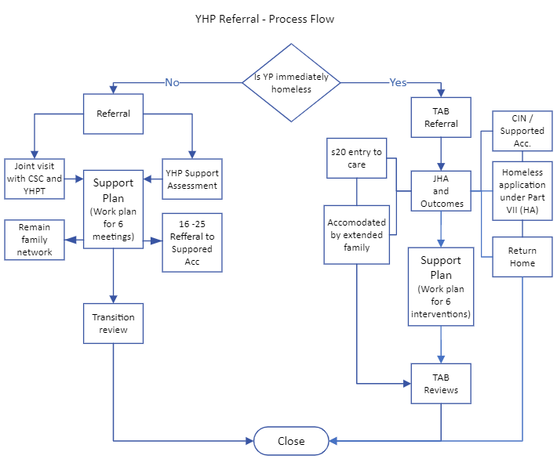

Review / Contacts / References
Document title: | Homeless Young People Joint Protocol 16 & 17 Year olds
Date approved: | 16.2.2023
Approving body: | Policy and Practice Steering Group
Last review date: | 16.2.2023
Revision history:
Next review date: | February 2025
Document owner: | Collette Visage – Head of Service MASH/IFD
Lead contact / author: | Sarah Bloor – Service Manager

