Safeguarding and Review Service
Child Protection Conference Practice Standards for Partner Agencies
January 2023

Top Tips for professionals.
RESTORATIVE PRACTICE
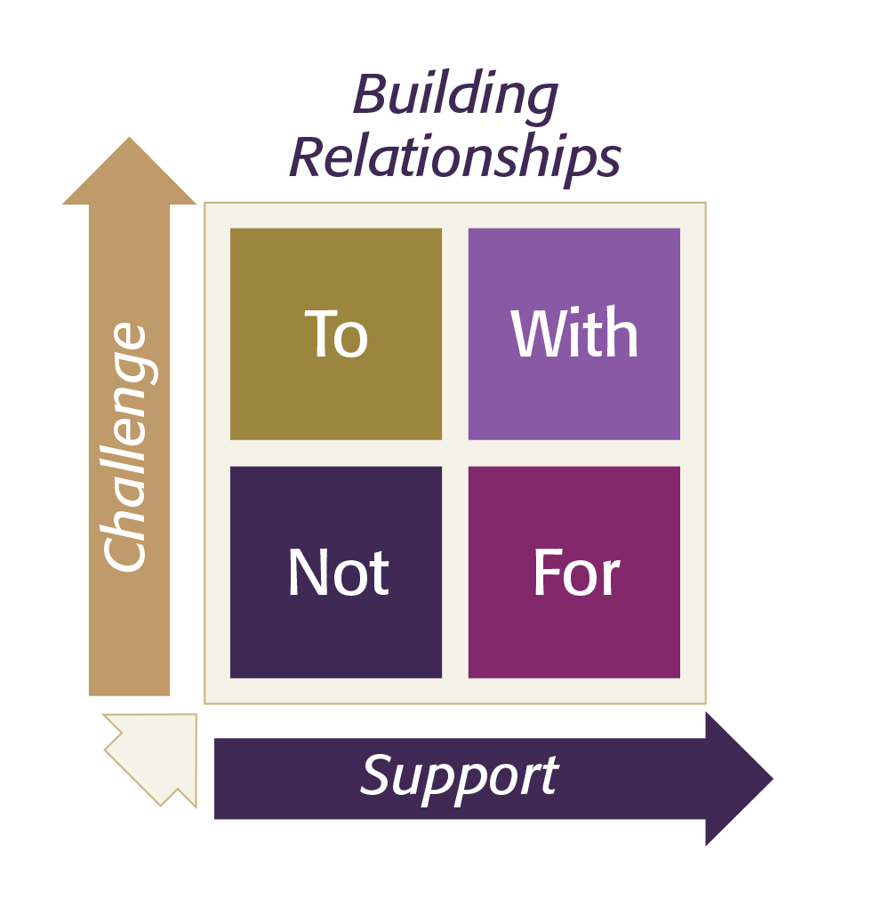
All contact and work received by families from Dudley Children’s Service are based around restorative practice principles. This is to ensure we improve the life outcomes for all children, young people and families we work with. In Dudley we intend to use restorative principles and behaviours with colleagues as well as children and families, to help develop positive working relationships.

This guide summarises the good practice standards required within Child Protection Conferences. The Safeguarding and Review Service are committed to ensuring all children are protected from harm and have plans that ensure their needs are met, and that their developmental outcomes are promoted. The Service has a strong focus on Restorative Practice, positive outcomes and holding agencies to account for their contribution towards these outcomes.
The principles underpinning all our work:

- The child’s welfare must be paramount, and this overrides all other considerations.
- Children have the right to be heard, to be listened to and to be taken seriously. Taking account of their age and understanding, they should be consulted and involved in all matters and decisions which may affect their lives.
- Parents/carers have a right to be respected and should be consulted and involved in matters which concern their families.
- All agencies concerned with the protection of children must work together in the best interests of children and their families.
- where appropriate children will be invited to attend their Conference or will be helped by other professionals to take part and share their views in another way.
We will best achieve this by working together:

- Please acknowledge and respond to meeting invites. Having you there is critical to effective planning for the child. (We also have virtual attendance options as well as face to face.)

- Prepare for your attendance. This may mean coordinating information from other colleagues across your service / agency.

- Be prepared to share your knowledge of the child’s experience and their views about what needs to change. If you are the closest professional to the child, speak to the Social Worker about how you could support them to attend the Conference or provide their views in another way (letter, video message, speaking to the Chair separately)

- The parent and the child should be kept informed and involved throughout the conferencing process. It is important that families do not hear a lot of new information within the conference. Therefore, your reports should be shared and discussed with the family 3 days prior to the conference.
Reports should be submitted even when you are also attending

- Be prepared to be involved in the drawing together of the plan for the child. Have in mind what services you and your agency can provide and what will make the most difference for the child

- Be mindful that every plan should have clear contingency arrangements. Think about the “what if” conversation. Have in mind your own SMART recommendations. (Specific, Measurable, Achievable, Realistic and Timely)

- Be prepared to “check in with families” after the conference. They may need to be reassured about next steps or helped to understand the plan that has been agreed

- Remember that you may be included within the “core group” for the child. These are critical meetings in developing the plan for the child your contribution will greatly improve outcomes.

- If in doubt of the plan or your contribution to it, talk to us. Contact the allocated Social Worker or Child Protection Chair.

Many thanks and we look forward to working with you.

