Transfer process for children moving between teams – early help/ children’s social care
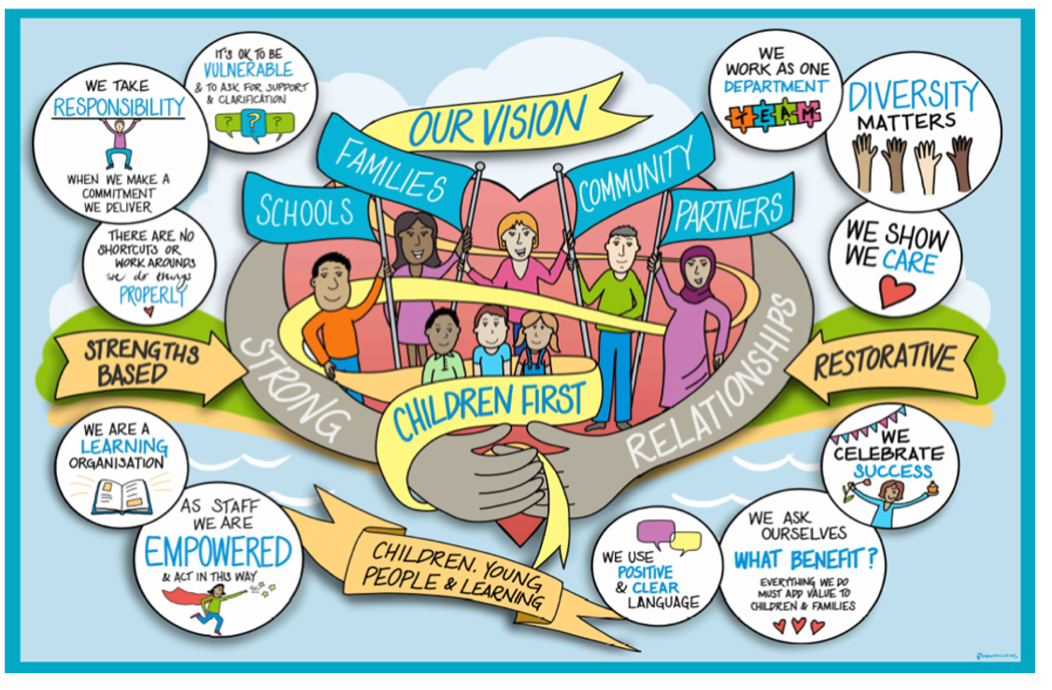

Contents
1. Introduction 3
2. Principles underpinning the transfer of children between teams 3
3. The transfer process between teams 4
4. Transfers between case holders in the same team 4
5. Transfer/closure summaries and children’s records 4
6. Handover meetings 5
7. Dispute resolution 6
8. Points of Transfer 6

1. Introduction
Continuity for children, young people and families is our priority. Continuity will ensure children and their families/carers can develop meaningful relationships with social workers and practitioners who can really get to know them well.

We will do all that we can to minimise the number of handover points in the child’s journey through our services and will ensure children know who will be working with them.

We will ensure we build on the existing good practice of effective transfers between teams, ensuring that purposeful relationships can be built quickly between workers and families.

This guidance focuses on transfers between teams. This includes Children’s Social Care, children receiving early help services within Early Help, children in need as defined by the Children Act 1989, (including those who are subject to a child protection plan), those who are looked after and those receiving leaving care services. It sets out the arrangements for all children and young people whose case is transferring between teams/ allocated workers.

2. Principles underpinning the transfer of children between teams
This guidance sets out 'best practice' principles and processes regarding case transfers so that the process of transfer works as effectively as possible for the children, young people and their families.

There are four key principles to transferring a Child’s Plan and case management responsibilities that require to be adhered to:

Firstly, there is the principle of ‘no delay’. Transfers should be timely, ensuring that children and families receive support with no gap in service provision. Delays can result in children not being effectively safeguarded, families reaching crisis point and children waiting longer than is necessary to achieve permanence. All teams have a responsibility to promote effective transfers for children to avoid drift and delay.

Secondly, there is the principle of ‘sharing of information’. It is essential that good quality assessment and plans that are shared provide a clear analysis of a child’s needs and risks. All teams have a responsibility for promoting and creating positive communication and information sharing within and between service areas in respect of the Child’s Plan.

Thirdly, there is the principle of ‘good order’ in respect of the child’s case file. This relates to the electronic and paper records held. All files shared and received must be up-to date at the point of transfer and have been checked and authorised by both the originating and receiving Team Manager. Safe transfer of work means early warning where possible, all relevant tasks completed, forward dates clearly identified, and all parties informed.

Fourthly, ‘the safety and welfare of the child is paramount’ when considering the transfer process and appropriate point to transfer case responsibility. There should be as minimal change of team and worker throughout the work with children and families as possible.

3. The transfer process between teams
Transfers between teams will be conducted in a timely manner, ensuring as much continuity as possible. All transfers between teams will be discussed and decided through transfer meetings. The transfer meeting involves the managers from each of the teams.

As soon as a transfer summary is sent to the receiving team, they have 2 working days to review the file and confirm the transfer date which should be as soon as is reasonably possible. This will ensure that there is no delay following the transfer meeting. If there is any outstanding work to be completed by the outgoing team the timescales for completion will be agreed by the managers from each of the teams.

If difficulties are experienced in transferring cases due to capacity this should be immediately raised between managers. Please see dispute resolution process below.

4. Transfers between case holders in the same team
All transfers (re-allocations) between allocated workers in the same team will be decided and managed by the service/team Manager.

At no point should a child be left without a named allocated worker.

5. Transfer/closure summaries and children’s records
Transfer arrangements will always be mindful of the need to ensure the safety of children. It is essential that good quality information is passed from the transferring team to prevent gaps in knowledge and delay in activity.

Wherever a child experiences a transfer between the allocated worker or team, the allocated worker must ensure the child's record is up to date with all relevant information and a transfer or closure summary is available. The social worker/practitioner is responsible for ensuring the child’s record is up to date before transfer.

Service Managers and Team Managers must ensure management oversight and recording of management decisions are on the child’s file when a child is transferred between teams. The outgoing team must also ensure that the child and family are aware that their case is being transferred and have been informed of who the receiving social worker/practitioner and team are.

6. Handover meetings
Children, young people, their parents/carers and other professionals engaged with the family should always be advised of any plans to change allocated worker and/or team in advance. Transfers should always involve a handover meeting with the transferring and receiving worker, with the family. If this is not possible, the reasons will need to be explained to the family and recorded on the child's record and the manager advised with reasons.

Transfers from Early Help to Children’s Social Care
If at any time the case holder in Early Help believes the child’s needs are escalating, they need to refer to MASH (Multi agency safeguarding hub) using the Integrated Front Door but can additionally consult with a MASH manager if needed.

The MASH will determine the need for a S17 CA 1989 single assessment with parental consent or S47 enquiries or no action required for Children’s Social Care.

Transfers from Children’s Social Care to Early Help

If good progress has been made on the child’s plan and outcomes that were identified have been met, consideration must be given to whether the work with the child and family requires “stepping across” to early help services or closing. This must be recorded on the child’s file.

If the work with the child and family is considered for transferring to Early Help services, there needs to be a discussion in supervision between the social worker and their manager. There needs to be clear management oversight recorded agreeing the need for consideration for level 3 support being offered to the child and family. This needs to be recorded on an up-to-date case summary which will include the following:

• How would stepping across meet this child and family’s needs
• Do the family understand the reason alternative support is being suggested
• Have the family given informed consent
• Child and family view and voice

The case summary document and chronology will be the information required for Step Across Panel. (see linked Step across guidance)

7. Dispute resolution
Managers must work co-operatively to resolve transfer issues as they arise to ensure the seamless transfer of children between team with minimum disruption for the child and family. Resolution should in all cases be achieved within 1 working day. In rare and exceptional circumstances where this is not resolved by the relevant Managers it will be necessary to refer the matter to service Managers.

8. Points of Transfer

Service child  is in | Commentary | Service child will  move to | At what point
MASH | Transfer-in Child Protection Conference. MASH/CPU complete necessary checks and  paperwork to assess suitability for  transfer request.  Transfer-in CIN case. MASH complete necessary checks and  agree that threshold is level 4  Referral received- MASH to complete necessary checks and agree threshold is Level 4 and a section 17 or section 47 assessment is required.  Section 37 report court ordered on child not currently allocated.  Section 7 report court ordered on child not currently allocated to children’s social care. MASH to check that this child has been significantly known to CSC, if not will refer back to CAFCASS  Early Help – MASH to complete necessary checks and agree that threshold is Level 3 | Family Safeguarding Team  Family Safeguarding Team  Assessment Team  Assessment Team  Family safeguarding team  Early Help Hub | Transfer-in Conference  Point of allocation.  Point of allocation  (Unborn baby – previous child removed in the family- progress straight to family safeguarding) (pre birth process)  (Re-referral within 6 months – progress straight to family safeguarding)  Point of allocation  Point of the Early Help Plan being sent to the Early Help hub
MASH | Child identified as having a disability that meets the criteria for the CWD Service.  Unaccompanied Minors and Asylum-Seeking Child. | Children with Disabilities Service.  Siblings will also be allocated to the CWD social worker if identified as having a Level 4 need.  UASC Team | Passed to MASH CWD social worker to process.  In some cases, where there is a large sibling group and the primary issue is not related to the needs of the disabled child, the children may be passed to A & I instead for assessment, with a co-worker from CWD.  Point of allocation.
Assessment Team | CFA completed – identification of need for continued support at CIN level  CFA completed – primary need is support for a child with a disability. | Family Safeguarding Team  Children’s disability team. | 1st CIN Review – family safeguarding social worker or team manager attends.  At completion of assessment.
Assessment Team | Arranges an ICPC – child is subject to a CPP. | Family safeguarding Team | ICPC – Family Safeguarding SW should attend the ICPC.  Best practice would be  that there is a joint visit with A & I following the ICPC
Assessment Team | Arranges an ICPC – child is not made subject to CPP / but CIN | Family Safeguarding Team | ICPC – Family Safeguarding SW should attend the ICPC.  Best practice would be  that there is a joint visit with A & I following the ICPC
Assessment Team | Working with a child, however significant concerns about safety  and well-being, so an application for an EPO/ICO is made.  Current social worker makes the ICO application and completes relevant paperwork for court  hearing. | Family Safeguarding Team | At the ICO hearing.
Assessment team | Significant concerns about child, and safety planning not keeping  child safe. Agreement via Service Manager to attend Legal Gateway  (LGM) Meeting.  A & I prepare paperwork for Legal Gateway. If Meeting Before Proceedings  (MBP) is agreed at LGM, A&I prepare MBP letter which is ratified by FS. FS social worker should attend MBP. | Family safeguarding team | If held - ICPC - although  as detailed, A & I will  undertake the  paperwork for LGM and MBP if needed in  collaboration with FS. A & I social worker will attend LGM and consideration to them attending MBP if proportionate.
Family safeguarding team  Family Safeguarding team  Assessment team  Assessment team/family safeguarding team | Child has been subject of care proceedings. The conclusion of  the proceedings is a Supervision Order with the child residing in the care of a parent / family member.  Child has been subject of care proceedings. The conclusion of  the proceedings is a Full Care Order.  Child Looked After (section 20) 15 years and over with a plan to return home.  Child Looked After (section 20) over 15 years old where there is no option for reunification home. | Case would  remain with  allocated worker  for duration of  supervision order  CWCF  FS  CWCF | Full responsibility for case at the point the final  order is made. However if the child has remained at home during care proceedings there should be co-working until the first CWCF review. CWCF manager will attend the final care planning meeting for children where the care plan is adoption or long term fostering and allocate a co-worker.  FS worker completes a later life letter in the life story workflow.  1st CWCF review. A & I social worker will have attended the entry to care panel for placement approval & referral to LGM completed where agreed.  1st CWCF Review. A & I social worker will have attended the entry to care panel prior to the 1st CWCF review and gain agreement for the plan of section 20 accommodation.  From FST – permanence agreed in latest CWCF review and ratified by the head of service that Sec 20 is permanence plan.
CLA | Child is 17 and requires  preparation for leaving care. | Leaving Care Service | LCS allocate a personal  advisor to co-work at 17  and child fully transfers  to LCS at 18.
FST/Assessment | CYPF need ongoing support at Level 3 to sustain and achieve identified outcomes | Early Help | Agreed at step across panel

Document Title: | Transfer process for children moving between teams – early help/ children’s social care
Prepared by: | Amanda Cole
Prepared for:
Date: | 2 February 2023
Version: | Update March 2023
Status:
Signed off by (name & role): | Jenny Boyd Assistant Director, Children’s Social Care
Date signed off: | 3 March 2023

