What face looks like how you feel when we talk about food at home?

 |  | 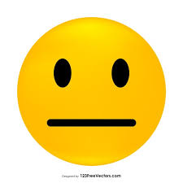 | 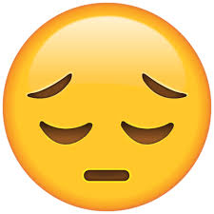

Can you tell me some meals that you have enjoyed at home recently?
Breakfast, lunch or tea. Where do you eat your meals?
Can we write them or draw them here?

What face looks like how you feel when we talk about home?

Lets drawn and write about your bedroom. Do you feel safe in your house?
What would you like to change if anything in your house?

Which face looks like you when we talk about your clothes?

Do you feel comfortable in your clothes? What you like to change? Do you think your clothes are clean and fit well?

How do you feel about your pets?

Do you have any pets? Whose job is it to look after them? Who helps you take care of them?

What about how you feel about having a bath or a shower and brushing your teeth?

How often do you brush your teeth? Take a shower? Who helps to make sure you wash? Do you need any help with looking after yourself?

When you are feeling poorly, do you feel like someone looks after you lots or a little bit?
LOTS and LOTS and LOTS and LOTS | Most of the time but not every time | A little bit | No one looks after me

Do you ever get ill?
Who looks after you/ takes you to the doctors?
Who takes you to the dentist?
Who gives you the best cuddles when you’re not feeling well?

Does someone look after you or help you?

Who takes care of you?
What about when that named person is busy?

How safe do you feel?
Really safe – nothing scares me! | A little safe but sometimes I worry or get hurt | Im scared lots and I don’t know who to tell

Do you know how to stay safe on the roads?
Do you always have someone with you when you’re out and about?
Do you ever walk to or from school by yourself?
How do you stay safe?

How do you feel about rules in your house?

What are the rules in your house? Do you have a set bedtime/ homework time?
What are the consequences if you don’t do what’s been asked? Tell me about home, do parents/carers problem solve when there is a disagreement?

What face shows me how you feel about your spare time – what you do when you are not in school?

Can you tell me what you like to do in your spare time?
Clubs:
Friendships:
How would you manage a fall out with your friends?

