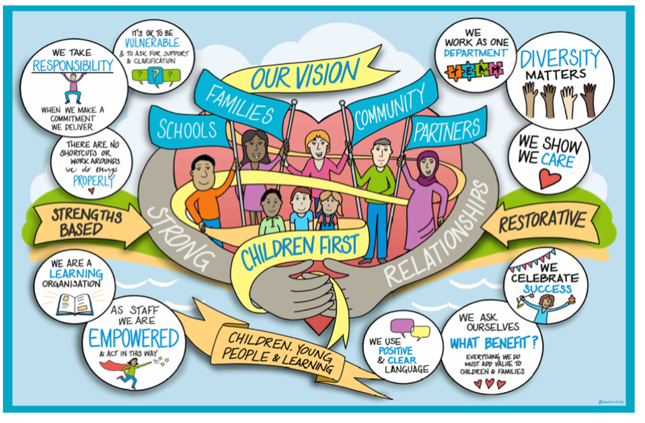
Children Services
Step Across Panel Guidance
Version 0.7
16th February 2023

Contents

Background 3
Purpose 3
Process for Children Social Care to Early Help 3
Process for Early Help to Children’s Social Care 5
Step Across Panel Terms of Reference 6
Frequency 7
Required Paperwork 7
Recording and Panel Administration 8
Expectations 8
Decision/Practice Standards 8
Evaluation and Measure of Success 9
Conflict Resolution 9
Step Across Pathway for Assessment, Family Safeguarding and EH 11
11
APPENDIX A – Step Across Process on MOSAIC 12
APPENDIX B – Supporting Families Criteria Form 13

Background

1. The current arrangement for stepping children from Childrens Social Care (CSC) to Early Help (EH) through Step Across Panel is sufficiently embedded and working well.
2. In October 2022 following a review we launched an improved panel model with the capacity to transfer children both up and down between CSC and EH. The step up element of panel was implemented for those children that have been supported by CSC and EH where the threshold of worries continues and outcomes for the children are not being met.
3. The structure for CSC and EH comes under one Assistant Director. The approach the directorate aims to achieve is one of consistency and integration.
4. The step across process seeks to achieve a more seamless transfer within an integrated service where the needs of the children, young people and families are paramount.
5. The next step in our journey will be to implement a further improvement to panel where only families where there is a concern about threshold, lack of sustainable change or repeat referrals/plans for EH and CSC need to be discussed. The ambition for this timeline would be to have this in place by the start of the financial year 2024/25.

Purpose

6. The purpose of the Step Across Panel and associated guidance is to ensure that children, young people and families receive the right support at the right time. The panel will achieve this by ensuring that the children, young people and families do not experience any gap in support. The panel will carefully consider all children, young people and families and where their needs will best be met from within the directorate.

Process for Children Social Care to Early Help

7a. The process for stepping across will be for the social worker to identify in supervision, with their Line Manager, that the plan is ready to close but that it needs further support at Level 3 to maintain progress and sustain outcomes for the children and young people. These are children and young people in families with multiple and complex needs who require a co-ordinated, whole family approach led by a lead worker. The families should meet 3 or more of the Supporting Families Criteria.
It is an expectation that all children will have a discussion in supervision with a view to stepping across to EH as part of their future plan.
When it is agreed by the social worker and manager that the children, young people, and families would benefit from EH support, this needs to be recorded on the case summary. The following information needs to be completed on the case summary:
- What is the suggested threshold level of support required?
- What are the needs and identified outcomes for the children, young people, and family?
- Do the family understand the reason support is being suggested and do they consent?
- What is the proposed plan if the family do not engage with support? What are the risks and bottom lines that could lead to further support being required at level 4?
In addition to this information the social worker needs to complete the Supporting Families criteria form. Please see Appendix B.
Wherever possible the decision to step across should be planned and discussed in supervision in advance of the final Child in Need/core group meeting to ensure a smoother transition for the children and families.
When the case summary is completed this needs to be sent by the social worker or their manager to the step across inbox below:
Earlyhelpstepacrossreferrals@westsussex.gov.uk

The CSC panel administrators will check that the case summary is dated within the last four weeks of panel and the four sections of the case summary are completed in line with the guidance above. In addition, they will check that there is an up-to-date impact chronology on the child’s file. If these are not completed prior to panel, then the social worker will not be offered a slot to present until completed. If there is a recurring issue around the completion of case summaries, the CSC panel administrator should escalate this to the relevant Service Manager for resolution.
The CSC panel administrators will collate the referrals for the panel meeting and populate the Step Across Form. The Step Across Form and case summaries will then be sent to the EH panel administrators by 5pm Tuesday at the latest.
The EH panel administrators will coordinate the requests from the Assessment, Family Safeguarding, and other social care teams. They will create the agenda and contact the social workers with their allocated time slots for panel.
The EH panel administrators will ensure that the relevant EH Duty Team Managers receive the agenda and case summaries to complete background checks at least two working days prior to panel.
The expectation is that social workers will attend panel to be available to provide any additional information required. This is normally for no longer than fifteen minutes. This process will ensure that the panel is able to make safe and informed decisions. In addition, this will save time and negate the need to follow up after panel meetings. A further benefit for the directorate will see enhanced relationships, clearer understanding of each other’s work across the service and most importantly provide a smoother, safer and clearer transition for children, young people and families.
Panel meetings are open for all children, young people and families in the Assessment and Family Safeguarding Teams countywide, regardless of which locality they are in, Central, Eastern or Western.
7b. The exception for needing to bring a family to panel to step across to EH will be where there is an existing open early help plan with an allocated early help worker. In these circumstances the expectation is that the Team Manager in CSC and the Team Manager from EH mutually agree that the family step back down to EH without the need to attend panel. If mutual agreement is not met, then the CSC social worker would need to refer to panel using the process above.

Process for Early Help to Children’s Social Care

8. The process for stepping across will be for the EH worker to identify in supervision, with their Team Manager, that the early help plan is not making sufficient progress for the children, and we need to have a discussion to determine if the threshold for Level 4 intervention has been met, or if any joint work can be identified that would support the children and family to remain on an early help plan.
EH will only bring families to panel when they have had previous CSC support within the last 12 months and where the worries meet threshold for Level 4 but are not urgent. It is critical that any child/children that have been significantly compromised, and/or are suffering significant harm or impairment are referred to the IFD for statutory and/or specialist intervention to keep them safe. For those children where there is not an immediate risk if we don’t act now, refer to panel.
When it is agreed by the EH worker and Team Manager that the children, young people and families would benefit from a panel discussion and threshold review, this needs to be recorded in the EH case summary. The following information needs to be completed on the case summary for panel:
- What’s happened in the last three months?
- What difference is the plan making for the child, young person and family?
- If things are not improving, why do you think this is? What do you think would help?
- Rationale for bringing the family to panel.
- Do the family consent? If not, why?
- Management oversight.
Possible outcomes from panel:
- To step up to CSC - threshold for Level 4 has been met and mutually agreed that the family need statutory support.
- To remain with EH with clear rationale, timescales, suggestions and next steps to move the plan forward.
- Panel agreement for a specific piece of joint work between EH and CSC, such as a safe uncertainty mapping, family network meeting, joint visit, or a piece of joint work, with the intention of reducing the risk/worries. Actions, roles, responsibilities, and accountability will need to be SMART and clear. The outcome of the joint work needs to determine if the EH plan remains open, or if there is agreement to refer the family to the IFD. If the actions are not completed in timescales the service managers from the panel who set them need to be contacted to ensure any issues are resolved as quickly as possible.
- The early help plan will close as the family do not meet the level for statutory intervention and the family do not consent to work with CSC or EH.
When the case summary is completed this needs to be sent by the EH worker or their manager to all the below the EH panel administrators:
Mel Benham – mel.benham@westsussex.gov.uk
Janice Judge – janice.judge@westsussex.gov.uk
Lawrence Reeves – lawrence.reeves@westsussex.gov.uk

There will be 3 slots reserved each week in panel for EH to present families. The EH panel administrators will collate the referrals for the panel meeting and populate the Step Across Form.
The EH panel administrators will create the agenda and contact the EH Team Managers with their allocated time slots for panel.
The EH panel administrators will ensure that the relevant Service Manager from CSC receives the agenda and case summaries to complete background checks at least 2 working days prior to panel. The EH panel administrators will specify in the email sent to the core panel group the preceding Thursday before panel, if there are any step-up cases.
The expectation is that the EH Team Manager will attend panel to be available to provide any additional information required. This is normally for no longer than twenty minutes. This process will ensure that the panel is able to make safe and informed decisions. In addition, this will save time and negate the need to follow up after panel meetings. A further benefit for the directorate will see enhanced relationships, clearer understanding of each other’s work across the service and most importantly provide a smoother, safer and clearer transition for children, young people and families.
Panel meetings are open for all children, young people and families countywide, regardless of which locality they are in, Central, Eastern or Western.

Step Across Panel Terms of Reference

9. The panel will be a virtual meeting. They will be held weekly for Assessment and Family Safeguarding Teams and EH combined. The chairs rota will be split geographically between the three localities. Each week the panel will discuss cases for the whole county. Dates will be booked three months in advance. The structure of the panel is as follows:
- Chair – there will be two chairs one EH Service Manager and one CSC Service Manager from each locality on rotation. They are responsible for threshold decisions, rationale, and outcomes from panel. Representation will be rotated. The chairs will share responsibility for introductions to social worker’s and leading the clarifying questions to ensure equity and accountability. They will mutually decide at the beginning of the panel meeting how they would like to share the lead e.g.- half each or rotate after 6 families.
- Current allocated social worker will be present at panel. If unavailable their Line Manager can attend.
- For EH the worker’s Team Manager will present at panel.
- Panel administrators (for the purposes of this guidance and meetings, all the panel administrators have the same title regardless of where their position sits in the service).
EH panel administrators - Mel Benham, Janice Judge and Lawrence Reeves.
Assessment and Family Safeguarding panel administrator – Mandy Murphy – back up support to be identified.

Frequency

10. The panel will be scheduled for a maximum of twenty families each week. Three slots will be reserved for EH each week. The duration will vary depending on the number of referrals received. Frequency and length of time will be kept under review.

Required Paperwork

11. Prior to booking onto panel, workers must have an existing case summary with the required information as per the guidance in this document from section 5 or 6. The case summary must be current (dated within four weeks of panel date). There must be an up-to-date child, young people and family’s impact chronology on Mosaic. For Assessment Teams, the child and family assessment must be completed and signed off by a manager. For all teams the children, young people and families need to remain open to the named social/EH worker until the outcome at panel is agreed. Assessments and plans must not be closed until next steps are agreed at panel. Please see Appendix A with flow chart for actions on Mosaic.

12. Case summary documents and Step Across Forms should be sent by the relevant CSC panel administrators to the EH panel administrators by Tuesday 5pm each week. Social workers and team managers will then be given a time slot to attend panel.

Recording and Panel Administration

13. There will be specific panel administrators. The EH panel administrators will record the meetings and circulate minutes and actions within three working days. The EH Service Manager will be responsible for reviewing the panel minutes prior to circulation. The EH panel administrators will be responsible for updating the outcomes for EH. The CSC administrators will be responsible for updating the outcomes for CSC on Mosaic.

Expectations

- Children, young people and families will have been consulted on the reason why another part of the service has been asked to offer support. This includes a clear understanding of why EH is being offered as support for their family. Their wishes and feelings about this will be clearly recorded.
- Lead workers – they will have considered all of the needs of the children, young people and families and their wishes and feelings. They will have had management oversight and agreement to step across. They will attend panel knowing the children concerned and be able to explain the child and family’s needs.
- Panel members – they will be clear on the thresholds within their own agency and have permission to make the decisions about step across. Ideally, members should read the papers before the panel meeting.
- Chairs – need to have designated responsibility for the panel, the decisions and outcomes for children, young people and families. Chairing the panel within the parameters set, including holding to time, behaviour and facilitating and maintaining constructive safe challenge.
- Panel Administrator – allocate slots to social workers and EH Team Managers, receive, prepare and circulate paperwork, produce accurate timely panel minutes. Record outcomes, rationale and decision on the relevant records on Holistix/Mosaic.

Decision/Practice Standards

14. The main decision of the panel is whether the children, young people and families should be stepped across. The practice standards are as follows:
Social Care to Early Help:
- Child and Family Assessment – where possible or if directed by panel a joint visit should be undertaken within five working days of panel agreement. Transfer to EH should be within ten working days of the panel or five working days from joint visit.

Child in Need/Child Protection – Joint visit and allocation should be conducted in line with panel recommendations and agreement between the social worker and EH worker.

- Mosaic record, including the case summary and chronology is up to date.
- Social Care - the children, young people and families need to remain open to the named social worker until the outcome at panel is agreed.
Early Help to Social Care:
- Consent should be obtained from the family prior to panel by the EH worker if consent is not given, we need to know why?
- The EH worker should feedback the outcome of panel to the family
- If agreed to step up from EH to CSC then the case summary and minutes of the panel including the SM who agreed step up and rationale, should be sent to the IFD email address: wschildrenservices@westsussex.gov.uk so they can create a contact on Mosaic and forward it on to the relevant team for processing.
- EH - the children, young people and families need to remain open to the named EH worker until the outcome at panel is agreed.

Evaluation and Measure of Success

15. The panel will be reviewed every 6 months, and will look at the following:
- Impact on improving outcomes for children
- Consistency of thresholds
- Process improvements/ Practice standards as above being met, including timescales
- User feedback

16. Performance measures will be reviewed monthly by service managers in locality areas using the data from the step across dashboard:

- Numbers of re-referrals both to EH and CSC
- Decrease in step up and a reduction in children going from one process to the next and back again

Conflict Resolution

17. Where the panel are unable to agree which service best meets the children’s needs within the allocated time slot (no longer than fifteen minutes per family) the chairs will agree to discuss outside of the panel and mutually agree threshold rationale and outcome. The chairs will be responsible for informing the social worker of the decision.
If the chairs are unable to mutually agree it should be escalated for review to the appropriate Heads of Service. In the interim the child should remain with their current support unless the risk is considered too high to do so.

Step Across Pathway for Assessment, Family Safeguarding and EH

APPENDIX A – Step Across Process on MOSAIC

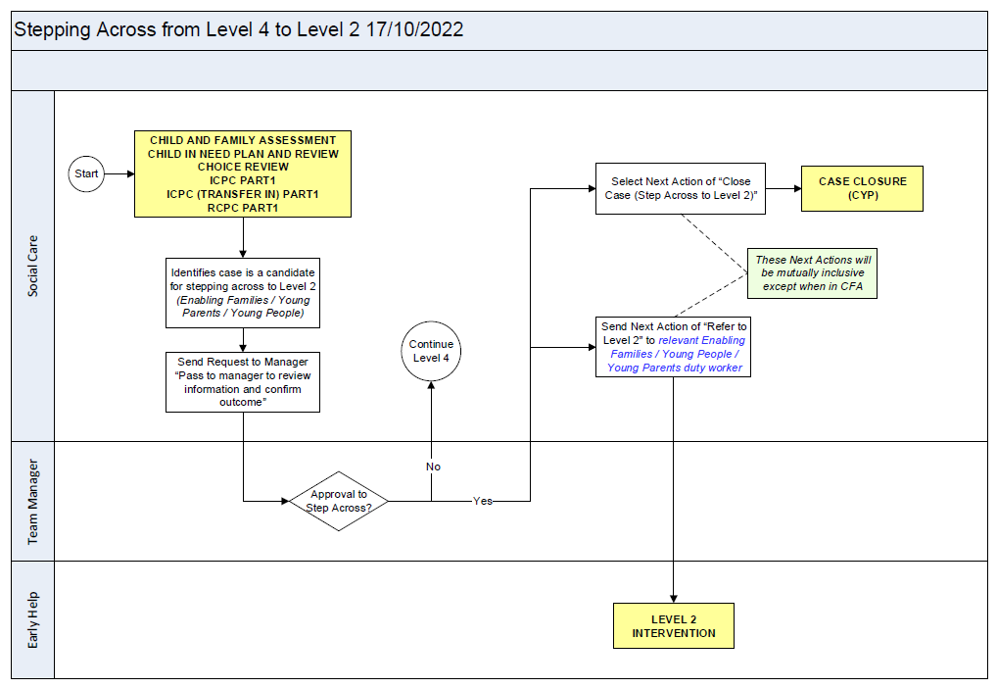

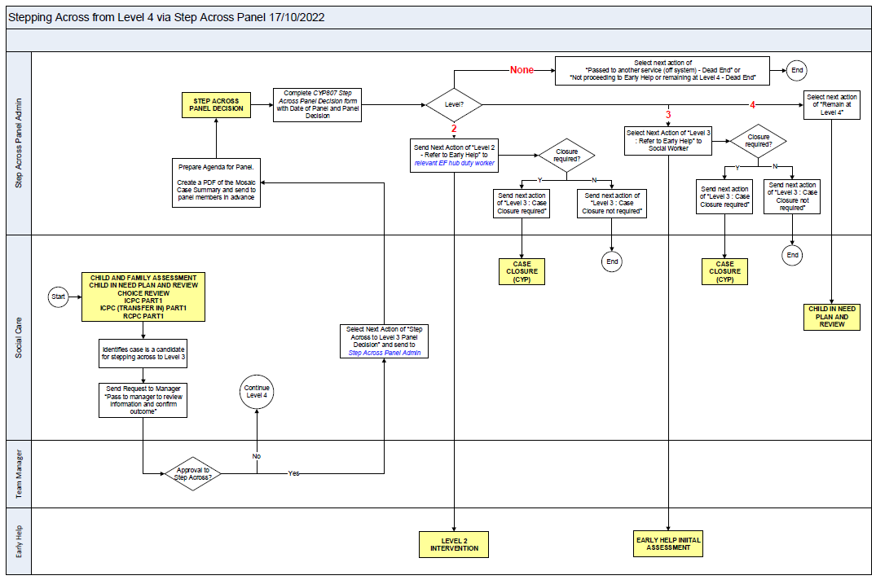

APPENDIX B – Supporting Families Criteria Form

Review / Contacts / References
Document title: | Step Across Guidance and TORs
Date approved: | Feb 2023
Approving body: | P and P- Assessment and Family safeguarding Workstream
Last review date: | Feb 2023
Revision history:
Next review date: | August 2023
Document owner: | Jenny Boyd
Lead contact / author: | Charlene Hornsey

