

**CHILDREN’S SERVICES**

Cultural Competence Toolkit

Direct work tools

Tools for self-reflection and supervision

**LANGUAGES MY FAMILY AND I SPEAK!**

**MY FAVOURITE TRADITION**

**MY FAVOURITE FOOD TO EAT!**

**HOLIDAYS CELEBRATED IN MY CULTURE**

**CLOTHES WORN IN MY CULTURE**

**OTHER INTERESTING FACTS!**

**JUST BECAUSE….**

What assumptions do people make about you when they see you? What’s the truth?

Just because I am………………………………….people think that I……………………………, but the truth is………………………………………………………………….

Just because I am………………………………….people think that I……………………………, but the truth is………………………………………………………………….

Just because I am………………………………….people think that I……………………………, but the truth is………………………………………………………………….

How do you think you can respond whenever people make these assumptions of you?

………………………………………………..……………………………………………..……………………………………………….…………………………………..………………………………………………..…………………………………………………………………………………………………………………………………………………………………………

……………………………



**WHEN THEY SEE ME**

What assumptions do people make when they first see you? What type of person do they think you are when they see your skin colour, height, weight, hairstyle etc?



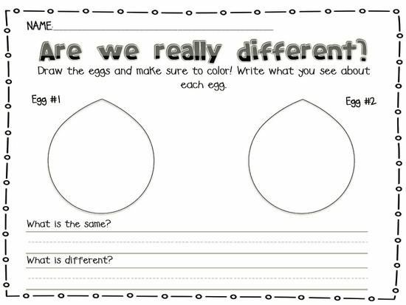

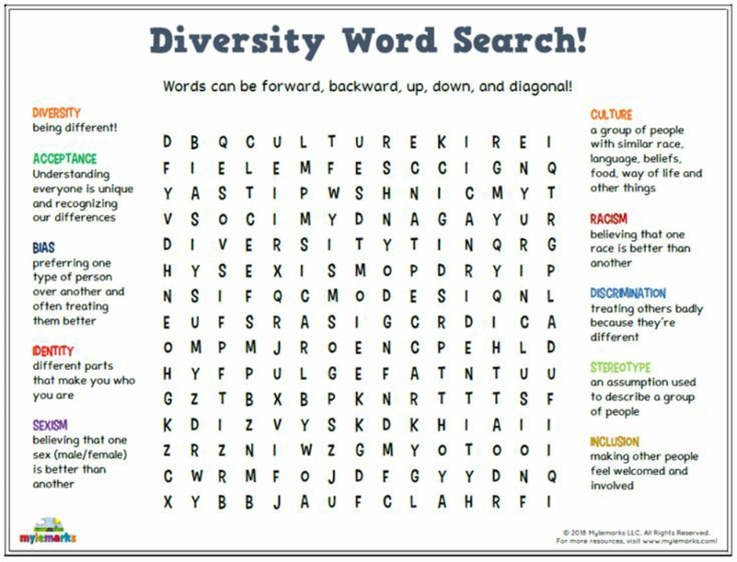

**Cultural Genogram**

A genogram is a picture of a person's family relationships and history. Most social work practitioners use genograms to explore family relationships. The cultural genogram derived from Hardy & Laszloffy (1995) is an educational tool to teach professionals a structured way to address patients' and families' cultural beliefs and practices.

**Preparing a cultural genogram:**

* Define one’s culture of origin
* Identify constructs that define your ethnic groups (do they exist other than stereotypes?)
* Identify pride issues connected to ethnicity
* Identify shame issues connected to ethnicity
* Selecting colours and symbols to represent specific areas
* Identifying interethnic marriages

**Questions to consider**

* Migration patterns
* Language
* Opportunities
* Any discrimination or oppression they may have faced
* Significance of race, skin colour and hair types
* Roles of religion and spirituality
* Roles of geography
* How are gender roles defined in their ethnicity
* Sexual orientation
* In what ways are pride/shame issues manifested in your family system?

**Reflective Questions**

* What aspects of your culture do you have the most difficulty “owning”, which aspects do you feel most comfortable “owning”?

**Reference**

Hardy, K. V. , & Laszloffy, T. A. (1995). The cultural genogram: Key to training culturally competent family therapists. Journal of Marital and Family Therapy, 21, 227-237.

Self-reflection and Supervision

**Anti-racist Practice: Critical self-reflection**

1. What is your lived experience of privilege and disadvantage?
2. How would you describe your identity?
3. How would you describe the context of your lived experience?
4. Where do you position yourself on the “becoming Anti-Racist” framework below?
5. Why this is and what has influenced where you position yourself?
6. Is there a position that you do not feel able to take?

**Cultural competence self-awareness checklist**

This self-assessment tool is designed to explored individual cultural competence. Its purpose is to help you consider your awareness in your interactions with others. Its goal is to assist you to recognise what you can do to become more effective in working and living in a diverse environment.

Read each entry in the section below and place a check mark in the appropriate column.

This is simply a tool and not a test. Remember that cultural competence is a process, and that learning occurs on a continuum and over a lifetime. While you complete this assessment, stay in touch with your emotions and remind yourself that learning is a journey.

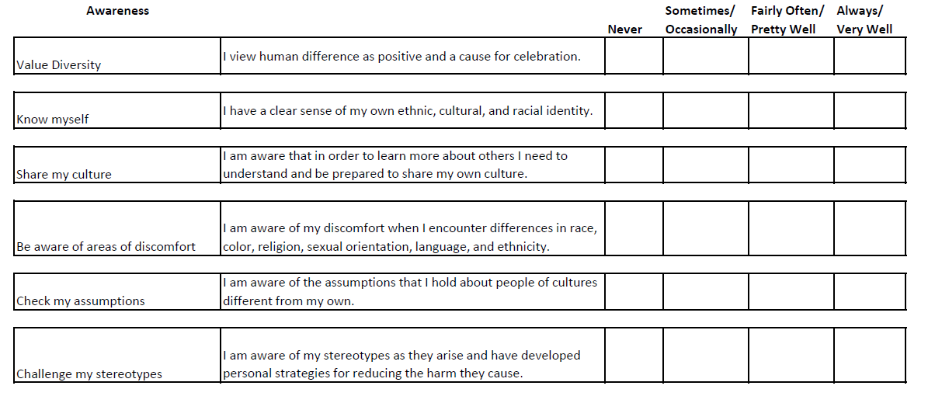

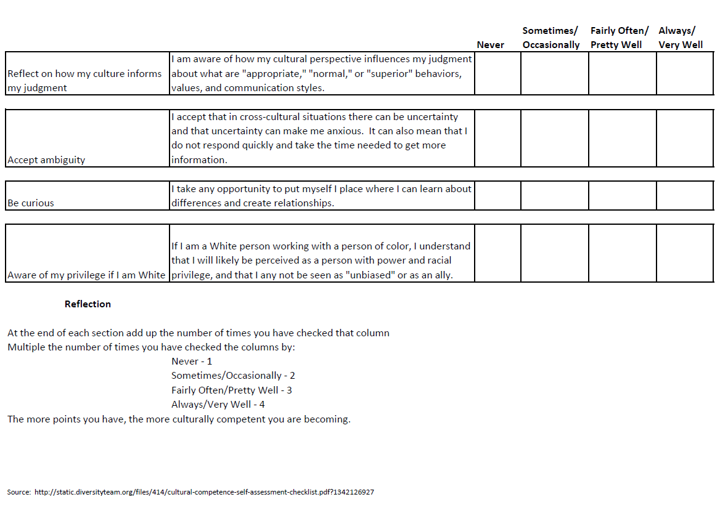

**Diversity Checklist**

|  |  |
| --- | --- |
| **Question** | **Answer** |
| What do you understand by the term diversity? |  |
| What are your six most important personal values? | 1.  2.  3.  4.  5.  6. |
| If you were asked what your prejudices were, what would you say? |  |
| What would you say you are doing to manage them? What diversities do you recognise in:   * Society * Your work context? |  |
| When you discuss diversity with people, how do you do it and what issues make you feel defensive? |  |
| How do you promote diversity in your practice? |  |
| What communities do you identify with? |  |
| How do you demonstrate leadership in support of diversity in your practice context? |  |

**Anti-Oppressive Practice Supervision Worksheet**

Oppression may be experienced as a result of factors such as race, colour, sex, age, class, disability, sexual orientation, poverty, religion, offending, drug user status etc. This worksheet can support in your supervision when discussing families and working anti-oppressively.

|  |
| --- |
| 1. What do you think might apply to this service user and why? |
|  |
| 1. How could you be OPPRESSIVE in the way you work with them? |
|  |
| 1. How can you work ANTI-OPPRESSIVELY with them? |
|  |
| 1. Do you need to acquire any new knowledge, or develop new skills in order to work anti-oppressively? If so, what would they be, and how might you achieve them? |
|  |

This exercise is adapted from the exercise ‘Anti-oppressive practice supervision worksheet’ by Hoople.

See: <https://www.hoopleltd.co.uk/media/1339/toolkit-for-assessing-social-work-students-in-practice.docx>