Children’s Social Care
EHM/LCS/ContrOCC Continuity

Document History:
Date | Version | Author | Details of Amendments
13/02/2023 | 0.1 | Gurpreet Kumari  Caroline Trinham | Created

Contents

Overview 4
Scope 4
Definitions 4
EHM/LCS Contingency Guidance 5
Portal contingency 6
ContrOCC contingency 6
Casework Recording (Templates/Tracker) 6

Overview

This document will give you an overview on our Business Continuity process in the event of the systems being down, whether this is planned or unplanned. Whilst there will be a read only copy of EHM/LCS available it is critical we continue to record and update information whilst EHM/LCS/ContrOCC is unavailable. To ensure we continue with the commitment to achieving high standards in record keeping and in particular recording accurate data for a person within EHM/LCS/ContrOCC.
Accurate record keeping is vital to the delivery of our services in an accurate, person centred and accountable manner. It will provide evidence of what we do and why, therefore protecting the not only the person but Children’s Social Care.

Scope

This document supports Children’s Social Care to understand how to manage whilst applications are unavailable to ensure that data is correct and re-entered when the applications are back on-line.
This document applies to all Children’s Social Care staff in the course of carrying out their corporate function. Records and documentation created, whether internally and externally funded are also subject to the Council’s wider contractual record keeping requirements. These records may exist in printed or digital form.

Definitions

This document identifies the activities to be undertaken in the event of planned or unplanned loss of applications in Children’s Social Care, together with the associated standards, applies to all created in EHM/LCS or any other case management system used internally or externally by Council staff or its representatives to ensure that the data is correct when transferred to ContrOCC when the applications are available.

EHM/LCS Contingency Guidance

Logging into EHM/LCS Read Only
Important Notice: Read Only looks exactly the same as live EHM/LCS and will enable you to input information. Any information added to Read Only will not be retained and cannot be retrieved.
The link for EHM/LCS Read Only is available on the Successor Support SharePoint site in the Business Continuity Tile:

Alternatively, if you are using an IGEL or your own kit you can access the system by following the link below for Contingency:
https://teams.dudley.gov.uk/sites/apps/liquidlogic/childrens-social-care/Business-Continuity/_layouts/15/start.aspx#/
You access EHM/LCS Read Only the same as you would with EHM/LCS Live.

Log on to EHM/LCS using your Network Log on and Password
E.g. Username: Firstname.Surname, Password: xxxxxxxx
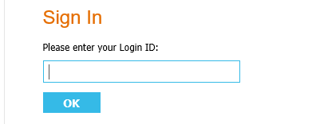
then enter your password which is the same as you use when logging onto your device every day.
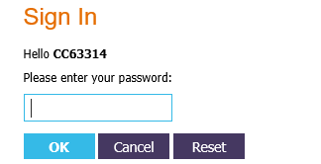

Portal contingency

Whilst the Portals are unavailable anyone attempting to access them will be diverted to a holding page with details of the contact numbers to use for telephone referrals.

ContrOCC contingency

There is not a Read Only service available for ContrOCC but ContrOCC_CS_UAT will be up to date with a copy of Live data at the time of cut-off to support Finance Teams (this is for information purposes only and must not be used for recording).
If you should need access to this, then please contact the ContrOCC Business Systems Lead.

Casework Recording (Templates/Tracker)

The below document will provide you detailed guidance on how to record your work during the system downtime.

