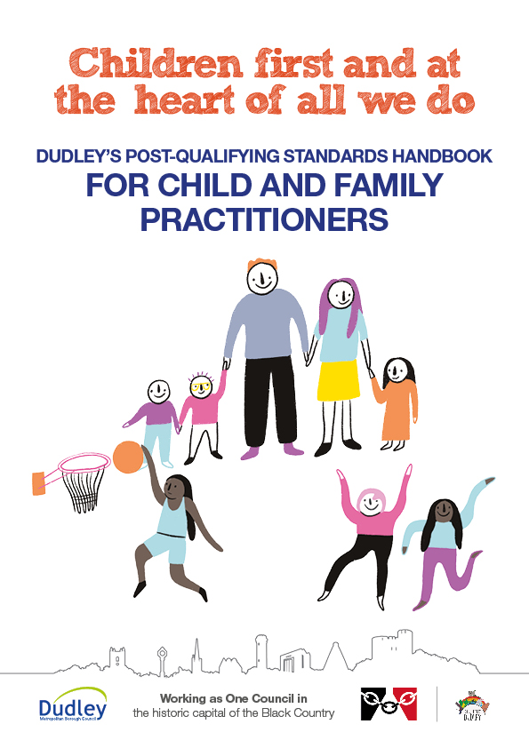

Contents

|  |  |
| --- | --- |
| Introduction | Page 3 |
| KSS 1 – Relationships and Effective Direct Work | Page 4 |
| KSS 2 – Communication | Page 7 |
| KSS 3 – Child Development | Page 9 |
| KSS 4 – Adult Mental Ill Health | Page 16 |
| KSS 5 – Abuse and Neglect of Children | Page 20 |
| KSS 6 – Child and Family Assessment | Page 25 |
| KSS 7 – Analysis, Decision Making, Planning and Review | Page 33 |
| KSS 8 – The Law and the Family Youth Justice | Page 39 |
| KSS 9 – The Role of Supervision | Page 44 |
| KSS 10 – Organisational Context | Page 49 |

**Who is this Handbook for?**

Dudley’s Centre for Professional Practice created this Handbook as a supportive learning tool for Child and Family Practitioners, to increase their knowledge and understanding of the Social Work Post Qualifying Standards (aka Knowledge and Skills Statement).

**What will this Handbook Cover?**

This Handbook will provide an overview of the Knowledge and Skills Statement, including some useful tools and models to use in practice, and factors to consider when working with children and families.

**How do the Social Work Post Qualifying Standards apply to my practice as a Child and Family Practitioner?**

The Post Qualifying Social Work Standards are considered to be aspects of practice that Child and Family Practitioners should do in their work with children and families.

They were introduced by the Department of Education to drive improvement in the following areas:

• Social Work education

• Training

• Career development

**What are the Knowledge and Skills?**

1. Relationships and Effective Direct Work

2. Communication

3. Child Development

4. Adult mental ill health, substance misuse, domestic abuse and physical ill health and disability

5. Abuse and Neglect of Children

6. Child and Family Assessment

7. Analysis, Decision Making, Planning and Review

8. The Law and the Family and Youth Justice Systems

9. The Role of Supervision

10. Organisational Context

KSS 1 – Relationships and Effective Direct Work

**Restorative Practice and Relationships with Children and Families**

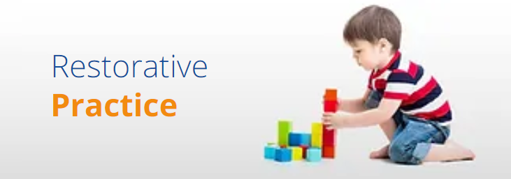

Restorative Practice is Dudley’s framework of practice. It is a values-based relational way of being, that is needs-led and strengths-focussed. It embodies a set of core beliefs, principles and behaviours that promote a way of being with people that actively and explicitly promotes change by working WITH people on a high challenge, high support basis.

Here are some key features of Restorative Practice:

**Values –** It upholds the values of being respectful, taking responsibility and the importance of relationships.

**Relationships –** Building, Maintaining and Repairing relationships with children and families.

**High Support and High Challenge** – Practitioners should work together with families and do things with them, not for or to them.

**Circles** – These bring people together so that they feel heard and respected. Dudley are encouraging practitioners to facilitate meetings in a circle to encourage participation.

**Relational Language** – Practitioners should use language that is emotionally intelligent, are inclusive and focus on the issue.

**Affective Statements** – These are statements that separate the behaviour from the person. These generally follow the three question format of:

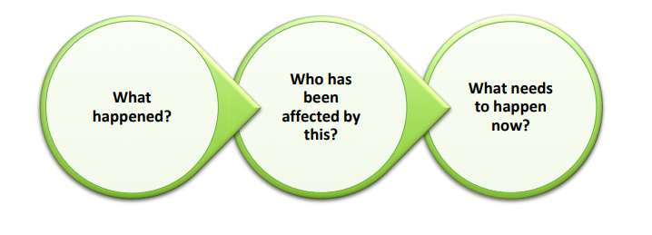

**Listen**; gain the views of families – this improves the quality of case recording, assessments and plans

Be **respectful**, even when some families may appear challenging

Be **open** and **honest** about what you are doing and what will happen next

Be **empathic** and **challenging** when families’ are talking about their experiences

**Engage fathers** in assessments and plans for children, visiting them where possible

**Developing Effective Relationships**

**Why is it Important to Develop Effective Relationships with Families?**



* Some families have never had involvement with Children’s Services and may be apprehensive, it’s hence important to establish a rapport with them and encourage their involvement with services.
* Some families will have a perception of what Children’s Services are like and this may make them reluctant to engage; developing an effective relationship with them will help bring down these barriers.
* It’s important to develop these relationships to encourage families to engage and become involved in assessments, plans and decision-making for their children.

**Links to Further Learning and Resources**

Restorative Practice - <https://www.dudleycpp.org.uk/restorative-practice>

Direct Work Tools - <https://www.dudleycpp.org.uk/direct-work-tools>

CAFCASS Resources for Professionals - <https://www.cafcass.gov.uk/grown-ups/professionals/resources-for-professionals/>

NSPCC Research Resources - <https://learning.nspcc.org.uk/research-resources/>

Social Worker’s Toolbox Direct Work Resources - <http://www.socialworkerstoolbox.com/>

KSS 2 – Communication

**Why is it Important to Communicate with Children?**

* It gives all children a voice so they can be advocated for.
* So the child’s views are at the forefront of their assessments and plans to keep them safe and ensure their needs are met.
* So they can build a positive, strong relationship with their Social Worker and feel comfortable around them.
* So that they can let someone know if they do not feel happy or safe.
* So that they can let someone know what does make them happy and if they do feel safe

**Communicating Clearly in Written Work**

Reports and Assessments prepared by Child and Family Practitioners are often shared with the parent/carer of a child. Children themselves can request to see a copy of their records when they reach 18 years of age. As such, it is important for practitioners to be open and honest in their writing and to always consider the lived experience of a child.

Practitioners should strive to:



* **Use language that is jargon free, succinct and clear.**
* **Ensure the needs of the child, parent or carers views are well represented.**
* **Acknowledge strengths as well as addressing risks.**
* **Write a clear analysis, using evidence and explaining decisions.**

**What Does Good Communication with Children and Families Look Like?**

* Being open and honest
* Listening to views and recording them accurately
* Building a rapport with families
* Speak to fathers and gain their views
* Giving families contact details so they can get in touch with you if they need advice, guidance and support
* Explain your role, what the concerns are and what you will do next
* Be supportive, but challenge when appropriate
* Manage tensions within families

**What are the Barriers to Communication with Children?**

* Language they speak
* Age of the child
* Disability or additional needs
* Confidence of the practitioner
* Child declining to be spoken to
* Parent/Carer not allowing access to the child

**Links to Further Learning and Resources**

Communicating with Children and Young People with Speech, Language and Communication Needs and/or Developmental Delay - <https://www.rip.org.uk/resources/publications/frontline-resources/communicating-with-children-and-young-people-with-speech-language-and-communication-needs-andor-developmental-delay-frontline-briefing-2016>

What Good Social Work Case Recording Looks Like and How Existing Practice Can Improve - <https://www.communitycare.co.uk/2019/08/05/good-social-work-case-recording-looks-like-existing-practice-can-improve/>

Social Work Recording - <https://www.scie.org.uk/social-work/recording>

Specialist Communication Skills for Social Workers - <https://www.youtube.com/watch?v=UVER1tforao>

Headings and Guidance when Recording Visits - <https://www.proceduresonline.com/dudley/childcare/user_controlled_lcms_area/uploaded_files/Visit%20guidance%20v2.pdf>

KSS 3 – Child Development

**Assessing Child Development**

**Observation** – This allows the practitioner time to observe the child to interact with their primary caregiver to assess the quality of their attachment to them. When observing the child, it is important to note what they are able to do/are seen doing, i.e. when observing a one year old, are they yet able to babble, stand independently etc.

**Gather Information** – Practitioners should liaise with other professionals who know the child, including parents/carers, nursery, school staff, health professionals. They will have recorded their own observations of the child and it will help the practitioner assess where the child is at developmentally.

**Play** – Practitioners can use play to communicate with a child and assess their development. It is useful for practitioners to ensure they carry a toolkit with them, including colourful pens, paper, small figures to represent people, worksheets or a puppet/soft toy.

**What are some of the Barriers to a Child Developing?**

* Lack of stimulation
* Disabilities
* Parental substance misuse in utero
* Neglectful or abusive parenting
* Complications at birth – being born too early (prematurely), low birth weight, not getting enough oxygen at birth
* Medical Conditions (not deemed to be disabilities) - chronic ear infections, vision problems, illnesses, conditions, or injuries.

**Child Development Chart – Research in Practice (RiP)**

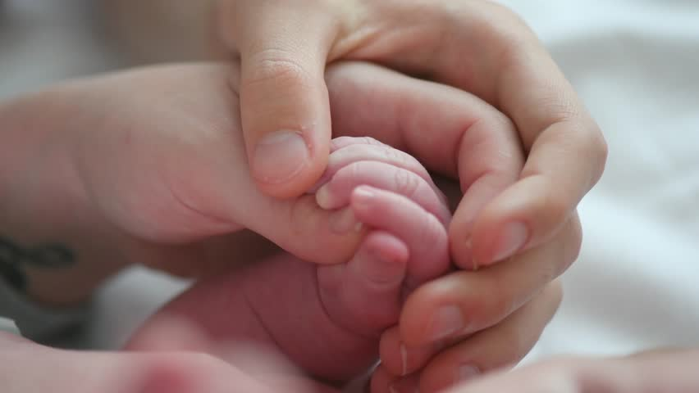This chart developed by RiP sets a guideline for the expectations of children’s development at various ages. It can be used as a guideline for practitioners visiting children to consider if their development is at the expected rate for their age. It is important to remember that development can be impacted by various things, i.e. disabilities or parenting and you should liaise with health professionals if you need advice and guidance.



**What are some of the Main Theories of Child Development?**

**Attachment Theory**

This theory was first proposed by John Bowlby in 1988. Bowlby suggested that all children needed to develop a secure, positive attachment with their main caregiver in their early years.

Bowlby said there were four main types of attachment:

* **Secure**
* **Insecure Ambivalent**
* **Insecure Avoidant**
* **Insecure Disorganised Attachment.**

|  |  |
| --- | --- |
| Attachment Style | Features |
| Secure Attachment | Seen when a child has formed a positive, emotional relationship with their caregiver.  This child is thought to feel confident when they should feel anxious and their caregiver will respond to them.  When observing this type of relationship, there should be sensitivity, warmth, consistent, responsive and the caregiver should be available and reliable.  This child will develop a good, strong sense of independence, should have good self-esteem and are able to form their own positive and meaningful relationships. |
| Insecure Avoidant Attachment | Seen when a child has received insensitive or rejecting care, particularly at times of stress.  The child appears to be independent and seek to meet their own care needs because they do not trust or rely on their carer.  The child may find it difficult to seek help and may be prone to sudden outbursts.  This child can be high achieving in some aspects of their lives but may find it difficult to form close relationships. |
| Insecure Ambivalent Attachment | Seen when a child has experienced inconsistent and unresponsive care.  The child can present as clingy or rejecting of their caregiver and are unable to be comforted by adults.  The child may be fussy, immature, angry or present as attention seeking, hyperactive and are not easily soothed. |
| Insecure Disorganised Attachment | Seen when a child has experienced some degree of neglect or have come from a chaotic home life.  The child may be frightened by adults, sensitive to criticism, defiant and controlling.  This child can be easily distracted, panic easily and may present with extreme or distressing behaviour. |

**Piaget’s Development Theory**

Piaget suggested that children progress through these developmental stages throughout their lives.

**The 4 Stages are:**

* **Maturation** – the physical and cognitive changes a child experiences growing up
* **Experience** – the child gains this as they engage with the world
* **Social Interaction** – the child engages with other children, with a focus on the influences of older children
* **Equilibration** – the child brings all the other 3 stages together to establish their sense of logic

**Stage One – Sensorimotor Stage**

**0 – 2 Years**

The child uses their senses to explore the world i.e. through sucking, grasping, looking and listening. The child begins to learn that they are separate beings from the people and objects around them. The child realises that their actions can cause things to happen in the world around them.

**Stage Two – Preoperational Stage**

**1 – 6 Years**

The child is focussed on their own perspective and can be egocentric. Whilst children are getting better with language and thinking, they still tend to think about things in very concrete terms. During this stage, the child grasps the difference in gender and gender roles.

**Stage Three – Concrete Operational Stage**

**7 – 12 Years**

The child begins to develop a sense of logic and they begin to understand the concept of conservation; that the amount of liquid in a short, wide cup is equal to that in a tall, skinny glass, for example. The egocentrism of the previous stage begins to disappear as children become better at thinking about how other people might view a situation.

**Stage Four – Formal Operational Stage**

**11 – 15 Years**

Abstract thought emerges in this stage and the young person can test out theories or hypotheses. Teens begin to think more about moral, philosophical, ethical, social, and political issues. This stage continues into adulthood.

**Erikson’s Stages of Development Theory**

Erikson suggested that each of the eight stages was a struggle between two emotional opposites. According to the theory, successful completion of each stage results in a healthy personality and acquiring basic virtues. Failure to successfully complete a stage can result in a reduced ability to complete further stages and therefore a more unhealthy personality and sense of self.

**Stage One: Trust – Mistrust**

**0 – 1 Years**

The child can trust if their needs are being met and they are cared for and they need emotional warmth and a sense of belonging from their caregiver. Rejection or poor care from their caregiver will result in the child being suspicious and even fearful of adults. The basic virtue gained from this stage is **Hope.**

**Stage Two: Autonomy – Doubt**

**1 – 3 Years**

The first opportunity for the child to develop skills and this should be encouraged to build their confidence. If the child is not supported, or is mocked and criticised then the child will doubt themselves. The basic virtue gained from this stage is **Will.**

**Stage Three: Initiative – Inadequacy**

**3 – 6 Years**

The child feels able to initiate actions, both physical and verbal. Children who are supported to initiate physical activities, i.e. bike riding or swimming, have their sense of initiative reinforced. To support their verbal/emotional initiative, the child needs to have their questions answered, and for conversations and play to be encouraged. If initiative is not encouraged, this can result in the child feeling inadequate. The basic virtue gained from this stage is **Purpose.**

**Stage Four: Industry – Inferiority**

**6 – 12 Years**

The child is interested in how things work, why things happen and how things are made. Children should be encouraged to do activities where they make things, i.e. baking and sewing and the end product should be praised. If the child’s creation is dismissed or criticised, then this can make the child feel inferior. This is the first stage where the child is aware of other children and their sense of industry or inferiority can be effected by their peers. The basic virtue gained from this stage is **Competency.**

**Stage Five: Identity – Role Confusion**

**12 – 18 Years**

The child is increasingly aware of the importance of what others think of them. They are becoming more independent, and begin to look at the future in terms of career, relationships, families, housing, etc. If the child has had positive experiences of the other stages, this should result in them developing a positive identity. If the child has not had a good experience, this could result in the adolescent experiencing role confusion and having an ‘identity crisis’. The basic virtue gained from this stage is **Fidelity.**

**What are Some Other Theories of Child Development that I Should be Aware of?**

**Psychosexual Development Theory** – Freud - Childhood experiences and unconscious desires influence behaviour

**Behavioural Theories** – Pavlov and Skinner – Classical and Operant Conditioning – Children learn from receiving rewards, punishment, stimuli and reinforcement

**Social Learning Theory** - Bandura – Child learn by imitating the behaviour of other children and adults

**Nature VS Nurture Theory** – A child’s genetics make them who they are VS relationships and culture impact on a child’s development

**Links to Further Learning and Resources**

Attachment in Children and Young People: Frontline Briefing - <https://www.rip.org.uk/resources/publications/frontline-resources/attachment-in-children-and-young-people-updated-frontline-briefing-2016/>

Attachment: Understanding and Supporting Parent/Carer Bonding Before Birth and in Infancy: Frontline Chart - <https://www.rip.org.uk/resources/publications/frontline-resources/attachment-understanding-and-supporting-parentcarer-bonding-before-birth-and-in-infancy-frontline-chart-2016>

From Birth to Five Years: Children’s Developmental Progress - <https://epdf.pub/from-birth-to-five-years-childrens-developmental-progress-3rd-edition.html>

Child Development: Chart - <https://www.rip.org.uk/resources/publications/frontline-resources/child-development-chart-2010>

Communicating Effectively with Children Under 5: Frontline Briefing - <https://www.rip.org.uk/resources/publications/frontline-resources/communicating-effectively-with-children-under-5-frontline-briefing-2013>

Communicating Effectively with Children Under 5 Tool - <https://www.rip.org.uk/resources/publications/frontline-resources/frontline-communicating-effectively-with-children-under-5-tool>

The Attachment Theory: How Childhood Affects Life Video - <https://www.youtube.com/watch?v=WjOowWxOXCg>

Piaget’s Theory of Cognitive Development Video - <https://www.youtube.com/watch?v=IhcgYgx7aAA>

8 Stages of Development by Erik Erikson Video - <https://www.youtube.com/watch?v=aYCBdZLCDBQ>

What is Child Development? Definition, Theories and Stages Video - <https://study.com/academy/lesson/what-is-child-development-definition-theories-stages.html>

KSS 4 – Adult Mental Ill Health, Substance Misuse, Domestic Abuse, Physical Ill Health and Disability

**Adult Mental Health**

Mental health problems can affect the way you think, feel and behave. They affect around one in four people in Britain. Mental health problems can be caused by genetic factors and biology, or can be brought on by life experiences including, unemployment, housing, relationships, financial difficulties etc. Some examples include Anxiety, Depression, Bipolar Disorder, Personality Disorders, Schizophrenia, Post Traumatic Stress Disorder.

**Adult Physical Health**

Adult physical health conditions can include:

* Diabetes
* High Blood Pressure
* Fibro Myalgia
* Asthma
* Those who have suffered a heart attack, stroke, tumour, severe head injury etc
* These conditions could make it difficult for adults to undertake some tasks within the home and they may require additional support and assessment as a result.
* It is important for practitioners to identify if children living in a family home are taking on additional responsibilities that could lead to or identify them as Young Carers.

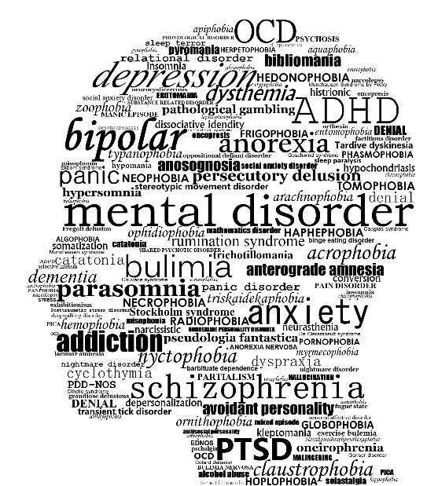

**Disabilities**

It is important to ensure that adults with disabilities have an assessment of their needs undertaken so that they are accurately supported. Practitioners should be mindful that sometimes children support their parents by taking on roles within the home, i.e. housework, cleaning, caring for a younger sibling – these children might be considered Young Carers and they need support too.

When assessing families where they may be adult/s with disabilities, it is important to explore if the child’s needs are being met or if the adults require more support/the child’s needs are being neglected to a certain extent.

**Young Carers**

A young carer is someone under 18 who helps look after someone in their family, or a friend, who is ill, disabled or misuses drugs or alcohol (Carers Trust 2019).

Young Carers might do:

* Cooking, housework and shopping
* Physical care, such as helping someone of out bed
* Offer emotional support
* Assist with personal care, i.e. helping someone dress
* Manage the family budget or collecting prescriptions
* Look after their siblings

**Adult Substance Misuse**

Substance Misuse involves the frequent use of drugs and/or alcohol. Substance misuse can result in adults’ spending money frequently to buy drugs or alcohol, and they may resort to engaging in criminal activities to finance their misuse, i.e. shoplifting, prostitution.

Adults misusing substances may care for children whilst they are under the influence, may misuse in front of the child or may spend time out of the family home to misuse whilst the child is home alone, at school or with someone else.

**The impact on children can vary:**

* An increased risk of developing drug or alcohol issues themselves.
* Physical abuse, emotional abuse or neglect due to poor supervision and parenting.
* Being separated from their parents due to Children’s Services involvement, incarceration or hospitalisation.
* Taking on the role of caring for younger siblings or their parents.
* Poor attendance to school/poor educational attainment.
* Living in poverty or being in unsafe accommodation.

**Domestic Abuse**

Domestic Abuse, as defined by the UK Government, is ‘any incident of controlling, coercive or threatening behaviour, violence or abuse between those aged 16 or over who are or have been intimate partners or family members, regardless of their gender or sexuality’.

Domestic abuse can take place in various forms:

* Physical or Sexual
* Emotional/Psychological
* Coercive Control
* Financial
* Harassment and Stalking
* Online Abuse

**The impact on children can vary:**

* Be scared and frightened of what they can see or hear.
* To intervene in physical assaults to break it up or protect someone; this can result in children sustaining injuries.
* Develop low self-esteem and low confidence
* Develop mental health issues, i.e. Anxiety or Depression
* Have suicidal thoughts/attempts.
* Develop behavioural difficulties.
* Blame themselves for the abuse.

**Assessing Adult Behaviours and Capacity to Change**

* Conduct checks with other agencies, i.e. Substance Misuse Services to assess their engagement and any progression with this.
* Liaise with other professionals who know the child and family, i.e. Schools, Health Visitor.
* Speak to the child, gain their views, wishes and feelings about their lived experiences.
* If parents are being tested for substance misuse, clearly record these findings on the child’s file and refer to these in assessments and plans.

Undertake direct work with parents/carers around their substance misuse, i.e. how long they have been using, the amount they use etc to help in assessing their capacity to reduce or stop using.

**Links to Further Learning and Resources**

Young Carers - <https://www.dudley.gov.uk/residents/care-and-health/children-and-family-care/young-carers/>

Meeting Some of Britain’s Youngest Carers Video - <https://www.youtube.com/watch?v=WoSQLrvf6E0>

Support for Parents - Domestic Abuse – Laura’s Story Video - <https://www.youtube.com/watch?v=HZsJs-XN0xw>

What is Domestic Violence? A Short Film for Children - <https://www.youtube.com/watch?v=U6OmeEBI7QY&feature=youtu.be>

Domestic Abuse Tools - <https://www.dudleycpp.org.uk/domestic-abuse-tools>

Atlantic House Contact Details - <http://www.dwmh.nhs.uk/service-users-and-carers/atlantic-house/>

Parenting with Mental Health Problems - <https://www.nspcc.org.uk/keeping-children-safe/support-for-parents/mental-health-parenting/>

Upholding the Independence of Disabled Parents - <https://www.disabilityrightsuk.org/news/2018/september/disabled-parents-often-seen-risk-their-children-rather-given-support-warns>

Mind Website - <https://www.mind.org.uk/>

KSS 5 – Abuse and Neglect of Children

**Harm Categories:**

|  |  |
| --- | --- |
| Physical Harm  Physical Harm occurs when someone hurts or harms a child on purpose. This can include slapping or punching, throwing, biting, scratching, burning, scalding and kicking.  The child can be seen to have frequent injuries, requiring medical attention often or have marks and injuries, i.e. swelling, bruising, fractures, breathing problems etc  This can cause a child to develop behavioural issues, anxiety and depression, drug and alcohol visits, eating disorders and suicidal thoughts and attempts. | Emotional Harm  Emotional Harm occurs when a child is continuously emotionally maltreated.  This can include a child being exposed to domestic abuse or parental substance misuse, threatening and shouting at a child, making them perform degrading acts, never saying anything kind.  This can make a child feel unconfident, they may struggle to control their emotions and have difficulty establishing and maintaining relationships.  This can have serious long term effects for children, including causing issues for their mental health, emotional development and behaviour problems. |
| Sexual Harm  Sexual Harm occurs whereby a child is tricked or forced into sexual activities (NSPCC).  This can include sexual touching of a child’s body (over or under clothing), forcing a child to take part in sexual activities, making a child touch someone else, making them undress and using a body part or object to rape or penetrate a child. This can also involve Child Sexual Exploitation.  A child is at risk of sexual harm if they are shown pornography, are made to masturbate, forcing them to make or view child abuse images or exposing them to sexual acts.  This can cause a child to self-harm, develop anxiety and depression, suicidal thoughts and suicide and feelings of shame and guilt. | **Neglect**  Neglect occurs when there is an ongoing failure to meet a child’s basic needs.  This can include a child being of poor appearance and hygiene, having health and development problems (with a lack of engagement with health services), being left home alone, living with poor home conditions or taking on the role of a Carer for family members.  This can cause a child to take risks, i.e. running away from home, difficulty forming and maintaining relationships, developing mental health issues and problems with their brain development.  The following children are deemed to be at greater risk of neglect: disabled children, children in care, babies/children who are born prematurely and children with complex health needs. |

**Child Sexual Exploitation (CSE)**

The Government definition of CSE is: ‘Child sexual exploitation is a form of child sexual abuse. It occurs where an individual or group takes advantage of an imbalance of power to coerce, manipulate or deceive a child or young person under the age of 18 into sexual activity (a) in exchange for something the victim needs or wants, and/or (b) for the financial advantage or increased status of the perpetrator or facilitator’.

* CSE can happen in person or online; a perpetrator will gain a child’s trust or control them before sexually abusing them.
* Children might be exploited to send explicit pictures of themselves, film sexual activities or have sexual conversations.
* Children might be invited to parties where they are given drugs and alcohol and might be sexually assaulted.

**Recognising the Signs of CSE**

* Children might have new/unexplained items, i.e. new phones, jewellery, clothes etc
* Drug or alcohol misuse
* Increasingly secretive and keeping to themselves
* Calls and messages at all times of the day
* Increased absences from school
* Physical signs of abuse, i.e. marks or injuries, bleeding
* Sexually Transmitted Infections (STIs or unwanted pregnancies)

**Grooming**

Grooming may take place in phases and is a process used by perpetrators to exploit children.

**Grooming may also involve the following:**

**Befriending** – The perpetrator or someone they know befriends the child to gain their trust.

**Exchange of Favours** – The perpetrator seeks favours from the child, i.e. a sexual act.

Examples of grooming can include; giving children attention, taking children on trips or outings, showing an understanding or giving advice or buying them gifts, i.e. jewellery.

**Criminal Exploitation**

Criminal Exploitation is a form of Modern Slavery whereby children can be forced to partake in forced begging, shoplifting and pickpocketing, cannabis cultivation, drug dealing and financial exploitation.

Some of the signs to notice are:

* an increased amount of visitors to the home
* substance misuse or drug paraphernalia in the home
* going missing
* truancy or disengagement from school
* anti-social behaviour
* unexplained injuries etc

**County Lines**

* Children are exploited by gangs or organised crime groups to export illegal drugs, using dedicated mobile phone lines.
* Children are befriended, manipulated and threatened to transport drugs and they are expected to carry drugs/weapons. It is a form of Modern Slavery.
* These gangs will target vulnerable adults and ‘cuckoo’ their houses, using them for the purposes of selling and making drugs.
* Practitioners can complete a National Referral Mechanism (NRM) which can be submitted to the National Crime Agency to consider if a child is at risk of modern slavery.

**Female Genital Mutilation (FGM)**

FGM refers to ‘all procedures involving partial or total removal of the female external genitalia or other injury to the female genital organs for non-medical reasons’.

FGM has been an offence since the Prohibition of Female Circumcision Act 1985, this was later replaced by the Female Genital Mutilation Act 2003.

The NSPCC reports that FGM can cause severe back pain, shock, bleeding, infection, organ damage, blood loss, long lasting health problems (incontinence, infertility, complications during pregnancy etc) and death in some cases.

**Recognising the Signs and Indicators of FGM**

* a relative or ‘cutter’ visiting from abroad.
* a special occasion or ceremony to 'become a woman' or prepare for marriage.
* a female relative being cut – a sister, cousin, or an older female relative such as a mother or aunt.
* a family arranging a long holiday or visit to family overseas during the summer holidays.
* unexpected, repeated or prolonged absence from school.
* a girl struggling to keep up in school and the quality of her academic work declining.
* a child running away from or planning to leave home.

**Forced Marriage**

Forced Marriage is where one or both parties do not want to get married but are forced to.Forced Marriage is illegal in the UK.This is often planned by a child’s parents, family members or religious leaders.It can involve the child being physically abused, emotionally abused or sexually abused.

An **Arranged Marriage** is a cultural tradition and there is a choice or **Forced Marriage** is an abuse of human rights and there is no choice.

Childline believe that some children are forced to marry because they…

* think it’s an important part of religion or culture.
* are worried about the family’s reputation and honour (in some cultures also known as 'izzat').
* want all of the family’s money to stay together.
* want to marry their children off in exchange for money.
* don’t approve of their child being gay, lesbian, bisexual or transgender.
* don’t want their children to have relationships or sex.
* feel pressured by the community or other family members to follow traditions.
* want to keep family values and honour.

**Links to Further Learning and Resources**

Why a Chronology Should be the First Thing You do in an Assessment

<https://www.communitycare.co.uk/2018/08/15/chronology-first-thing-assessment/>

Gathering Information

<https://www.scie.org.uk/assets/elearning/communicationskills/cs04/resource/html/object4/object4_7.htm#slide03>

FGM Prosecution Guidance

<https://www.cps.gov.uk/legal-guidance/female-genital-mutilation-prosecution-guidance>

Female Genital Mutilation

<https://data.unicef.org/topic/child-protection/female-genital-mutilation/>

Protecting Children from FGM

<https://learning.nspcc.org.uk/child-abuse-and-neglect/fgm/#heading-top>

Forced Marriage Tools

<https://www.dudleycpp.org.uk/forced-marriage-tools>

Forced Marriage

<https://www.childline.org.uk/info-advice/bullying-abuse-safety/crime-law/forced-marriage/>

Layla’s Forced Marriage Story: Your Tomorrow Video

<https://www.youtube.com/watch?v=MY7BhF-f96M&feature=youtu.be>

Child Sexual Exploitation: Practice Tool

<https://www.rip.org.uk/resources/publications/practice-tools-and-guides/child-sexual-exploitation-practice-tool-2017-open-access>

Criminal Exploitation of Children and Vulnerable Adults: County Lines - <https://www.gov.uk/government/publications/criminal-exploitation-of-children-and-vulnerable-adults-county-lines>

What is Criminal Exploitation - <https://www.stopthetraffik.org/criminal-exploitation/>

**KSS 6 – Child and Family Assessment**

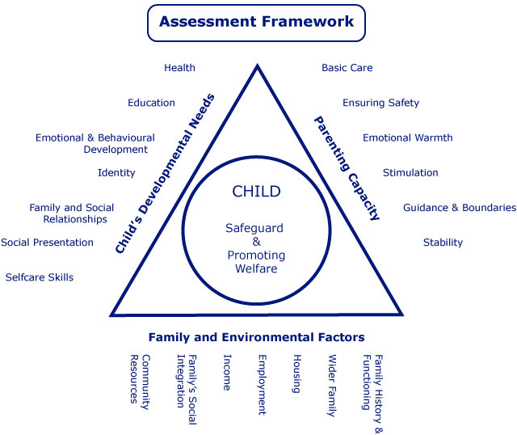**Framework for Assessment**

* A systematic method of gathering and analysing information to support professional judgement around how to help children and families.
* It’s divided into 3 key areas: -
  + A Child’s Developmental Needs
  + The Capacity of Parents to Respond Appropriately and Meet the Needs of the Child
  + The Impact of the Wider Family and Environment on Parents and Child

**What Does this Mean in the Context of a Child?**

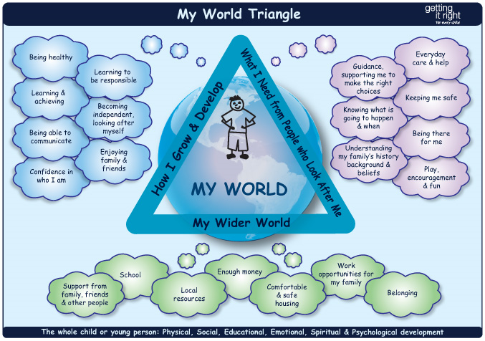

**The Assessment Process**

* Working Together to Safeguard Children (2018) states ‘Assessment should be a dynamic process, which analyses and responds to the changing nature and level of need and/or risk faced by the child from within and outside their family.’
* Preparation – Complete an assessment plan - What is the purpose of the assessment? Who do you need to see? What information will you need?
* Data collection – obtain the information required for the assessment.
* Weighing up the data – Use the information gathered to answer the question ‘is there a problem and is it serious?’.
* Analysing the data – Analyse the information to obtain a greater understanding. Formulate possible interventions.
* Utilising the Data – Use information to evidence judgements and recommendations for intervention.
* Working Together 2018 describes the purpose of assessment as: -
  + To gather information about a child and family
  + To analyse their needs and/or the nature and level of any risk and harm being suffered by the child.
  + To decide if the child is a Child in Need (Section 17) or is suffering or likely to suffer significant harm (Section 47).
  + To provide support to address those needs to improve the child’s outcomes and welfare and where necessary to make them safe.

**Assessment as Part of a Social Work Process**

* Taylor and Devine (1993) described the assessment process as the ‘basic helping cycle’: -

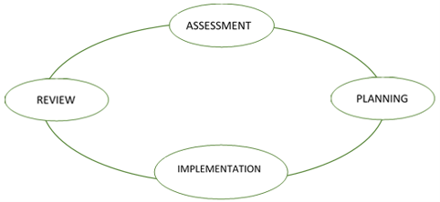

**Confirmation Bias**

* Working Together to Safeguard Children (2018) states ‘A social worker may arrive at a judgment early in the case but this may need to be revised as the case progresses and further information comes to light. It is a characteristic of skilled practice that social workers revisit their assumptions in the light of new evidence and take action to revise their decisions in the best interests of the individual child.’
* Confirmation bias is a cognitive process which changes the way you seek, view and use information because of your own bias or prejudgements.
* Thinking a situation through from a different hypothesis can be helpful to challenge this.

**Assessment Tools**

**SHARE: Develop Empathy in Assessments**

* The word SHARE for the model is important as it links to the importance of taking a partnership approach with children and families, as well as the importance of information sharing with other agencies.
* The components can be covered in any order.
* A social worker will need to consider ‘SHARE’ in the following way: -

**S**eeing – Who have they seen? Who with? What have they seen? Who haven’t they seen? How might they draw on observations in the assessment? What might they have lost sight of?

**H**earing – What have they heard? Who from? Whose voice have they privileged? Why? Who else do they need to hear from?

**A**ction – What action has been taken? What impact has this had? What actions have others taken?

**R**eading – What have they read that they may draw on in the assessment? This may include research, theory, legislation, assessments from others or case notes/chronologies.

**E**valuation – How is the evidence being evaluated? Is there conflicting evidence – i.e. what was seen and what was heard?

**Genograms**

* Genograms are used to clarify complex relationships.
* They indicate gaps in our knowledge.
* They visibly identify intergenerational and life cycle issues.
* Completing genograms engages family members and allows observations of their interactions.
* It may be relevant to change the symbols to be respectful.
* Genograms require the full name, DOB or written age of a person.

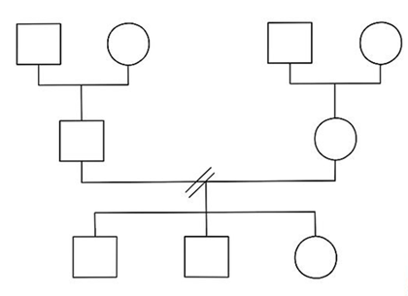

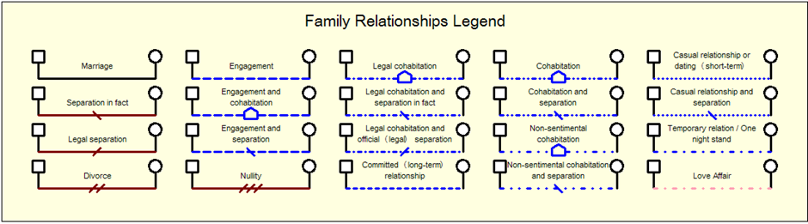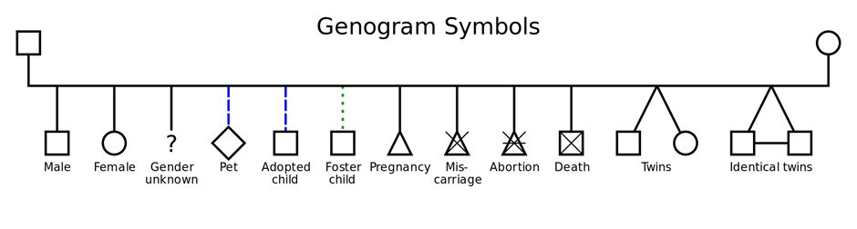

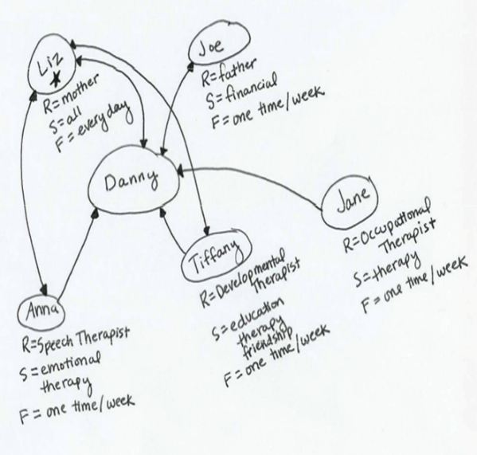**Ecomaps**

* Ecomaps should show a child’s social and personal relationships and their relationship with their environment or the different systems impacting on their lives.
* Ecomaps should highlight the strength of connections, reciprocity of relationships and access to resources/networks.
* Child should always be at the centre of an ecomap.
* Formulating ecomaps is not a one off exercise – relationships change.

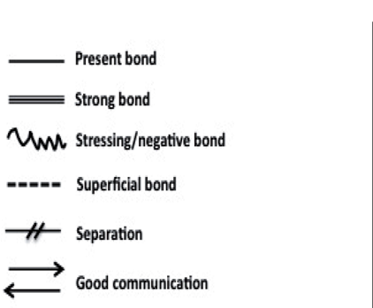**Drawing an Ecomap**

* Place the child or young person in the centre of the Eco Map.
* Identify important people, organisations/professionals and hobbies.
* Draw the circles as close to the child in the centre dependant upon how close the child’s connection is to them.
* Draw lines between the circles where connections exist depending on the nature of the relationship.

**Chronology**

* Provides a prompt, concise, factual and visual outline of significant events and information in the child’s journey.
* Early identification of patterns of risk or concern.
* Tool to identify chronic neglect.
* Highlights significant changes in a child’s life.
* Summarises outcomes relating to significant events.
* Helps understand the impact on the child.
* Contributes to risk assessment and informs decision making in the child’s journey.

**What to Include…**

* Family history, births, marriages, new partners and separations, bereavements, changes in household composition, employment, unemployment and homelessness.
* Referral history and outcomes.
* Evidence of engagement/non engagement.
* Education / behaviour / exclusions.
* Periods of being missing.
* Changes in behaviours.
* Hospital admissions.
* Missed health appointments.
* Domestic abuse incidents.
* Substance misuse issues drug testing results disclosures of use.
* Involvement with police / criminal justice (parent carer and young people).
* Statutory meetings ICPC RCPC LAC CIN CAF/EHA and outcome
* Observations of concern such as home conditions, attachment, appearance of the child

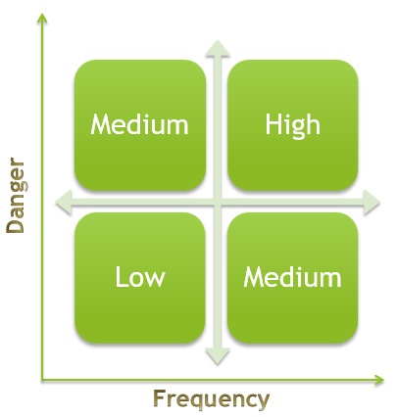**Assessing Risk**

* Rating
  + Which concerns are the most relevant?
* Probability
  + How likely are the possible negative events to happen
* Timescale
  + Are the concerns immediate or long-term?
* Frequency
  + Are there recurring concerns or rare events?
* Movement
  + Are the strengths/vulnerabilities static or dynamic?

**Diclemente’s Model of Change**

**Termination vs. Relapse**

* Two end outcomes to the Model of Change: -
* Termination is when the person is no longer tempted and there is no struggle to avoid relapse, but for some this may not ever happen and they will remain in maintenance.
* Relapse is when change is not upheld and old problems reoccur, taking someone back through the stages of change again.

**SMART Planning**

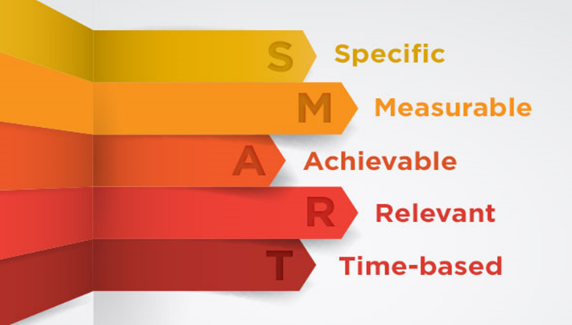

**Journey Mapping**

* Journey maps can be developed at the start of interventions.
* They can help families to plan what they need to do and develop strategies should they face obstacles along the way.
* They can help review progress towards goals.

**Working with Fathers**

* Actively seek details of fathers.
* Where possible, engage fathers from the start.
* Communicate with both parents as standard practice.
* Consider timings of meetings or engagement with services to allow fathers to attend around work commitments.
* Helping a father see the ‘evidence’ of a problem, e.g. sharing information and assessment results could encourage him to engage in services.
* Working with non-statutory agencies who can provide alternative locations for the provision of services may help to engage fathers who may be unwilling to engage with the local authority services.
* Give it time, male ego and pride can sometimes get in the way of fathers asking for help.

**Links to Further Learning and Resources**

Framework for the Assessment of Children in Need and their Families

<https://webarchive.nationalarchives.gov.uk/20130404002518/https:/www.education.gov.uk/publications/eOrderingDownload/Framework%20for%20the%20assessment%20of%20children%20in%20need%20and%20their%20families.pdf>

Confirmation Bias Video

<https://www.youtube.com/watch?v=jOjIAiJCNIk>

Genograms

<https://southwark.proceduresonline.com/pdfs/genogram.pdf>

Ecomaps Video

<https://www.youtube.com/watch?v=oLUCKyWeoK4>

Chronology

<https://www.youtube.com/watch?v=940k3_tUwwo>

Assessing Risking Video

<https://www.youtube.com/watch?v=93_MVEx1D0k>

Diclemente’s Model of Change

<http://socialworkpodcast.blogspot.com/2009/10/prochaska-and-diclementes-stages-of.html>

Stages of Change Video

<https://www.youtube.com/watch?v=OAUmTw9YXYk>

SMART Planning <https://www.proceduresonline.com/dudley/childcare/user_controlled_lcms_area/uploaded_files/SMART%20Planning%20Guidance.pdf>

Working with Fathers

<https://www.youtube.com/watch?v=iJcrbdeyiSk>

Working with Fathers: Key Advice from Research

<https://www.communitycare.co.uk/2018/02/19/working-fathers-key-advice-research/>

Good Practice with Fathers in Children and Family Services

<https://www.research.ed.ac.uk/portal/files/45742312/Clapton_IRISS_2017_INSIGHTS38.pdf>

The Relationship between Poverty, Child Abuse and Neglect: An Evidence Review <https://www.jrf.org.uk/report/relationship-between-poverty-child-abuse-and-neglect-evidence-review>

Working Together to Safeguard Children <https://assets.publishing.service.gov.uk/government/uploads/system/uploads/attachment_data/file/779401/Working_Together_to_Safeguard-Children.pdf>

Assessing Parental Capacity to Change when Children are on the Edge of Care: an Overview of Current Research Evidence - <https://assets.publishing.service.gov.uk/government/uploads/system/uploads/attachment_data/file/330332/RR369_Assessing_parental_capacity_to_change_Final.pdf>

Assessing Parental Capacity to Change: Research in Practice Training Course <https://www.rip.org.uk/resources/publications/frontline-resources/teambased-learning--assessing-parental-capacity-to-change-training-course/>

Signs of Safety

<http://www.aascf.com/pdf/What_is_the_Signs_of_Safety.pdf>

Editable Ecomap and Guidance <https://www.google.com/url?sa=t&rct=j&q=&esrc=s&source=web&cd=14&ved=2ahUKEwj_rY3R-7vkAhXklFwKHVtpCioQFjANegQIBRAC&url=https%3A%2F%2Fwww.gov.scot%2Fbinaries%2Fcontent%2Fdocuments%2Fgovscot%2Fpublications%2Fadvice-and-guidance%2F2012%2F11%2Fnational-risk-framework-support-assessment-children-young-people%2Fdocuments%2Feditable-template-ecomaps%2Feditable-template-ecomaps%2Fgovscot%253Adocument%2F00409307.doc&usg=AOvVaw2W7IqrWN-5yaPux4tMeYGO>

Why a Chronology should be the First Thing you do in an Assessment

<https://www.communitycare.co.uk/2018/08/15/chronology-first-thing-assessment/>

Guidance on undertaking a Parenting Capacity Assessment <https://www.google.com/url?sa=t&rct=j&q=&esrc=s&source=web&cd=3&ved=2ahUKEwjbu-C7ibzkAhWEShUIHY71DBoQFjACegQIDBAE&url=https%3A%2F%2Fwww.proceduresonline.com%2Fkent%2Fchildcare%2Fuser_controlled_lcms_area%2Fuploaded_files%2FGuidance%2520on%2520Undertaking%2520a%2520Parenting%2520Capacity%2520Assessment.docx&usg=AOvVaw1sWNGVntCLjWa9EY64SDdj>

Attributional Bias

<https://www.youtube.com/watch?v=1jBAetCVYwc>

Research in Practice – KSS 6 Resources

<https://www.rip.org.uk/search/?tab=ALL&search_area=site&keyword=kss-assessment&topic=43&type=0&searchSubmit=SEARCH>

KSS 7 – Analysis, Decision Making, Planning and Review

**Framework for the Assessment of Child in Need and their Families**

Working Together to Safeguard Children (2018) has been developed to provide a systematic way of analysing, understanding and recording what is happening to children and young people within their families and the wider context of the community in which they live. From such an understanding of what are inevitably complex issues and interrelationships, clear professional judgements can be made. These judgements include whether the child being assessed is in need, whether the child is suffering or likely to suffer significant harm, what actions must be taken, and which services would best meet the needs of this particular child and family.

**The Assessment Process – Thinking and Analysing in Practice**

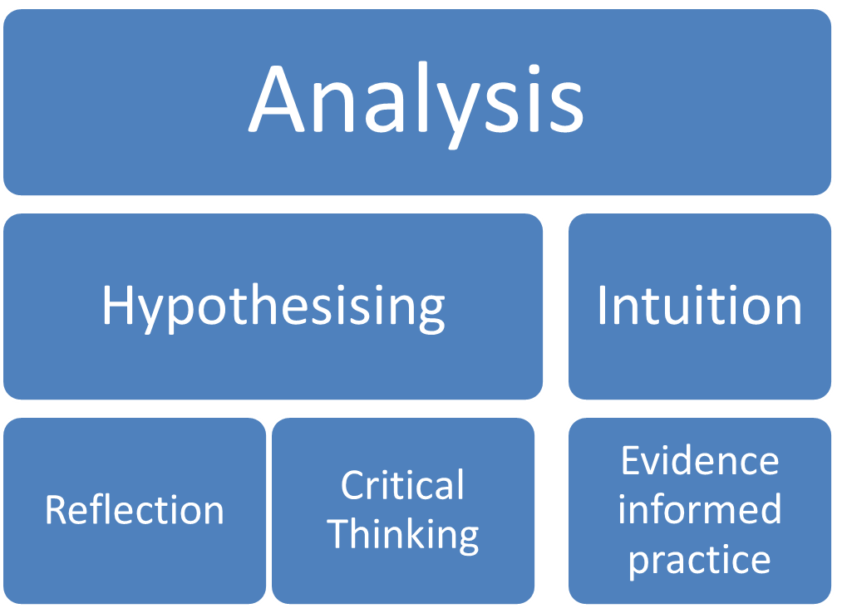

**Questions to Inform the Assessment Process**

**Why?**

* Why is the assessment needed?
* What is the reason for the referral?
* Is the child safe now?
* If not what needs to happen?
* Is the child's health and/or development impaired? In what way
* Will it be impaired without the provision of services?

**Who?.....And Who Else?**

* Who is involved?
* Which children, family members, step parents, wider family or others significant to the child?
* Which workers are involved with the child?
* Who is best placed to respond to the needs of the child at this stage?
* What help is being asked for?
* If you need further information who else will you talk to?
* Who else needs to be involved?
* Who can help with cultural, language or disability issues?
* Are there communication difficulties?
* What communication method will be required?
* Is an interpreter needed?
* Which other professionals should be involved?
* Who does what?
* What other family members or significant adults should be seen?
* What about the community or neighbourhood? Local support?
* Who else needs to be involved?
* Who can help with cultural, language or disability issues?
* Are there communication difficulties?
* What communication method will be required?
* Is an interpreter needed?
* Which other professionals should be involved?
* Who does what?
* What other family members or significant adults should be seen?
* What about the community or neighbourhood? Local support?
* Who else needs to be involved?
* Who can help with cultural, language or disability issues?
* Are there communication difficulties?
* What communication method will be required?
* Is an interpreter needed?
* Which other professionals should be involved?
* Who does what?
* What other family members or significant adults should be seen?
* What about the community or neighbourhood? Local support?

**What?**

* What is the response of the wider family to these concerns?
* Do they understand them and accept them or do they have other concerns or disagree?
* How do you know?
* Who is going to do what in terms of thinking planning and deciding?
* What about your support and supervision?
* What services, intervention or treatment needs to be provided for the child and family from the outset?
* What is the main purpose of the assessment?
* What are the main areas of need for the child?
* What is the impact of parenting of the wider family?
* What influence of the environment in this situation?
* What are the consequences of the present situation? And for whom?
* What are the strengths of this family?
* What needs to change?
* What are the immediate tasks?

**Where?**

* Where should the assessment be carried out?
* Office? Home?
* Family centre or a combination?
* Where are you going to see the child?
* Would time observing the child help?
* Where is the Child in their Journey?
* Have these concerns been raised before? Use your chronology and read previous files.

**How?**

* How will you engage the family and child with the assessment process?
* How will you record the information you have gathered?
* How will the information gathered be analysed and who will be involved?
* Is it likely further assessment or specialised assessment will be needed?
* How should the assessment be approached? How should you explain this to the family and child?
* What other sources of knowledge of child and family are available and how will other family members and professionals be involved bearing in mind confidentiality and consent?
* How will you gain a family history without asking lots of questions?

**When?**

* When does the assessment process start?
* When does the assessment finish?
* Timescale working to national guidance?
* What is the child’s timescale given their age and needs?
* When are you going to meet parents/wider family/child – dates sessions to cover
* When are you going to write this up?
* When are you going to share the assessment with the family?

**Hypothesising**

* **Look at the broader picture...**

What you’re there for might not be the only thing you need to know about

* Remember, your **initial Hypothesis is incomplete**...you are missing information...don't stick to one judgement
* It’s about **disproving or proving** your hypothesis and moving between these

***Professional Curiosity***

***Child’s Voice and Journey***



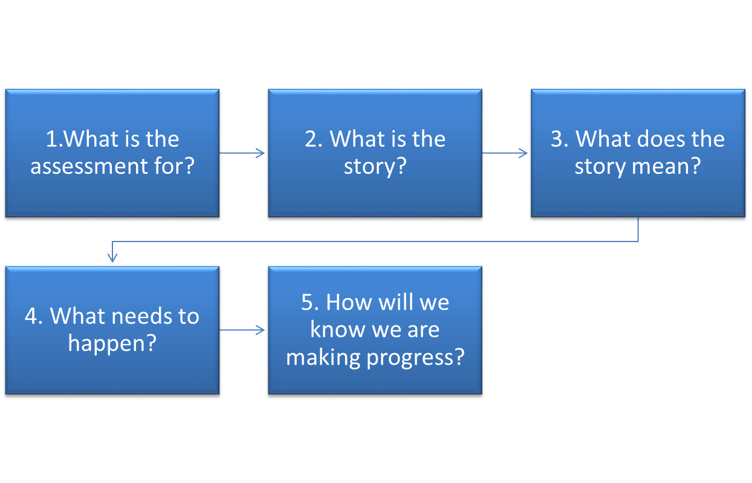

**The Anchor Principles**

**What is Analysis?**

* Working Together to Safeguard Children provides information about analysis within paragraph’s 56–62.
* **A**ccuracy – all information must be accurate.
* **N**ew – be open to new information and how this can change the picture.
* **A**cknowledge – acknowledge any missing or conflicting information.
* **L**ook – carefully examine the information and how this may connect with other information.
* **Y**ou – your perspective/role will impact how you interpret information.
* **S**cepticism – question the information you have.
* Investment – who has a vested interest in how the information is interpreted and the decision making process?
* **S**ynthesis – consider the information in terms of the whole picture.

Analysis and reflection should be happening at every stage: -

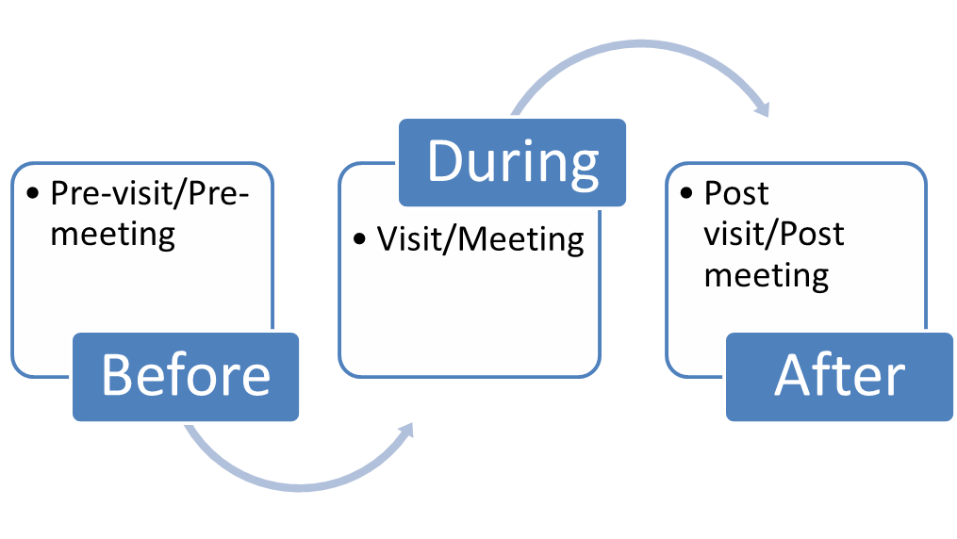

**Social Work Decision TREE**

* Reaching analytical, ethical decisions calls for social workers to draw on each of the branches of the TREE: -
* [**T**heory](https://www.google.com/url?sa=t&rct=j&q=&esrc=s&source=web&cd=13&ved=2ahUKEwjM48X_orzkAhWeQUEAHXmrCW0QFjAMegQIBRAC&url=http%3A%2F%2Fwww.coventry.gov.uk%2Fsclf%2Fdownload%2Fdownloads%2Fid%2F342%2Fsocial_work_theory_and_methods_comparison_table.doc&usg=AOvVaw0yNindpiLAPkzhDPNAJA1Z) – theory informs our thinking, and a model informs our doing.
* [**R**esearch](https://www.youtube.com/watch?v=NmByiEA5Ytk) – drawing on research evidence and using research skills.
* **E**vidence – seeing, hearing, action, reading, evaluation.
* [**E**xpertise](https://coppguidance.rip.org.uk/wp-content/uploads/2014/06/v1_tools_munro_areas-of-a_social_workers_expertise_300514.pdf) – who is the expert and why? Social worker (professional expertise), families (lived experiences), other agencies (health/education/police etc).

**A Sound Analytical Assessment will have…**

**Aims…**

* Picture of the child, parent and their story.
* Understanding of why the assessment is taking place and what you’re expecting from it.
* Specific about the child’s needs.
* Clarity of seriousness of identified needs and consequences/risks if not addressed.
* Measurable outcomes linked directly to identified needs with success and failure outcomes.
* Clear statements of work required to achieve outcomes and address needs identified.

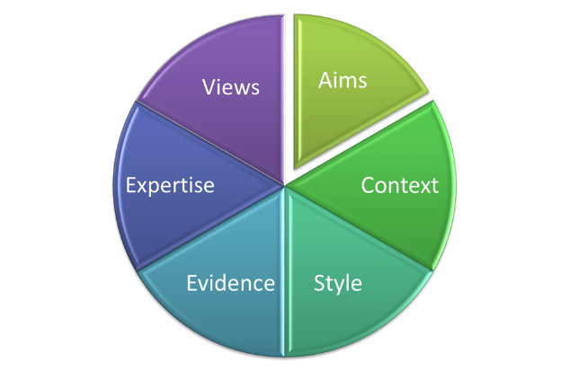

**Context…**

* Understanding of family history and its possible influence on current situation.
* Analysis on what we don’t yet know.
* Understanding of emotional impact on family and observations.
* Open minded and questioning approach – ‘is there another way of approaching this’?
* Only relevant information directly associated to the purpose of the assessment.

**Style…**

* Your work must be logical, clear, structured. Showing how you got from each point to reach a conclusion.
* Succinct, concise, relevant and specific at each stage.
* Free of jargon, phrases, acronyms etc.
* Link action plan to specific parts of the assessment. The plan must clearly emerge from the analysis undertaken.

**Evidence…**

* Make explicit the underpinning knowledge(theories/models used) and evidence (observations, research etc) that have informed your argument.
* Clear, evidence informed prediction of impact/consequences if identified needs not met (short and long term).
* Confidence in your analysis ‘this is what I think’. Include evidence based statements rather than generalities.

**Expertise…**

* Be clear about your concerns, and the reasons behind these concerns.
* Contain hypotheses, i.e your preliminary (tentative) explanations for the situation or behaviours issue.

**Views…**

* Include views, wishes and feelings of the child and family’s views and an analysis of those views.
* Describe clearly how it might feel to be standing in the child’s shoes.
* Seek the views of others.

**Analysing Risk**

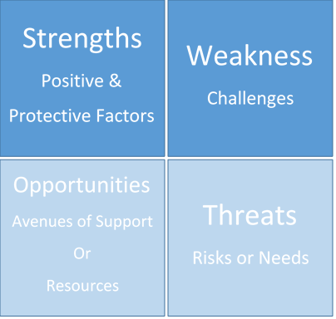

Risk Assessment should consider

* Type and level of harm.
* The effects of harm (Impact).
* The likely outcomes of intervention
* Safety factors.
* A tool to support this information gathering is the SWOT analysis.

**Links to Further Learning and Resources**

Working Together to Safeguard Children (2018) <https://assets.publishing.service.gov.uk/government/uploads/system/uploads/attachment_data/file/779401/Working_Together_to_Safeguard-Children.pdf>

Analysis and Critical Thinking in Assessment: Resource Pack

<https://www.rip.org.uk/resources/publications/practice-tools-and-guides/analysis-and-critical-thinking-in-assessment-resource-pack-20132014/>

The Anchor Principles

<https://www.local.gov.uk/sites/default/files/documents/analysis-and-critical-thi-0c9.pdf>

Tips for Improving Analysis and Decision Making in Social Work Video

<https://www.youtube.com/watch?v=jqa-XkpyI1A>

Social Work Theory and Methods Comparison Table

<https://www.google.com/url?sa=t&rct=j&q=&esrc=s&source=web&cd=13&ved=2ahUKEwjM48X_orzkAhWeQUEAHXmrCW0QFjAMegQIBRAC&url=http%3A%2F%2Fwww.coventry.gov.uk%2Fsclf%2Fdownload%2Fdownloads%2Fid%2F342%2Fsocial_work_theory_and_methods_comparison_table.doc&usg=AOvVaw0yNindpiLAPkzhDPNAJA1Z>

Incorporating Research into Everyday Social Work Practice Video

<https://www.youtube.com/watch?v=NmByiEA5Ytk>

What are the Areas of a Social Worker’s Expertise?

<https://coppguidance.rip.org.uk/wp-content/uploads/2014/06/v1_tools_munro_areas-of-a_social_workers_expertise_300514.pdf>

Social Work: Risks, Needs and Balanced Assessments <https://www.open.edu/openlearn/ocw/pluginfile.php/854430/mod_resource/content/1/k216_activity3_seden_reading.pdf>

Analysis and Critical Thinking in Assessment

<https://www.ryantunnardbrown.com/wp-content/uploads/2012/11/analysiscriticalthinking_core_publication-2.pdf>

Systematic Review of Models of Analysing Significant Harm <https://assets.publishing.service.gov.uk/government/uploads/system/uploads/attachment_data/file/183949/DFE-RR199.pdf>

Working Together to Safeguard Children – A Guide to Inter-Agency Working to Safeguard and Promote the Welfare of Children

<http://www.workingtogetheronline.co.uk/chapters/intro.html#child>

Research in Practice – KSS 7 Resources

<https://www.rip.org.uk/resources/kss-for-child-and-family-practitioners/analysis-decision-making-planning-and-review/>

**KSS 8 – The Law and the Family Youth Justice**

**Breaking Down Legislation**

* **Acts of Parliament** - Key Acts which inform children’s social work include the Children Acts of 1989 and 2004.
* **Regulations/Statutory Instruments** – Regulations can often be added to Acts of Parliament at a later date via Statutory Instruments, which are presented before Parliament. Regulations outline more detailed laws within the passed Acts.
* **Statutory Guidance** – Working Together to Safeguard Children (2018) is an example of Statutory Guidance.
* **Codes of Practice** – Offer guidance and advice regarding practice and legal requirements of certain Acts of Parliament. For example, Mental Health Act 1983 Code of Practice, which informs practice around young people engaged with mental health services.
* **Good Practice Guidance** – Guidance regularly issued and updated by the Government to support organisations and practitioners to comply with the law. Unlike Statutory Guidance, there is no legal obligation to comply with Good Practice Guidance however it is often adhered to.
* **Case Law** – When a law is disputed, a Court has the ability to clarify or change the law, setting a precedent for others to follow.

**Key Principles of the Children Act 1989**

* Paramountcy Principle (S1) – Children are always at the centre of what we do.
* Parental Responsibility (S3; 1) – Mother automatically has PR, Father has it if married or on the birth certificate (after 01/12/2003).
* Partnership – Working with parents.
* No Order Principle (S1; 5)
* Protection of Children – Threshold Criteria (S31; 2-9)
* No Delay Principle (S1; 2)

**Welfare Checklist**

* To ensure that the courts are acting in the child’s best interests at all times the Court should have regard to a list of items known as the “Welfare Checklist” which can be found in Section 1 Paragraph 3 of the Children Act 1989.
  + Ascertain wishes and feelings of the child.
  + The child’s physical, emotional and educational needs.
  + The likely effect on the child of any change in circumstances.
  + The child’s age, sex, background or any other relevant characteristics.
  + Any harm the child has suffered or is at risk of suffering.
  + How capable the child’s parents / carers are in meeting their need.
  + The range of powers available to the court.

**Welfare Reports – Section 7**

* Report written by an Independent Social Worker in cases where an application has been made to the Court in accordance with Children Act 1989 Section 8.
* An independent evaluation and assessment of a situation normally in relation to residence or contact of a child and the findings are reported to the Court.
* Normally CAFCASS make these reports to Court unless the case is open to Children’s Social Care or there is significant past involvement with them.
* Social Worker will report direct to the Judge and will not be supported by a Local Authority Solicitor. You may be cross examined in Court.

**Child Arrangement Orders and Other Orders with Respect to Children – Section 8**

* Child Arrangement Order – Details who a child shall live with as well as contact arrangements.
* Prohibited Steps Order – Prevents someone with PR from performing an action without permission of the courts; i.e. removing a child from the country, changing a child’s surname.
* Specific Issue Order – Instructs on something specific; i.e. direction of medical treatment, which school to attend.
* The Local Authority can’t apply for these in its own right – can only recommend them as part of a Care Plan to be enacted by others.

**Special Guardianship Orders – Section 14**

* A Special Guardianship Order places a child to live with someone other than their parent on a long-term basis.
* A Special Guardianship Order: -
  + grants Parental Responsibility to the Special Guardian
  + maintains links with the child’s parents
  + enables the Special Guardian to have daily control to exercise Parental Responsibility
  + can last until the child is 18 years old
  + doesn’t allow a child’s name to be changed
  + doesn’t allow a child to be taken out of the country without permission for more than 3 months.

**Provision of Service for Child in Need, their Families and Others – Section 17**

* Section 17 – all local authorities have a duty to ‘safeguard and promote the welfare of children within their area who are in need’.
* Parental consent is required – parents cannot be forced to engage under Section 17, it is voluntary.
* Financial assistance can be provided for example, to buy food or beds if required.

**Local Authority’s Duty to Investigate – Section 47**

* Under section 47 of the Children Act 1989, the Local Authority has a duty to make enquiries and to investigate if there are reasonable grounds to suspect that a child is suffering, or is likely to suffer, significant harm.
* Harm is defined as:

*“The ill-treatment, or the impairment of health or development, including for example, impairment suffered from seeing or hearing the ill-treatment of another.”*

* “development” refers to physical, intellectual, emotional, social or behavioural development;
* “health” refers to physical or mental health;
* “ill-treatment” includes sexual abuse and forms of ill-treatment which are not physical.’ (**s31 (9) Children Act 1989**)
* Where the question of whether the harm suffered by a child is significant relates to the child’s health or development, it is necessary to compare their health or development with what could reasonably be expected of a similar child (**s31 (10) Children Act 1989**).

**Young Carers – Needs Assessments – Section 17za**

* If there is an adult being looked after, then the local authority has a duty to consider whether there are any children involved in providing care, and if so, what the impact is on that child.
* The local authority have a duty to assess ‘on the appearance of need’ (ie without a ‘request’ having to be made).
* The assessment must look at whether or not the young carer wishes to continue caring, and whether it is appropriate for them to do so. When doing this they have to take into account any education, training, work or recreational activities the young carer is or wishes to participate in.

**Provision of Accommodation for Children – Section 20**

* Can accommodate without getting a Court Order under Section 20 (S20).
* S20 can only be used on a short term basis, e.g. if a parent is hospitalised or to accommodate an unaccompanied asylum seeking child.
* All those with Parental Responsibility must consent to S20 accommodation.
* Under S20 there is: -
  + no legal aid provision
  + no guardian provided for the child
  + no Parental Responsibility provided to the Local Authority



**Southwark Judgement – Section 20 (3)**

* Duty to assess and support 16 and 17 year old young people who are homeless, with no accommodation.
* LA must attempt to support reunification with family members.
* LA must offer options through housing or through Section 20 (received into care).
* Ensure the Young Person makes an informed choice and record these decisions in detail.

**Secure Order (Welfare) – Section 25**

* Young person needs to be over the age of 13 years old.
* Only a Strategic Director can in an emergency request secure accommodation for no more than 72 hours pending an application
* A secure application has to be made by the Local Authority alongside a Care Application or a Section 20 arrangement agreed by both parents with PR
* Secure applications can be made for very short periods, sometimes weeks and rarely last for more than 3 to 6 months. A guardian is always appointed and the arrangement has to be overseen by an IRO
* Secure Orders are made in extreme situations when the LA can evidence that all other ways of safeguarding the child have been tried and have failed.

**Care Orders – Section 31**

* Parental responsibility is shared between the local authority and the parent.
* Applications for Care Orders need to meet the significant harm threshold.
* Permanence of children must be considered – what is the long term plan for the child – along with contact arrangements.
* Under the [Public Law Outline (2014)](https://www.justice.gov.uk/courts/procedure-rules/family/practice_directions/pd_part_12a) and the [Children and Families Act 2014](http://www.legislation.gov.uk/ukpga/2014/6/contents/enacted), guidance states that care and supervision proceedings should be completed within 26 weeks.
* All options must be explored – a Care Order must be the last resort.
* The court can make an Interim Care Order – Section 38 (for up to 8 weeks) to allow further investigation of a child’s circumstances.

**Supervision Orders – Section 35**

* A Supervision Order is normally made at the end of proceedings where parents may have made improvements but there are still concerns around significant harm which the Local Authority must monitor.
* A Supervision Order imposes a duty on the local authority to ‘advise, assist and befriend’ the child. It may require a child to live in a specified place, do certain activities and report to a particular place at a set time.
* A supervision order can last for one year, and may be extended yearly to a total of three years. It can last until the child reaches the age of 18, unless discharged at an earlier date.
* Unlike a Care Order, a Supervision Order does not grant Parental Responsibility to the Local Authority.

**Child Assessment Order – Section 43**

* Often used for cases such as neglect.
* Order can be obtained when parents are not cooperating with the Local Authority.
* Normally requested alongside another Order, e.g. Section 8.
* Can be used to obtain a Child Protection Medical – unless the child refuses.
* Reasonable proof is required to suspect harm and therefore require an assessment.
* Assessment needs to be completed within 7 days.

**Emergency Protection Order – Section 44**

* Ensures the short term safety of the child.
* Can be obtained the same day (or night).
* Risks must be significant.
* Parents must be given 3 hours notice.
* An EPO can be made for a maximum period of 8 days, with a possible extension of up to a further seven days, to a maximum of 15 days.

**Police Protection (Power)**

* Not an Order – Power to be used within an emergency by the police.
* The child may be removed to a suitable accommodation for up to72 hours.
* Leads to a Section 47 Enquiry.
* Problem – The decision to remove is made on a Police Officers view of ‘significant harm’.

**Recovery of Abducted Children (Recovery Order) – Section 50**

* If a child is not produced following an Emergency Protection Order, a Recovery Order could be obtained.
* Anyone with Parental Responsibility can apply.
* It can only be served once – you have to go back for further Orders if the child disappears again.
* Failure to comply results in a fine or prison.

**Regulation 24 Placement Regulations**

* The temporary approval of carers under the provisions set out in the 2010 Regulations are intended to be used **exceptionally.**
* It must be clearly identified why the full assessment process (as required under Regulations 25 & 26 of the 2011 Regulations) cannot be undertaken before a placement is made.
* There is a possibility that the connected person may not be approved at the end of the assessment process.
* Any such approval can *only* be given for 16 weeks from the date of the placement until assessment is completed to avoid inappropriate long term placements.
* If carer is not approved following assessment, the child must be moved.

**Clare’s Law and Sarah’s Law**

* Due to data protection, Social Workers cannot share information about partner’s offences without consent.
* Clare’s Law gives people in a new relationship, or their friends or relatives, the right to ask police whether a new partner has a record of committing domestic abuse with previous partners. Police will decide if a disclosure will be made to a person who is in the best position to safeguard anyone who is vulnerable.
* Sarah’s Law lets people who care for children apply to find out if someone has a record of child sexual offences. Police will reveal details confidentially to the person most able to protect the child if they think it is in the child’s interests.

**Links to Further Learning and Resources**

Understanding Legislation - <http://www.legislation.gov.uk/understanding-legislation#Howlegislationworks>

Children Act 1989 - <https://www.legislation.gov.uk/ukpga/1989/41/contents>

Parental Rights and Responsibilities - <https://www.gov.uk/parental-rights-responsibilities>

Welfare Principle and Checklist Video - <https://www.youtube.com/watch?v=mfyrZtbxidw>

Section 8 Orders Explained Video - <https://www.youtube.com/watch?v=R1NVfFGoh3E>

Public Law Outline - <https://www.justice.gov.uk/courts/procedure-rules/family/practice_directions/pd_part_12a>

Children and Families Act 2014 - <http://www.legislation.gov.uk/ukpga/2014/6/contents/enacted>

Child Assessment Order Explained - <https://www.inbrief.co.uk/child-law/child-assessment-orders/>

Clare’s Law - <https://assets.publishing.service.gov.uk/government/uploads/system/uploads/attachment_data/file/575361/DVDS_guidance_FINAL_v3.pdf>

Sarah’s Law - <https://www.gov.uk/guidance/find-out-if-a-person-has-a-record-for-child-sexual-offences>

Parental Responsibility Explained Video - <https://www.youtube.com/watch?v=aTH5mcqAaH8>

Dudley Policies and Procedures - <https://www.dudleycpp.org.uk/policies-procedures>

NSPCC Child Protection Systems in England - <https://learning.nspcc.org.uk/child-protection-system/england/?_ga=2.243413573.1155332015.1566898081-695904753.1566898081>

Tips for Social Workers on Preparing Section 7 Reports for Court –

<https://www.communitycare.co.uk/2017/06/14/tips-social-workers-preparing-section-7-reports-court/>

Special Guardianship Orders Explained Video - <https://www.youtube.com/watch?v=L3aklOEmt2M>

Child Arrangement Orders Explained Video - <https://www.youtube.com/watch?v=Xwcs1Nsrbc8>

Care Orders Explained Video - <https://www.youtube.com/watch?v=bkK7Rb92_Co>

Supervision Orders Explained Video - <https://www.youtube.com/watch?v=l4jAtUyGhl8>

Interim Supervision Orders Explained Video - <https://www.youtube.com/watch?v=0BTfER31yp8>

Interim Care Orders Explained Video - <https://www.youtube.com/watch?v=xuM6ckvj7zg>

Young Carers Needs Assessment

<https://www.local.gov.uk/sites/default/files/documents/Young%20Carers%20needs%20assessment.pdf>

Supreme Court Outlines Nine Key Principles of Section 20 Practice

<https://www.communitycare.co.uk/2018/07/20/supreme-court-outlines-nine-key-principles-section-20-practice/>

Secure Accommodation Orders - <https://childprotectionresource.online/category/secure-accommodation-orders/>

Research in Practice – Court Orders and Pre-Proceedings - <https://coppguidance.rip.org.uk/>

Research in Practice – KSS 8 Resources - <https://www.rip.org.uk/resources/kss-for-child-and-family-practitioners/the-law/>

KSS 9 – The Role of Supervision

**Functions of Supervision**

* Morrison (2005) outlines four objectives to social work supervision: -
  + **Ensure competent accountable practice** – Space to discuss work, reach decisions with guidance, create a level of shared decision making and clearly agreed accountability.
  + **Encourage continuing professional development** – Opportunity for reflective discussion about practice to enable learning and development, space to discuss learning objectives and career development.
  + **Offer personal support to practitioners** – Personalised support regarding challenges of the role, space to discuss the emotional context of practice.
  + **Engage the individual practitioner with the organisation** – Understanding of professional role and clarity of responsibilities in the organisational setting.

**Models of Supervision**

**4x4x4 Model**

The 4x4x4 Model of Supervision’s emphasis is on seeing supervision as itself an integral part of the intervention with children and families.

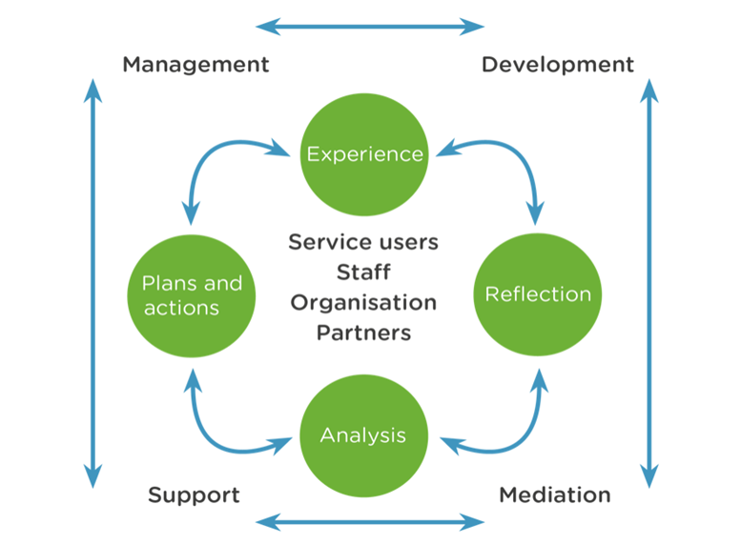

**CLEAR Coaching Model**

* **Contracting** – set ground rules for working together and establishing outcomes and priorities for both supervisor and supervisee.
* **Listening** – use a person centred approach, help supervisee gain an understanding of their situation with respect to the standards, priorities and tasks required.
* **Exploring** – help the supervisee to understand the impact of their performance and the effects on themselves, both personally and professionally. Challenging the supervisee to consider future actions to resolve situation or develop practice.
* **Action** – support supervisee to choose a way ahead and decide next steps.
* **Review** – reinforcing ground covered, decisions made and value added. Reflect with supervisee what was helpful about supervision, what was difficult and what would be helpful in future.

**Egan Model of Problem Management and Opportunity Development – Adapted for Supervision**

* Stage 1 – Where the Supervisee is now:
  + Begin the supervision - ‘check in’, acknowledge achievements and progress.
  + Focus where to start – review previous supervision, agree agenda items and prioritise.
  + Offer new perspectives – supervisor provides essential information and updates, performance management issues to be identified and challenged.
* Stage 2 – Where the Supervisee needs to be:
  + Clarify and agree outcomes – supervisee to understand specific organisational & individual performance targets, required standards of work.
  + Options to achieve outcomes explored – outcomes are assessed for relevance and cost (finance, time & effort) and degree of change involved.
  + Options for action agreed – these need to meet the aptitudes, abilities and level of responsibility of the supervisee.
* Stage 3 – How to get there
  + Action plan devised:

**Specific**

**Measurable**

**Achievable and Agreed**

**Relevant and Realistic**

**Timed**

* + Implementation – consider any resources or support required, challenge unrealistic expectations, be clear who does what and plans if circumstances change.
  + Action plan reviewed – items to be reviewed at next supervision are identified and agreed.

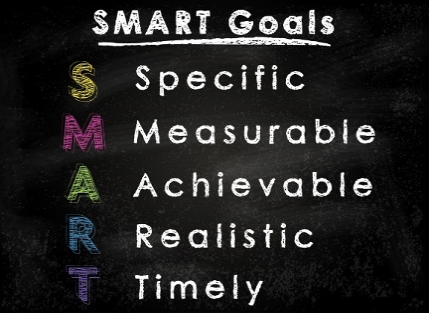

**Responsibilities of the Supervisor**

* Maintain balance between reflection and accountability; between positive feedback and constructive challenge; between celebrating strengths and identifying issues to be addressed.
* Record supervision sessions clearly and promptly.
* Include workload considerations.
* Ensure casework practice meets the practice standards.
* Ensure safeguarding processes are being followed.
* Ensure issues arising from the case planning process are addressed.
* Ensure a child-centred approach to all casework discussions.
* Observe direct engagement with children on a planned basis at least once during each year.
* Record any case-related supervision notes on the child’s file.

**The Golden Thread of Supervision**

* **What?** Do we know what the social worker is going to do?
* **Why?** Do we understand why the social worker is doing this and how?
* **How?** Has the discussion helped the social worker think more carefully about what they are going to do, how and why?
* Supervision very often focusses on what the social worker is doing. It needs to focus much more on the why? and the how? Connecting the answers around a clear focus on the child – the main concluding question being: HOW WILL THIS IMPACT UPON THE CHILD?

**Understanding Professional Limitations**

* Supervision is closely related to practitioners understanding their own professional competence and limitations.
* Knowing your own limitations is vital in terms of safe practice.
* Professional limitations may relate to: -

Learning needs

Lack of experience

Workload demands

Emotional pressures

Personal blocks or bias

How you see things

Impact of personal issues on professional practice

* Any professional limitations should always be balanced with:

Strengths

Professional abilities

Networks of support

**How and When to Seek Advice**

Social workers need to seek advice on a range of issues from a range of people. Drawing on the fullest range of questions, as listed below, is important in reaching decisions about seeking advice and support:

* What? – What advice do I need?
* Who? – Who can give the advice needed?
* Why? – Why do I need this advice? Why is this person the best to give advice?
* When? – When questions always relate to timing; When is the advice needed? Consider timescales for decision making and what stage you will need advice by.
* Where? – Where questions always relate to environments; What advice will you get from varying professionals? How will their organisational positions impact on the advice given?
* Which? – Which questions always relate to asking about specifics. When asking for advice, have some specific questions to ask.
* How? – How should I ask for the advice (by email, phone, in person)?

**Using Supervision and Advice to Support Decision Making**

* Shared decision making involves 6 main safeguards and benefits:
  + Peer review of professional decisions
  + Protection of civil liberties
  + Protection of service users
  + Protection of staff
  + Protection of the agency
  + Openness
* Within supervision, social workers must present a case analysis and recommendation to their manager to enable shared decision-making.

**Reaching Shared Decisions in Supervision**

* Seeing – Draw on observations; e.g. family environment, family interactions, children’s behaviour. What hasn’t been seen? Reflect on what a good outcome for the family looks like?
* Hearing – What do the children and families say? What do other professions say? Who hasn’t been heard? Who’s voice is being privileged and why? Is the child’s voice central throughout?
* Action – What has the social worker done? What have others done? What impact has this had? Why?
* Reading – Has the chronology or previous case notes been read? Is there relevant theory or research to use?
* Evaluation – Using the first four components a social worker can understand what is happening by drawing on evidence gathered. The evaluation enables the social worker to develop a hypothesis about what is happening, what needs to happen and what would be helpful in moving towards this.
* Decision Making – The social worker should take a clear case hypothesis to supervision. This should be open to discussion and debate to address issues of individual bias in decision making.

**Emotional Intelligence**

Emotional Intelligence includes the ability to identify, understand, manage and use emotions. It can be useful to consider emotional intelligence in terms of identifying emotions in self and others and managing emotions in self and others: -

* Relationship Management
  + How did I respond to them?
  + What impact did that have?
  + What will the impact be on our future relationship?
* Social Awareness
  + How were they feeling?
  + How do I know?
  + What made them feel that way?
  + Do they often feel that way?
* Self Management
  + What did I do?
  + Did that ‘display’ my emotions?
  + How?
* Self Awareness
  + How did I feel?
  + How do I feel?
  + What made me feel that way?
  + Do I often feel that way?

**Person Centred Approach**

Person-centred approach creates a positive supervision environment through: -

* Respect – offer non-judgmental acceptance.
* Empathy – understand supervisee’s perspectives and feelings.
* Genuineness – being oneself; influence the level of trust between supervisor/supervisee.
* Unconditional Positive Regard – regard the supervisee as a separate person of intrinsic worth and value, not just a ‘worker’.

**Reflective Supervision**

* Reflective supervision aims to create a culture of intellectual enquiry, to promote empathy and support long term professional development.
* Includes discussions about intervention goals, the process of service delivery, values, reactions and emotions, identification and analysis of pertinent knowledge, risk assessment etc.
* Reflective supervision helps gain an in-depth understanding of a situation, awareness of reactions and responses to service users, interventions which took place and the consequences of these. It encourages exploration of other ways of working leading to greater creativity, develops critical thinking and problem solving skills and decision-making processes.

**The ‘What’ Model of Reflection**

The ‘What’ Model contains 3 key elements of reflection: -

* + - * ‘What’ – a description of the event
      * ‘So what’ – an analysis of the event
      * ‘Now what’ –proposed actions following the event
* Example questions to assist reflective supervision: -
  + How does the child feel, what do they want?
  + What were you aiming for when you did that?
  + What alternatives were there?
  + How successful was it?
  + What theories/models/research informed your actions?
  + How would you do it differently next time?
  + What knowledge/values/skills were demonstrated?



**Links to Further Learning and Resources**

4x4x4 Model of Supervision - <https://www.local.gov.uk/sites/default/files/documents/supervision-now-or-never--0a4.pdf>

Reflective Supervision: Resource Pack - <https://www.rip.org.uk/resources/publications/practice-tools-and-guides/reflective-supervision-resource-pack-2017/>

Dudley Council’s Supervision Policy - <https://www.proceduresonline.com/dudley/childcare/user_controlled_lcms_area/uploaded_files/Practice%20Briefing%20Note%2029%20Supervision%20Policy.pdf>

Achieving Effective Supervision - <https://www.iriss.org.uk/resources/insights/achieving-effective-supervision>

Reflective Supervision: The Cornerstone of Good Social Work Practice - <https://www.rip.org.uk/news-and-views/blog/reflective-supervision-the-cornerstone-of-good-social-work-practice/>

Tools to Help with Reflective Practice and Using Theory in Supervision - <https://www.communitycare.co.uk/2018/05/15/tools-help-students-reflective-practice-using-theory/>

Supervision and Effective Social Work Practice - <https://socialcareinspection.blog.gov.uk/2018/10/23/supervision-and-effective-social-work-practice/>

Supervision: Now or Never – Reclaiming Reflective Supervision in Social Work - <https://www.in-trac.co.uk/supervision-now-or-never/>

Research in Practice KSS 9 Resources - <https://www.rip.org.uk/resources/kss-for-child-and-family-practitioners/the-role-of-supervision/>

KSS 10 – Organisational Context

**The 7 Principles of Public Life**

* **Selflessness –** you should act solely in terms of the public interest.
* **Integrity -** avoid placing yourself under any obligation to people or organisations that might try inappropriately to influence you in your work. They should not act or take decisions in order to gain financial or other material benefits for yourself, your family, or your friends. You must declare and resolve any interests and relationships.
* **Objectivity –** you must act and take decisions impartially, fairly and on merit, using the best evidence and without discrimination or bias.
* **Accountability –** you are accountable to the public for your decisions and actions and must submit yourself to the scrutiny necessary to ensure this.
* **Openness –** you should act and take decisions in an open and transparent manner. Information should not be withheld from the public unless there are clear and lawful reasons for so doing.
* **Honesty -** you should be truthful.
* **Leadership –** you should exhibit these principles in your own behaviour. You should actively promote and robustly support the principles and be willing to challenge poor behaviour wherever it occurs.

**Social Worker Standards of Proficiency**

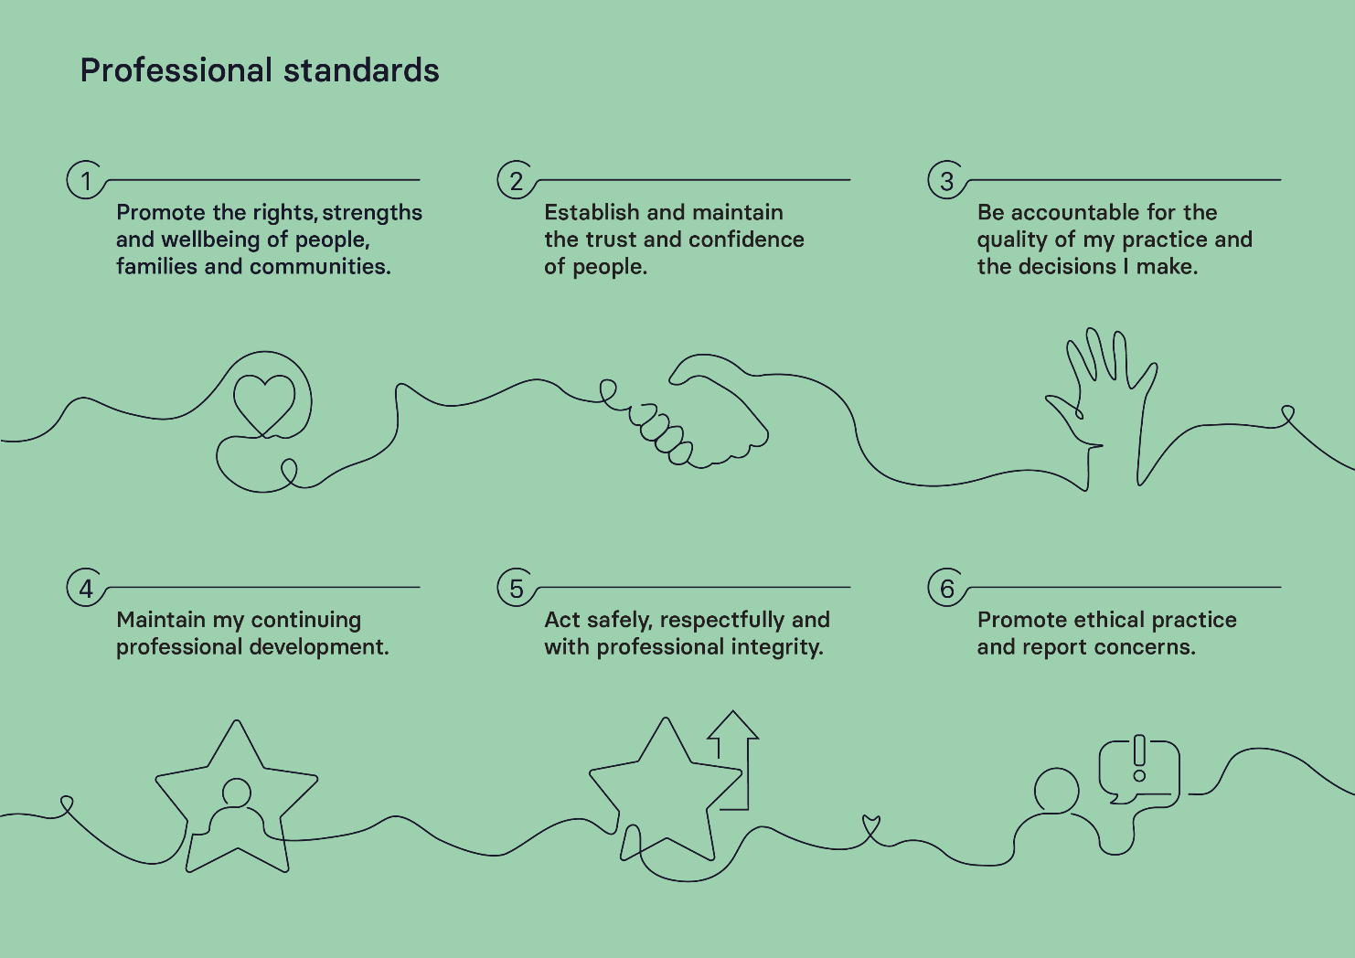

**Multi-Agency Working**

* Multi-agency working is key to effective safeguarding and child protection.
* Effective multi-agency working requires: -
  + Effective communication and information sharing.
  + Developing a shared purpose.
  + Effective planning and organisation.
* Benefits of effective multi-agency working include: -
  + Improved communication between agencies/services.
  + Improved interaction amongst professionals.
  + Improved access to information from other agencies.
  + Greater opportunities for information sharing and problem-solving.
  + Improved support for children and young people.

**Organisation as Corporate Parent**

* A child or young person who comes into local authority care, or is under the age of 25 years old having been looked-after for a minimum of 13 weeks after their 14th birthday, the local authority becomes their corporate parent.
* As corporate parent, the local authority should: -
  + act in the best interests, and promote the physical and mental health and wellbeing, of those children and young people.
  + encourage those children and young people to express their views, wishes and feelings.
  + take into account the views, wishes and feelings of those children and young people.
  + help those children and young people gain access to, and make the best use of, services provided by the local authority and its relevant partners.
  + promote high aspirations, and seek to secure the best outcomes, for those children and young people.
  + ensure children and young people are safe, and for stability in their home lives, relationships and education or work; and
  + prepare those children and young people for adulthood and independent living.

**Links to Further Learning and Resources**

The 7 Principles of Public Life - <https://www.gov.uk/government/publications/the-7-principles-of-public-life/the-7-principles-of-public-life--2>

Social Worker Standards of Proficiency - <https://www.socialworkengland.org.uk/standards/professional-standards/>

Applying Corporate Parenting Principles to Looked-After Children and Care Leavers - <https://assets.publishing.service.gov.uk/government/uploads/system/uploads/attachment_data/file/683698/Applying_corporate_parenting_principles_to_looked-after_children_and_care_leavers.pdf>

Research in Practice – KSS 10 Resources - <https://www.rip.org.uk/resources/kss-for-child-and-family-practitioners/organisational-context/>