Practice Improvement Team: Capturing Family Feedback
The purpose of capturing family feedback is to understand what impact the support offered from children’s services has had for the child(ren) and family. Information will help inform what has gone well, what we could do differently to improve services, celebrate success for the family and worker and identify learning opportunities. Please note all feedback captured will be anonymised.
Feedback will be captured from:
- Cases that are stepping down or closing from Child Protection from parents, carers and children
- Children Looked After once yearly
For accessibility there are paper versions of the feedback forms, as well as online forms to support different learning needs and preference. You can either print your own feedback forms or collect pre-printed forms from the Practice Improvement Team based at Cheshire Lines.
If the family has English as a second language, we suggest that feedback is sought when an interpreter is present. If this is not possible, please email the Practice Improvement Team who will explore options to have the forms translated.
Feedback from families closing or stepping down from Child Protection
As part of the closing process, the social worker will encourage the parents and carers and children to give feedback on how the support they have received has made a difference to their family. The QR code or link can be shared by email or mobile phone to access the online feedback form for parents and carers and children. The QR code is also included on the letter that is given to the family when the case is closing or stepping down from Childrens Services.
Pre-printed feedback forms are available upon request from the Practice Improvement team. If you would like to print out your own forms, the PDF template is saved within the PI and Thinking Thursday Channels and Local Resources area.
When the paper feedback forms are being used, please give the family an envelope to put their feedback form in to help keep feedback confidential. The completed forms are to be handed to a member of the Practice Improvement team or left with Concierge at Cheshire Lines.
NB: The feedback forms are not to be scanned into Liquid Logic as information captured is for the Practice Improvement Team only at this stage. Positive feedback will be shared at the Learning and Celebration Events.
Feedback from Children Looked After
The Independent Reviewing Officer will gain feedback from children and young people, either using the printed feedback form or sharing the QR code to the online form. Feedback is to be captured at one of the two Child Looked After reviews. Paper forms to be put in an envelope to keep confidentiality and handed into the Practice Improvement team or left with concierge at Cheshire Lines.
If you would like more information, please email: practiceimprovement@wirral.gov.uk

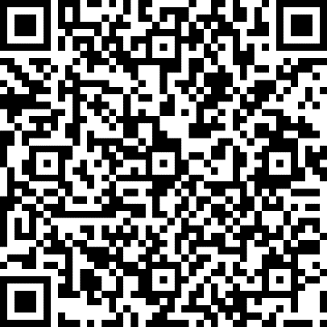
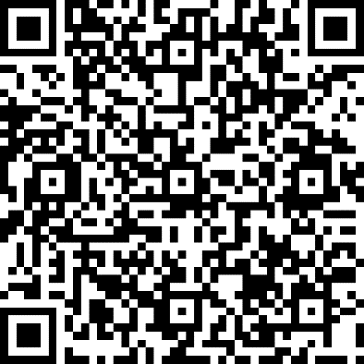
QR Code: Parent and Carer Feedback Form QR Code: Child and Yong Person Feedback Form

