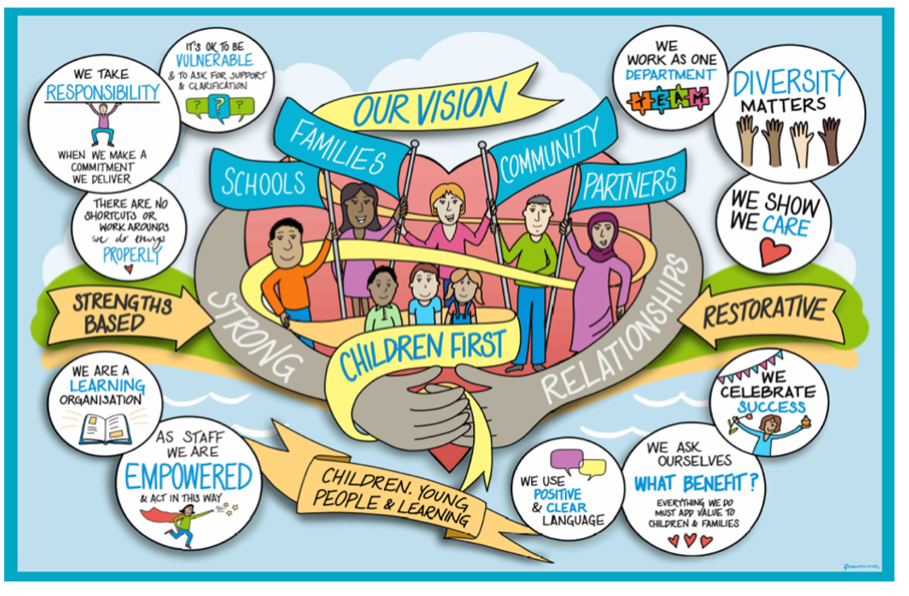

Together or Apart (Sibling) Assessment

Index | Subject | Page
 | Contents | 2
1. | Introduction | 3
2. | Legislation Guiding Practice | 3
3. | Defining a Brother/Sister/Sibling Relationship | 4
4. | Who Should Be Responsible for Completing the Assessment | 4
5. | When Should an Assessment be completed | 4
6. | Consultations | 5
7. | What to Include in the Assessment | 5
8. | Importance of explaining outcomes to children and young people | 6
8. | Thinking about Transition Planning | 7
9. | Recommendations for Successful Transitions | 8
10. | Factors that should not automatically determine Care Planning Decisions | 8
10. | Appendices – Links to helpful tools | 10

- Introduction
The aim of this practice guidance is to assist the Children's Social Care teams when making decisions about the future living arrangements for children within a family, through completing an Assessment of the Relationships between Children in the Family (Together or Apart Assessment).

“Brothers and sisters who share a childhood and grow up together have potentially the longest lasting, and one of the closest relationships of their lives with each other. In common with all relationships, sibling relationships have enormous capacity for shared understanding and activity, can stimulate warmth, care, and joy, and can help sustain children and adults through distressing times. They also have the potential to be undermining, driven by conflict, and marred by other difficulties.
Whilst these qualities are evident in most relationships, there are also differences and unique aspects of sibling interactions that are important to understand, think about and address when working with looked after children. Even when a child has never lived with his or her siblings, the significance of the relationship may be keenly felt during childhood with a sense “what might have been” stretching into adult life. (Beckett, 2018, p.1)”

Whilst the presumption should be that brothers, sisters and siblings will grow up together and we should make every effort to enable this to happen, there will be occasions when carefully thought-out decisions will need to be made to separate, not to reunite or unite brothers, sisters or siblings due to their assessed needs whilst making further decisions around their contact needs and arrangements.
“Practice should stem from a rights based and child centred approach wherein children’s relationships with their brothers and sisters is valued and accorded priority alongside each child’s individual needs . . . sibling relationship always need to be carefully considered and we should be rigorous in making plans that not only recognise the current sibling relationships but their capacity for change during their childhood and beyond.” Beckett, 2008, pg.7

- Legislation Guiding Practice

- The Children Act 1989 (s23(7)(b) places a duty on local authorities to accommodate a child together with his/her/their brother(s) and/or sister(s) so far as is ‘reasonably practical and consistent with his welfare.’
- The Adoption and Children Act 2002 s1(4) requires the court to consider “the likely effect on the child (throughout his life) of having ceased to be a member of the original family and become an adopted person” and “the relationship which the child has with relatives (…) including the likelihood of any such relationship continuing and the value to the child of it doing so.” The Act also requires the court to consider contact arrangements, and it allows the child and any relative to apply for contact (s26).
- Adoption Regulations, 2013, “siblings should be adopted by the same prospective adopter unless there is good reason why they should not be. Where an agency is making a placement decision on two or more children from the same family, it should be based on a comprehensive assessment of the children’s relationship, their individual needs, and the likely capacity of the prospective adopter to meet the needs of all the siblings being placed together. Where it is not possible for the siblings to be

placed together the agency should consider the need for the children to remain in contact with each other and the need for adoption support.
- Adoption Statutory Guidance, 2014, “there should be clear a decision-making process which enables social workers to decide early whether it is the best interests of each child to be placed together or separately, and the impact on each child of that decision. The decision-making process should be set out clearly with the supporting information and evidence so that all the professionals involved in the making of decisions about each child’s future can see how and why the decision was reached. It will also be important in future for the child, as an adult, to be able to see how and why a decision was reached. The decision should be based on a balanced assessment of individual needs of each child in the group, and the likely or possible consequences of each option on each child. Agencies may wish to have a formal assessment process in place to assist with the analysis and decision-making process”
- Article 8 of the Human Rights Act 1998 covers the right to private and family life and prohibits interference with this. Provided that family life is established, each member of the family including brothers and sisters has their own right to respect for family life.

- Defining a Brother/Sister/Sibling Relationship?
Families today come in a variety of forms. The increase in divorce and separation has created reconstituted families where stepbrothers and sisters and relationships where siblings have only one parent in common has become almost a norm. Although blood ties are still a significant factor another important dynamic in sibling relationships is family position. Understanding of dynamics of sibling groups particularly those which are larger and have complex histories, needs to begin with asking children who their regards as their brothers/sisters/siblings and who they feel close to or estranged from. The significance of a sibling relationship is personal and interpersonal rather than biological or legal and this understanding should therefore guide thinking and practice in our working with siblings.

- Who Should Be Responsible for Completing the Assessment?
The child’s social worker is the lead professional who in most cases will complete the assessment. Consideration must be given for a second social worker to be co-allocated for larger families with five or more children to support the assessment and analysis process. Support can be obtained in these cases from the Advanced Social Workers within the Permanence Team. Team Managers should email the Permanence Team at Permanence.team@westsussex.gov.uk.

- When should an Assessment be completed?
An assessment of the relationship between children in the family must be completed when two or more children within a sibling group may potentially have different permanency plans. It is good practice to undertake an assessment as part of parallel planning and the earlier in the care planning process this is achieved, the better, ensuring there is minimal delay for each child in achieving permanency.

As well as formal assessment, the sibling relationship should always be considered in each area of our work with a family, within:

- Child and Family Assessments – Assessing brothers and sisters should always start within the Child and Family Assessment and under the Child Development domain. The quality of the attachment each brother(s) or sister(s) has with their primary care giver will affect a child’s relationship with their brothers and sisters. The Framework for the Assessment of Children in Need and their Families

(DoH, 2000) states ‘The quality of relationships between siblings may also be of major significance to a child’s welfare.’
- Home Visit Observations – should also include on-going analysis of brother and sister relationships.

A comprehensive Assessment of the Relationship between Children in the Family should be undertaken in the following situations:
- Pre-Proceedings – if a family is subject to pre-proceedings, then the Internal Review Meeting should discuss the parents/carers progress in their parenting. If significant concerns continue with the likelihood being that carer proceedings will be issued, then a decision needs to be made whether a 6-week assessment needs to be completed at home. This would inform the interim care plan and placement request whether brothers and/or sisters are to live together or apart. It is recommended that an assessment of the relationship between brother and sisters should be completed as part of the assessment process in decision making about the need to remove the child(ren) from the family home. Research shows that children who are initially placed together are much more likely to remain together and this has implications for how initial placement decisions are made.
- Care Proceedings – if an assessment was not completed during the pre-proceedings stage, then an assessment should be undertaken during the Court process, assessments should be completed within 12 weeks. If a 6-week assessment was completed with pre-proceedings, in most cases good practice is that a further assessment, which is likely to take 6-8 weeks is directed by the Court to build on the existing assessment completed during the pre-proceedings stage.

An updating Together or Apart Assessment may be required in the following situation:
- Change of Placement – A updated assessment may be needed to review the care plan, for example if a foster carer gives notice for one brother or sister in placement, or where there are signs of significant changes in the brother and sister relationship which raises concerns. Therefore, further assessments are needed to inform what support and intervention is needed. The assessment should focus on the brother, sister and sibling relationship and not the relationship the brothers and sisters have on their carer with the former leading to decisions around ‘together or apart’. The timeframe for completion may be dependent on the issues emerging from the foster care home as well as the number of brothers, sisters and siblings involved and should take no longer than 12 weeks to avoid drift and delay.

- Consultations
All social workers can access consultations when undertaking and making decisions for brother, sisters and siblings. Consultations can be accessed from the Permanence Team via permanence.team@westsussex.gov.uk

- What to Include in the Assessment?
Some of the hallmarks of high-quality assessments identified are that they are: child centred; holistic; focused on action and outcomes; involve children and families and build on strengths as well as identifying difficulties; are multi-agency and multi-disciplinary; and are transparent and open to challenge. All these elements are central when assessing brothers and sisters.

Where consideration is being given to keeping brothers, sisters and siblings together or separating them the following areas will require exploration in order to ensure that one child’s needs do not override another’s.

At the point of completing the assessment the following information needs to be included: -
- Background information including the child’s lived experience and their experience of being parented.
- Direct work and the child’s wishes and feelings
- Information about the individual needs of the child.
- Assessment of the quality of the relationship through observation of the child in different setting and as a brother, sister, and sibling group.
- Views of parents and significant relatives need to be obtained.
- Views and observations by foster carers, school staff(s), contact supervisors and health professionals.
- Strengths and Difficulties Questionnaire and the brother and Sister assessment tools (see appendixes) need to be completed by family and professionals, and the outcome of these will then require further analysis.
- An understanding of the brother and sister group relationship, including strengths and vulnerabilities.
- Detail of any support or intervention needed for the brother and sister group as a whole or for an individual child around promoting, repairing, developing, or maintaining the brother and sister relationships.
- Analysis, conclusions, and recommendations including recommendation regarding placement and views on how placement moves could be facilitated.

Please remember social workers are not trained and accredited in assessing attachments and therefore are not to label the child with an attachment style. Shemmings (2018) strongly recommends substituting the word ‘attachment’ with ‘relationship’ instead, “ … ‘say what you see.’ Of course, that may assume we all see the same thing but if we then expose fully what assumptions we are making, including the use of theory, then we remain accountable, both to the court and to family members.”

- Importance of explaining outcomes to children and young people

When an assessment is undertaken it is important to consider how to explain this process to children. You may consider it appropriate to undertake a words and pictures exercise to help them to understand the assessment and any recommendations being made, particularly when you are seeking their views, wishes and feelings around sibling relationships.

It is important that the assessment is considered from the perspective of the child and that appropriate information and explanations are provided.

For children in foster families you might want to consider can you help a child to understand the following:
- I know why it wasn’t possible to place us together.
- I know where my brothers and sisters are living.
- I know how I can contact my brothers and sisters.
- I know when I will see my brothers and sisters.

- I have photos of my brothers and sisters.
- My social worker has talked to all of us about why we are in foster care.
- I sometimes have/have had life history sessions that include my brothers and sisters.
- My foster carer knows important details about my brothers and sisters.
- I know that I can talk to my foster carer and social worker about my brothers and sisters – including any mixed up, confusing feelings that I might have.
- I know that my foster carer and social worker will help me to maintain links with my brothers and sisters.
- My social worker has written down the dates of my brothers’ and sisters’ birthdays and given these to me.
- I know that my foster carer knows how to contact the foster carers of my brothers and sisters.
- I know that my social worker thinks carefully about how to help me and my brothers and sisters and wants to make the best plans for all of us.
- I know that my social worker and foster carer will try to help if I have problems or fall-outs with a sibling.
- I know that my social worker works in a department that thinks relationships between brothers and sisters are really important – not just now but for when I’m older.

For children living apart in permanent care arrangements such as long term fostering, special guardianship or adoption:
• I know the reasons why I am not living with all my brothers and sisters.
• I have information and explanations in my life story book about my brothers and sisters.
• I have met the family who care for my brothers and sisters.
• I know that my family met my brothers and sisters and have photos of us all together.
• I receive news about my brothers and sisters and how they are doing.
• I have recent photos of my brothers and sisters.
• I know when I will see my brothers and sisters (or why I cannot see them).
• I know that I can talk about and ask questions about my brothers and sisters.
By telling the children we are supporting why decisions were made about their sibling relationship and more importantly how we are ging to support them to maintain links where possible, we can provide a clearer sense of understanding from a child centred perspective.

- Thinking about Transition Planning
Following the completion of the assessment there needs to be careful consideration to the transition planning for sibling groups whether this be for them to live together or live apart. Traditionally, all children would probably move together. However, this can often overwhelm, parents/carers and children. Particularly if there are difficulties, or if the children have previously been placed apart.

Things to think about:
- Children should be involved in transition planning. They need to know what is happening and be involved in the decisions made.
- Brothers, sisters, siblings already living together may struggle with a staggered move for one or more of them and it may not be in their best interest not to be move together.
- If the assessment suggests a staggered move is recommended due to their completing needs, then it is important to involvement them in the planning to increase the changes of a successful transition.

- Children who have never lived together or have a very limited relationship could find it very overwhelming to move to a new home at the same time and a staggered move could be more appropriate.
- Consider carefully the needs and balance this against how they seek adult attention, for example in stressful or pressured situations, which will impact on how introductions with their new family are planned.
- Seek the views of current carers and the new carers/family in planning the move.

- Recommendations for a successful Transition
- In most situations’ brothers, sisters, siblings should be placed at the same time, particular if they are already living together.
- If it is assessed as being in the children’s best interest to stagger the placement with one child being introduced, start with the oldest.
- The time interval when staggering children into their new homes will depend on their ages, their wishes and feelings and those of their new family.
- Use longer rather than shorter periods of introductions as this can enable children to settle and adjust to their new homes whilst helping to form relationships with new parents/carers.
- It is good practice not to change schools for children who we care for where this can be avoided. However, when a child is being adopted a change of school will be necessary. If changing schools, defer the start date to avoid too many transitions taking place in a short period of time.
- Parents/Carers need to be at home through the process of integrating each child.

- Factors that should not automatically determine care planning decisions
- The plan for permanence is not age dependent and should be centred on the assessed individual and collective needs of the child and the sibling group.
- Younger children should not automatically be placed separately because they could secure early permanence or permanency through adoption. The advantage of early permanence should be carefully balanced against the life-time loss of growing up without their brothers, sisters, siblings.
- If family finding efforts have not been successful within the younger child’s timescale, and they are placed on their own, then meaningful and sustainable contact arrangements must be explored and agreed. The factors that have led to a decision to change the care plan needs to be evidenced clearly.
- If children have never lived together previously (i.e., if brought in to care at different times), this does not mean the brothers, sisters, siblings should not be placed together in the future. Placements together enable them to develop relationships and could potentially be an important investment for the future.
- Difference in care plan status (i.e., long-term fostering/adoption and in legal status) between younger and older children. It may be possible to adopt some children together and to have different care plans for others, e.g. where an older child does not want to be adopted.
- Disability should not be a pre-conceived idea that a disabled child needs a separate placement from brothers, sisters, siblings or if brothers, sisters, siblings need to be split s/he should be the one placed on his/her own.
- Emotional/Behavioural difficulties – a thorough assessment of needs and the scope for improvement through focused time-limited direct work or brief therapy whilst in care should be considered. The aim to improve the relationship and prevent the need for permanent separation.

- Experience of abuse – a thorough assessment of need and risk assessment to be completed to understand the impact on the sibling group and how this will impact on them living together. Identifying what support is needed.

Appendix

There are a number of tools that may support assessment and decision making, additional research and resources can be found on sharepoint, via the Permanence title on Tri.x

1 | Parents' and Relatives' Views About the Children and Their Sibling Relationship - Template for Social Workers (BAAF)
2 | Exploring Siblings' Roles and Any Differential Treatment of Children - Template for Social Workers (BAAF)
3 | Daily Diary of a Child at Home or a Child We Care For  Carers Report - Template for Foster Carers (BAAF)  Note: Foster Carers can either complete this form or the templates listed below at xx xx xx
4 | Foster Carers' Initial Overview of Each Child (BAAF)  Note: One to template per child
5 | Children's Physical Aggression Towards Others (Handout for Foster Carers)
 | Identifying Difficult Patterns of Behaviour and Aggression (Handout for Foster Carers)
6 | Observations of Sibling Relationships Positive and Negative Aspects - Template for Foster Carers (BAAF)
7 | Observations of Contact between Separated Brothers and Sisters - Template for Foster Carers (BAAF)
8 | Observations of Contact with Parents and Brother and Sisters - Template for Contact Supervisors (BAAF)
9 | Observations of Education Staff - Pre-School (BAAF)
10 | Observations of Education Staff - School Age (BAAF)
11 | Observations of Health Professionals (BAAF)

Review / Contacts / References
Document title: | Together or Apart (sibling) Practice Guidance
Date approved: | 13/4/2023
Approving body: | Policy & Practice Steering Group
Last review date:
Revision history:
Next review date: | April 2025
Document owner: | Linda Steele Assistant Director Safeguarding and QA
Lead contact / author: | Kelly Steele, Service Manager Permanence & Melanie Bowley, Team Manager Permanence

