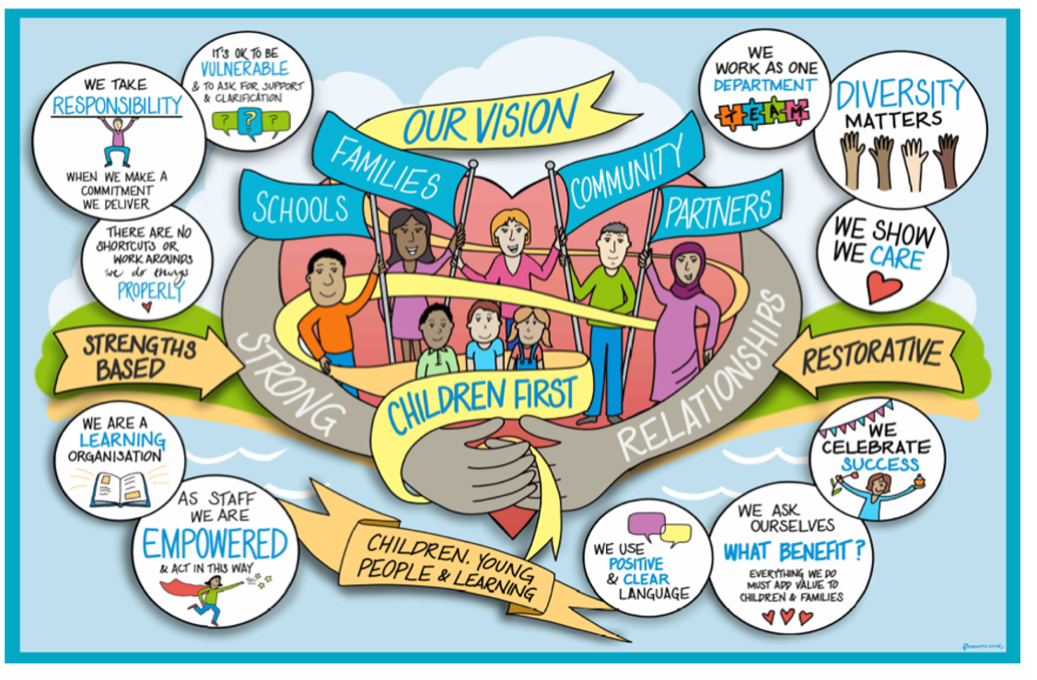

Permanency Planning Practice Guidance

Index | Subject | Page
 | Contents | 1
1. | Introduction | 2
2. | Key Objectives in Permanence Planning | 2
3. | When Does Permanence Planning Start? | 2
4. | Options for Permanence | 2
5. | Timescales for Permanency Planning Meetings | 8
6. | Permanency Planning Meetings | 8
7. | Second Statutory Case Review | 9
8. | Final Care Planning Meeting | 10
9. | Permanency Panel | 10

- Introduction
The aim of this practice guidance is to assist the Children's Social Care teams with the requirements and process when looking at permanency planning for Children. Permanence is the term used to define the long-term plan for a child’s upbringing. It provides an underpinning framework for all social work with children and their families from family support through to adoption. It aims to ensure a framework of emotional, physical, and legal conditions that will give a child a sense of security, continuity, commitment, identity and belonging throughout their childhood into their adult life.

- Key Objectives in Permanence Planning
The objectives of planning for permanence are to ensure that children have a secure, stable, and loving family to support them through childhood and beyond. Giving them a sense of security, continuity, commitment, identity and belonging. It is also important to remember that older children and young people also need to achieve permanence in their lives although they may not wish (for a variety of reasons) to be in a foster home or to be adopted.

Permanency planning should consider the child’s permanence plan and how we are working towards accomplishing this plan. The purpose a Permanence Planning meeting is to review a child or young person’s permanence plan, consider the steps that are being taken to achieve the proposed plan, to ensure parallel planning is in place until permanence has been attained and any barriers to achieving this plan so that actions can be implemented in a timely manner.

- When Does Permanence Planning Start?
Permanence Planning should start immediately a child is referred into Children’s Services, during the initial assessment process and beyond. Early permanency planning is essential for all children to avoid drift and ensure that children have the opportunity of reaching their full potential from a safe and secure base whether this is inside or outside of parental care.

Every child we care for, including those accommodated under Section 20 arrangements, will have a care plan, and by the second statutory review, this should outline plans for permanence. It is important to note that this plan may be a parallel plan for permanence and as such any permanence plan should capture a child’s primary permanency plan and a contingency plan.

- Options for Permanence
Placements under section 20 legal status can include: short-term respite or short-break care, therapeutic placements, residential and assessment units, secure units, homes of family members, parent and child foster placements, foster care and fostering-for-adoption placements. However section 20 is not typically considered a long term permanence plan and consideration should be given to whether a legal order is required to safeguard the welfare of the child. Other Permanence Options are:

Remaining at home/ Reunification home
The Children Act 1989 requires that all reasonable efforts are made to ensure children remain with or return to the care of a birth parent wherever possible. Staying at home offers the best chance of stability. Research shows that family preservation has a higher success rate than reunification. This of course has to be balanced with risk of harm to the child or young person.
No Order Principle | This should always be our primary plan for children and young people if it is safe for them if it is safe for them to live with one or both parents.
Child Arrangement Order | This order regulates with whom a child is to live, spend time or otherwise have contact with. This is usually granted when a child is to reside with one of their parents or a family member where parental responsibility is retained by the parents and shared more equally with those set out in the order.
Supervision Order | The Supervision Order requires the local authority to 'advise, assist and befriend' the child who will be living at home. This is usually under a ‘Child in Need’ plan but may also be under a Child Protection Plan if safeguarding concerns are raised. It may require a child to live in a specified place, do certain activities and report to a particular place at a set time.
Care Order | In some instances, it may be appropriate and safe for a child to return home following intervention with the family. In these instances, a Placement with Parents Assessment should be carried out and ratified by Permanence Panel prior to the child returning home. These arrangements are reviewed at a minimum of 3 monthly before seeking to discharge the Care Order.
Living with Friends/relatives carers
Where a child cannot live with birth parents, the preferred options under The Children Act 1989 is to seek a home for them with extended family, where this is consistent with their welfare. Existing positive relationships will contribute to provide the continuity that a child needs. Relative/friend carers need to be approved as foster carers if a child is remaining a child we care for (LAC).
Child Arrangement Order | This may be appropriate in determining the living arrangements for a child. A Child Arrangement Order may be sought for a parent, family member or friend in order to maintain strong links and shared parental responsibility with the child’s parent/s.
Special Guardianship Order | Special Guardianship Orders can offer children who are unable to return to live with their birth parents a firm foundation for a lifelong permanent relationship between the child and their family member or friend whilst preserving the basic links between a child and their parent/s.
Care Order | In some instances, it might be agreed that the child and family continue to require intervention and support from the local authority. In this case the family member or friend may become an approved Foster Carer and as such the child’s care plan becomes long-term fostering with relative or friend. This long-term fostering permanence plan will need agreement at Permanence Panel.
Living with a Foster Family - Long Term Fostering
This can provide a supportive relationship and adult attachment for a child but can also allow attachments to parents and the child’s wider family to continue, where this has been assessed to best meet the child’s life-long needs. Where the permanence plan for the child is longer-term foster care, this may be where the current short-term foster placement is assessed to meet the long term needs of the child for permanence or where a new placement is identified for a child as a result of an assessment and matching process.

This option has proved to be particularly useful for older children who retain strong links to their birth families and do not want or need the formality of adoption or special guardianship and where the carers wish for the continued involvement of the local authority.
Section 20 | Under section 20 of the Children Act 1989, a child or young person may be accommodated by the local authority where there is agreement to this arrangement by those with Parental Responsibility. The local authority must not use Section 20 as a prelude to care proceedings on a long-term basis where there are concerns about significant harm for the child. It may be appropriate to continue with Section 20 accommodation, if, for example parents indicate their consent will be forthcoming and they have no intention of requesting their child returns back to their care.  The “No Order Principle” guides decision making in this area, by stating that an order should not be sought where parents give their consent, however this has to be balanced against what is right for the child. If the young person is likely to remain in care long term, the Local Authority should consider whether it is in the child’s best interests to share Parental Responsibility with the birth parents and thus seek a legal court order.  However, if seeking a legal court order is not deemed appropriate or proportionate for the child and they are unable to reunify with their family or friends, permanence may be sought with a foster family.
Care Order | Children should be cared for in long-term foster care when this is deemed to be in their best interests and is set out clearly in their care plan.  Long-term foster care should mean that the care plan for the child is to remain in a specific fostering placement, usually throughout childhood until the young person leaves care and an aspiration that the relationships between the child and the foster family may endure into adulthood and indeed throughout life, on the basis of voluntary mutual attachments.  One of the key advantages which long-term foster care can offer is respect for the continuing role of the birth family, and support for the child to maintain a relationship with their birth family unless this is considered detrimental to the child’s interests.  Children who have been living with a foster family for significant periods of time with no permanence planning should not be confused as long term fostering. Permanence with a specific foster family can only be agreed by Permanence Panel following the making of a Care Order.
Living in a residential provision
Residential provisions should largely be used as short-term interventions to promote a child or young person getting ready to reunify home or step across into a foster family setting. However, for a few children, a home within a residential setting until independence will be the placement option that best meets their needs. Where this is the identified aim of the child’s agreed Care Plan, the plan must address how the child’s needs for secure attachment to significant adults will be achieved and supported.
Section 20 or Care Order | For some young people a sense of permanence and positive transition to adulthood can best be achieved by a residential care placement. This is particularly relevant to those young people who are unable to live with their parents for a variety of reasons nor do they wish to be living in a foster home or to be adopted. For these young people a therapeutic residential provision that can offer stability, a sense of permanence and community membership whilst supporting their family membership, identity and supporting them to make sense of their journey into care can be more beneficial then joining a foster family environment.  Although they will remain a minority, there are children and young people whose needs for a sense of permanence, and their own wishes, can best be met by a longer stay placement in a children's home in which they can put down roots and which will provide continuity of relationships and a sense of community as they move into adult life.
Adoption
Adoption can offer children who are unable to return to their birth families a legally permanent new family to which they will belong all their lives. Adoption is therefore an important means of securing permanence for children. Research strongly supports adoption as a parallel consideration and as a main factor contributing to the stability of children, especially for those under younger children who cannot be reunified with their birth or extended family.

Family finding should begin as soon as adoption is under consideration and following the Agency Decision Maker deciding that the child should be placed for adoption, or a placement order is made.

For some children, Foster to Adoption arrangements are a means of securing early permanence for children where they are unlikely to reunify with their birth or extended family and adoption is the only other parallel plan.

- Timescales for Permanency Planning Meetings
Event | Timescales
Children new into care | - First Permanency Planning Meeting to be held within 4 weeks of entering care.  - Frequency of review PPMs is then determined by the placement and legal status.
Child becomes subject to Care Proceedings | - Initial Permanency Planning Meeting to be held within 3 weeks of the Initial Court Hearing/ Case Management Hearing  - Progress towards permanence plan should be reviewed in Supervision.  - Review PPM to be held if change of care plan or care proceedings extends over 26 weeks and a Final Care Planning meeting has not taken place.
Child becomes a child we care for under S20 arrangements | - Initial Permanency Planning Meeting to be held within 4 weeks of child becoming subject to Section 20. This PPM must be held prior to the Second Child Looked After Review, or at change of care plan/placement.  - Child should be presented to Entry to Care panel.  - There should be an Entry to Care Panel review if the s.20 arrangement lasts more than 12 weeks.  - Review PPMs to be held every 12 months to refresh consent and to consider steps towards reunification or permanence. This meeting should be held prior to Children we Care For Reviews unless attendance at Permanence Panel or Head of Service has agreed a different reviewing frequency which should be clearly recorded on file.
Unregistered Placements | - Initial Permanency Planning Meeting to be held with 7 working days of child moving to placement.  - Review of this arrangement undertaken by Head of Service weekly until change of care plan/placement or until placement is regulated.
Unapproved Placements | - Initial Permanency Planning Meeting to be held with 7 working days of child moving to placement.  - Review of this arrangement to be undertaken in line with the timescales set out in the Assistant Directors sign off/approval of the placement.
Remanded to Local Authority Care | - Initial Permanency Planning Meeting to be held within 4 weeks to consider whether child will be returning home if released or will require a placement.
Secure Accommodation | - Permanency Planning Meeting to be held at the point that exit is being planned.
Child subject to Care Order or agreed s.20 arrangements living in a foster family – not long term agreed | - Review Permanency Planning Meeting to be held within 4 weeks of Care order being made.  - Review PPMs to be held at a minimum of every 3 months, prior to CWCF reviews until such a time that Permanence with the foster family is agreed at Permanence Panel.  - A review PPM may be arranged earlier if a change of care plan/ placement occurs.
Child subject to Care Order or agreed s.20 arrangements living in a foster family – long term fostering arrangement agreed | - A Review Permanency Planning Meeting to be held where a significant change of care arrangements occurs.  - A Review Permanency Planning Meeting could also be held if the young person is expressing a wish to reunify with family or to explore alternative care arrangements.
Child subject to a Placement Order | - Review Permanency Planning Meeting to be held within 4 weeks of Care order being made.  - Review PPM to be held every 12 weeks, or at change of care plan/placement until a child is matched with their adoptive carers.
Child subject to Care Order or agreed s.20 arrangements living in a residential | - Review Permanency Planning Meeting to be held within 4 weeks of Care order being made.  - Review PPMs to be held at a minimum of every 6 months, prior to CWCF reviews to consider readiness to step across with Commissioning and Placement Finding Team.  - A review PPM may be arranged earlier if a change of care plan/ placement occurs.  NOTE: Semi-independent and supported lodgings arrangements should follow the entry to care route and be reviewed within pathway planning.
Child subject to Care Order but Placed with Parents | - Review Permanency Planning Meeting to be held within 4 weeks of Care order being made.  - Placement with Parents assessment should be completed on mosaic and discussed at Permanence Panel.  - Review PPMs to be held every 6 months, or at change of care plan/ placement until the order is discharged.

In addition to the above timescales, a review permanency planning meeting should be held if there has been any of the following:
- A change of placement
- A significant change of circumstances
- Delay or drift is identified, and proceedings are going to be extended beyond 26 weeks
- Assessments have identified new information that impacts of parallel planning
- A change of care plan is required – for example, consideration of revoking a placement order is required or alternative permanency option needs to be considered.

- Permanency Planning Meetings

The Initial Permanency Planning meetings for children new into care will be chaired by the Team Manager or Advanced Social Worker from the Permanence Team. Subsequent Permanency Planning meetings should be progressed via the Social Worker and Team Manager. The Team Manager retains case management and must oversee and agree any recommendations made if a Permanency Planning meeting is chaired by an Advanced Social Worker from the Permanence Team.

Key membership to attend the Permanency Planning Meetings | Team Manager/Advanced Social Worker, Permanence Team (chair), Allocated Social Worker, Supervising Social Worker or Manager of Placement Provision and Conference and Reviewing Officer (CRO).  Foster Carers, SGO/Connected Carers Assessor, Adoption Southeast, Virtual School, CAMHS and Children’s Guardian.
If appropriate/required:  Foster carers | The current carers for the child should usually be invited. If it is not possible for them to attend, it is essential that their feedback is provided to the chair through a brief written report. It may be necessary to hold the meeting in two parts if the professionals involved need to discuss the capacity of the current foster carers to permanently care for the child. A decision needs to be made about how the decision is then discussed with the carers in a fair and transparent way.  The social worker must be clear with the foster carers that the Permanency Planning Meeting is not a matching meeting. It is to consider the child’s permanence plan and any barriers to achieving this. When all are in agreement to permanence being sought with current carers then this is explored within the meeting and captures how the carers can meet the child’s needs.
SGO/Connected Carers Assessor | For all children and young people where SG/ Connected Carers Assessors are undertaking an assessment they should be invited to attend the meeting. Where they are unable to attend, a brief update should be provided to the chair of the meeting.
Adoption Southeast | For all children where adoption is one of the parallel plans, Adoption Southeast Duty Social Worker should attend.  If the current care plan is unknown, then Adoption South East should be notified of all children under the age of 10 where adoption is a likely plan.
Children’s Guardian | Where appropriate the Children's Guardian should be invited as an observer.
Virtual School, CAMHS | Where education or mental health services are likely to be causing barriers to achieving permanence the relevant representative should be invited.

A permanence planning meeting is a professionals meeting to ensure:

- Timely planning takes place avoiding drift and delay;
- Contingency options are actively being pursued;
- Previous actions have been carried out;
- Placement planning is realistic;
- Likely placement needs are identified early on so that placement commissioning/finding activity is informed;
- Placement support needs are identified;
- Decision to make an application to apply for early family finding court permission must be considered both for adoption and permanent fostering

Where children are accommodated under Section 20 of the Children Act 1989, consideration will need to be given as to how Permanence will be achieved within the existing partnership arrangements with the child’s parents as the current holders of Parental Responsibility, in line with Section 20 guidance.

The Permanence Planning Meeting will produce a Permanence Plan (incorporated into the Care Plan) that is presented to the child’s first, or at the latest the second, Children in Care Review. It is an expectation that the Permanence Plan includes one or more /parallel contingency plans. The social worker must ensure that the parents are informed of the reasons why more than one plan is being made to meet the child’s needs and prevent unnecessary delay.

The Permanence Plan must be updated, following a Permanence Planning Meeting, where clarity is reached around which option is most likely for a child. This needs to be reflected in the Care Plan. If there is a significant change in the overall Care Plan, this must be communicated with the Conference Reviewing Officer and may trigger a Children We Care For Review.

The need to focus on Permanency planning is paramount where a child’s legal status remains undetermined and the decision to remain in the UK is outstanding. Children and young people who arrive in the country and meet the status of UASC will be subject to permanence planning, however this is approached with an understanding that any permanence plan will need to consider the legal complexities around the settled status of the young person. Like all Children We Care For, our unaccompanied asylum seeking children require a clear Permanency Plan prior to the second Children We Care For Review which will need to be endorsed by the Conference and Reviewing Officer. These plans should be discussed and reviewed in supervision with the Team Manager.

For unaccompanied asylum seeking young people who are living in foster families their permanence plan should consider the appropriateness of agreeing the arrangement as their long term foster family until their 18 or their settled status application is resolved. When seeking to ratify foster families as a long term arrangement for unaccompanied asylum seeking children, a Permanence Planning Meeting Episode should be completed to capture the needs of the child and an overview from the Supervising Social Worker as to how the carers are able to meet the needs of the child, using the secure base headings. This will then be reviewed by Permanence Panel.

7. Second Statutory Case Review
By the time of the Second Child’s statutory Review at the latest, a child must have a Permanence Plan (incorporated into the Care Plan), which must be presented for consideration at the review. The review will consider the Permanence Plan as part of the Care Plan and ensure that this can meet the child’s needs for permanence within realistic timescales. It is good practice for a primary permanence plan to be presented at the child’s first Statutory Case Review and we should aim for this to take place as often as possible.

If assessments have not been completed in time for the second Review, or another option for the care of the child emerges at a later stage of the planning process, a further Review should be convened by the child’s Conference Reviewing Officer (CRO) once the outcome is known, in order that the plan may be discussed and agreed as appropriate.

8. Final Care Planning Meeting
A Final care planning meeting should take place in all cases, where the Head of Service ratifies the plan for the child, before the Final Evidence is filed. Legal advice should be available. The CRO view must be given due consideration during the decision-making process. If the primary permanence plan is Adoption, this meeting must take place before the ADM decision made (also known as SHOBPA -Should be placed for adoption) to inform the Agency Decision Maker’ that Adoption is considered the right permanence plan.

A Final Care Planning meeting must set clear timescales to review the planning. For example, if Adoption has been identified as the best option for the child, but this cannot be realised, timescales must be set to review and robustly pursue secondary planning in the child’s best interests. A review final care planning meeting must be convened if there is significant delay or information available which changes the care plan or if there has been additional reports which indicate alternative must be considered.

9. Permanency Panel
The function of this panel is to:
- Ensure that children's permanence plans are progressed with the pace and urgency that is needed to ensure that our children and young people are living with carers who love, support, care and respect them and who will do so throughout their children into adolescence and adulthood.

The purpose of the panel is to review and have oversight of children’s proposed permanence plans, discuss and ratify decisions in order to achieve permanency in a timely manner. The Permanency Planning Minutes act as the referral form for Permanence Panel. Please see Permanence Panel Practice Guidance for more information about its functions and purpose.

Review / Contacts / References
Document title: | West Sussex Practice Guidance: Permanency Planning
Date approved: | 13.4.2023
Approving body: | Policy & Practice Steering Group
Last review date:
Revision history:
Next review date: | April 2025
Document owner: | Linda Steele Assistant Director Safeguarding and QA
Lead contact / author: | Kelly Steele, Service Manager Permanence

