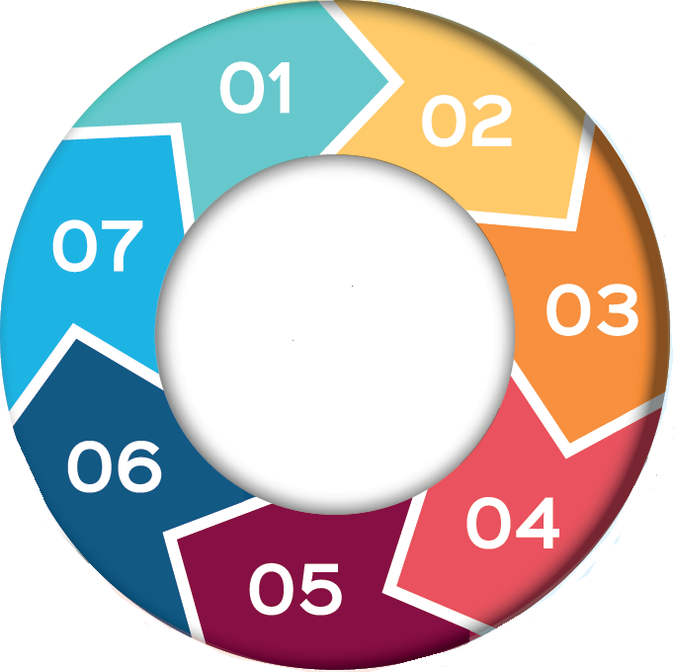

**2. How does it work?**

**CP-IS links IT systems across health and social care via a child’s NHS number (or birth mothers NHS number for unborn children).**

**CP-IS is updated automatically every 24 hours.**

**A CP-IS alert remains in place for 364 days after CPP or Looked After status ends. Notifications for children who no longer have a social worker are reviewed via MASH.**

**For CP-IS to work NHS numbers MUST be recorded on Carefirst files.**

1. **What is CP-IS?**

**The Child Protection- Information Sharing System (CP-IS) shares information securely between health and social care about children who are subject to Child Protection Plans (CPP) or who are Children Looked After.**

**CP-IS tells health professionals if a child has a CPP or is Looked After and notifies social workers when a child attends an unscheduled healthcare setting.**

**CP-IS is a national system across all Local Authorities and unscheduled care settings in England. information when a child is out of area.**

**Background**

Cannabis is a hallucinogenic drug. It is also known as weed, hash, marijuana and pot. Cannabis can be taken in a variety of ways; smoked mixed with tobacco in a cigarette or bong, mixing into edibles such as cake or sweets or vaped.

The strength of cannabis on the market has increased significantly over the past 20 years**.**

The effects of cannabis can vary widely, some people feel relaxed, happy and giggly, others feel paranoid, anxious or confused.

abis on the market has increased significantly over the past 20 years**.**

The effects of cannabis can vary widely, some people feel relaxed, happy and giggly, others feel paranoid, anxious or confused.

abis on the market has increased significantly over the past 20 years**.**

The effects of cannabis can vary widely, some people feel relaxed, happy and giggly, others feel paranoid, anxious or confused.

Howew

**7. Importance of NHS Numbers**

**The child (or pregnant mothers) NHS number must be entered on the child’s CareFirst record by the social worker for CP-IS to create an alert.**

**If a child who is known to have a CPP or to be Looked After doesn’t have an appropriate alert on CP-IS, the health professional should contact the social worker, providing the child’s NHS number, and requesting that this be added to CareFirst as a matter of urgency.**

.

**Watch** : [Child Protection - Information Sharing service - NHS Digital](https://digital.nhs.uk/services/child-protection-information-sharing-service)

**CP-IS does not replace usual safeguarding processes, such as MASH referral**

**CP-IS**

**6. How does this work for Unborn children?**

**CP-IS provides alerts for unborn children who have a CPP plan. These are recorded on CP-IS under their mother’s NHS number.**

**When the baby is born, this must be updated on CareFirst to the baby’s NHS number.**

**5. What does this mean for social workers?**

**The social care team is automatically notified that a child who has a CPP or is Looked After has attended an unscheduled care setting.**

**No clinical information or reasons for the visit are shared via CP-IS.**

**The child’s social worker must review each notification and contact the appropriate health setting to gather further information and record this on Carefirst.**

**4. What does this mean for health professionals?**

**CP-IS should be checked whenever a child/pregnant woman attends an unscheduled care setting.**

**CP-IS will tell the health professional whether the child has a CPP or is Looked After and provides the contact details of the social care team.**

**If the health professional has concerns about the visit, direct contact should be made with the social worker to share appropriate information.**

**3. What health settings use CP-IS?**

**CP-IS is currently in use in unscheduled care settings:**

**A&E departments,**

**Maternity services,**

**Out of Hours GP services,**

**Urgent care units**

**Paediatric wards**