Children’s Disability Resource Panel
Terms of Reference
Jan 2023

Contents
- 1. Purpose
- 2. Principles
- 3. Panel Process
- 4. Tier 1
- 5. Tier 2
- 6. Tier 3
- 7. Panel Members
- 8. Panel Chair
- 9. Case Presenters
- 10. Quoracy
- 11. DRP Requests
- 12. Contingency Planning
- 13. Funding
- 14. Panel Administration
- 15. Review
- 16. Appendix One

Purpose
The purpose of the Panel is to provide an opportunity for multi-agency partnership working to agree individual care packages to achieve outcomes identified following an up-to-date assessment of the child/young person’s needs.
The Panel will give due consideration to a child’s health and well-being and ensure children with profound and complex disabilities or health needs receive co-ordinated, high quality child and family-centred services.
The Disability Resource Panel will have a number of functions relating to the allocation of resources. The Panel will agree how funding would be split if bi-partite (usually between Health and Social Care). The Panel also ensures that funding is monitored in line with the budget, and that the social care package is based on child’s assessed needs.

Principles
- For children and young people to be cared for wherever possible within their family and community.
- To be safe, enable access and inclusion and to have opportunities to achieve identified outcomes
- Outcomes and strength-based planning, to ensure we are clear about the education, health and care outcomes being worked towards.
- Early identification and clarity of what will improve arrangements for a child or young person.
- Flexibility, to ensure a focus on the best intervention to achieve the right outcomes for the child or young person.
- Preparation for adulthood.
- Regular reviews where children will be brought back to Panel to ensure outcomes are being achieved, at least annually in line with the child/young person’s date of birth.
- Where additional resources are identified as needed, these will be given due consideration by the budget holders and final decisions as to funding the package of care will be made as appropriate.
- All agencies will act in the best interests of the child, recognising their responsibilities for children with complex needs and children in care.
- The Panel will ensure that the agreed placement or resource is value for money in delivering outcomes.
- Placements are expected to be at an Ofsted rating of Good or above or CQC approved.
- The Panel will ensure a joint approach to managing risk.

Panel Process - DRP is split into 3 tiers depending on the costs and complexities of the care package. (You can refer to the flowchart in Appendix One 16.5, page 10)

Each DRP panel will occur every 2 weeks to ensure prompt agreement of care packages. Allocated workers should speak to partner agencies and providers prior to creating the care package to present to DRP.

Tier 1
  - Chaired by Team Managers, these meetings will be held every 2 weeks. Team managers will present these cases to each other so that there can be healthy oversight and challenge to ensure consistency across the service. These cases will not involve seeking funding from health/ education.
  - The package cannot be agreed until all team managers in attendance have agreed that this is the right care package for the child to meet the child’s needs. The team manager must have had supervision/ case reflection with the social worker prior to attending this Panel so that they are able to present and answer any questions asked. Where the team manager/practitioner is unable to attend due to court, annual leave or sick leave, then a nominated colleague will need to attend and present the case in their absence to prevent delay in the package being agreed.
Tier 1 | Membership
Chair | Team Managers (minimum of 2)
Required | Finance Representatives
Required | Panel Administrator

Tier 2
  - Chaired by Service Managers, where possible the health/education cases will be heard first. The Panel will be held every 2 weeks, but the intention will be that the first panel will be for joint funding care packages, and the second will be social care only packages. This will reduce the need for partner agencies to attend DRP every 2 weeks and takes into account their need to also attend the Joint Commissioning Panel.
  - For Tier 2, the practitioners accompanied by CWD team manager must attend the DRP and present the case and why they endorse the proposed care package, based on the child’s needs. Where the practitioner is unable to attend due to court, annual leave or sick leave, the manager or nominated colleague will need to attend and present the case to prevent delay in the package being agreed.
Tier 2 | Membership
Chair | Service Manager
Optional | Transitions Development Manager
Required | Senior Commissioner Clinical Commissioning Group
Representation from | Gateway to Resources Head of Service, Specialist Lead Continuing Care,
Required | Finance Representatives
Required | Panel Administrator

Tier 3
  - Chaired by Assistant Director and Service manager can deputise , where tri-partite funding is required, the care package will be agreed at tier 3 and will then be presented at Joint Commissioning Panel for the tri-partite funding to be agreed.
  - Where the Assistant Director for CWD is unable to chair the panel meeting this can be delegated to the service manager however they can only agree financial limits within their delegated authority .
  - Whilst DRP can agree the costs and the care packages, the Joint Commissioning Panel must agree how these costs are split between health, education and social care in relation to tri-partite funding. Business support will be expected to book the DRP Tier 3 and Joint Commissioning Panel (JCP) at the same time and as close together as possible to prevent any delay in decision making. DRP must be held first.
  - For Tier 3, the practitioner will need to present the child’s needs to the DRP so that they are able to answer any questions asked. The DRP paperwork must have the rationale and endorsement of the team manager and service manager before this will be heard at panel. Where the practitioner is unable to attend due to court, annual leave or sick leave, the team manager or nominated colleague will need to attend and present the case to prevent delay in the package being agreed.

Tier 3 | Membership
Chair | Assistant Director
Required | Service Manager (alternate)
Optional | Transitions Development Manager
Required | Senior Commissioner Clinical Commissioning Group
Representation from | Gateway to Resources Head of Service Specialist, Lead Continuing Care, SEND area manager (to be invited for discussion where education provision is an issue)
Required | Finance Representatives
Required | Panel Administrator

Panel Members
Panel members are expected to read Panel papers before the meetings and to communicate Panel decisions and actions to be taken where appropriate to their teams/colleagues. Where members of the Panel cannot attend, every effort should be made for a substitute to attend.

Panel Chair
The role of the Panel Chair is to reflect the views expressed and reach a conclusion on whether the recommendation is accepted or whether the application should be referred back for further evidence.

Case Presenters
Case presenters are to complete the required documentation in time and for it be quality assured and evidence management rationale in support of the care package and submit to the Panel administrator by required deadline.

10.Quoracy
The Panel will be quorate provided there is sufficient agency representation and those with delegated authority to make budgetary decisions and if not quorate rather than cancel the panel cases will be discussed and then ratified by the missing agencies.

11. DRP Requests
All children will be brought to DRP, two months prior to the child/young person’s birthday. In order for this to occur, a C&F/Short Break assessment will be initiated 4 months prior to the child/young person’s birthday. For packages below 75 k DRP frequency can be reduced to two years ie the package must be presented every 2 years for renewed financial authority . The expectation of these packages is that they will be overseen by the CIN process and an annual updated CFA . Packages of care where there are issues of concern or regarding tripartite funding can be bought back as required for a discussion at DRP . Packages of care that are over 75k will be bought back to DRP on an annual basis with an updated CFA .

The purpose of the C&F assessment is to assess the child’s need, it should be holistic and include any siblings and parents/carers needs. As part of all C&F/short break assessments the practitioner is expected to liaise with both SEND and Health to ensure that assessments are holistic and reflect partner agencies assessments, views and packages. All care packages must be agreed by management and presented at the appropriate DRP. DRP can only be booked with team manager agreement and should be evidenced on the DRP form. This provides a clear line of responsibility and accountability and provides quality assurance of the proposed care package.

In exceptional circumstances a care package can be agreed ‘outside of panel’, however this should not be because there has been a failure to either

- complete the C&F assessment or book the DRP.

Practitioners and team managers are expected to ensure that

- C&F/Short Break assessments are scheduled 4 months before the child/young person’s birthday.
- the child/young person is presented at DRP 2 months prior to their birthday.

What packages of support do I need to take to DRP?
- All new packages of care or where it is being proposed for the package to increase.
- All requests for accommodation (S.31/S.20)- Tier 3. (after attending High Risk Panel)
- Requests to spot purchase residential accommodation- Tier 3.
- Requests for fostering placements – in and out of County- Tier 3.
- Complex multi-agency cases where there is or will be a need for joint funding of the support package - Tier 2 or 3.
- Requests for OT Adaptations that exceed the DFG (Disabled Facilities Grant of £30,000) - Tier 3
- All Requests for Residential Short Breaks- Tier 1 or 2

Contingency Planning
  - All DRP care packages should be presented with a contingency plan. If after 3 months we are unable to source the provider, the team manager can agree to the contingency plan being implemented. If the contingency plan is implemented, this does not mean we should stop searching for a provider as per the original plan. The care package will need to return to DRP within 3 months of any contingency plan being implemented.
  - The team manager is expected to record the contingency plan clearly with rationale on the child/young person’s file and is expected to track and ensure a pro-active approach is taken to fulfilling the original plan. When the care package returns to DRP due to the contingency care package being activated, the team manager will need to evidence the efforts made and being made to implement the original plan. DRP will then make a decision as to the care package going forward.

13. Funding
DRP decisions will remain agreed for one year, so any requests for payment within that twelve-month time frame are agreed, as per the DRP decision.
The care package must be reviewed annually, in line with the Child & Family/Short Break. It is possible where the needs of the child have not altered that the return to DRP is simply to confirm that there is no change in needs and therefore the request will be for the care package to continue unaltered.
The care package must include costs beside each part of the care package to reflect the weekly and monthly costs, as well as a final total amount. The care package must relate to the child/young person’s needs. If it is unclear how the care package relates to the assessed needs, the care package will not be agreed.
Funding disputes will be addressed and agreed at the Panel with further escalation through corresponding organisations where required.

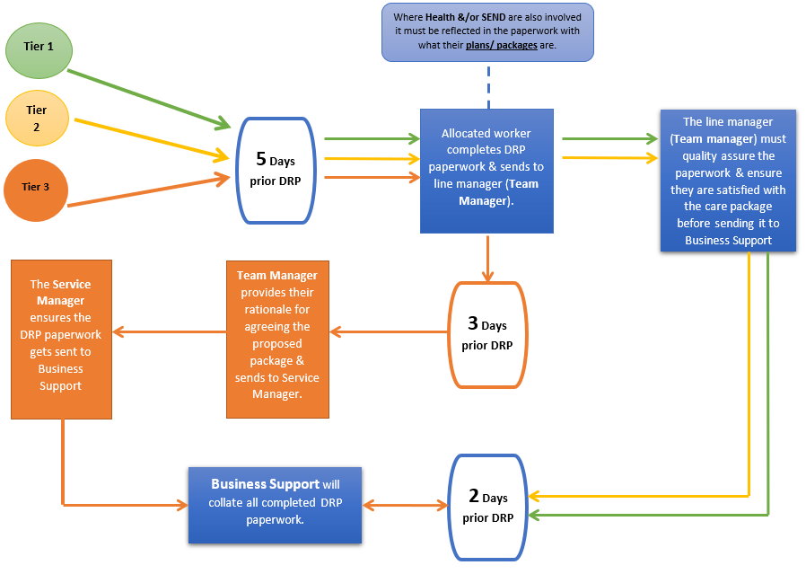
14. Panel Administration (See timelines below to consult business support/Panel Administrator)

The Team Manager must make it clear what DRP Tier the child needs to be heard.

  - Where the team manager does not agree with the proposed care package, a discussion with the worker making the request needs to occur and the package reviewed. The child cannot be presented to DRP until the proposed package is agreed by the team manager a clear rationale as to how the care package would meet the child’s needs.
  - The DRP currently takes place fortnightly, and tiers are co-ordinated so that they occur at different times. Maximum duration of Panel meeting is 3 hours and should include a 10-minute break.
  - The Panel Administrator will minute the meetings, this should capture an overview of the discussion and any decisions. The minutes are reviewed, agreed, and authorised by the Panel Chair.
  - The Chair will decide in conjunction with DRP members when a support package will be reviewed when the package is agreed. All children will have an annual review of their needs when the C&F/Short Break assessment is reviewed, and this should shape the care package.
  - Parents, carers, child/young person, should be informed of the decision within 5 working days in writing by business support. The letter should include information relating to the care package and the necessity to review all service provision, at a minimum of 6 monthly intervals.
  - There is no reason why the allocated worker cannot inform the parents as soon as the DRP case note is recorded on LCS. Management oversight needs to be added to LCS to reflect the decision made and the rationale behind that decision within 48 hours.
  - Business support will maintain an action tracker to ensure that any cases that need to return does so in a timely way.
  - The DRP business support administrator will invite you to the review through a calendar invitation at least 8 weeks before you are required to attend. You will be required to complete the DRP form at least 5 working days in advance of the DRP date and send to your line manager. The team manager will need to consider the proposal and add clear rationale to their decision based on the child’s needs. The DRP form must be returned to business support 2 days prior to the DRP.

15. Review
These terms of reference can be reviewed and updated at any Panel meeting. They must be considered by Panel members at least once every 12 months.
Next review by January 2023

16. Appendix One

16.1 Confidentiality

The professional support network around the child/young person as part of their due processes will already have sought permission from children, young people and families to share information and have applied appropriate information sharing protocols and comply with current legislation, regulations and statutory guidance.

The business discussed at DRP is confidential in nature. As such all details will remain confidential and are only to be shared with those with a legitimate interest in an individual case.

16.2 Conflicts of Interest
Conflicts of interest should be openly declared and revisited regularly. Where a clear conflict of interest arises, then it may be appropriate for members to withdraw from part of the meeting and come back after the relevant agenda item has been discussed.

16.3 Equality & Diversity
It is recognised that children and young people have individual needs and will work in a way which allows for individuality to be recognised and promoted.

16.4 Dispute Resolution
The Panels adheres to a culture of joint problem solving and partnership working whereby dispute resolution should seldom be required. Funding disputes will be addressed and agreed at the Panel with further escalation through corresponding organisations where required.

16.5 Panel Process- Flowchart

