**Dudley Safeguarding and Review Service**

**Independent Reviewing Officer**

**Practice Standards**

|  |  |
| --- | --- |
| **Contents** | **Pages** |
| * **Scope and Introduction**   **“Listening and working Children is at the heart of all we do”** | **2-3** |
| * **Our commitment to Restorative Practice within the Safeguarding and Review Service** | **3** |
| * **The principles underpinning our work and**   **Restorative Practice** | **3-5** |
| * **The IRO’s commitment to working in a participatory way** | **4 - 5** |
| * **The role and responsibility of Independent Reviewing officer** | **5** |
| * **The purpose of Child In care review** | **6 – 7** |
| * **Notifications and Planning** | **7 - 8** |
| * **Documentation: Importance of Sharing with children and parents** | **7** |
| * **Invitations and the child’s participation** | **7** |
| * **Frequency and timings of reviews** | **8 – 9** |
| * **Process for Cancelling Review Meetings** | **9 – 10** |
| * **Reviews in particular circumstances (adoption, secure, remand, pathway reviews)** | **10-13** |
| * **Dispute Resolution and Progress Reviews** | **13 - 14** |
| * **Quality Assurance of the Safeguarding and Review Service** | **14-16** |
| * **Appendix 1 Children In Care Review Process chart** | **16-17** |
| * **Appendix 2 - Child In Care consultation** | **18** |
| * **Appendix 3 - Child’s information booklet on role of their IRO** | **18** |
| * **Appendix 4- Role of the Social worker in Child in Care Review** | **18 - 19** |

**Introduction**

This document sets out the responsibilities the of the local authority regarding the Child in Care Statutory Review process.

The procedure relates to all children and young people in the care of Dudley Local Authority whether in a family placement, (including those subject to Care Orders at home and those placed for adoption); residential care; children within the Youth Justice System; children subject to Secure Accommodation Orders; and (under specific circumstances) children admitted to hospital.

Our practice standards reflect our commitment to our children and young people to deliver the best service from the Independent Reviewing Officer, regarding all aspects of quality assurance, care planning and the review process within the safeguarding and review service.

This document outlines how the Safeguarding and Review Service will work together with children, families, partner agencies and the Children’s Social Work teams to enable children, young people, and their families/carers to reach their full potential. Our promise to our children is to ensure all children and young people have a choice, a right to be heard and remain at the heart of all we do.

**Introduction – Related legislation:**

The Safeguarding and Review Service is set within the legal framework of the [**Independent Reviewing Officer (IRO) Handbook (Department for Children, Schools and Families, 2010),**](https://assets.publishing.service.gov.uk/government/uploads/system/uploads/attachment_data/file/337568/iro_statutory_guidance_iros_and_las_march_2010_tagged.pdf)The Children Act 1989, and the[**Care Planning Regulations and Guidance (2015**](https://assets.publishing.service.gov.uk/government/uploads/system/uploads/attachment_data/file/441643/Children_Act_Guidance_2015.pdf)**) and** [**Working Together to Safeguard Children (2018**](https://assets.publishing.service.gov.uk/government/uploads/system/uploads/attachment_data/file/779401/Working_Together_to_Safeguard-Children.pdf)**)** statutory guidance. The responsibility of the Independent Reviewing Officer (IRO) includes regular monitoring and follow-up between formal reviews.

The Safeguarding and Review Service is committed and has a strong focus on positive outcomes for children and families and holding agencies to account for their contribution towards these outcomes.

All children and young people, and their families and carers, have the same right to protection, respect, and rights, regardless of age, disability, gender reassignment, race, religion or belief, sex, or sexual orientation. The Service aims to identify any additional needs of children from minority ethnic groups and children with disabilities, and seek to reduce the barriers they may face, especially around communication, in their day to day lives and in reviewing their care plans.

**The principles underpinning our work:**

These principles complement those set out in Dudley’ Practice Framework:

* The child’s welfare must be paramount, and this overrides all other considerations.
* Children have the right to be heard, to be listened to and to be taken seriously. Taking account of their age and understanding, they should be consulted and involved in all matters and decisions which may affect their lives.
* Parents/carers have a right to be consulted and involved in matters which concern their families.
* All agencies supporting children in care must work together in the best interests of children and their families.
* Each agency must have an understanding of each other’s professional values and accept their respective roles, powers, and responsibilities.

The Safeguarding and Review Service Manager is responsible for ensuring that there are policies in place to ensure the quality-of-service delivery. This should include obtaining regular and routine feedback from children, parents, social workers, and partner agencies, as well as auditing of the records, supervision, and direct observation of IROs.

**Restorative Practice within the Safeguarding and Review Service for Children in Care:**

|  |
| --- |
| **RESTORATIVE PRACTICE**  building relationships art |
| All contact and work received by families from Dudley Children’s Service are based around restorative practice principles.  This is to ensure we improve the life outcomes for all children, young people, and families we work with. In Dudley we intend to use restorative principles and behaviours with colleagues as well as children and families, to help develop positive working relationships. |

**Working with the Local Authority to Improve Children’s Outcomes**

The Safeguarding and Review Service works with Children’s Social Work Teams to enable children, young people, and their families/carers, to reach their full potential. This is achieved by challenging and supporting social workers, their managers, their teams, and wider Children’s Services departments to promote good practice. Furthermore, the IRO service will ‘identify good practice but should also highlight issues for further development, including where urgent action is needed’ **(DCSF, 2010).** Thus, the IRO’s focus is both individual children’s care planning and the promotion of good practice across the organisation.

The IRO Handbook **(DCSF, 2010)** highlights the unique position of IROs to be able to identify systemic weaknesses and to make suggestions to the Local Authority for improvement, contributing to system-wide learning (Clements & Street, 2016). To ensure this capacity is fully utilised there are established mechanisms in place for IROs to contribute and share learning across Children’s Services to both front line staff and senior managers:

* IRO representation at various Subgroups and Panels across the Local Authority.
* IRO modelling good practice and SMART planning principles in outline plans and recommendations and decision documents.
* Quality assurance of the work completing by the local authority; identifying good practice and providing feedback to the Children’s Social Work Teams.
* Completing Progress Reviews for every child between statutory reviews.
* Applying effective challenge as per the local Dispute Resolution Process.
* Participation in the quality assurance framework, completing audits and moderation
* Presentation of an Annual report.

**The IRO’s commitment to child participation:**

* We will ensure that each child knows who their IRO is, understands their role and knows how to contact them between reviews, and this will be clearly recorded in all children’s files. Introduction letters, profile cards and farewell letters will be provided to children when children first come into care and should there be a change of IRO)
* Visits or contact via telephone/text/email (dependent on the child’s expressed choice) between IROs and children and young people will be undertaken in between Reviews.
* We will make sure the child’s lived experience is at the centre of our work.
* We will ensure there is evidence of direct work with the child and all practitioners will use creative methods to involve the child or young person in seeking their voice and involving them in their care plans and reviews.
* We will make sure all children understand the purpose of their review meetings; they have a say about where the meeting will be held, who attends and how they wish to participate. This may mean the review is held in a series of meetings in order for all information and parents with Parental Responsibility are able to participate within the review process
* We will provide information about and promote the use of advocates, independent visitors, Dudley Pledge, and the Children in Care Council.
* Wherever possible, we will work hard to ensure parents and significant adults are able to attend their child’s meeting or help them to contribute in another way.
* Where a Children’s Guardian is appointed for the child/young person, the IRO will liaise with them in accordance with the local protocol.

**The role and responsibility of the Independent Reviewing Officer:**

* To be fully prepared for the Review, having read all available reports and information.
* To meet with the child/parents/carers before the Child in Care Review is held and enable their views to be shared
* To ensure the child understands the reason for the meeting
* To encourage and support the child to chair or co-chair their meeting
* To manage the meeting and ensure everyone has an opportunity to speak and to be heard
* To ensure decisions and recommendations are recorded in a SMART way which means agreeing the care plan, identifying the person responsible and time scale agreed for each task identified.
* To bring to the attention of the Social Work manager any areas of the care plan are in dispute or where to any review decision may have an urgent implication on resources or urgent manager decision is required.
* To ensure that the record of the meeting is written to and for the child, in language the child or young person can understand; and to be sent to the child and attendees within 20 working days. Translation of records will be arranged if required for the child and parent.
* To quality assure the work completed by the Local Authority and provide feedback to the Social Worker and Team Manager.
* To ensure feedback is sought from the child and the attendees on their experience of the meeting to inform and improve service delivery.
* To manage the Review as a series of meetings/discussions if necessary to ensure the child is best placed to attend and participate in the Review.

Additional and specific information regarding the Appointment of the Independent Reviewing Officer (IRO) and Role of the IRO can be located via the link below.

[**https://dudleychildcare.proceduresonline.com/p_app_role_iro.html**](https://dudleychildcare.proceduresonline.com/p_app_role_iro.html)

**The purpose of Child in Care reviews:**

The Child in Care Review is a meeting that covers the arrangements for making sure the plans put in place for a child in care happen. The review will evaluate the quality of the child’s care plan, based on the local authority assessment of the child’s needs.

The purpose of a review is to consider whether the child’s Care Plan is making a positive impact for the child and his/her family, in order to keep the child safe and secure safe and permanent care longer term.

The review is always focussed on the permanence plan for the child, this is not exhaustive as dependant on individual circumstances however would consider plans for return to birth parent or parents, extended family and friends or adoption.

Additional and specific information in Relation to Children Subject to Care Proceedings can be located via the link below.

[**https://dudleychildcare.proceduresonline.com/p_app_role_iro.html**](https://dudleychildcare.proceduresonline.com/p_app_role_iro.html)

**A Child in Care Review should:**

* Monitor the progress of the plan and ensure actions are being progressed effectively and there are clear contingency arrangements
* To make decisions, as necessary, for amendments to those plans and reflect any change in knowledge and /or circumstances.
* Take stock of the extent to which the child’s needs, as identified in the updated assessment and Care Plan that is presented to the Review have been met or are being met and to make recommendations where necessary to safeguard and promote the child’s welfare.
* Have regard not only to the child’s needs in the present, but also to what is needed to secure the child’s wellbeing and development in the longer term.
* Reviews should empower young people by placing them at the centre of their care planning process and ensure that a child’s wishes, feelings, and experiences are the focus and that they are at the centre of the review.

**Achieving permanence for the child will be a key consideration from the day that they come into the care of the local authority.** The IRO will ensure every child has a permanence plan ratified at their second review (DfE, 2015).

**Significant changes will not be made to the child’s care plan unless the proposed change has first been discussed at a Permanence Planning meeting and presented to the Child in Care Review.**

The key documents that should be available for a Child in Care Review and considered by the IRO include:

* Care Plan (before the first and every subsequent review)
* Individual Health Plan
* Pathway Plan and Needs Assessment (for children aged 15 ½ onwards)
* Personal Education Plan (PEP)
* Court documentation and timescales
* Genogram
* Assessments (child, parenting, viability)
* Placement plans
* Delegated authority agreements
* Agency reports

**Notifications:**

Within 24 hours of a child placed in local authority care, the Social Work team business support will send a notification which will include details of the child who has become looked after, with a request for an independent reviewing officer to be allocated. **( Please refer to appendix 1)**

**Invitations and the Importance of Child’s Participation:**

The IRO and Social Worker will decide together who should be invited to an Initial Child in Care Review and where the Review should be held. IROs issue their own MS Teams invitations for CIC Reviews. There is an expectation that the allocated Social Worker provides Safeguarding and Review Business Support with a convening checklist to issue formal written invitations and consultation documents. The social work report should be available to the IRO and parents at least 3 days prior to each review meeting.

For subsequent Reviews, the social worker should arrange a visit to discuss the child’s ‘Review Choices’ (subject to age and understanding), at least 20 working days before the review, to plan how the child would like their Review arranged, who the child would like to attend the meeting and where the meeting is to be held, this may include for example, having snacks and drinks at the meeting.

The Social Worker and the IRO should discuss (15 days before the Review) the child’s wishes and agree the final plans for the arrangements of the Review. The IRO and Social Worker should liaise to confirm invites to the review, in order for the IRO to issue the invitations. The Social Worker should provide a Convening Checklist to Safeguarding and Review Business Support in order for formal written invitations and consultation documents to be sent. **( Please see appendix 1 and 4).**

The IRO will visit or speak to the child prior to their review and ensure they understand the process of the meeting and their views and choices have been listened to.

Consideration must be given to any additional requirements for the child or parents to facilitate attendance and meaningful participation, such as the need for interpreters if child or parents first language is not English, should there be a physical, mental, or learning disability requiring physical adjustments, advocacy, transport etc. Should parents not be in attendance at the Review (because of safety considerations or the expressed wish of the child) then the IRO can arrange a separate meeting or telephone call with them, or they can provide their views in writing using the consultation form. The child will be consulted about what information is shared with the parent arising from the Review and a redacted record will be provided to parents if necessary.

A balance must be struck in relation to who the child wishes to be present and the need for information and input from the professionals and family members involved and professionals will only attend if the child explicitly invites them. Efforts should be made to keep the number present at the review as small as possible. Professionals not invited to the Review will be requested to forward written contributions or professionals report to the IRO.

Where the child does not wish to attend the review or meet with their IRO, the IRO must ensure that the child has had the opportunity to submit their views by other avenues they may choose such as using the consultation booklets, having a telephone or video call with their IRO, or providing written/drawn views.

**Frequency and timings of reviews:**

* The first review of a child within twenty (20) working days of the date on which the child being in care.
* The second review is no more than three months (90 days) of the date of the first review
* The third and subsequent reviews should be held no more than six months (180 days) after the previous review.
* A review is required whenever the IRO directs; and in all other circumstances specified in the Regulations.

In the event of a change/event in the child’s life that is significant, the social worker must inform the IRO. Where the changed circumstances mean significant alterations to the child’s Care Plan are needed or are being proposed the IROshould considerwhether the review should be brought forward.This could include the following situations and is not an exhaustive list. The IRO may judge that other events are significant and require an earlier review. The child and the parents or carers should also be consulted about the need for an additional review:

* Where there is a proposed change of care plan for example arising at short notice in the course of proceedings following on directions from the court.
* Where there are significant changes, for example to proposed contact arrangements that have been discussed within a Care Planning meeting.
* Any safeguarding concerns involving the child, which may lead to enquiries being made under section 47 of the 1989 Act (‘child protection enquiries’) and outcomes of child protection conferences in relation to the family, Strategy Meetings or Position of Trust meetings, or any other meetings not attended by the IRO
* Complaints from or on behalf of child, parent, or carer.
* Unexpected changes in the child’s placement provision which may significantly impact on placement stability or safeguarding arrangements
* Significant changes in birth family circumstances for example births, marriages or deaths which may have a particular impact on the child
* Where the child is charged with any offence leading to referral to youth justice services, pending criminal proceedings and any convictions or sentences as a result of such proceedings
* Where the child is permanently excluded from school
* Where the child is running away or missing from the approved placement.
* Significant health, medical events, diagnoses, illnesses, hospitalisations, serious accidents
* Panel decisions in relation to permanence.

**Process for Rearranging Review Meetings**

Review dates should not be rearranged unless there are exceptional circumstances and then only if the rearranged meeting can take place within statutory timescales, in which case the social worker discuss and agree this with the IRO and their team manager.

The social worker should then notify and make arrangements directly with the allocated IRO. It is the responsibility of the IRO to decide whether a review can or should be re-arranged. The IRO Service Manager must be consulted to authorise and change of Review date which would take the Review out of the specified timescale.

It is the responsibility of the social worker/social work team to notify invited attendees when a review has been cancelled and advise the child, family, and other attendees of the new date. **(Please see appendix 4)**

Service managers and Team managers should make every effort to cover any absences, where appropriate or possible to do so in order to prevent the need to rearrange the child’s review.

The review should not take place without the allocated social worker or their line-manager being present. Where neither is available, consideration should be given to rescheduling the review. A record for the reasons for a cancelled review should be recorded clearly on the child’s file.

In some circumstances it may be necessary to adjourn the review. This might be situations in where:

* The IRO is not satisfied that the local authority has complied adequately with all the requirements relating to reviews (e.g. the duty to consult the child, the child’s parents, and others before taking decisions with respect to the child, or the Care Plan and paperwork being available) and that such omissions will adversely affect the efficacy of the review.
* The IRO not being satisfied that the child has been properly prepared for the meeting or adequate arrangements not being in place for the Review

The IRO should carefully consider the impact of delaying the review and take into account the views of the child, carer, and parent (if appropriate).

Where the review is adjourned or managed as a series of meetings, the date, for recording purposes, is the date on which the review was originally scheduled to take place. The review may only be adjourned once and should be completed within 20 working days from the date of the adjourned review.

Power to adjourn reviews,Responsibility for deciding to adjourn a review rests with the allocated IRO for the child concerned. Reasons for adjournment must be recorded in the Record of the Review by the IRO and reported to the IRO Service Manager.

Decision not to adjourn. Where the IRO considers criteria met for adjournment of a review and a decision is made to proceed with the meeting, the reason for doing should be recorded in the Record of the Review.

The review may be one stand -alone meeting, or a number of meetings with one central meeting attended by the IRO and the child and may include other meetings with the social worker and some of the relevant adults in the child’s life. Reasons for holding the review in separate parts should be recorded in the Record of the Review. All contributions to the review process are to be recorded in a single ‘IRO Review Record’ document.

**Adoption Reviews**

These procedures should be read in conjunction with Adoption Agency Regulations 2005.

Where a child is subject to a Placement Order or parents have given formal consent to their child’s placement for adoption, or a child has been placed for adoption, the child’s Review will be subject to Adoption Regulation 2005 until the Adoption Order is made.

Where the child has not been placed for Adoption, the first review should take place within three months after the agency obtained a Placement Order, and six monthly thereafter.

When a child has been placed for adoption, the first review should take place within four weeks following placement, then three months and subsequently six monthly until the Adoption Order is made. Additional Reviews will be held if the child or the adopter requests this or the IRO considers the need to do so.

In the majority of cases, it should be possible at the first review to agree that adopters progress to lodging their application to adopt. Where this is not considered appropriate, the IRO should record the reasons for this in the record of the review. The discussion around timing of lodging the application should be outlined and referenced in the Review decisions.

**Adoption Reviews: Matters for Consideration :**

The IRO must obtain the views, so far as reasonably practicable of:

* The child, having regard to his or her age and understanding
* The prospective adopter if the child is placed for adoption
* Any other person the agency (IRO on their behalf) considers appropriate. This would include the child’s parent or guardian where this is considered appropriate.

**Matters to be considered for the review:**

* Whether the agency remains satisfied that the child should be placed for adoption
* The child’s needs, welfare and development, and whether any changes need to be made to meet the child’s needs or assist their development
* The existing arrangements for contact, and whether they should continue or be altered
* Where the child is placed for adoption, the arrangements in relation to the exercise of parental responsibility for the child, and whether they should continue or be altered
* The arrangements for the provision of adoption support services for the adoptive family and whether there should be any re-assessment of the need for those services
* In consultation with the appropriate agencies, the arrangements for assessing and meeting the child’s health care and educational needs

Where a Child is Subject to a Placement Order and has not yet been placed for Adoption at the time of the first Six Month Review

**The IRO in chairing the review should ensure that they:**

* Establish why the child has not been placed for adoption and consider what further steps should take place to arrange for the child to be placed for adoption and;
* Consider whether it remains satisfied that the child should be placed for adoption

Where children are subject to a Placement Order but not yet placed for adoption, the Family Finder must attend the review or submit a report to the IRO detailing family finding activities during the review period.

The Adoption Agency family finder is to ensure that the IRO is kept up to date with the progress the agency is making in matching a child with prospective adopters. This will normally be through attendance at the child’s review or submitting a written report to the review.

Where a child is placed for adoption, the Adopter’s social worker should attend the review along with the social worker for the child.

**Children/Young People Subject to Secure Accommodation Orders (Section 25)**

The allocated IRO should be informed when the local authority is considering an application for a Section 25 Accommodation Order.

Arrangements for identifying the Panel for a Secure Accommodation Review are the responsibility of the Safeguarding Service.

<https://dudleychildcare.proceduresonline.com/p_sec_accom_crit_rev.html?zoom_highlight=secure+review>

The IRO Manager will identify an IRO, other than the child’s allocated IRO, to chair the Secure Review.

The person’s appointed to the Panel, in reviewing the child’s case, and having regard for the welfare of the child, must satisfy themselves that:

* The criteria for keeping the child in secure accommodation continue to apply.
* The placement in secure accommodation continues to be necessary; and
* If any other type of accommodation would be more appropriate.

If the Panel concludes that the criteria for restricted liberty no longer apply, the local authority must immediately review the child’s placement. The Chair of the Secure Accommodation Panel is responsible for notifying the child’s allocated IRO of the outcome of the Panel Review.

**Children/Young People within the Youth Justice System**

The Youth Justice Service will notify the Safeguarding and Review Service as soon as a child is placed in custody, including details of where he/she is placed and the relevant order.

The Review process (as detailed above for all children in care) applies. This includes:

* Children who are subject to a Care Order who are remanded/sentenced to Youth Detention.
* Children who have been remanded to the Local Authority
* Children who have been remanded to Youth Detention

Children who were remanded but not subject to a Care Order cease to be ‘in care’ upon custodial sentence.

Children who were ‘in care’ (Section 20) cease to have a care status whilst in custody, though may need to return to local authority placement on release.

**Pathway Plan Reviews**

When a young person in care reaches the aged of 15 ½ a pathway needs assessment should be undertaken to inform their Pathway Plan, which must include their Care Plan. The Review frequency and process is the same as all children in care. The IRO role and function remains unchanged.

The Review can ratify the plan for a young person to move from Accommodation to unregulated independence (semi-independence / supported living arrangements) or independent living prior to their 18th birthday. The IRO in consultation with the Young Person, their Social Worker and their Personal Advisor should agree whether the IRO is to continue to have an active role in Chairing the Young Person’s Review.

Where it is agreed that the IRO should not remain directly involved, the reasons for the decision must be recorded by the IRO in the final Review report. Regardless of whether or not the IRO retains a direct role in Chairing the review, the review services continues to have oversight of the young person’s case. The original IRO for the young person may re-establish a direct role if requested to do so or in the event that the young person’s circumstances indicate the need for such intervention.

In exceptional circumstances, IROs may Chair Pathway Plan Reviews following the child’s 18th Birthday. This would be in agreement with the Young Person and the Young Person’s Advisor. The IRO Service Manager must be consulted to authorise the ongoing allocation of an IRO post 18 and set clear timescales for the planning of the post 18 Review. The allocation post 18 would be time-limited in order to ensure priority Care Planning decisions are in place pertaining to the child’s accommodation and support needs.

**Quality Assurance and Challenge - Dispute Resolution:**

The DRP process can be found in the IRO handbook:

<https://dudleychildcare.proceduresonline.com/files/iro_handbook.pdf?zoom_highlight=Dispute+resolution#search=%22Dispute%20resolution%22>

* We will resolve disputes about a child’s care plan in a timely way. This will be evidence on the child’s electronic file and the impact for the child clearly recorded using the Dispute Resolution Protocol by initiating this formal process on the child’s LCS file.
* The IRO will identify good practice and areas requiring improvement via the Quality of Practice form on the child’s LCS file, again, the impact for the child will be clearly recorded.
* We will only utilise the CAFCASS protocol when proportionate and necessary.
* Positive working relationships are at the heart of this process and ensuring the child’s voice, needs and the impact of the intervention being child focussed, is at the heart of all we do.

Additional and specific information regarding a Referral to CAFCASS can be located via the link below.

[**https://dudleychildcare.proceduresonline.com/p_app_role_iro.html**](https://dudleychildcare.proceduresonline.com/p_app_role_iro.html)

**Good Practice for Progress Reviews:**

The IRO Handbook outlines the duty upon IROs “to review the child’s care plan and progress between formal reviews”. A Progress Review is an opportunity to ensure that IROs monitor the progress made and the impact of the interventions and care provided and to avoid unnecessary drift and delay for children.

* Take place at the mid-point. (More frequently if deemed necessary by the IRO)
* Include dialogue with the Social Worker
* Evidence how the recommendations and decisions of the last Review were being progressed within timescales.
* Areas of concern and/or lack of progress will be raised formally with the Social Worker and or Team Manager.
* Record on the child’s file (LCS) using the Progress Review case note

**Quality Assurance of the Safeguarding and Review Service:**

In order to achieve better outcomes for all vulnerable children in Dudley and drive forward practice development and improvement, there are a number of quality assurance arrangements in place to ensure that the Safeguarding and Review Service is effective. Jelicic et al (2014) recommends quality assurance activity includes case file audits, observations of practice, and obtaining feedback from children and their families and feedback from partner agencies. Therefore, as a service, we commit to the following quality assurance measures:

* **Governance Arrangements:**

The Annual Report is considered by the Cabinet Member for Children’s Services each year and is subject to Cabinet Scrutiny and Corporate Parenting Board.

The Annual Report is presented to the Child in Care Council.

* **Stakeholder Engagement:**

Children, families, and multi-agency professionals who attend Conferences and Reviews are invited to comment on the service they have received. Service Managers also chair quarterly Partnership Meetings to build relationships and develop practice across partnership agencies.

* **Staff recruitment, supervision, appraisal, and continuous development:**

All staff are recruited through fair, transparent, and equal opportunities process in accordance with safe recruiting practices. All staff have regular monthly supervision provided within the framework of a supervision agreement. All staff receive an annual appraisal where development and training needs are identified in addition to the service Workforce Development Plan and specifically tailored IRO Development Days throughout the year.

* **Observations of practice:**

Each IRO will have their practice, chairing a meeting observed by their line manager at least once in a 12-month period. This will enable all IROs to continue to develop and maintain their practice skills and ensure the highest quality of service is provided to children and their families.

* **Case file auditing:**

All Children’s Service managers are expected to undertake audit activity each month as part of the Council’s Quality Assurance and Learning Framework. IROs and Service Managers contribute to the audit cycle.

* **Measuring against National Performance Indicators**

We review our performance against the national and statistical neighbours set targets on a monthly basis. Efforts are made to maintain targets and reduce unnecessary delay for children without compromising the quality and stability and permanency.

* **Complaints and representation:**

All complaints are monitored by the Children’s Complaints manager to ensure that remedial actions can be taken, and service improvements delivered.

**Appendix 1 : Child in Care First and subsequent Review Process chart:**

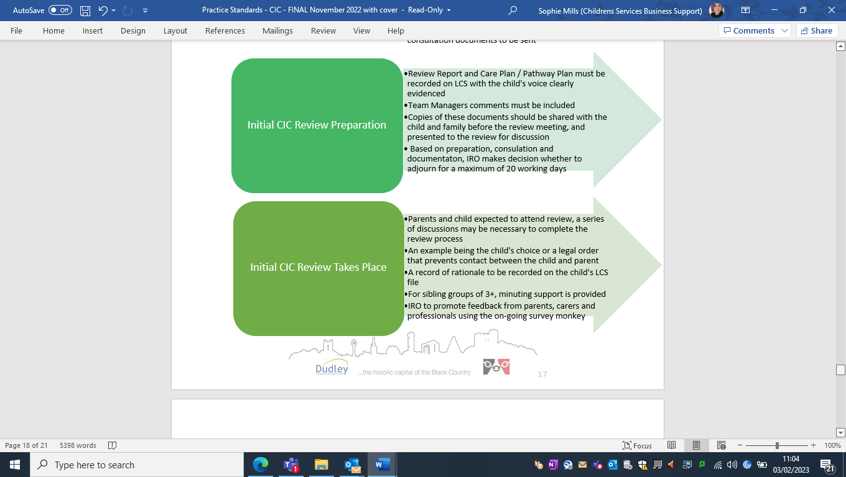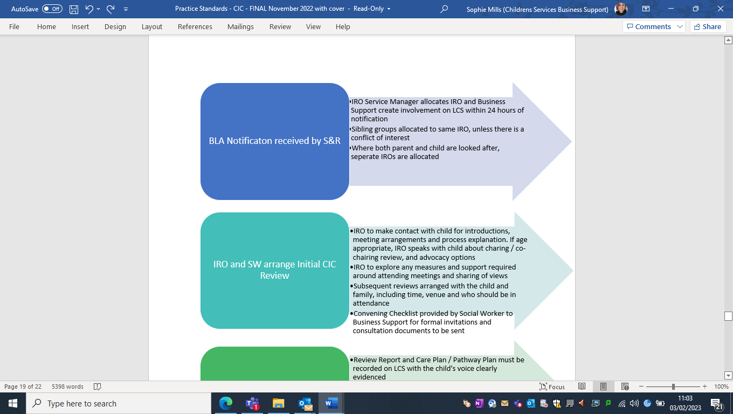

**Appendix 2a:**

CIC top requests from their IRO’s



**Appendix 2b:**



**Appendix 3:**

Child’s information leaflet about their IRO



**Appendix 4: SW role in reviews**

**Initial review:**

**Subsequent reviews:**will discuss ‘Review Choices’

SW will Discuss Review report, proposed care ar

Additional and specific information regarding the Duty of the Social Worker to Keep the IRO Informed can be located via the link below.

[**https://dudleychildcare.proceduresonline.com/p_app_role_iro.html**](https://dudleychildcare.proceduresonline.com/p_app_role_iro.html)