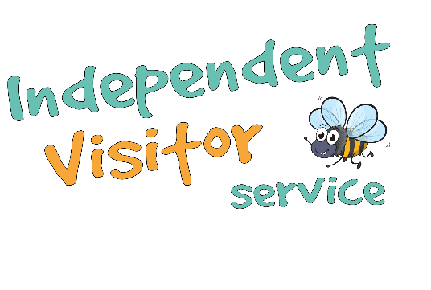

Independent Visitor Referral Form:

Local Authority:
Office address:
Office Telephone:
Social Worker:
Social Worker email:
Social Worker telephone:
Date of referral:

Young Person’s Information:

Young Person’s name:

Date of birth:

Current placement type:

Current address:

Name of carer or keyworker:

Identified gender:

Any disabilities:

Identified ethnicity:

Language spoken:

Best contact telephone number:
Email address for updates and keeping in touch:
Preferred method of contact (phone, email, text):
Has the young person given consent to the referral?
Care Plan Information:

Time at current placement:

Date of last Looked After Child review:

Date of next Looked After Child review:

Any significant or additional information, may include the following:
- Agreed arrangements for parental/family contact
- Any siblings
- Any risk factors incl history of running away
- Any presenting behaviour issues.
Purpose of Referral:
Are there any desired outcomes or objectives from the referral?

What opportunities, if any, would you like the IV to explore with the young person?

Young Person’s Section
(to be completed by or with the young person)
Would you like a male or female Independent Visitor?
Can you tell us what type of things you like to do?
This can be places to visit, hobbies or activities.
Are you active, like being outside or interested in sports?

Do you prefer more chilled out or laid back things to do?

Do you like art or museums?

Are you interested in films, books or music?
Anything else we need to know to help get you an IV match?

Please return this completed form to:
IV@nepacs.co.uk
For further information or support please contact Dawn Simpson, Service Manager on:
Email:adonaghy@nepacs.co.uk

Mobile: 07903818365
For office use only:

Confirmed receipt of the referral
Any additional information required
Added to the database
Matched IV
Best contact details/method for IV:

