Use of Mobile Devices to support involvement of children, young people and families

What is the Aim of the Guidance?

The guidance aims to provide information around the use of mobile devices by frontline workers, and how this can support their intervention with children, young people and families.

What is changing?

- All frontline workers will be provided with a new 4G enabled device which will enable them to log into the core systems anywhere, and therefore be able to update a child/young person’s record at any time. If a frontline worker currently has a smart phone, this will be replaced with one that only allows calls and texts, as the 4G device will do everything else.

- WhatsApp cannot be downloaded onto a 4G device as it needs to be linked to a mobile telephone number. It has been identified that a number of individuals use Whatsapp extensively to communicate with children and families, therefore these individuals will receive the same device but 4G will not be enabled, and they will retain their smart phone. They will then be able to tether their laptop to their smart phone, providing them with the ability to access core systems remotely.

How will this support our work with children, young people and families?

- The use of these mobile devices supports Dudley’s restorative way of working WITH families, through working in partnership and encouraging involvement. For example,
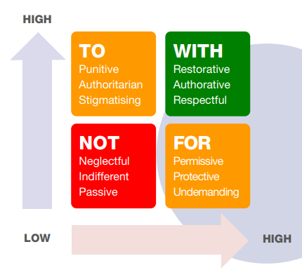
  - Individuals can be supported to attend virtual meetings where they otherwise would struggle to gain access.

  - Assessments and plans can be accessed and updated during a visit.

  - Signatures can be obtained during visits using the included stylus, therefore ensuring that individuals are part of agreeing assessments and plans.

Feedback so far from individuals who have used the devices includes:
A young person can see their pathway plan on the screen, and we can work together to co-produce their plan during the visit.

It will be easier to support young people to progress benefit/job applications as we can sit and do it together.

I like the idea of the laptop being more accessible to the children and families that I work with- I can engage them in direct work in a fun, creative way.

- This smarter way of working will help to free up practitioners to spend good quality time with children and families and build effective relationships. Practitioners can record during visits where appropriate, or in between visits in order to ensure timely and accurate recording. There will be no need to return straight to an office base as recordings can be completed in real time or immediately after a visit.

- As well as to help flexible working, practitioners can utilise technology when working with children to explore different ways of gaining their wishes and feelings, and for those who may have additional needs in respect of communication.

- In order to support participation, children and families should be routinely involved in the process of gathering and recording information about them. They should feel they are part of the recording process and that they are contributing to their own story. They should be asked to provide information, express their own views and wishes, and contribute to assessments, reports and to the formulation of plans.

Date: 17th May 2023

