KENT COUNTY COUNCIL

SOCIAL CARE, HEALTH AND WELLBEING

SERVICE USERS ADVICE NOTE No 9

RAILS

SAFETY CONSIDERATIONS: What is the rail going to be used for?

In bathroom areas where an electric shower is present, it is essential that a plastic rail is used (this is due to earth bonding). Do not use a metal or plastic coated rail.

TYPES OF RAILS MOST COMMONLY USED
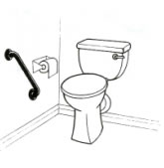

Grab rails. These come in a variety of
lengths and can be used beside a bath,
toilet or next to a door entry on the
frame, for added safety.

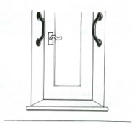

A ridged plastic rail might be more beneficial in wet areas rather than a smooth rail, to allow added grip/safety.

An “Offset “rail may be useful at a door way to allow easier access in a narrow space

Drop down rails.
These are used beside toilets to
assist and provide stability in getting up.
Some rails have an additional supporting
leg for added strength.
Drop down rails come with wall or
floor fixing plates
NB. The fixing plate for these rails is
quite large and care should be taken
to ensure there is room to fit one.
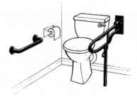

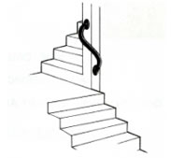
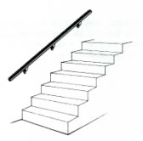
Newel post rails. These come in right hand or left hand design. They are used
at the top, bottom or mid way on the stairs to assist with turning corners.

Stair rails.
A mop stick rail (round rail on brackets) will allow good hand grip for a stair area.
These are available in different diameters and can be cut to specific requirements.
Remember that additional rails will narrow the stair width, which might be a consideration prior to fitting.

- If the walls on the stairs are not sound e.g. stud partition/lathe and plaster, there may be alternative options on which the Kent Social Care, Health and Wellbeing County Technicians Service would be able to provide individual advice.

Outside rails. Most plastic coated or metal rails will be suitable for outside use.
  - For long stretches of pathways/steps it might be useful to look at fitting a galvanised rail which is concreted into the ground for safety. Professional help is likely to be required to fit these.
  - If you are considering the installing of galvanised rails see a copy of Service User Advice Note 10 about galvanised rails for more detail.
  - Where possible, rails fitted to steps should extend beyond the top/bottom step for added safety.
  - In all cases ensure that the height of any rail fitted is comfortable/suitable for the person who is to use it i.e. at wrist height.

This advice note is designed to assist service users/carers who are planning installation of rails. Additional information may be found at
Disabled Living Foundation,
380-384 Harrow Road,
London
W9 2HU
0845 130 9177 - 10 a.m. - 4 p.m., Mon-Fri
email helpline@dlf.org.uk

Ricability
Unit G03
The Wenlock Business Centre
50 – 52 Wharf Road
London
N1 7EU
Telephone: 020 742 72460
Textphone: 020 7427 2469
Fax: 020 7427 2468
www.ricability.org.uk www.product-reviews.org.uk

