KENT COUNTY COUNCIL

SOCIAL CARE, HEALTH AND WELLBEING

SERVICE USERS ADVICE NOTE No 3

SAFE USE OF A BATHBOARD AND SEAT

It is always wise to use a non slip mat or non slip patches in the bath.
To use the bath board and seat
- Fill the bath
- Get undressed

To get in
- Sit on the board
- Shuffle your bottom towards middle of the board.

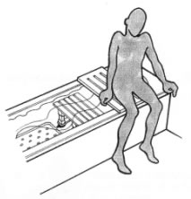

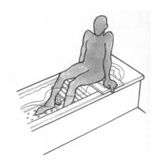
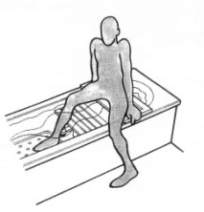
- Turn slightly as you lift your leg over the side of the bath.
- Place it on bottom of the bath preferably on a non-slip mat NOT THE SEAT.

- Lift other leg into bath.
- Make sure you are seated in the middle of the board.

NB: If you have had a stroke, have limited strength in your legs and trunk, or balance problems you may need assistance in lifting your legs over the side of the bath.
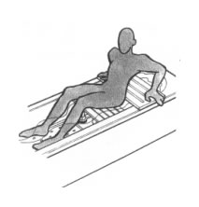
- Put your hands on the side of the board.
- Feet on the base of the bath or on the mat,
- Lean forward and lower yourself onto the seat.

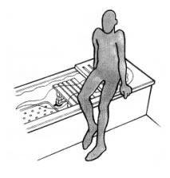
To get out
reverse stages 1-4
- Pushing up, with feet on the mat, whilst leaning forward
- Place your hands on the board or the side of the bath.
- Lift yourself up onto the board.
- Lift your legs over the side
- Sit on the board to dry yourself.

If you are unable to get down onto the seat, you may be able to sit on the board and have a shower.

If this is the case:
- Ensure that you can reach the taps/controls easily from the seated position.
- If using the board with your back to the taps/controls remove the shower hose from the wall mount to use it as a hand held spray, hang it over the front edge of the bathboard. Adjust the water to run to the correct temperature before getting onto the board.
- Make sure that you can tuck the shower curtain around yourself to prevent water on the floor beside the bath.

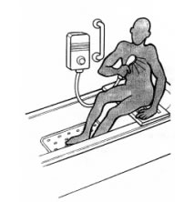

A well placed grab rail may be helpful.
Please note that Kent Social Care, Health and Wellbeing
do not recommend the use of suction grab rails.

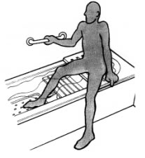

This Kent Social Care, Health and Wellbeing
advice note is only a brief guide.
Additional information is available from:
Ricability
Unit G03
The Wenlock Business Centre
50 – 52 Wharf Road
London
N1 7EU
Telephone: 020 742 72460
Textphone: 020 7427 2469
Fax: 020 7427 2468
www.ricability.org.uk www.product-reviews.org.uk

Disabled Living Foundation,
380-384 Harrow Road,
London
W9 2HU
0845 130 9177 - 10 a.m. - 4 p.m., Mon-Fri
email helpline@dlf.org.uk

For more information on the range of bathing equipment available contact:
Kent Social Care, Health and Wellbeing CANNOT ACCEPT responsibility for any equipment purchased from private companies.

