KENT COUNTY COUNCIL
SOCIAL CARE, HEALTH AND WELLBEING

SERVICE USERS ADVICE NOTE No 6

INSTALLING A FLUSH FLOOR SHOWER

This advice note is designed to assist service users/carers who are planning alterations to a bathroom. Additional information may be found at

Disabled Living Foundation,
380-384 Harrow Road,
London
W9 2HU
0845 130 9177 - 10 a.m. - 4 p.m., Mon-Fri
email helpline@dlf.org.uk

Ricability
Unit G03
The Wenlock Business Centre
50 – 52 Wharf Road
London
N1 7EU
Telephone: 020 742 72460
Textphone: 020 7427 2469
Fax: 020 7427 2468
www.ricability.org.uk www.product-reviews.org.uk

Flush floor showers can be installed where floors are of solid concrete or suspended timber construction at ground or upper floor levels in new or existing buildings.
NEW BUILD
SOLID FLOOR: Where a floor is a sand and cement screed on a concrete slab, the screed within the shower area (1200mm sq) is laid to falls to a floor gully which is located according to site conditions and drainage, and prepared to receive floor finish.
TIMBER FLOOR: The tops of floor joists are trimmed to give falls of approx 15mm within the shower area to floor gully.
Exterior ply is then cut and screw fixed to complete area of room.

EXISTING BUILDING
SOLID FLOOR: Break up existing screed to the 1200mm sq and slab as necessary to suit drainage.
Prepare and lay new screed to falls as indicated above.
TIMBER FLOOR: Remove floorboards to the 1200mm sq area and trim joists to provide fall to gully.
Lay 19mm exterior ply to area, screw fixed ready to receive floor finish.

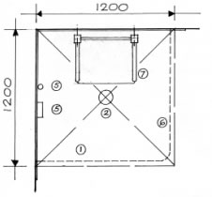
KEY

1. Floor
2. Floor outlet
3. Wall tiling
4. Soap dish
5. Shower unit
6. Shower curtains
7. Shower seats
8. Grab rails

PLAN

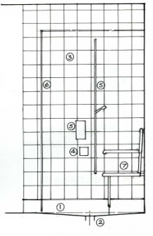
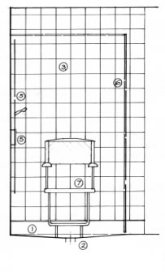

ELEVATION ELEVATION
1. FLOOR FINISHES
Sheet vinyl to be provided to complete shower room, non-slip flooring to be turned up 150mm against all walls and finished with cap-tile strip. Eg Marley Safetred Aqua or Altro Safety Marine

NOTE: It is advisable to check the floor (new or existing) for levels, i.e. although falls have been provided within shower to gully, general floor may fall in the opposite direction.

NOTE: if remaining area of floor is in a poor condition it may be advisable to completely replace it with 19mm ply to giva a satisfactory surface for the floor finish

2. FLOOR OUTLET
The type of floor outlet will be dependent on the site conditions etc. The most suitable for Marley or Altro flooring is the Wade gully designed for flush floor showers.Obtained from: Wade International UK Ltd Tel: 01787 475151

3. WALL TILING
To be full height around shower area and splash back to basin.

4. SOAP DISH
To be fully or partially recessed, position to suit user.

5. SHOWER UNIT
Shower unit to be electronically thermostatically controlled depending on site conditions.
eg: Mira Advance. Tel: 01242 221221
Triton (Millennium Care). Tel: 024 7634 4441.
In hard water areas use line scale fighter. Shower fitting to be on a 1500mm riser rail with a 2.0m extended flexible hose.
Exact positions will depend on users needs

6. SHOWER CURTAINS
Two curtains with weighted hems to enclose shower area. Curtains to be of sufficient length to provide 10mm gap above floor. Provide a vertical support bar from track to ceiling on curve.

.
7. SHOWER SEATS
A wide range of seats are available to suit all needs, these include seats with arms, backrests and support legs in plastic or padded. NOTE: All seats have maximum weight limits.
Eg Chiltern Invadex. Tel: 01869 246470
Eastbourne Showers. Tel: 01323 465800
Aidapt Ltd. Tel: 0181 771 6147
In new build where lightweight blocks are specified, it is advisable to use brick for a more solid fixing where shower seats are positioned.

8. GRAB RAILS
Additional grab rails may be required around WC and within shower area. These to be plastic coated and slip resistant type to shower area. Any drop-down rails should have support legs.

NOTE: Provide heat and ventilation to shower room and all to comply with current Building Regulations.

