KENT COUNTY COUNCIL

SOCIAL CARE, HEALTH AND WELLBEING

SERVICE USERS ADVICE NOTE No. 7

RAISING BEDS & CHAIRS

If you are finding it difficult, or need assistance from someone else to get on/off your bed and / or chair, some of the following information may be useful.

Is the bed or chair too low?

- Check the height – For the correct height, whilst seated, measure from the floor to the back of the knees. If considering raising a soft chair or bed add 2” to this measurement to estimate the best height for the chair or bed to be raised to. This compensates for compression of the cushion or mattress.

- If the leg measurement is more than that of the bed/chair height, a suitable bed or chair raiser may be helpful.

There are many types of raisers on the market, including the following individual leg raisers, and there are interconnecting raisers:

Chair Raisers

Langham Raisers Medici Raisers
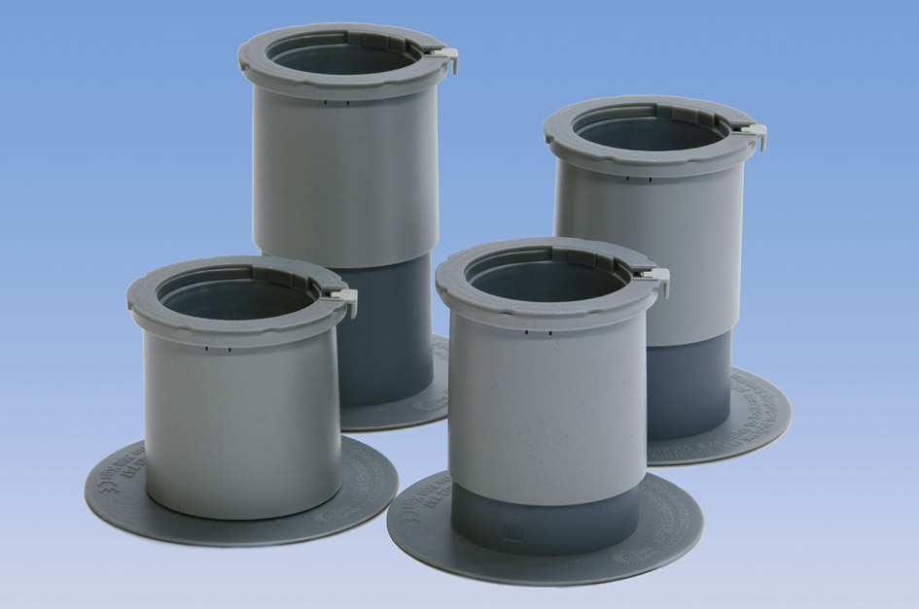

Langham linked raisers Morris raisers
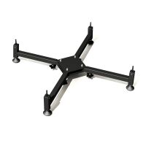

NB It is not safe to raise a reclining chair
Raising Sofas

Some sofas can also be raised, but care should be taken not to damage furniture with a bow fronted or scalloped trim. Some sofas have additional feet / legs to support the centre of the frame, and all feet / legs need to be raised equally.

Alexander Sofa Raisers Morris sofa raisers
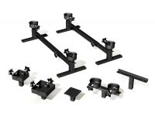
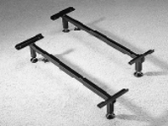

NB It is not safe to raise a sofa bed
** If you feel your chair or sofa is the correct height but you are still having problems getting up from it, ask for a copy of Service Use Advice Note 8 “Choosing a Suitable Chair”

Bed Raisers are of similar design to chair raisers, and may be fixed or adjustable height. Examples are -
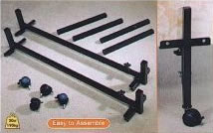
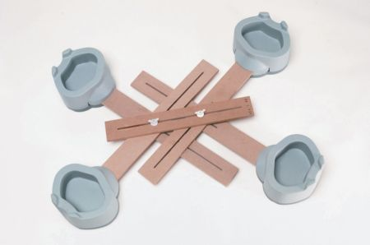

Langham Bed Raisers Morris Bed Raisers
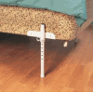

Exmouth Adjustable Bed Raiser

If your bed is the correct height but you are having problems getting up to a sitting position, one of the following might be useful:-

- A grab rail fixed to the wall by the side of the bed.

- A bed leaver: this is a simple looped grab rail, fixed to a board that fits under the mattress. This can assist transfer from a lying position to a sitting position, then onto a standing position. It can also assist with rolling over in bed.

NB Bed Leavers and Bed rails should always be fitting according to manufacturers instructions and the MHRA notice 2006
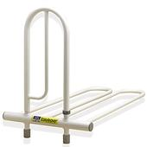

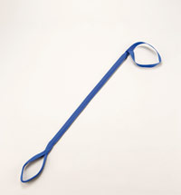

Liftwell Bed Leaver Leg Lifter

- A leg lifter: this is a stiffened fabric stirrup that can be hooked over the foot to assist lifting legs onto a footstool or into bed.
- A rope ladder: the rungs of the ladder can be gripped to help you pull yourself up into a sitting position.

This Kent Social Care, Health and Wellbeing advice note is only a brief guide.
Additional information is available from:
Ricability
Unit G03
The Wenlock Business Centre
50 – 52 Wharf Road
London
N1 7EU
Telephone: 020 742 72460
Textphone: 020 7427 2469
Fax: 020 7427 2468
www.ricability.org.uk www.product-reviews.org.uk

Disabled Living Foundation,
380-384 Harrow Road,
London
W9 2HU
0845 130 9177 - 10 a.m. - 4 p.m., Mon-Fri
email helpline@dlf.org.uk

Kent Social Care, Health and Wellbeing CANNOT ACCEPT responsibility for any equipment purchased from private companies.

