MAINTAINING SIDE LYING SUPPORT WEDGE

Always refer to Moving and Handling Care Plan for correct positioning of wedge.
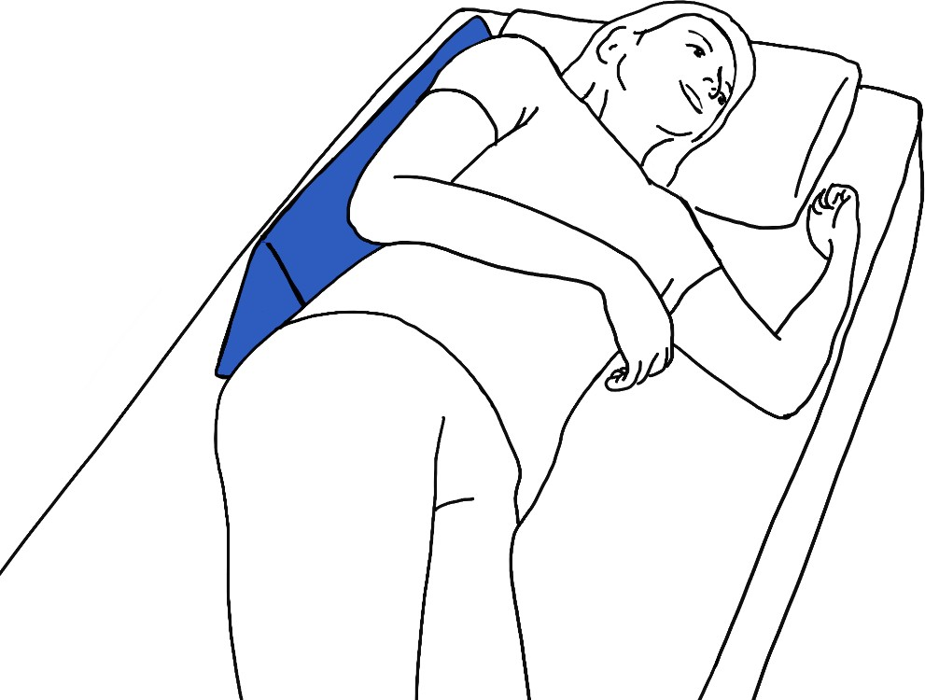

Person to roll onto their side. Carer to position support wedge behind the person, next to their upper body.

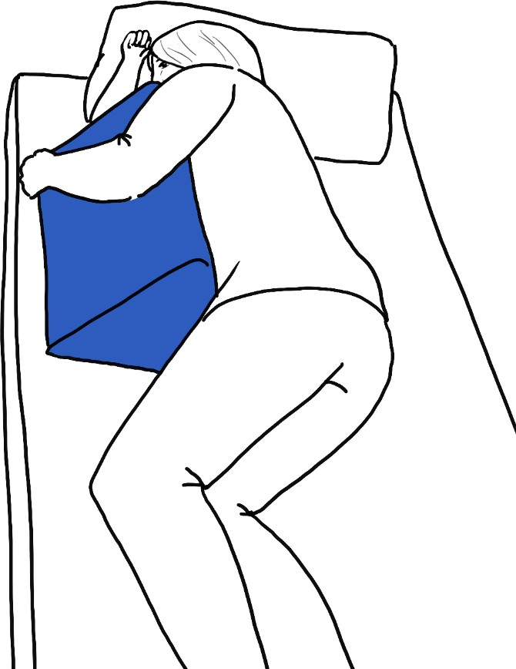
Carer to position support wedge to side of person.
Person to roll onto their side towards support wedge.

N.B. • Carer should avoid leaning over person to place support wedge.
- Never leave person unattended when resting on support wedge near edge of bed.
For enquiries, terms and conditions apply to:
Adult Social Care, Town Hall, St. Stephen’s Road, Bournemouth. BH2 6DY Tel: 01202 123654 / Email: caredirect@BCPcouncil.gov.uk

© Copyright Bournemouth Christchurch Poole Council 2019

