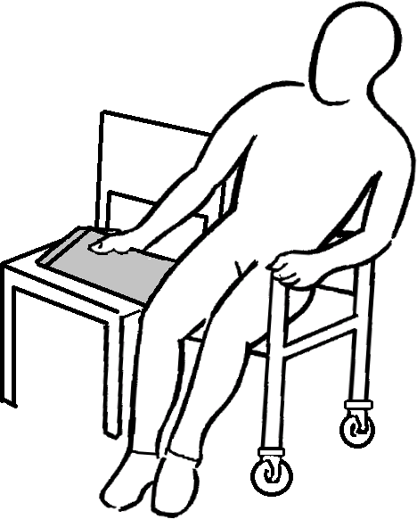
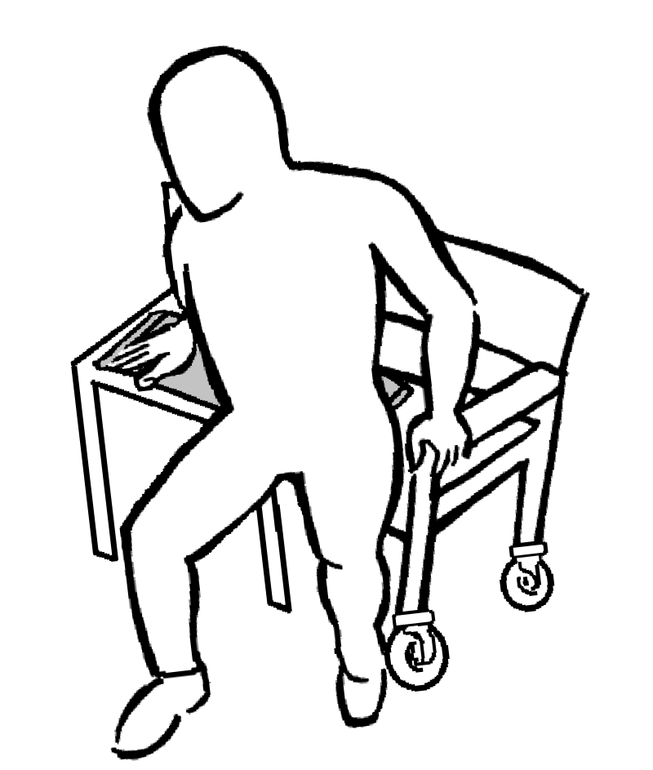
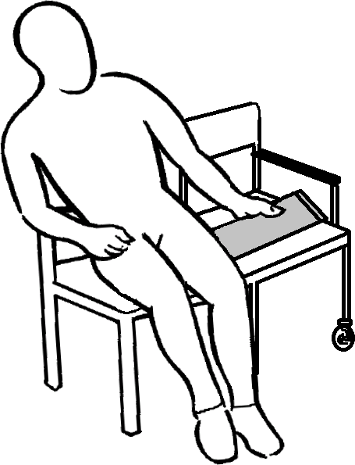
SIDE TRANSFER
For all enquiries please contact BCP Council Workforce Development Team. Email: sctraining@bcpcouncil.gov.uk
© Copyright Bournemouth Christchurch Poole Council 2019
Position chairs as shown.
Remove centre armrests and footplates.
Lean to side and position transfer board underneath buttock.
Place hand on far end of transfer board.
Shuffle across board in small movements.
Lean to side and remove Transfer Board.
N.B. •
Ensure brakes are applied.

STRAIGHT TRANSFER BOARD

- Care must be taken not to trap fingers under transfer board.
- Two surfaces should be approximately the same height.

