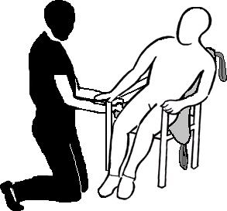
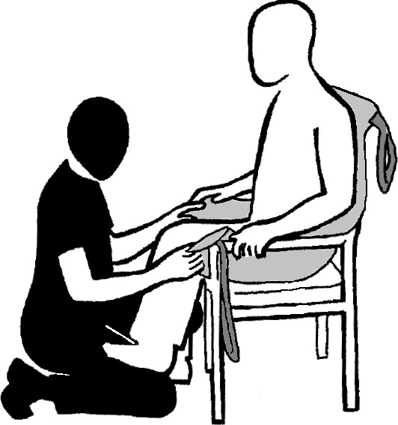
SEATED POSITION

1 of 2

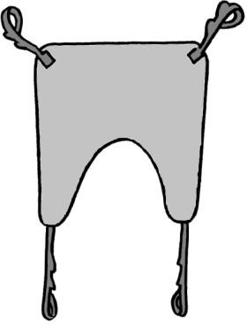
S S – (Shoulder Strap)

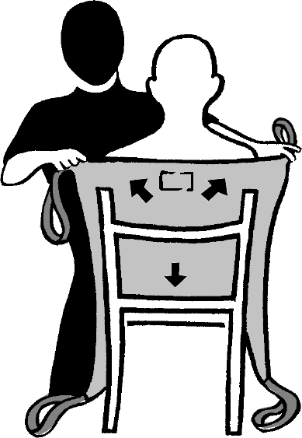
L L – (Legs strap)

FITTING SLING FROM SEATED POSITION
Person to lean forward, slide the sling down the back of the person with the aperture tucked slightly under bottom. Top of the sling should be across the shoulders.

Person to lean to one side.
Carer to move leg section of sling underneath thigh.
Repeat for other leg.

Bring leg strap (L) through to the front and under legs, towards back of knees. Ensuring the sling remains under the buttocks.

N.B. • It may be easier to place the person’s
foot on the carer’s thigh in order to do this.

SEATED POSITION

Cross legs straps (L); passing one strap through the other.

ATTACHING SLING TO HOIST
Connect both Shoulder straps (S)
onto spreader bar hooks. S (Refer to Moving and Handling Care Plan L
(MHCP) for recommended loops)

Connect both leg straps (L) onto spreader bar hooks.
(Refer to MHCP for recommended loops)

Ensure all sling straps are secure. Operate the hoist.
As the hoist starts to lift, stop and check the sling is comfortable before fully lifting; ensure that the leg straps do not ride up and cut into groin area.

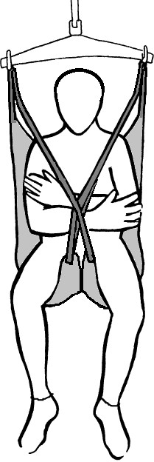
N.B.

2 of 2
- Ensure that labels and handle(s) are on the outside of the sling.

