KENT COUNTY COUNCIL
SOCIAL CARE, HEALTH AND WELLBEING

SERVICE USERS ADVICE NOTE No10

GALVANISED RAILS

Galvanised rails are considered when:
- A user is able to walk but is unsafe on steps

- Where a user needs to be independent in gaining access to/egress from their property.

- Where a user has sufficient grip to use a rail.

- Where more than one step is involved and therefore a grab rail is insufficient.

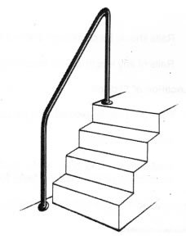

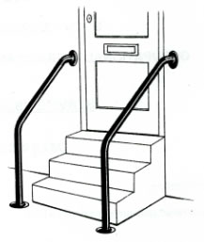

Rails both sides may be necessary in some circumstances
Eg when a person with weakness on one side needs support during both entry and exit of the property.

Position

- Identify the access location.
- Identify the most appropriate side for the rail.
- Rails should be continuous and not broken
- Rails of any length should have uprights every metre.
Location of Fixings

- Rails are usually fixed into the wall and/or the ground
- Both ends must be secure.
- Wall fixings – the brick work, plaster or pointing should be in a good enough condition to obtain a secure fixing for the flange.
- Ground fixings – should be concreted into the existing surface for stability.

Measurements
Galvanised rail measurements vary according to each individual’s circumstances and environment.

- The height should be to suit the user. As an approximate guide the rail should be level with wrist joint when standing with their arms by their side.
- Choose the internal diameter of the galvanised rail required to ensure a comfortable grip.
- The galvanised rail should extend horizontally beyond the bottom and top step(s) – if possible by 300mm
- If used in conjunction with an existing rail, the new rail should be the same height.
- Parallel rails should be sufficiently close to allow both hands to be used on the rails simultaneously.

This advice note is designed to assist service users/carers who are planning installation of galvanised rails. Additional information may be found at

Disabled Living Foundation,
380-384 Harrow Road,
London
W9 2HU
0845 130 9177 - 10 a.m. - 4 p.m., Mon-Fri
email helpline@dlf.org.uk

Ricability
Unit G03
The Wenlock Business Centre
50 – 52 Wharf Road
London
N1 7EU
Telephone: 020 742 72460
Textphone: 020 7427 2469
Fax: 020 7427 2468
www.ricability.org.uk www.product-reviews.org.uk

