KENT COUNTY COUNCIL
SOCIAL CARE, HEALTH AND WELLBEING

SERVICE USERS ADVICE NOTE No. 13

CHOOSING A RAMP & PLANNING A CONCRETE OR WOODEN RAMP

RAMP OR STEPS

- Choose a ramp if you are a wheelchair user, or if you use a walking aid with wheels.
- If you walk with difficulty, perhaps using a stick or wearing a caliper, you may find walking down a ramp difficult; in this case, shallow wide steps may be easier and safer for you.

CONCRETE OR WOODEN

- A wooden ramp should only be used for short term purposes or where a concrete ramp can not be used.
- Care should be taken that wooden ramps are treated with a non-slip surface and are well maintained.
- Wooden ramps should be edged with 100mm ‘upstands’, and also handrails if required.
- Very long timber ramps should not be used, unless there is no alternative or a concrete one is not allowed, e.g. Mobile Homes.
- Current building regulations should be checked with the local borough / city / district council.

CONCRETE RAMPS

- These are the preferred types, unless the use is short - term.
- Advice on how to plan a ramp is attached to this sheet.
- Ramps should be built by a competent builder who has to consider levels, surfaces, drainage etc.

GRADIENTS

- It is important that a ramp is not too steep, either for an independent wheelchair user or for those people pushing a wheelchair.
- A 1:15 gradient is recommended, but some people may find this is too steep, and will require perhaps 1:20 if there is enough room.
- A steeper gradient may be suitable if an electric chair is used, providing access is not dangerous for pedestrians.

LEVEL ACCESS

- If you have a ramp built, the landing should be level with the door. If there is a raised threshold, it may be best to have this replaced by a flexible threshold; your builder can advise you on this aspect.

FUNDING CONCRETE RAMPS

- If the cost of a concrete ramp is over £1000, you may need to apply to your Borough, City or District Council for a Disabled Facilities Grant to help with the cost. The grant is means tested for adults so you will need to complete a test of resources form.

- An Occupational Therapist can advise you on the best type of ramp to suit your needs and the Borough, City or District Council will help you with their Financial Assessment.

This Kent Social Care, Health and Wellbeing advice note is only a brief guide.
Additional information is available from:
Ricability
Unit G03
The Wenlock Business Centre
50 – 52 Wharf Road
London
N1 7EU
Telephone: 020 742 72460
Textphone: 020 7427 2469
Fax: 020 7427 2468
www.ricability.org.uk www.product-reviews.org.uk

Disabled Living Foundation,
380-384 Harrow Road,
London
W9 2HU
0845 130 9177 - 10 a.m. - 4 p.m., Mon-Fri
email helpline@dlf.org.uk

PLANNING A CONCRETE OR WOODEN RAMP

GRADIENT: Not less than 1=12

WIDTH OF RAMP :
Minimum width = 1200mm.
Each section of ramp not to exceed 10 metres. Concrete finish to be textured for
maximum grip.
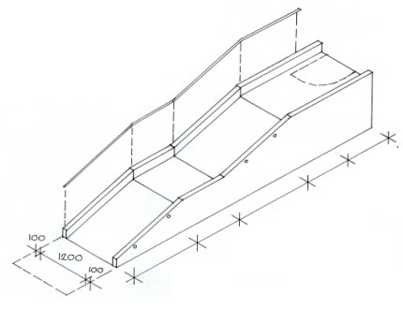

1

4

5
2

3
2

6

- LANDING Outward door swing requires a 1500mm landing clear of the door swing
- RAMP LENGTH maximum is 10 metres
- LEVEL LANDING between ramps must be 1500mm
- HANDRAIL: Required both sides of the ramp. Height to be between 840mm and 1000mm.
- UPSTANDS: Minimum height of 100mm. Leave gaps or pipes for dispersal of water,
- CLEARANCE Allow 1200 clear of bottom of ramp.

.

Dimensions in millimeters.
Sketch : Not to Scale.

TIMBER RAMPS AND LANDINGS

Ramps are constructed from 19mm external grade plywood with anti-slip painted surfaces and wood preservative on the sides and edges. They should be positioned to stand on hard surface (not grass).
Timber ramps are intended for temporary use only, i.e. life expectancy 2-5 years,

Minimum sizes are shown as required for wheelchair use.
The landing must be increased to 1500mm if the doorway is at a right angle to the landing.

GRADIENT: Not less than 1=12
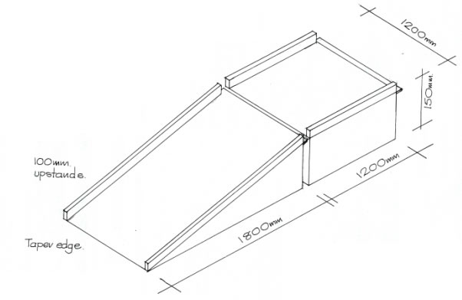

WIDTH: Minimum – 1200mm
Dimensions in millimeters.
Sketch : Not to Scale.

This advice note is only a brief guide. If more specific details are required, please contact KCC Social Care, Health and Wellbeing.

