**Domestic Abuse Practice Guidance**

**Contents**

|  |  |
| --- | --- |
| **What is the aim of the guidance?** | **Page 3** |
| **What is Domestic Abuse?** | **Page 3** |
| **What is Coercive and Controlling Behaviour?** | **Page 4** |
| **Understanding Trauma** | **Page 4** |
| **Shining a Light on the Perpetrator and Tackling Victim-Blaming Attitudes** | **Page 5** |
| **Active Listening** | **Page 6** |
| **Mental Health and Substance Misuse** | **Page 6** |
| **Child and Adolescent to Parent Violence and Abuse (CAPVA)** | **Page 10** |
| **Relational Practice in Action** | **Page 10** |
| **Assessment**  **Initial Contact with Families** | **Page 12** |
| **Multi-Agency Working** | **Page 13** |
| **How to Talk About Domestic Abuse** | **Page 13** |
| **Recording Conversations** | **Page 14** |
| **Assessment** | **Page 15** |
| **Risk Factors** | **Page 15** |
| **Working with Children and Young People** | **Page 16** |
| **Working with Perpetrators of Domestic Abuse** | **Page 19** |

**Contents cont.**

|  |  |
| --- | --- |
| **Effective Support for Survivors**  **Local Authority Housing Support** | **Page 20**  **Page 21** |
| **Refuge Support** | **Page 21** |
| **Remaining at Home** | **Page 21** |
| **Legal Orders** | **Page 22** |
| **Clare’s Law** | **Page 22** |
| **Non-Fatal Strangulation and Suffocation** | **Page 23** |
| **Appendix A – The Power and Control Wheel** | **Page 24** |
| **Appendix B – Direct Work Templates** | **Page 25 - 28** |
| **Appendix C – Dudley’s Domestic Abuse Directory** | **Page 29 - 38** |

**What is the aim of the guidance?**

The guidance aims to assist Social Workers to recognise and respond appropriately to situations of Domestic Abuse. For the purpose of this guidance, the word ‘children’ or ‘child’ will be used to denote a person under the age of 18 years old.

**What is Domestic Abuse?**

There are approximately 2.3 million victims of domestic abuse a year aged 16 to 74 (two-thirds of these are women) and more than one in ten of all offences recorded by the police are domestic abuse related (Gov.UK).

The Domestic Abuse Act 2021 defines domestic abuse as: -

* Where the perpetrator and victim are both aged 16 or older;
* The behaviour is **abusive**;
* The victim and perpetrator have a relationship which makes them ‘*personally connected*’.

**Abusive** behaviour is described as, but not limited to, the following: -

* Physical or sexual abuse;
* Violent or threatening behaviour;
* Controlling or coercive behaviour;
* Economic abuse;
* Physiological, emotional abuse and other.

The Act recognises that the above can take place post-separation.

The term *personally connected* includes those who:

* are or have been married to each other;
* are or have been civil partners of each other;
* are or have been engaged to marry one another;
* have entered into a civil partnership agreement;
* are or have been in an intimate relationship with one another;
* have each had a parental relationship for the same child.

The NSPCC report that around one in five children have been exposed to domestic abuse. Children don’t just ‘witness’ domestic abuse, being exposed to it can have a significant impact on a child’s health, development and wellbeing. Within the Domestic Abuse Act 2021, it has been recognised that a child who is related to the person being abused or the perpetrator and sees, hears or experiences the effects of domestic abuse shall be regarded as a victim of domestic abuse in their own right. The Crown Prosecution Service have advised that under new guidance, Children affected by domestic abuse will be automatically treated as victims regardless of whether they were present during violent incidents.

**What is Coercive and Controlling Behaviour?**

As highlighted within this definition, a key feature of domestic abuse is coercive and controlling behaviour - it is widely acknowledged that a perpetrators’ desire to have power and control over another person is what drives their behaviour. Coercive and controlling behaviour is designed to isolate a person from their support networks, making them dependant on the perpetrator and giving them greater control to regulate everyday behaviour. Acting in this way, the perpetrator works to limit the victim’s human rights by depriving their liberty and limiting their ability to action. Experts in the field, such as Evan Stark, compare coercive control to being held hostage: “the victim becomes captive in an unreal world created by the abuser, entrapped in a world of confusion, contradiction and fear.” Professionals who have a poor understanding of these dynamics can often result in the minimisation or even denial of domestic abuse taking place, and/or the advocation of poor or unsafe interventions such as mediation taking place. See **Appendix A** for the Power and Control Wheel, which highlights and provides examples of the many types of abuse perpetrators use.

It is also important to recognise the impact coercive and controlling behaviour can have on children. To highlight this, one study found that “non-violent behaviours from perpetrators/fathers placed children in isolated, disempowering and constrained worlds which could hamper children’s resilience and development and contribute to emotional/behavioural problems” (Katz, 2015).

The Home Office have issued guidance in relation to controlling or coercive behaviour (Controlling or Coercive Behaviour - Statutory Guidance Framework - 5th April 2023). Please see the attached link: [Controlling or Coercive Behaviour Statutory Guidance](https://eur01.safelinks.protection.outlook.com/?url=https%3A%2F%2Fproceduresonline.com%2Ftrixcms2%2Fmedia%2F18939%2Fcontrolling_or_coercive_behaviour_statutory_guidance_-_final.pdf&data=05%7C01%7CNisha.Sharred%40dudley.gov.uk%7C0e77403223ca4a0135a708db4571461e%7Ce6a7eb3fec2a421693de823d273b1d03%7C0%7C0%7C638180125023736151%7CUnknown%7CTWFpbGZsb3d8eyJWIjoiMC4wLjAwMDAiLCJQIjoiV2luMzIiLCJBTiI6Ik1haWwiLCJXVCI6Mn0%3D%7C3000%7C%7C%7C&sdata=yFsYauzCCHKQ%2FInd2BebMqewHFy2Y59pvEZqNqDEtl0%3D&reserved=0).

**Understanding Trauma**

Living with domestic abuse is both exhausting and traumatic. It is possible that survivors may also have experience of other forms of trauma caused by oppression, for example racism or homophobia. Having an understanding around the impact of trauma and the different ways it can manifest is very important – in particular, how women may ‘present’ in a safeguarding context and how Social Workers interpret these actions. There are many reasons why victims of abuse may not report this to the police, may defend the actions of a perpetrator or not wish to press charges against them. Survivors may respond in this way as a coping or survival strategy due to the coercive control they have experienced. Analysis of serious case reviews, published by the government, between 2011 and 2014 found that women who lived with controlling men - who were isolated and had restrictions imposed upon them - may not have been able to disclose the abuse but may have been able to highlight the fear they experienced in other ways. Women who experienced coercion and control had significant barriers to being able to disclose their own suffering, or that of their child’s – especially in circumstances where the abusive partner was present.

**Shining a Light on the Perpetrator and Tackling Victim-Blaming Attitudes**

It is all too common within the work of children’s social care that the non-abusive parent is held responsible for the abuse (e.g. ‘failure to protect’), while the perpetrators are almost invisible from the assessment process. Leaving an abusive relationship can be the riskiest time for victims – in 2018, 41% (37 of 91) of women killed by a male partner/former partner in England, Wales and Northern Ireland were those who had separated, or were taking steps to separate from perpetrators (Femicide Census, 2020). Many women remain in relationships due to the fear of what will happen if they leave but there are also complex barriers which make this decision much harder for survivors. Examples of this can include impacts of trauma, shame and low confidence; a lack of support available to meet unique needs, and practical barriers such as finances and housing. Having an awareness of these victim blaming attitudes and the barriers they may face will help to hold the perpetrator to account and support and empower the non-abusive parent. It is important for professionals to be mindful that their actions and language do not re-victimise survivors of domestic abuse, they should also be aware that some perpetrators may try and use professionals to manipulate and continue to control victims. Further information on this can be found via the e-learning [Awareness of domestic abuse perpetrator behaviour (thinkific.com)](https://eur01.safelinks.protection.outlook.com/?url=https%3A%2F%2Fblackcountrywa.thinkific.com%2Fcourses%2FAwareness-of-domestic-abuse-perpetrator-behaviour%3Fth__ug%3D40c66de7&data=05%7C01%7CVicki.Silvester-Grant%40dudley.gov.uk%7C8772fa54ef8946910cb308db0ddce74d%7Ce6a7eb3fec2a421693de823d273b1d03%7C0%7C0%7C638119014637355346%7CUnknown%7CTWFpbGZsb3d8eyJWIjoiMC4wLjAwMDAiLCJQIjoiV2luMzIiLCJBTiI6Ik1haWwiLCJXVCI6Mn0%3D%7C3000%7C%7C%7C&sdata=jrvi5rkejw6rZHl75IVq4rHRE%2F5wozsstIXqzVIeemo%3D&reserved=0).

When we speak to survivors of domestic abuse, it is important to think about how many blaming and shaming questions begin with the word ‘why’: -

* + Why didn’t you leave?
  + Why did you stay?
  + Why didn’t you see this coming, given your previous experience?
  + Why didn’t you tell someone?
  + Why didn’t you use the strategies you learned on your Women’s Aid course?
  + Why didn’t you call the police?

Instead of asking ‘why’, it is more effective and empathic to start with softer language such as ‘what’ or ‘Tell me…’ or ‘Describe to me…’.

Examples of how to use this questioning can be seen below: -

|  |  |
| --- | --- |
| **Blaming or Shaming Question** | **Non Victim-Blaming Question** |
| Why did you choose them as a partner in the first place?  Why will you not leave? | Describe how the relationship was in the beginning?  What do you feel has changed?  When did you notice things had changed? |

**Active Listening**

It is also important that you are aware of the non-verbal communication you are displaying while holding these sensitive conversations. Active listening demonstrates to the speaker that we are listening, hearing what is said is not enough, we need to show the person we have heard them through our actions. Below are some active listening tips: -

* **Sit squarely in relation to the speaker** – this demonstrates you are ready to listen.
* **Open position** – open body language indicates attentive listening (don’t fold your arms etc).
* **Lean slightly towards the speaker** – this shows the speaker that you are interested in what they have to say.
* **Eye contact** – maintain good eye contact throughout; this helps to create a human connection and more empathic listening.
* **Relax** – sit still, don’t fidget.

**Mental Health and Substance Misuse**

Commonly associated impacts of domestic abuse are serious emotional and psychological consequences for the survivor and their children. Psychological effects of domestic abuse can include: -

* Negative emotions, i.e. low self-esteem, fear, guilt, or shame.
* Stress-related medical conditions, i.e. headaches
* Mental health conditions and disorders, i.e. depression, anxiety, obsessive-compulsive disorder (OCD), post-traumatic stress disorder (PTSD), eating disorders or sleep disorders.
* Substance misuse, i.e. drugs or alcohol
* Self-harming to cope with the abuse.

Women who experience abuse from their partner are three times more likely to suffer from anxiety, depression or more severe conditions such as schizophrenia or bipolar disorder (Chandan et al., 2019). At it’s most extreme, domestic abuse can lead to suicide ideation or suicide (Southall Black Sisters, 2011). Everyday, approximately 30 women attempt suicide to escape domestic abuse and three women a week take their own life (Refuge, 2017). For further support around suicide ideation, survivors or perpetrators can access support online via <https://www.reachoutdudley.co.uk/share-the-right-support>.

Practitioners should also be aware of how perpetrators may escalate the abuse of their partner when she’s pregnant. Research shows that suffering domestic abuse during pregnancy can impact the foetal growth and development due to physiological effects of stress (Allen, 2013). It is concerning that pregnancy significantly increases a woman’s risk of being a victim of domestic abuse and domestic homicide; men who abuse their pregnant partners are extremely dangerous and more likely to kill them (Campbell, 2002; Moncrieff, 2018).

Perpetrators can also exploit a partner’s poor mental health, i.e. belittle them, control and manipulate their decision making, parenting and ability to cope. Gaslighting is an act of manipulating a person to an extent where they question their own thoughts, feelings and memories. It is a very harmful form of emotional abuse and survivors can be pushed so far, that they begin to question their own sanity.

There are many ways to start a conversation about someone’s mental wellbeing, for example: -

* How are you feeling in yourself?
* How are you feeling emotionally right now?
* Do you have any concerns about your health, including how you think or feel inside?
* Have you ever been diagnosed or treated for a mental health problem?

There are a variety of ways you can ask about someone’s mental health in relation to abuse or trauma they may be experiencing now or previously. Examples include: -

* Being hurt by a partner doesn’t just cause physical injury but also emotional or psychological harm. The effects of living with violence and abuse can cause people to feel depressed, anxious or ill. Have you noticed any changes in the way you feel?
* Some people feel depressed, traumatised, suicidal or distressed after being abused. Have you felt anything like this?

Follow on questions might include:

* How does the way you feel impact on how you function? For example, are you able to go out, buy essential items, cook for yourself, go to work, socialise with others?
* Have you had any help from your doctor, a psychologist, a counsellor, or anyone else because of problems with your mental health? Is anyone or any agency supporting you around your mental health now? Do you have a psychiatrist?
* Have you ever been prescribed medication for mental health problems? Are you taking anything now? If yes, what and who has prescribed them?
* If taking medication, when was your last medication review?
* Have you ever harmed yourself, e.g. cutting, burning, poisoning, not eating, not caring for yourself?
* Do you find that it helps you cope? Are you able to care for yourself when you hurt yourself?
* Have you ever felt so bad that you have thought about suicide? What happened?
* Have you ever been hospitalised due to mental ill-health?
* Do you ever use alcohol or drugs to help manage how you feel or your thoughts?
* How do your mental health problems affect your ability to be a parent?
* Have you ever thought about or been violent towards others? Have you ever thought about harming your child(ren)?

While it is important to understand that mental ill-health and substance misuse does not cause domestic abuse – and should never be used as an excuse – there is evidence to suggest that alcohol use by a perpetrator can increase the seriousness and frequency of violence. It is also true that substances may be used by survivors as a coping strategy – this however could be weaponised by the perpetrator. Having an understanding of these factors and how they interplay is vital when assessing domestic abuse. Below are some possible questions you can ask around substance misuse which are not shame or blaming: -

Where it is known that a survivor uses substances, you could ask clarifying questions such as:

* How much alcohol do you drink every day/each week?
* What sort of drugs do you use?

If their substance use is unknown, a starting point could be to ask:

* Do you take any medication prescribed by a doctor?
* Have you used drugs other than those required for medical reasons?
* Do you drink alcohol at all?

In circumstances where domestic abuse has been disclosed by a survivor, it can be helpful to use a

question that starts to make a link between experiencing abuse and using substances,

such as asking: -

* Some people find that the use of drugs or alcohol help them cope with the abuse/how they are feeling – do you use anything to help you manage your situation or what you have been through?
* Does your partner ever make you feel you have to use drugs or alcohol? If yes, how often and when has this occurred?

Questions you can ask to ascertain the types of risk someone might be facing relating to drug or alcohol use: -

* How much do you use?
* Is this usage: occasional/weekly/ daily/payday use?
* For prescription and over-the-counter medication, do you ever use more than instructed to on the package/by a GP or pharmacist?
* Do you often drink or use other drugs more than you plan to?
* How much time during the week do you spend obtaining, using, or recovering
* from the effects of alcohol, other drugs or medication?
* Since you began using or drinking, have you stopped spending time with family and friends and begun spending more time using alcohol and other drugs or spending more time with people who do?
* On a scale of 0-10 (0=no problem; 10=significant problems) where would you place yourself in relation to whether your drug use/drinking has affected/is affecting your health?
* Has your use of medication or drugs/drinking caused any other problems in the past, or are causing problems now?
* Do you think your drug use/drinking is causing you a problem? Has anyone else said that your drug use/drinking is problematic?
* Have you had any arguments or been violent with people other than your partner when affected by alcohol or drugs?
* What effect does drinking or using drugs have on your ability to be a parent? How do you think your drug or alcohol use has affected your children? Do the children ever have to do without the basics because you have spent money on drugs or alcohol? Do the children ever see you using drugs or drinking? Are they ever left unsupervised or with unsuitable carers?
* Do you ever take them places where they might be at risk? Or do people come to your home as a place to use drugs or drink?
* Are drugs, alcohol, medication stored safely and away from children?
* Are you currently in contact with any services or agencies in relation to your substance use? If yes, can you give the name and contact details of current worker(s)? If not, would you like information about local services?

The phrases ‘toxic trio’ or ‘trio of vulnerabilities’, when a victim or perpetrator may be using alcohol/drugs and have mental health issues, are harmful label as they can be seen to take the focus off the perpetrator and place problems or issues on the victim. The terms therefore suggest that the survivor is ‘toxic’ or a main source of the risk. Instead, consider using phrases such as ‘multiple needs’ or ‘multiple disadvantage’.

Three key messages for working with women who experience domestic abuse from the UK charity AVA (Against Violence & Abuse), which is committed to ending violence against women and girls: -

1. Professionals should be aware that women have faced a range of traumatic experiences and our interactions with them should support their physical and emotional safety.
2. Women will often use substances as a copying strategy to manage their experiences. Acknowledge what they have done to survive, do not blame them, instead listen and believe them.
3. Understand behaviour as a communication – be professionally curious and focus on building trusting relationships with women, acknowledge their strengths and capabilities.

**Child and Adolescent to Parent Violence and Abuse (CAPVA)**

Violence and abuse towards parents and caregivers is an increasing issue, with minimal UK policy. It can affect families of all sizes and backgrounds, however it appears to be highly gendered, with mothers being the most likely target and sons the most likely to display abusive behaviour. Violent and abusive behaviour appears to peak around the ages of 13 to 17, but abuse can take place outside of this age range. Below are some of the indicators of CAPVA to look out for: -

Injuries Fighting or bullying

Missing from school Substance use

Distress Offending and ASB

Damage to property Families evicted

Constantly tired Multiple GP visits

Staying out Noise complaints

Increasing isolation Police call-outs

Further information about CAPVA can be found [here](https://domesticabusecommissioner.uk/wp-content/uploads/2021/11/CAPVA-Rapid-Literature-Review-Full-November-2021-Baker-and-Bonnick.pdf?msclkid=ce4449aeb68111eca1586e5c615c640b).

**Relational Practice in Action**

Survivors of domestic abuse were asked what skills, knowledge and attributes they would identify a good social worker/practitioner as having in order to best support them. The answers can be seen in the image below: -



Here are some top tips from survivors about how to support victims of domestic abuse: -

* **Listen to survivors** – they are the experts in their own lives.
* **Ensure you have a real understanding of the dynamics of domestic abuse** – especially coercive control, and how perpetrators can manipulate the system and professionals.
* **Understand the impact of domestic abuse on our mental wellbeing and the different coping mechanisms survivors may have.**
* **Approach them on a human level and as a whole person.**
* **Respect their different cultures, identities, and life experiences** – do not make judgements based on prejudices, stereotypes, or assumptions.
* **Make sure perpetrators are part of the picture and try to work with them** – the perpetrator is responsible for the abuse, not the survivor!
* **Don’t jeopardise their safety.** For example, ensure you know the safe methods to communicate for the survivors you are working with.
* **Be transparent and clear.**
* **Don’t unnecessarily make them re-tell their story** – read the notes but do not pre-judge.
* **Don’t assume that a child survivor is less knowledgeable than an adult survivor.**
* **Work with them – not against or for them – take a collaborative and empowering approach.**
* **Focus on well-being not just risk and physical safety.** For example, help them build their self-esteem, and support them to connect to others in their community.

**Assessment**

**Initial Contact with Families**

Historically, there has been a tendency for the main responsibility being placed onto the non-abusing parent, typically the mother. When phrases such as ‘failure to protect’ are used, this reinforces the notion that it is the responsibility of mother to safeguard the child. Taking a victim-blaming approach can stigmatise and re-victimise a survivor of domestic abuse, it can also tilt the power and control in favour of the perpetrator. While protecting children must always be at the heart of interventions – it is difficult to achieve this when the relationship between the Social Worker and survivor is lacking in trust (Robbins & Cook, 2018). For this reason, it is important that the Social Worker adopts a needs-led and strengths-based approach to working in partnership. A strengths-based approach is underpinned by these principles: -

* Every individual and family has strengths.
* Trauma, abuse and adversity may be harmful however they may also be sources of strength and resilience.
* Don’t assume you know the limits of an individual’s ability to change and grow – agree aspirational outcomes for the family.
* Collaborative practice is best practice (co-produce assessments and plans).
* Every environment (family or community) will have resources to support (use genograms and eco-maps to find out more about the family).
* Social Work is about care, care-taking and hope (Saleebey, 2013).

Within this approach, the survivor is seen as a ‘whole person’ – someone with resilience and skills – and a collaborative approach by the Social Worker is necessary to build a relationship in order to promote safety, wellbeing and change. This allows the Social worker to work alongside the survivor and centralise them in the decision making process, i.e. what do they see as their strengths, risks, needs etc. This approach can be highly restorative for a person who has lived with domestic abuse and may have a diminished sense of self-worth or confidence to plan for their future.

**Multi-Agency Working**

Multi-agency working is vital for effective safeguarding and child protection – no social worker, no matter how experienced, should respond to domestic abuse cases by working in silo. Evidence for this can be found within many Child Safeguarding Practice Reviews, where poor or absent communication between organisations have contributed to devastating consequences for children and families. Examples of working together can occur in the following contexts: -

* Referrals being made to the Multi-Agency Safeguarding Hub (MASH) for an assessment to be undertaken by Children’s Services.
* Engagement with the Domestic Abuse Response Team (DART).
* Referrals to the local Multi-Agency Risk Assessment Conference (MARAC). A MARAC meeting will consist of representatives of statutory and non-statutory organisations who actively support those at high risk of domestic abuse. MARAC representatives discuss and analyse ongoing risks of both adult survivors and children, and actions are agreed within the meetings with the aim of supporting and safeguarding the family.
* Multi-agency ownership of plans and contribution to holistic assessments.

**How to Talk About Domestic Abuse**

A survivor of domestic abuse may not wish to disclose their experiences straight away due to feelings of fear, mistrust, anger or shame. Building trust with the survivor will help to make them feel more confident in opening up about their experiences of domestic abuse, however developing these relationships will often take time. In reality, having adequate time to build those relationships will be dependant upon your role and the nature of your team, for example Social Workers within an Assessment Team will have less time to engage with families than those based within longer-term Safeguarding Teams. In these circumstances, the Social Worker can support trust building by: -

* Creating a safe environment to speak with the survivor; a confidential space where the perpetrator isn’t present (i.e. don’t hold virtual meetings if you cannot ensure the perpetrator won’t be present), don’t use family members or children to translate, give them non-verbal ways to disclose they are in danger (i.e. writing in a red pen rather than a black pen, agreeing a safe code word when calling).
* Listen without judgement – never excuse the perpetrator’s behaviour, blame them for the abuse, ask why they haven’t left or tell them to leave.
* Believe them – validate what they tell you by using affirming statements, e.g. ‘I’m really glad you told me’, ‘It’s not your fault’, ‘You’re not alone’.
* Be honest and transparent.
* For information about affective statements, view this helpful video ‘[L30 Affective Statements](https://www.youtube.com/watch?v=IZLoTsN_sSA)’.
* For further guidance and support on Restorative Practice please see the [Dudley Children’s Services Practice Framework](https://www.dudleycpp.org.uk/_files/ugd/19265b_2b471456ea53467aa959f29d4af66d86.pdf).

**Recording Conversations**

Below are some examples of how important language can be when responding to a survivor: -

|  |  |  |
| --- | --- | --- |
| **Commonly Used Language** | **Explanation** | **Alternative for a Trusted Professional** |
| ‘An incident of domestic abuse’ | It is important to hold the perpetrator to account. This language hides the emotional impact of the abuse and hides emerging patterns. | Instead of focusing on incidents, try to describe emerging patterns. Make sure your notes join the dots between conversations and make the actions of the perpetrator visible. |
| ‘Relationship problems’ | This language can hide the intensity of abuse and holds both parties accountable for the ‘problems’. | Where you suspect domestic abuse, try to ask direct questions about the abuse to build an accurate picture and record this. |
| ‘Alleges’ | This was introduced as a way of ensuring professionals were not taking sides, but it implies disbelief of the account and can damage credibility. | Try ‘states’ or ‘records’ and where possible use the survivor’s own words in inverted commas to highlight the power of the account. NB: Be clear who has shared the information recorded – a recent Domestic Homicide Review found that an incident had been minimised by professionals because they hadn’t realised information being shared was from a parent’s account and not a Police report. |

**Assessment**

It can be difficult to ask questions about domestic abuse, consider asking these questions to begin to get an understanding of what the survivor is experiencing : -

* Have you ever been hurt or frightened by your partner or a family member?
* Do you ever feel controlled by your partner?
* Do arguments ever result in hitting, kicking or pushing?
* Do arguments ever result in you feeling down or bad about yourself?

If you notice an injury, rather than asking how it happened, ask: -

* “Who hurt you?”

If someone does disclose experiencing domestic violence, your first concern should be their immediate safety. You can start to explore this by asking the following questions: -

* Do you feel safe right now?
* Do you feel safe leaving this meeting/office/going home?
* What do you fear might happen in future? ie what types of violence or abuse might happen?
* What threats has the perpetrator made to/about you and/or your children?

A holistic assessment should ensure that all members of the family are included – this includes ensuring the perpetrator is not invisible. It is important that fathers are included in direct work and their views, wishes and feelings are incorporated into the assessment and plan. This is particularly important when the father is the perpetrator of the abuse, has parental rights and is likely to pursue contact with his child in the future.

It is also very important that the child’s voice is incorporated within, and is the heart of the assessment. Children should also be supported to have choices and control in their life. While there is debate around ‘protection’ versus ‘participation’ in the assessment process, the majority of research concludes that sensitive, age-appropriate participation is not harmful (Cossar et al, 2016).

**Risk Factors**

Risk factors associated with a high risk of serious harm include: -

* Recent separation.
* Escalation of abuse (frequency or severity).
* Stalking and harassment.
* Isolation from friends/family.
* Threats to kill.
* Threats by perpetrator to commit suicide.
* Sexual violence.
* Use of objects/weapons.
* Strangulation, choking, suffocating, drowning.
* Excessive jealousy.
* Perpetrator tries to control everything the victim does.

If the survivor mentions any of the risks above, it is recommended that a DASH ([Domestic Abuse, Stalking and Harassment](https://safelives.org.uk/sites/default/files/resources/Dash%20risk%20checklist%20quick%20start%20guidance%20FINAL.pdf)) risk identification checklist is completed, which is a standard domestic abuse assessment tool used across England and Wales. Most commonly, high risk victims identified through the DASH tool will qualify for referral to MARAC and support from an Independent Domestic Violence Advocacy (IDVA) worker. Domestic abuse support is also available for lower risk clients via the Dudley Single Point of Contact.

**DUDLEY SINGLE POINT OF CONTACT (SPOC) - Tel: 01384 455411 (24 Hours)**

* The SPOC is a single point of contact for victims of domestic and sexual violence and abuse in Dudley, including Forced Marriage and ‘Honour’ Based Abuse, regardless of gender.
* The number gives those who need help a direct line to a range of support services offered by specialist providers including refuge accommodation or additional home security.
* The number is also open to victim's families and professionals and helps people get to the right service as easily as possible as and when support is needed.
* You can also now Text or WhatsApp on 07384 466 181 – messages checked 9am-9pm Monday-Friday except bank holidays (messages received at other times will be responded to within these hours) or Live chat with the SPOC on [www.blackcountrywomensaid.co.uk](https://eur01.safelinks.protection.outlook.com/?url=http%3A%2F%2Fwww.blackcountrywomensaid.co.uk%2F&data=05%7C01%7CVicki.Silvester-Grant%40dudley.gov.uk%7C8772fa54ef8946910cb308db0ddce74d%7Ce6a7eb3fec2a421693de823d273b1d03%7C0%7C0%7C638119014637355346%7CUnknown%7CTWFpbGZsb3d8eyJWIjoiMC4wLjAwMDAiLCJQIjoiV2luMzIiLCJBTiI6Ik1haWwiLCJXVCI6Mn0%3D%7C3000%7C%7C%7C&sdata=t2VZT7iCLYyOkz8NWu1BaFOMz6WC%2FuvbzPi8I8%2B82g0%3D&reserved=0)  – just look for the chat icon on the left hand side of the screen; web chat is open Monday to Fridays, 10am to 2pm, except on bank holidays).
* There is also specific support available for men and LGBT community - all accessible via the SPOC – direct contact details can also be found at: <https://www.dudleysafeandsound.org/domesticabuse>

**Working with Children and Young People**

It is estimated that children witness around three-quarters of abusive incidents where domestic abuse is present (Royal College of Psychiatry, 2020). Children experience domestic abuse in different ways, and the affects of this are equally as varied, however below are some of the common traits identified according to age groups (Royal College of Psychiatry, 2020): -

**Common to all children:**

* May develop Post-Traumatic Stress Disorder
* Nightmares
* Flashbacks
* Becoming ‘jumpy’
* Headaches
* Physical pains
* Difficulties concentrating on school or school refusal

**Younger children:**

* Tummy aches
* Bed wetting
* Difficulties sleeping
* Difficulty separating from non-abusive parent when going to school or nursery
* Demonstrating behaviours which may be expected of children at an earlier stage of development

**Older children:**

(The Royal College of Psychiatry (2020) suggest that girls and boys may respond differently)

**Girls** may be more likely to:

* Keep their distress inside
* Become withdrawn
* Become anxious or depressed
* Think badly of themselves
* Develop an eating disorder
* Self-harm through cutting or taking overdoses
* Report vague physical symptoms
* Enter into a relationship with an abusive partner

**Boys** may be more likely to:

* Express distress more outwardly
* Act aggressively
* Refuse to follow instructions
* Imitate violent behaviours to solve problems
* Refuse to go to school
* Use alcohol or substances as a way of blocking out disturbing memories

Impact of domestic abuse on children can have long-term affects; children who witnessed abuse are more likely to become involved in similar relationships themselves. That said, many children will grow up to develop healthy and respectful relationships but early intervention is important in minimising the long-term harms witnessing domestic abuse can cause. Receiving support early will enable children to learn about what a healthy, loving relationship looks like, whilst also providing an opportunity for safety planning to take place.

When working with children who are experiencing domestic abuse it is important to: -

1. Validate their emotions and experiences – acknowledge their disclosure and experience and let them know they are believed.
2. Reassure them the abuse is not their fault.
3. Create a protective network around them – ensure key professionals are aware of the risks and can offer appropriate safeguards and support.
4. Ensure school is a positive, rather than an oppressive, environment for them – experiencing domestic abuse may impact upon a child’s attendance, performance or behaviour, it’s important that school is seen as a respite from stress and emotional harm and the child is not penalised over possible impacts of domestic abuse.
5. Include the child in their own safety planning – research shows that listening and involving children in planning and decision-making can have a positive impact on their ability to cope (Mullender et al, 2002).

Children who live with domestic abuse don’t become ‘used to it’ or feel the impact lessen. The longer they are exposed to the abuse, the more harm can be caused. (English, 2003 in Stanley 2011). It’s important to consider these feelings when completing direct work with children who’ve experienced abuse: -

* They may feel powerless because they can’t stop the abuse.
* They may feel angry towards the non-abusive parent for not protecting them.
* They may feel it’s their fault for parents separating.
* They may feel confusion around their feelings of loss for the abusive parent.
* They may feel afraid of other people finding out about the abuse.
* They may feel lonely, or isolated.
* They may feel conflicted and worried at the consequences of disclosing.

Below are some questions you can ask children when gathering information for the assessment: -

* Who is in your family?
* Who are you least close to?
* Who makes you feel safe in your family?
* Are there some things which happen in your family which are scary?
* What do you do when scary things happen?
* What do you think needs to change to make things better at home?
* How do you think you can change things?
* What can other people do to change things?

At the end of this guidance are some direct work tools you can use when gaining a child’s views, wishes and feelings and safety planning with them (Appendix A).

**Working with Perpetrators of Domestic Abuse**

It is important that the parent perpetrating abuse should be contacted as part of the assessment process, unless contacting them will increase the risk to the survivor and their children. If a decision is made not to engage the abusing parent, then this decision should be clearly recorded within the assessment with a defensible rationale.

Accountability for the abuse, it’s impact on the child and the responsibility to end abuse, should always sit with the perpetrator. Language within case notes and allocations of actions within plans should also reflect this. If a perpetrator’s actions and abuse have impacted on the survivor’s parenting, mental health or substance misuse and in turn this has impacted on the child, then accountability for this harm should be clearly evidenced within the case notes (i.e. mother has been struggling to get out of bed and tend to her son’s needs due to currently experiencing poor mental health – mother’s poor mental health is a direct result of the domestic abuse she has experienced from her current partner).

The use of vague and mutual language to describe domestic abuse should be avoided – for example, instead of saying ‘there is a history of domestic abuse’, describe the type of abuse, it’s frequency and be clear in distinguishing who perpetrated the abuse and who has been harmed by it (including impacts on children).

It can be daunting speaking to a perpetrator of domestic abuse, below are some questions which may help to begin these conversations.

If the perpetrator presents with a problem such as drinking, stress or depression, for example, but does not refer to his abusive behaviour, these are useful questions you can ask:

* “How is this drinking/stress at work/depression affecting how you are with your family?”
* “When you feel like that what do you do?”
* “When you feel like that, how do you behave?”
* “Do you find yourself shouting/smashing things…………?”
* “Do you ever feel violent towards a particular person?”
* “It sounds like you want to make some changes for your benefit and for your partner/children. What choices do you have? What can you do about it? What help would you like to assist you to make these changes?”

If the perpetrator has stated that domestic abuse is an issue, these are useful questions you can ask:

* “It sounds like your behaviour can be frightening; does your partner say she is frightened of you?”
* “How are the children affected?”
* “Have the police ever been called to the house because of your behaviour?”
* “Are you aware of any patterns – is the abuse getting worse or more frequent?”
* "How do you think alcohol or drugs affect your behaviour?"
* “What worries you most about your behaviour?”

If the perpetrator responds openly to these prompting questions, more direct questions relating to heightened risk factors could be asked:

* "Do you feel unhappy about your partner seeing friends or family - do you ever try to stop her?"
* "Have you assaulted your partner in front of the children?"
* "Have you ever assaulted or threatened your partner with a knife or other weapon?"
* "Did/has your behaviour changed towards your partner during pregnancy?"

**Effective Support for Survivors**

When working with survivors of domestic abuse, it is important to have a basic understanding of options available to them, allowing you to inform them of their rights and, where necessary, be able to advocate on their behalf.

**Local Authority Housing Support**

The Domestic Abuse Act amends homelessness legislation to give victims of domestic abuse automatic priority need status for settled housing, without needing to fulfil the vulnerability test.

The charity Shelter can provide information on what support is available to survivors who may not be able to access help in the first instance due to issues surrounding residence or immigration.

Survivors who are fleeing their home due to domestic abuse can approach any council where they feel safe. They cannot be referred back to their council of residence if there is a risk of violence. In circumstances of domestic abuse, the survivor can request a housing officer of the same gender and an interpreter can be requested if required.

**Refuge Support**

A refuge is a safe accommodation where people experiencing domestic abuse can stay, free from fear. While most refuges provide accommodation to women and children, there are options available for male victims of abuse – to gain further information about male refuges, contact Men’s Advice Line (Tel: 0808 8010327). To search for vacancies for women and children’s refuges you can contact the Freephone National 24-hour Domestic Violence Helpline on Tel: 0808 2000 247, or contact Women’s Aid’s dedicated service for professionals seeking refuge accommodation and support for survivors: www.womensaid.org.uk/dedicated-service-for-professionals.

**Remaining at Home**

If a survivor chooses to remain in their property, or they are unable to move, there are several ways they can be safeguarded. Some examples of safety measures available to survivors who are not living with the perpetrator include: -

* Installing alarms.
* Replacing or strengthening locks of doors/windows.
* Strengthening resistance to doors, door frames and windows.
* Installing fireproof letterboxes.

In cases where the perpetrator remains living in the family home, the survivor should be supported to create a safety plan. Survivors should feel in control of their safety plan and supported to update it regularly. It may also be useful to consider safe words that the survivor can use to alert you of any danger they may be facing from the perpetrator, this is particularly useful when opportunities to see the survivor alone are limited. Further information and guidance around safety planning and preparing to leave a perpetrator can be found [here](https://www.womensaid.org.uk/information-support/the-survivors-handbook/making-a-safety-plan/#1447926965295-8f67f8a6-62c7).

CHADD run the Sanctuary Service in Dudley, which provides safety enhancements to enable survivors to stay safer within their home. Dudley Sanctuary Service is provided free of charge for anyone at risk of /or experiencing domestic abuse. This service can be offered to anyone who wishes to remain in their own home or to those not able to access refuge accommodation. The service is available for residents of the Dudley Borough. 1-1 support is also provided, tailored to individual need.

CHADD also run the local Refuge accommodation in Dudley and associated support. This includes units available specifically for men, older people, larger families and those with complex needs. This can be accessed via the SPOC (see page 16 for details) or directly by calling Tel: 01384 864334.

**Legal Orders**

Anyone who has experienced domestic abuse can apply for an injunction through the court via orders described below: -

A Non-molestation Order – this protects survivors and their children from being harmed or threatened by perpetrators of domestic abuse.

An Occupation Order – this decides who can live in the family home or enter the surrounding area.

Anyone can apply for an injunction online via <https://injunction.courtnav.org.uk/register>, the website is easy to use and clearly explains what a survivors options are and how to apply for the relevant Order(s).

Other Orders available to survivors are: -

A Prohibited Steps Order – this prohibits anyone with parental responsibility from taking away a child from the care and control of a survivor with parental responsibility (NCDV, 2020). Only a person with parental responsibility can apply for this Order.

A Restraining Order – if the police charge an abuser and the case goes to the criminal courts, the court may make a Restraining Order to protect the survivor. A Restraining Order can be made whether or not the abuser is found guilty. Further information can be found at <https://rightsofwomen.org.uk/>.

**Clare’s Law**

The Domestic Violence Disclosure Scheme gives any member of the public the right to ask the police if their partner may pose a risk to them. It is often called ‘Clare’s Law’ after the landmark case that led to it.

This scheme also allows a member of the public to make an enquiry into the partner of a close friend or family member. To make a request under Clare’s Law, and the person you think is at risk lives in the West Midlands, use the online form found here:

<https://www.west-midlands.police.uk/your-options/clares-law-domestic-violence-disclosure-scheme/form>

Alternatively, the person can visit your local police station to apply. After the form has been received and initial enquiries have been completed, the referrer may be asked to come to a face to face meeting with an officer. If they find a record of abusive offences, or if they feel there is a risk of abuse or violence, the police will consider sharing this information.

If they do decide to make a disclosure, this will normally be made to the person at risk. In certain circumstances though, someone else may be in a better position to use the information to protect the person. The aim of this information is to help people make a more informed decision on whether to continue with their relationship, as well as providing help and support when making the choice.

**Non-Fatal Strangulation and Suffocation**

Non-fatal strangulation was made a specific offence as part of the Domestic Abuse Act. The practice typically involves a perpetrator strangling or intentionally affecting their victim’s ability to breathe in an attempt to control or intimidate them.

It followed concerns that perpetrators were avoiding punishment as the act can often leave no visible injury, making it harder to prosecute under existing offences such as Actual Bodily Harm (ABH). [Studies](https://www.ncbi.nlm.nih.gov/pmc/articles/PMC2573025/) have shown that victims are seven times more likely to be murdered by their partner if there had been non-fatal strangulation beforehand.

**Appendix A**

**The Power and Control Wheel**



Source: www.coercivecontrolcollective.org

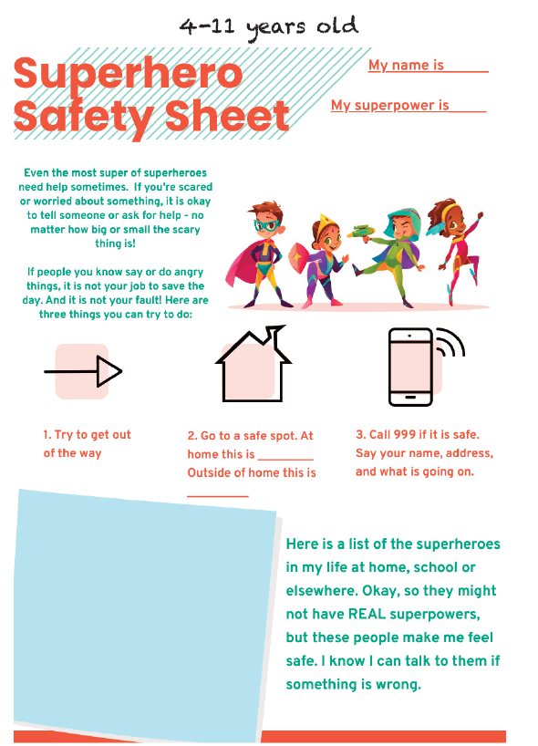**Appendix B**

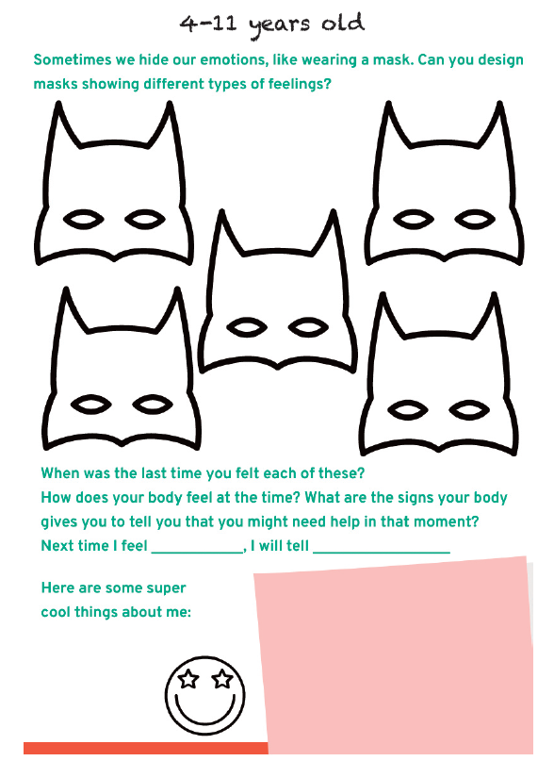

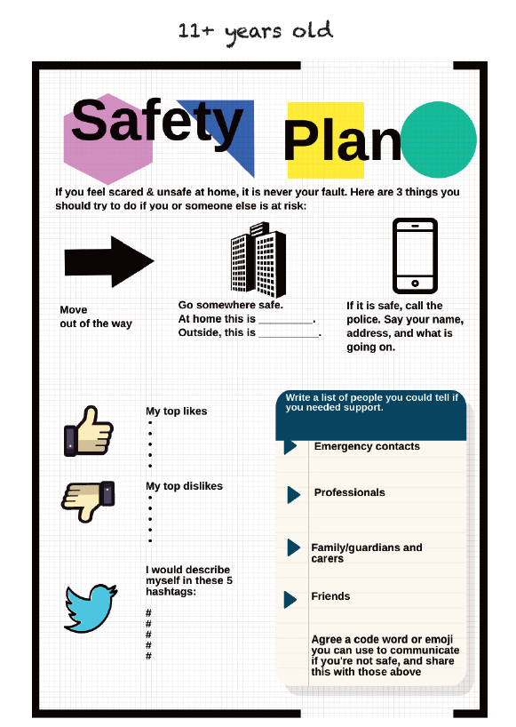

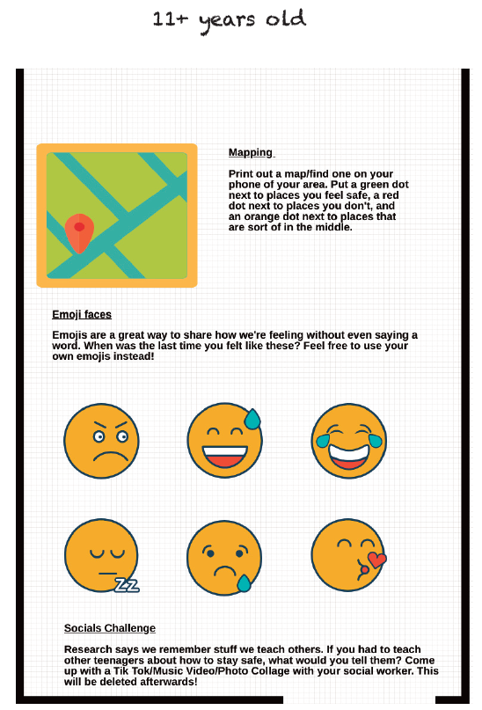

**Appendix C**

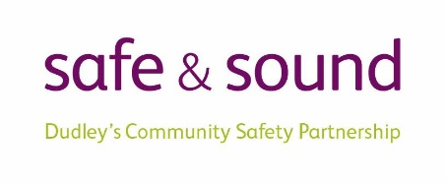

**Dudley Domestic Abuse: Directory of Specialist Services for All Ages**

**Please Note:** The below listed services operate within Dudley Borough or provide services to Dudley residents. The service delivered is either by a statutory agency or through an organisation that holds a contract with one of these statutory agencies. A comprehensive ***Dudley Domestic Abuse: Directory of Specialist Services for All Ages*** can be accessed [here](https://www.dudleysafeandsound.org/_files/ugd/970b20_b0beb4da1f6d4680943bcc01c1389498.pdf).

**Services for Adults**

|  |  |  |  |  |
| --- | --- | --- | --- | --- |
| **Organisation & Name of Service** | **Service Provided** | **Age Range for Service Provided** | **Gender for Service Provided** | **How To Access The Service (Referrals/Contact Details)** |
| **Black Country Women’s Aid** | Offers the nationally recognised Independent Domestic Violence Advice (IDVA) Service, providing support, advocacy, safety planning, and risk management to victims of domestic abuse (including Forced Marriage and Honour Based Abuse) assessed as being at medium to high-risk of harm according to the DASH risk assessment tool.  BCWA also support victims of Stalking and Sexual Violence. The service also offers advice, training and support to health professionals, relevant third sector organisations and police. | 16+ | All | **Self-referral:** Victims can refer themselves to the service, and we will complete a DASH to assess service eligibility. Depending on the level of risk service users will either be allocated an IDVA or signposted to appropriate services.  **Agency Referrals:** agencies will need to complete a referral form and undertake their own DASH risk assessment to determine eligibility for service. If help is needed in completing the DASH, our IDVAs are on hand to offer advice and guidance.  **GP Referrals:** any GP surgery that is IRIS trained. DA IDVA team.  SPOC team 01384 455411  **Regional Head of DA services:** 01384 455 411  Emails can be sent to [info@blackcountrywomensaid.co.uk](mailto:info@blackcountrywomensaid.co.uk) or via their Facebook message.  To request a referral form or to refer in: idva@blackcountrywomensaid.co.uk  Secure email for referrals: referral.team@sandwellwa.cjsm.net  Email for information, training details/dates info@blackcountrywomensaid.co.uk  The Cedar Centre Dudley Unit 5, Dudley Court The Inhedge, Dudley,DY1 1RR. |
| **Ask Marc** | Ask Marc offers men living In the Black Country specialist support around domestic abuse, rape and sexual violence, childhood sexual abuse, grooming and exploitation, stalking, forced marriage and so-called “honour”-based violence.  Ask Marc sends out a clear message of hope telling victims you don’t have to deal with it alone: someone is here to listen. | 16+ | Male and Transgender | **Email:** [info@askmarc.org.uk](mailto:info@askmarc.org.uk) or [askmarcreferrals@sandwellwa.cjsm.net](mailto:askmarcreferrals@sandwellwa.cjsm.net)  **Website:** <https://askmarc.org.uk/>  **Call:** 0121 289 6402 |
| **CHADD New Beginnings Domestic Abuse Services**  **Housing & Homeless IDVA It’s Never Too Late IDVA & refuge 55+ years Outreach& Support Groups**  **IDVA for All**  **Sanctuary Service Refuge Accommodation & Support:** | Individual projects to provide a ‘wrap around service’ for each stage of a person’s journey to safety; offering choices that enables empowerment and confidence to those who are currently or have previously experienced domestic abuse:  • Providing support, advocacy, safety planning and risk management and safe refuge accommodation to reduce the immediate risks faced and reduce the harmful effects from domestic abuse (DA).  Supporting 16+ survivors of domestic abuse from LGBTQ+, Minoritised and disabled communities. This is part of their outreach provision.  Any risk levels project dependant (high, medium, low) Including abuse by partner or ex- partner; same sex partners, LGBTQ, child to parent, adult child to parent, other family members, forced marriage, honour based violence, sexual assault. | 16+ | All | Self referral (phone) People can refer themselves to our various New Beginnings projects (including refuge) – we complete a DASH and will allocate the individual to the right service or signpost to the appropriate service.  Self-referral ‘Drop-In’ Drop-in service is to enable quick access to an IDVA who can provide immediate safety & support and make referrals to Outreach services, Refuge and any other domestic abuse support with a weekly drop-in session that is located within Dudley Council Plus Housing Department.  Agency referrals Received via a referral form, having completed a DASH risk assessment with the person they wish to refer (where possible).  • Agencies can refer directly via phone to refuge; we would also like to speak with the individual who is being referred.  • Agencies will need to complete a referral form and complete their own DASH  • When we have no vacancies we will offer to find alternative accommodation out of borough via a UK wide support network of refuges.  Contacts Outreach, Support Groups & Sanctuary services: Phone 01384 864232 Monday – Friday.  Email: Outreachpt@chadd.org.uk  Housing/Homelessness IDVA: Idva@chadd.org.uk It’s Never Too Late/Older Victims: [Idvantl@chadd.org.uk](mailto:Idvantl@chadd.org.uk)  Refuge Accommodation & Support – **Call:** 01384 864334 - 24 hours/ 7 days.  **Email:** dat@chadd.org.uk |
| **LGBT IDVA Service - Dudley, Sandwell and Walsall** | The service offers specialised LGBT IDVA support to people aged 16+ who are experiencing abuse from partners, expartners and family members.  They also support LGBT people who are experiencing or are at risk of honour-based violence and forced marriage. They can support clients who are high, medium, and low risk and we provide crisis intervention, advocacy, safety planning, emotional and practical support. | 16+ | All | **Call:** 0121 643 0821  **Website:** [https://blgbt.org/domestic -violence/](https://blgbt.org/domestic%20-violence/) |
| **Victim Support** | This service provides confidential emotional and practical help to people who have been affected by crime. They are an independent charity and victims can contact them for support regardless of whether they have contacted the police, and no matter how long ago the crime took place.  This service provide support for as long as it takes to overcome the impact of crime. They provide support to enable individuals and families to cope and recover following the impact of a crime. The services are provided through trained community volunteers in the main, but are supported by dedicated IVA (Independent Victim Advocates) working with children and young people.  The support the service provide is based on an individual’s needs assessment and can vary from emotional support to advocacy and practical help, i.e. with Criminal Injuries Compensation claims.  The service offer a range of one-to-one interventions (over the phone, face to face, and through home visits) to support people who need emotional support, whether they are referred to from the police, through another agency or contact the service independently. Support workers specially trained in Domestic Violence and Sexual Violence and Hate Crime are also available.  They also offer the iMatter Programme. Victim Support’s online iMatter programme has been designed for women aged 16 and over who have been, or are currently, victims of domestic abuse.  It is suitable for those who are not high risk, and is available in the following languages: English, Welsh, Urdu, Bengali, Polish and Gujarati.  The programme is delivered online, by Zoom, across 10 weeks in groups of up to 12 women. Sessions are facilitated by two specially-trained Victim Support staff members. Each session lasts approximately 90 minutes.  Each session focuses around group discussion and the sharing of ideas, but participants will not be asked to share anything they do not wish to. The focus of iMatter is not on individual experiences, but on helping victims of domestic abuse move on in their recovery journey.  The programme looks at the importance of self-worth, self-care and mindfulness. | 18+ | All | Any staff member will be able to take the call and then pass onto the relevant IVA Contact.  **Call:** 01384 241 511 / 0300 303 1977  **Website:** <https://www.victimsupport.org.uk>  <https://www.victimsupport.org.uk/more-us/why-choose-us/specialist-services/imatter/> |

**Services for Children and Young People**

|  |  |  |  |  |
| --- | --- | --- | --- | --- |
| **Organisation & Name of Service** | **Service Provided** | **Age Range for Service Provided** | **Gender for Service Provided** | **How To Access The Service (Referrals/Contact Details)** |
| **Barnardo’s Dudley MARAC Service** | Dudley MARAC is a therapeutic programme of support for children, young people and their families who have been identified as high risk through the MARAC screening process. Support can be provided through 1:1 direct work , Children and young people’s group work or as a family model of intervention. | 5-13 | All | **Call:** 01384 411722 or [mhwbwestmidlands@barnardos.org.uk](mailto:mhwbwestmidlands@barnardos.org.uk) |
| **Barnardo’s Dudley MARAC Service** | We provide a specialised programme for children and young people aged 4 - 18 years, who have been victims of domestic abuse. The service aims to provide holistic support for children and young people of Dudley who live in safer accommodation for example a refuge, move on accommodation or are part of the Staying Put service. | 4 - 18 | All | **Call:** 01384 411722  **Email:** [mhwbwestmidlands@barnardos.org.uk](mailto:mhwbwestmidlands@barnardos.org.uk)    **Referrals into service are in partnership with CHADD** |
| **Black Country Women’s Aid** | Young Person’s IDVA Support. | 16 – 24  25 if Care Leaver | All | Referral in to BCWA SPOC service 01384 455411 – 24 hours 7 days a week Text or WhatsApp on 07384 466 181 – messages checked 9am-9pm Monday-Friday except bank holidays (messages received at other times will be responded to within these hours).  Live chat with the SPOC on www.blackcountrywomensaid.co.uk – just look for the chat icon on the left hand side of the screen;  Web chat is open Monday to Fridays, 10am to 2pm, except on bank holidays. |
| **Black Country Women’s Aid** | CHISVA (Childrens Independent Sexual Violence advocate) | 5 – 11 | All | Referral in to BCWA SPOC service 01384 455411 – 24 hours 7 days a week Text or WhatsApp on 07384 466 181 – messages checked 9am-9pm Monday-Friday except bank holidays (messages received at other times will be responded to within these hours).  Live chat with the SPOC on www.blackcountrywomensaid.co.uk – just look for the chat icon on the left hand side of the screen;  Web chat is open Monday to Fridays, 10am to 2pm, except on bank holidays. |
| **Black Country Women’s Aid** | CHISVA | 11 – 18 | All | Referral in to BCWA SPOC service 01384 455411 – 24 hours 7 days a week Text or WhatsApp on 07384 466 181 – messages checked 9am-9pm Monday-Friday except bank holidays (messages received at other times will be responded to within these hours).  Live chat with the SPOC on www.blackcountrywomensaid.co.uk – just look for the chat icon on the left hand side of the screen;  Web chat is open Monday to Fridays, 10am to 2pm, except on bank holidays. |
| **CHADD Children Young People Workers – Refuge** | Helping Hands – Group Work A range of activities around supporting wellbeing, safety and confidence building. | 6 – 12 | All | CHADD in house service. |
| **DMBC Families Come First** | A Child In Need team which sits within Childrens service that offer CHIDVA and IDVA support for both Domestic Abuse and Child to Parent Violence.  CHIDVA support is available for young victims/survivors up to their 18th birthday, or 25 for Care leavers or those with learning difficulties, whilst the IDVA can support any family member experiencing behaviours used by a person to control, dominate, threaten or coerce. The IDVA will create a practical guide that helps to lower the risk of being hurt by the abuser and understand what a healthy relationship looks like. | Children up to the age of 18 or 25 for Care Leavers or those with learning difficulties, alongside their parents and/or carers | All | Internal referrals can be made via LCS or EHM.  **Call:** 01384810647  <https://www.dudley.gov.uk/residents/care-and-health/children-and-family-care/families-come-first/> |
| **Family Nurse Partnership** | A targeted service for young mothers where support is provided for young parents, including those affected by domestic abuse. | Under 19 (have to be age 19 when the baby was conceived) and up to 24 (If they are a Care Leaver only). | All | **Website:** <https://www.dudleyfnponline.com/>  **Call:** 01384 366662 |
| **Foyer (CHADD)** | Young Peoples Supported Accommodation. | 16 – 25 | All | **Call:** 01384 455464  <https://www.chadd.org.uk/on-route-foyer/> |
| **Kooth** | Kooth provides online support and counselling children and young people and are commissioned by Public Health. | 11 – 25 | All | **Website:** https://www.kooth.com/ |
| **Phase Trust** | This service offer support and mentoring for young people, addressing their emotional health and well-being.  The Phase Trust also works with young people were harmful sexual behaviour, criminal exploitation and child sexual exploitation may be a concern. | 17 + | All | **Call:** 0121 585 9419  **Email:** [info@phasetrust.co.uk](mailto:info@phasetrust.co.uk)  <https://phasetrust.org.uk/> |
| **The What Centre** | Counselling Services - Group and one to one session for children and young people | 9 – 25 | All | **Call:** 01384 379992  **Email:** [thewhatcentre@hotmail.co.uk](mailto:thewhatcentre@hotmail.co.uk)  <https://www.thewhatcentre.co.uk/> |