www.westsussex.gov.uk
Domestic Abuse Officers:

Protocol, Procedures and Guidance on Referrals

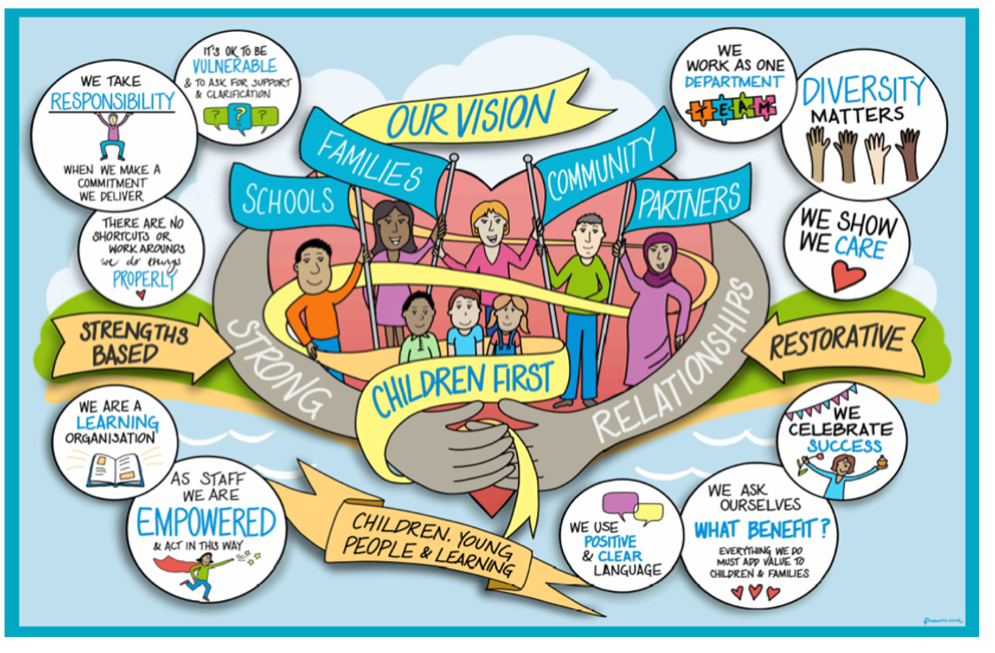

Review / Contacts / References
Document title: | Domestic Abuse Officers: Protocol, Procedures and Guidance on Referrals
Date approved: | 28/07/23
Approving body: | Policy & Practice Steering Group
Last review date: | 25/05/23
Revision history: | Version 1
Next review date:
Document owner: | Alistair Sherlock, Family Safeguarding Team Manager (Domestic Abuse Officers)
Lead contact / author: | Alistair Sherlock, Family Safeguarding Team Manager (Domestic Abuse Officers)
Contents
1. Introduction 3
2. Team Structure 4
3. Referrals into the team 5
4. Allocation of cases 6
5. Domestic Abuse Officer Pathway 8
6. Appendix documents 10

1. Introduction
The Family Safeguarding Team (FST) recognises the importance of adult workers to work across the service to support bringing about changes to children and families’ lives. One of the principles of the service is the use of ‘motivational interviewing’ techniques to motivate parents to make and maintain changes and reducing the risk of significant harm to children. The aim is for more children to remain in their homes with parents/carers who are provided with tools and strategies to parent safely, and for Children’s Services not to be a ‘revolving door’ for families (that is, for families not to keep returning to the attention of Children’s Services). The MI approach is embedded as part of the FST model and helps ensure shared language and understanding.
As part of this work, the FST has appointed adult workers within the teams spread across all three areas of the county (Central, East and West). This protocol relates to the Domestic Abuse Officer role, who work with parents who have perpetrated domestic abuse. This guidance is designed to better identify the work required, to promote the effectiveness of the referral system, and to ensure consistency across the service. It will support all professionals in sharing risk and review how families move through the cycle of change. It allows concerns to be addressed holistically within a family unit.
The Senior Domestic Abuse Officer (Team Manager) will manage the referrals and allocate work to the domestic abuse officers. Domestic abuse officers, once allocated a case, will work closely with the allocated social worker and will undertake a range of work with perpetrators. This includes:
- Completing risk assessments
- Assisting with risk management planning
- Supporting safety planning for survivors
- Delivering individual interventions
- Delivering group-work interventions
- Raising awareness of the impact of domestic abuse on children
- Evaluating the outcomes of group work programmes
- Providing support and advice regarding Court Orders
- Contributing to service development through consultations, training and support
The one-to-one work completed by the domestic abuse officers can be bespoke to the perpetrator’s situation or may follow the group-work programme outline. Work can be completed as part of a Child Protection Plan, Child in Need Plan, as part of the Public Law Outline (PLO), or Care Proceedings. However, work should not be directed as part of any of these proceedings, as the service is based on consent.

2. Team Structure
Domestic abuse officers are seconded from the Probation Service. The Senior Probation Officer who holds the role of Team Manager oversees the team across West Sussex, manages referrals and allocates work. Members of the team are either Qualified Probation Officers (PO) or Probation Service Officers (PSO). PO’s generally work with the more complex and challenging cases. The team should comprise a total of 13 members with 1 x SPO, 3 x PO and 9 PSO.
During the term of the secondment and in this guidance POs and PSOs are referred to as Domestic Abuse Officers (DAO). A DAO is attached to a Family Safeguarding Team (see below); however, DAO’s work across all teams, not just for the team they are based in.
Central
Adur/Worthing & Horsham
Bridge House (Worthing)

FST 1 | FST 2 | FST3 | FST 4 | FST 5 | FST 6 | FST 7 | FST 8
 | Sophie Hide | Amy Mitchell |  | Jon Potter

Western
Arun & Chichester
Durban House (Bognor)
St James (Chichester)
FST 1 | FST 2 | FST3 | FST 4 | FST 5 | FST 6 | FST 7 | FST 8

Eastern
Crawley Library (Crawley)
Sydney West (Burgess Hill)
FST 1 | FST 2 | FST3 | FST 4 | FST 5 | FST 6 | FST 7 | FST 8

3. Referrals into the team
Criteria
There are no strict criteria in place regarding referrals for risk assessments or intervention work; however, there are some general principles which need to be followed. See Screening Form (appendix) for more information on this. All intervention work including the delivery of Better Me, Better Us must be informed by a risk assessment.
- DAO’s work with male and female perpetrators of domestic abuse, over the age of 18 years who are resident in West Sussex.
- The perpetrator must be willing to work with the DAO and have shown some recognition that their behaviour has been abusive. They must have already provided their informed consent to engage with the team (see Consent Form in appendix).
- There must be current or recent domestic abuse (e.g., in the preceding 18 months), which refers to behaviour from one adult to another.
- The behaviour to be addressed must constitute domestic abuse. If the concerns are better explained through the principles of parental conflict, especially post-separation conflict, the DAO or Team Manager can provide advice on direct work that the allocated social worker or family support worker could complete instead.

- The family must remain open to the Family Safeguarding Team for the duration of the intervention. The DAO’s cannot work with families being stepped down to Early Help. The only exception is applied to families working with the Children, Young People & Learning Team.

- The perpetrator should not be able to access domestic abuse perpetrator work via another route which would be more appropriate (e.g., the Probation Service).

- The perpetrator needs to be able to attend office-based appointments in West Sussex.

- Where Service Users are subject to ongoing Police investigation the case may not be accepted but the allocated DAO will carry out checks with the Police to ensure that any potential contact made by the team does not have untended consequences in respect of ongoing investigations and court outcomes.

- As our service is consent-based, we do not generally accept referrals for cases which have already progressed to Family Court, except in specific circumstances (e.g., case already in court arena following allocation from the assessment team). Work should never be directed or made compulsory as part of Care Proceedings.

Referrals Process
- The social worker should complete a ‘DAO/DAP Request for Service and send this via Mosaic. They should also attach a signed Service User Consent Form.
- The DAO or Team Manager will arrange a case discussion with the social worker to explore information about the key issues, what work is required, and the purpose of the work.
- A three-way meeting with the social worker and service user should be arranged (if appropriate); alternatively, the DAO should be invited to the next multi-agency meeting to facilitate contact with the parent.
- The social worker should ensure that the allocated DAO is invited to future core group meetings, Review Child Protection Conferences, Child in Need meetings, and group case supervision sessions. It is vital that workers are invited to group supervision meetings in advance so they can prioritise attendance.
- The next steps are covered below in the section regarding the DAO pathway.

4. Allocation of cases
All referrals should be sent via Mosaic as a Request for Service - Domestic Abuse Officer (Probation). All referrals need to evidence the service has been discussed with the potential Service User and a copy of the Consent Form is attached.
The Team Manager will acknowledge receipt of the referral and inform the social worker of the next steps. The Team Manager is responsible for allocating cases to an appropriate DAO, depending on staff workloads and risk level. Caseloads will be monitored through management oversight of cases that are being closed and during clinical supervision. Where cases are not accepted a case consultation may be offered.
Cases will be allocated dependant on who has been waiting the longest and who is assessed as a priority. Once a case is allocated, it is expected that the DAO will liaise with the allocated social worker and arrange a consultation, and a joint meeting with the client as soon as possible.
If all DAO’s are at full capacity, new referrals will be added to the waiting list. If someone is placed on a waiting list, the Team Manager will communicate to referrers when they are getting towards the top of the waiting list, with a view that the social worker will give notice to the parent and help motivate them to engage with the DAO.
Any urgent referrals need to be endorsed by the FST Service Manager and the DAO Team Manager. Dependant on agreement by both, these may be prioritised over other cases waiting. This would usually involve an immediate concern in relation to potential risk of harm to the child.
At times it might be necessary for DAO’s to work across teams within their office locations and across the county. Working outside the team structure will be considered to ensure an equal workload across the DAO’s, manage fluctuations in team workload / referrals, manage varying workload commitments (e.g., when an officer is delivering the group programme), and cover any absences or vacancies.
Caseloads
Each case will have different needs and will therefore attract a different level of resource from professionals. Individual DAO caseloads are expected to be in the region of 15 cases at any one time. Staff workloads will be managed via the Team Manager through monthly supervision and additional support when needed.
It will be the DAO’s responsibility to prioritise their cases in conjunction with support given by the Team Manager. When prioritising within their workload, DAO’s will consider what the current risk is and which referral is a priority through considering the individual circumstances of the cases – for example, whether the perpetrator and victim are living together or still having contact, any recent police call outs, how motivated the individual is, whether any work has been completed previously, etc.
Risk Escalations
Where an increase or escalation in risk is identify by the DAO it will be incumbent on them to share the concerns with their Team Manager and other professionals involved with the family. This might be identified through direct interaction with the client or from information obtained from other sources such as police. Where a risk escalation is identified there will be consideration as to the safety of continuing to offer the DAO intervention. If the intervention is suspended this will be communicated with the victim/survivor and the perpetrator along with a supporting rationale if appropriate to do so.
Professional Disagreements
DAO will attend the social workers Group Supervision sessions. The focus of these sessions is to review the work on each family and give input on the intervention being delivered via the DAO team. There is also a need to propose a level of risk/need and make suggestions for future areas of focus. During these discussions it is anticipated that there will be instances where professionals are not all in agreement. This is inevitable, where each professional is working with a different member of the family they will be exposed to different behaviours, attitudes and presentation. Where professional disputes occur, this should be brought to the attention of the DAO Team Manager at the earliest opportunity. Team Managers will seek to resolve professional disagreements and identify a plan to move forwards.

Cases already working with Probation Services
When referrals are received and the individual is already working with the Probation Service, careful consideration will be given as to whether the DAO can add further value. If an individual is already able to access perpetrator intervention support via the Probation Service, they will not be considered for support by a DAO unless there are exceptional circumstances. Should DAO’s have need to accept referrals for current Probation cases, the statutory responsibility will remain with the relevant Probation Practitioner, who will be responsible for enforcing the Order or Licence.
The DAO team can offer support to social workers to facilitate improved communication with the Probation Service where required.

5. Domestic Abuse Officer Pathway

Following the referral and consultation, a DAO will be formally allocated to work with the person using harmful behaviours. The DAO completes a risk assessment on the individuals they work with. This can take in the region of six weeks in order to obtain information from various sources (e.g., Police, Probation, MARAC, IDVAs etc), consult local systems, and interview the perpetrator. In some cases, it may be necessary to gather information from the victim, which may be completed by the DA Practitioner or social worker. It may also be necessary to speak with previous or current partners in some cases. The DAO may complete other assessments to inform their risk decisions, including the Spousal Assault Risk Assessment (SARA) and a Behaviour Inventory.
Should the risk assessment conclude that further work is needed, an Action Plan will be developed with the perpetrator identifying the proposed intervention. Such interventions could comprise of one-to-one work and / or the group work programme, “Better Me, Better Us”. In some circumstances, it might be suitable to do some joint work with both parents; this will be discussed with the social worker and DA Practitioner and undertaken as appropriate.
All intervention appointments will be recorded on the Workbook embedded in Mosaic. Once the work is completed, a final summary will be completed.
Risk assessments and reports can be presented to CIN/Child Protection conferences, taking into account confidential information and the safety of sharing this information in such a forum (see below).
Risk assessments which are required as part of court proceedings need to be discussed with the Team Manager in advance of any proposal being made. These reports must be completed by a qualified probation officer to ensure they are defensible in a formal legal setting, and as such staff workloads will need to be considered. There could be exceptions to this but all potential consequences and defensible decision making need to be considered.
Confidential Information
As part of the risk assessment process, the DAO will likely obtain information from the victim or other sources that cannot be shared with the perpetrator to ensure that risk is not increased. This information should be recorded in a separate confidential report.
When considering disclosure, the following principles should be met:
- The social worker should seek informed consent from the perpetrator prior to a referral being made (Consent Form in appendix). Open information sharing is a vital requirement of the work offered.
- The safety of the child and adults is the key focus when considering the issue of sharing / not sharing information.
- Information that will increase the risk of harm to the victim should not be shared with the perpetrator; it could also increase the risk of harm to the child. This would include information disclosed by the victim relating to abusive behaviours from their partner, which have not previously been shared in a public arena, and to which the perpetrator might react abusively upon discovering these things have been shared.
- All confidential information not suitable to be shared should be clearly labelled as such.
- Should it be felt that information from the victim needs to be shared more widely (e.g., via court proceedings), then this should be discussed with the victim, the potential consequences explored, consent obtained, and safety measures taken as appropriate. Caution should be applied as to the extent of the detail shared and where concerns are raised only what is absolutely necessary and proportionate to manage risk should be shared.
- Information from the perpetrator will generally be shared with the victim / other professionals unless otherwise requested by the perpetrator and where keeping the information confidential would not undermine the management of the case. For example, if information is known that a perpetrator has been in a previously abusive relationship, but the perpetrator requests that this be kept from his partner, consideration must be taken as to whether the partner needs to know in order to keep her children and herself safe.
- With any disclosures that are deemed to be necessary, the perpetrator should be given the opportunity in the first instance to share the information with the relevant parties and be supported in doing so. A further check will be necessary to confirm the disclosure has been made.

- All staff should adopt a transparent and honest approach by explaining the above principles to parents at the beginning of any work being undertaken with them.
Workbooks and Group Supervision
During the process of assessment and delivery of intervention the DAO will be required to complete the relevant workbooks. These fall under two heading, Workbook Summary and Programme Summary. During the assessment phase and in the delivery of any intervention that is not the structured Better Me Better Us programme, a record of work must be recorded on the Workbook Summary in Mosaic. If the client moves onto a programme this is, then recorded in the Programme Summary. The use of the workbooks does not replace the use of the Healthy Relationship Assessment, or any post intervention report they service different purposes and should all be completed.
Group Supervision led by the social worker’s Team Manager is undertaken once a month, the DAO should ensure they are aware of the date and time of the Group Supervision and use this to plan their completion of the relevant workbook. The workbooks must be “completed” two working days in advance of the Group Supervision with a new one being opened where the work with the client will continue. For further information please review the Family Safeguarding Model guidance on Tri.X.

6. Appendix documents
- Screening form
Guidance to assist social workers to determine whether a case is suitable for DAO intervention work.

- Consent form
To be completed prior to referral to DAO services. Open information sharing is an important condition of the role.

- Healthy Relationships Assessment
To be completed with all clients referred to the service by the DAO. This will then guide the next phase of intervention or decision to close.

- Risk Assessment – Confidential Information
Completed by DAO following interview with victim / partner. Not to be shared with perpetrator.

- Addendum Risk Assessment
Completed by DAO when reviewing original risk assessment.

- Action Plan
May be completed with DAO and perpetrator following risk assessment where further work is recommended. The Action Plan will reflect the plan of action both DAO and perpetrator have agreed upon. (Plan may need to consider recommendations from CP conferences/ core group meetings/ group case supervision).

- Post-Intervention Report
Completed by DAO once one to one work has been completed to summarise work completed and progress made.

- Post-Programme Report
Completed by DAO once the groupwork ‘Better Me, Better Us’ has been completed. Report summarises perpetrator’s engagement on programme and progress made.

Domestic Abuse Officer Referrals – screening form

The following guidelines are to help you determine whether an individual is suitable to be referred for intervention work with the domestic abuse officer team.

- Is the individual already subject to Probation Service supervision?
☐ Yes, they are already working with probation – Those on probation are already able to access domestic abuse intervention work, and as such they are not eligible for DAO support as well. If you are unsure, please enquire with the DAO team to check. You can still book a consultation for advice and guidance.
☐ Yes, but they are due to finish soon – Proceed to question 2.
☐ No – Proceed to question 2.

- Has there been a domestic abuse incident within the past 18 months?
☐ Yes – Proceed to question 3.
☐ No, but domestic abuse is the reason SCS are involved – Proceed to question 3.
☐ No, there has only been historical abuse – Most cases of historical abuse are not eligible for DAO intervention. Please check with the DAO team before making a referral. You can still book a consultation for advice and guidance.

- Has the individual given informed consent to engage with domestic abuse perpetrator intervention? Informed consent means that they know why they have been referred and the type of work being offered. Please ask them to sign the consent form (attached) and provide a leaflet about the service.
☐ Yes, the individual is fully aware of the referral – Ensure they have signed the consent form, and proceed to question 4.
☐ No, the individual is not aware they are being referred or has not given informed consent – Those who do not consent to engage with DA perpetrator intervention are not eligible for our service. Please arrange a consultation with the DAO team if support is required.

- Does the individual recognise they have behaved abusively in some way? Do they show a desire to change?
☐ Yes, they recognise at least some of their abuse and want to change (DECISION / ACTION STAGE) – Proceed to question 5.
☐ Partially, they recognise at least some of their abuse but are ambivalent about change (CONTEMPLATION STAGE) – Proceed to question 5, some motivational work may be needed first.
☐ No, they deny having behaved abusively and/or show no desire to change their behaviour (PRECONTEMPLATION STAGE) – The individual is not eligible for DAO intervention, as extensive motivational work is required first. You can still book a consultation for advice and guidance.

If you have ticked only green boxes, it is likely that the individual would be suitable, and we recommend you make a referral via DAOfficer.Referrals@surreycc.gov.uk.

If you have ticked any red boxes, you can still make a referral, but the individual is unlikely to be accepted for intervention work unless circumstances change. A consultation can be arranged to offer you support and guidance.

Consent Form – Domestic Abuse Officer intervention

You are being asked to sign this document because a request has been made for you to engage with a Domestic Abuse Officer (DAO). DAOs are employed by the Probation Service and have been seconded into Surrey Children’s Services to undertake work in relation to domestic abuse. This may include completing a risk assessment and/or ongoing intervention work. A leaflet about this service should be provided to you which explains the nature of the referral.
It is a requirement that in completing the risk assessment and/or interventions, the DAO will utilise information from and make contact with statutory organisations. This includes:
- Police
- Probation Services
- Children’s Services
In certain circumstances, we may also need to liaise with the following organisations. Please indicate if you do not give consent for any of the following to be contacted:
- Drug and Alcohol Support Services (external)
- General Practitioner
- Community Mental Health Recovery Service
- Other:
Anything which is discussed with a Domestic Abuse Officer can be used to inform the risk assessment. Once complete, the risk assessment is the property of Surrey County Council.
There is open information sharing within the Family Safeguarding Team. All information collated is recorded within case records and is regularly reviewed by the social worker, the team manager, and other staff within the Family Safeguarding Team.
Consent
I ……………………………………………………………… consent to Surrey County Council referring me to the Domestic Abuse Officer Team for a risk assessment and/or perpetrator intervention work. I have read and understand the above conditions and have been provided an opportunity to ask questions about this. I have been provided with a leaflet to explain the DAO service.

Signature:

Name: Date:

Healthy Relationships Assessment
Workbook V1

Participant’s Name:

Participant’s D.O.B:

DAO Officer:

Start Date:

Case Reference no:

Social Worker:

Consent Form – Domestic Abuse Officer Intervention

You are being asked to sign this document because a request has been made for you to engage with a Domestic Abuse Officer (DAO).

DAOs are employed by the Probation Service and have been seconded into West Sussex Children’s Services to undertake work in relation to domestic abuse. This may include completing a risk assessment and/or ongoing intervention work. A leaflet about this service should be provided to you which explains the nature of the referral.

It is a requirement that in completing the risk assessment and/or interventions, the DAO will utilise information from and make contact with statutory organisations. This includes:
- Police
- Probation Services
- Children’s Services

In certain circumstances, we may also need to liaise with other organisations. Please indicate if you do not give consent for any of the following to be contacted:
- Drug and Alcohol Support Services (external)
- General Practitioner
- Community Mental Health Recovery Service
- Other:

Anything which is discussed with a Domestic Abuse Officer can be used to inform the risk assessment. Once complete, the risk assessment is the property of West Sussex County Council and will be shared with the social worker.

There is open information sharing within the Family Safeguarding Team. All information collated is recorded within case records and is regularly reviewed by the social worker, the team manager, and other staff within the Family Safeguarding Team.

Consent

I …………………………………………………………………………….. consent to my social worker referring me to the Domestic Abuse Officer Team for a risk assessment and intervention work (if suitable). I have read and understand the above conditions and have been provided an opportunity to ask questions about this. I have been provided with a leaflet to explain the DAO service and what this entails.

Signature:

Name: Date:

Assessement structure

Session | Objective | Tasks
One  (2hr session) | Develop understanding and create motivation | - Consent Form/ Introduction  - Why am I engaging? Questionnaire  - Expectations & Goals  - Self-Assessment Questionnaire  - Risk & Needs  - My Relationship Circle  - Introducing Life Map (Homework)
Two  (2hr session) | Digging deeper - evaluation phase | - Check In (Police Callouts/ Change in Relationships)  - Review Life Map  - What are you worried about?  - Storyboarding  - What makes a good relationship? (Equality Wheel)
Three  (2hr session) | Understanding risk in my relationship | - Check In (Police Callouts/ Change in Relationships)  - Reflections of Equality Wheel  - My Relationship (strengths & areas for improvement)  - Relationship Health Check  - Behaviour Inventory
Four  (2hr session) | Managing Behaviour and creating an action plan | - Check In (Police Callouts/ Change in Relationships)  - Reflections of Power & Control Wheel  - Behaviour Inventories  - Self-Control  - Action Plan/ Next Steps

Session one

Why Am I Engaging? Questionnaire

On a scale 1 – 10, say how important each of the following reasons is to you for seeking support.

- To avoid trouble with the police / courts.
- To preserve or resume the relationship with my partner.
- To impress or prove something to my partner.
- To maintain or gain contact with my children.
- To gain the approval of people other than my partner (e.g., social services, family).
- To stop being abusive or violent to my partner / future partners.
- In your own words, why have do you believe you have been referred to this service?

…………………………………………………………………………………………….
…………………………………………………………………………………………….
…………………………………………………………………………………………….
…………………………………………………………………………………………….

My Expectations & Goals

My expectations of this intervention are?
What’s expected of me?
- (e.g. I recognise that I must be open to change)

My goals?
- (e.g. I want to achieve…..)

Self-Assessment Questionnaire (SAQ)

Are any of these a problem for you? | Yes | No | Tick if you would like help/ support with this
Accommodation
Finding a good place to live
Maintaining your accommodation
ETE
Reading and/or writing skills
Getting a job
Keeping a job
Getting qualifications
Finances
Managing money
Dealing with debts
Health
Worrying about things
Experiencing thoughts of suicide or self-harm
Feeling depressed
Diagnosed / undiagnosed mental health needs
Relationships/ Support network/ family
Looking after my children
Getting on with my partner
Getting on with my parents
Understanding other people’s feelings
Alcohol/ drugs
Using drugs
Drinking too much alcohol
Alcohol and/or drugs get me into trouble
Lifestyle/ use of time
Getting on with people in authority
Mixing with people that cause me trouble
Being bored
Setting goals and keeping to my plans
Involvement with the criminal justice system
Emotions/ thinking skills
Getting violent when annoyed
Losing my temper
Solving my problems
Is there anything else that causes you a problem?

RISK & NEEDS (Current Situation)

Accommodation

Drugs/ Alcohol

Employment/ Finances

Emotional Wellbeing/ Health

My Relationship Circle

Me

Who is in your relationships circle?
How important are they?
Are the a Red or Green flag

Life Map

Life maps are an accessible and familiar way of helping participants reflect and look back over their life and to identify learning, events, influences and experiences that they feel have shaped the way they think, feel and behave. They can also be a useful means of helping participants to start thinking about how these things are related to their violent and aggressive behaviour in their relationships. There are many different ways of constructing a life map depending on what it is that you want to achieve. In this case the aim of the exercise is, as outlined above, to gain a greater understanding of the participant by looking at important developmental areas including;
• Background influences
• Learning history including things that reinforce and maintain aggressive and nonaggressive behaviour
• Beliefs related to issues such as masculinity and the use of violence and aggression in
relationships
• The origin of hostile attribution biases i.e. a tendency to perceive hostile intent on the part of others even when there’s no evidence that others mean or intend harm.
• Existing skills including the participant’s ability to act in a positive, non-violent manner
Example:

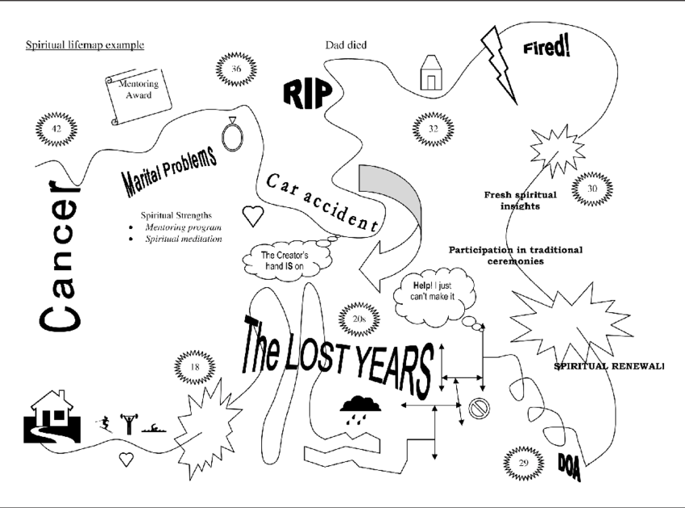

My Life Map:

Session Two

What are you worried about?

What are you worried about currently?

What do you think the local authority are worried about?

What have you already done to address this?

What steps do you need to take next?

What help might you need? Who might be able to help you?

Why is it important to make these changes?
Storyboarding

Discuss an incident with your partner or ex-partner which didn’t go well. Try to focus on your own behaviour and what you could have done differently, prompt with using “I” statements.
What happened leading up to the incident? (e.g. how was your day, was anything on your mind, how were you feeling generally)

How did the disagreement start?

Was there a trigger just before?

What did you do during the incident?

What did you do afterwards? Where did you go?

What were the consequences? (Long and short term)

What could you have done differently? What difference would it have made?

WHAT MAKES A GOOD RELATIONSHIP?

Aim:
To increase the participants motivation to change by creating some dissonance between what he wants from a relationship with a partner and what is abusive behaviour will result in.

Method:
List the qualities of a good relationship with partner. Write down what makes a good relationship. A way into this exercise is to ask him to name a couple who have had a good relationship or do still have a good relationship and describe the qualities

Discuss the Equality Wheel.
List the behaviours that present obstacles to achieving a good relationship with a partner.

EQUALITY WHEEL

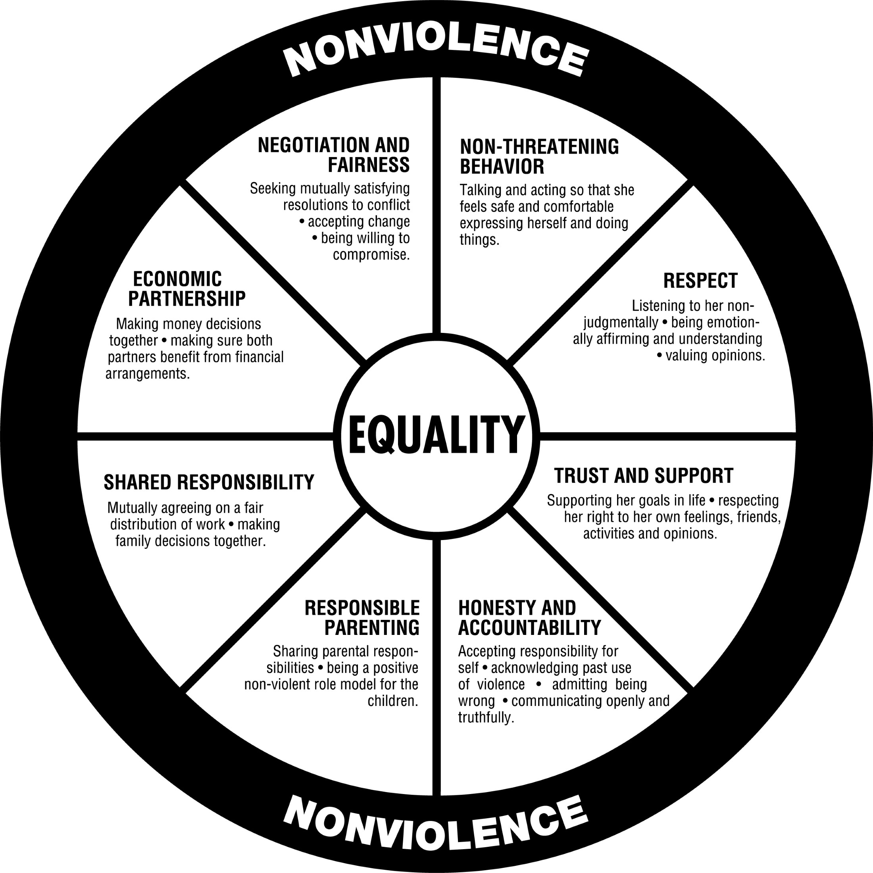

My Relationships
In a relationship we all have strengths, areas to develop and triggers. In your past and current relationships, consider the following.
My Strengths are? | I’d like to improve? | I need to focus on…

Recognising when we are being unkind or disrespectful in a relationship can be hard to identify and even harder to accept. However, identifying the unhelpful behaviour enables self-reflection and growth, which will ultimately lead to healthier and happier relationships.
The below diagram is entitled the Power and Control wheel, with your officer, explore and discuss this tool

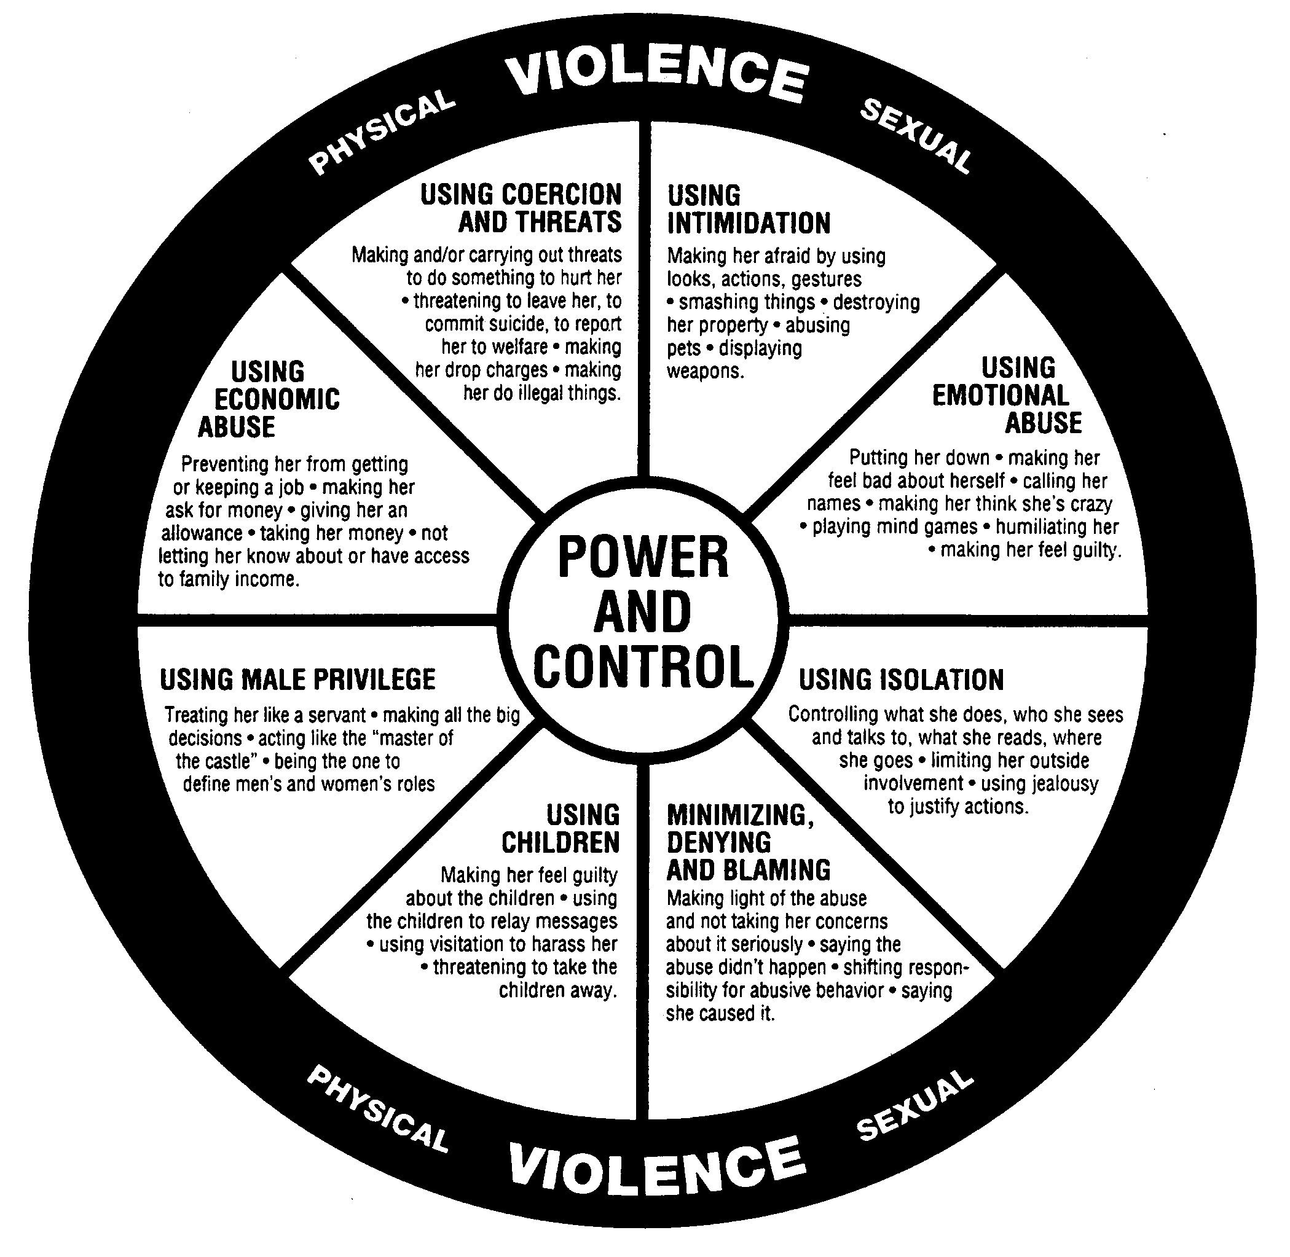

Session three

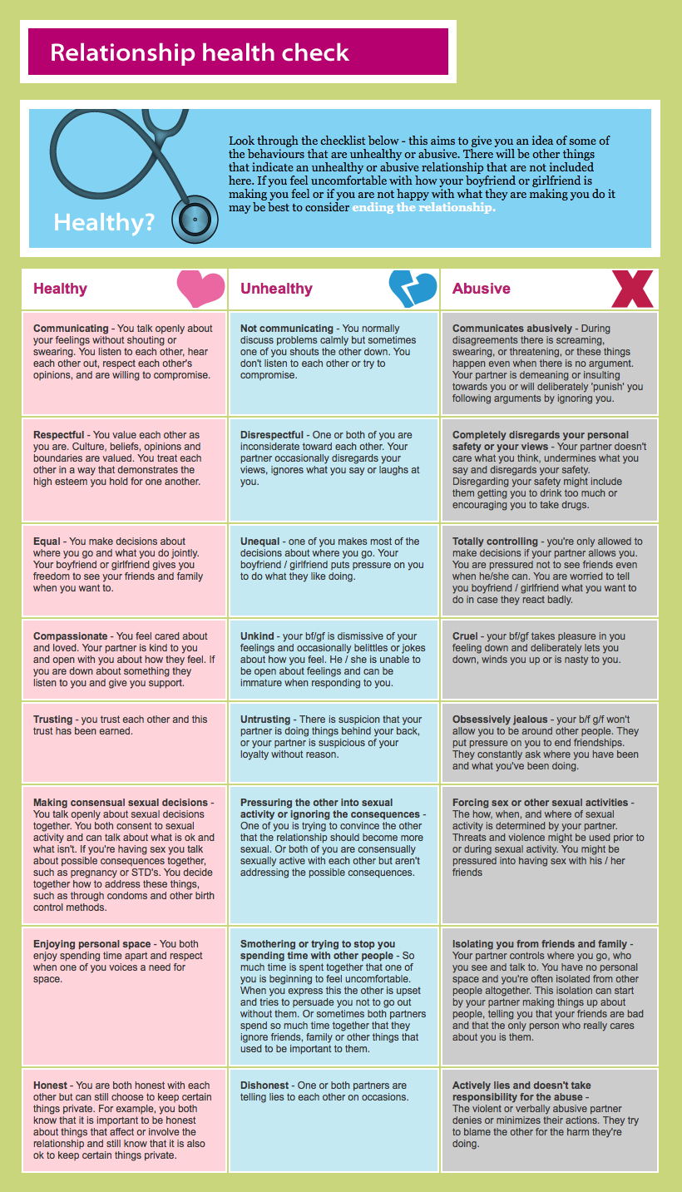

Behaviour Inventories

Name: |  | Date:

Abuse
?  Don’t Know | 0  Never | 1  Once | 2  Occasionally | 3  Frequently | 4  Constantly

Score yourself here – what I did | Instructions: Using the scale above, place a score in each box in the left-hand column to indicate how often you have behaved towards your (ex-) partner in the way described. Then score them in the right-hand column. Delete or change any words that don’t apply.
 | Insulted them (such as calling them a hurtful name)
 | Humiliated them (made fun of them)
 | Told them that they were worthless or ugly
 | Told them that they were stupid or mad
 | Told them that they were a bad parent
 | Told them that no one else would put up with them
 | Told them that they wouldn’t be able to cope on their own
 | Tried to stop them having contact with their friends or family
 | Insisted on accompanying them whenever they went out
 | Locked them in
 | Insisted on knowing who they were with at all times you were not together
 | Accused them unfairly of having sex with other people
 | Followed them or checked up on them when you were not together
 | Threatened to kill yourself if they left you
 | Threatened to report them to the police/social services/immigration if they left you
 | Threatened to kidnap the child/ren if they left you
 | Told them that you would never let them bring up the child/ren with another partner
 | Insisted they obey you or tried to control just about everything they did
 | Insisted they carry out housework to your standard
 | Forced them to cook meals that you chose
 | Forced them to wear clothes or make-up that you chose for them
 | Controlled the money (e.g. dictated how the family income was spent)
 | Put them on an “allowance” or made them ask or beg for money
 | Made them account for every penny they spent
 | Made false allegations about them to the police/social services
 | Frightened them with your temper
 | Punched or kicked the door, wall or furniture
 | Stopped them using the phone to get help
 | Intentionally damaged their clothes, possessions or property
 | Swore and shouted in their face
 | Physically threw them out of the home
 | Smashed plates or threw food or objects around
 | Threatened them by raising your fist at them
 | Threatened them with an object
 | Threatened to kill them

Violence
?  Don’t Know | 0  Never | 1  Once | 2  Occasionally | 3  Frequently | 4  Constantly

Score yourself here – what I did | Instructions: Using the scale above, place a score in each box in the left-hand column to indicate how often you have behaved towards your (ex-) partner in the way described. Then score them in the right-hand column. Delete or change any words that don’t apply.
 | Spat at them
 | Poked them with your finger
 | Pushed them
 | Dragged them by the clothes, arm, leg or hair (delete as necessary)
 | Held them by the arms or shoulders
 | Grabbed or shaken them (delete as necessary)
 | Pinned them up against the wall
 | Pulled their hair
 | Thrown them around
 | Twisted or bent their finger, arm or leg (delete as necessary)
 | Pinched, scratched or squeezed them (delete as necessary)
 | Bitten them
 | Poured or thrown a drink or other liquid over them (delete as necessary)
 | Thrown things at them that could hurt
 | Burnt them with a cigarette
 | Slapped them
 | Hit them with the back of your hand
 | Punched them to the arm, leg, body, head or face (delete as necessary)
 | Kicked them in the arm, leg, body, head or face (delete as necessary)
 | Banged their head
 | Head-butted them
 | Pushed them down the stairs
 | Smothered their mouth
 | Held them by the throat
 | Tried to choke or strangle them
 | Hit them with an object
 | Stabbed them
 | [Male partner only] Assaulted your partner when you knew she was pregnant
 | [Male partner only] Punched your partner in the abdomen when you knew she was pregnant

Note: Inventories developed by and used with permission of Calvin Bell at Safer Families/ Ahimsa.

My Self Control….

I struggle to maintain self-control when…
I find it easier to maintain self-control when…

Action Plan

Name: |  | Start date:
SAQ items:

What is the issue? | What are we trying to achieve? | What will we do?  Who will be responsible? | When will we review/ completed by? | Outcome
Service User Signature: |  | DA worker signature: |  | Date:

Session Four

Spousal Assault
Risk Assessment Guide

Name of Accused: |  | DoB:
Name of Assessor: |  | Title:
Signature: |  | Date:

Criminal History | Rating  (0-1-2) | Critical Item  (Check box)
- Past assault of family members
- Past assault of strangers or acquaintances
- Past breach of conditional release or community supervision
Evidence:

Psychosocial Adjustment | Rating  (0-1-2) | Critical Item  (Check box)
- Recent relationship problems
- Recent employment problems
- Victim of and/or witness to family violence as a child or adolescent
- Recent substance abuse/dependence
- Recent suicidal or homicidal ideation/intent
- Recent psychotic and/or manic symptoms
A provisional score only can be entered on evidence of presenting behaviour - if a MH assessment is unavailable
- Personality disorder with anger, impulsivity, or behavioral instability
A provisional score only can be entered on evidence of presenting behaviour - if a MH assessment is unavailable
Evidence:

Spousal Assault History | Rating  (0-1-2) | Critical Item  (Check box)
- Past physical assault
- Past sexual assault/sexual jealousy
- Past use of weapons and/or credible threats of death
- Recent escalation in frequency or severity of assault
- Past violation of “no contact” orders
- Extreme minimisation or denial of spousal assault history
If appropriate, take into account evidence from current offence(s)
- Attitudes that support or condone spousal assault
If appropriate, take into account evidence from current offence(s)
Evidence:

Alleged (Current) Offence | Rating  (0-1-2) | Critical Item  (Check box)
- Severe and/or sexual assault
- Use of weapons and/or credible threats of death
- Violation of “no contact” order
Evidence:

Other Considerations |  | Critical Item  (Check box)

Summary Risk Ratings
 | Low | Moderate | High
1. Imminent risk of violence towards partner
2. Imminent risk of violence towards others
Specify:

Risk Assessment

Name of parent:
DOB of parent:
Name of child(ren):

Sources of Information
PSR, previous convictions, police callouts, interview, home visits, CSF assessments (don’t forget to include dates)

Other assessments
SARA, behaviour inventory

Family information/ other relevant individuals
Parents, children, siblings, partner

Other agencies involved
Probation, drug / alcohol agencies, mental health (include what work has been completed with other agencies)

Concerning behaviour / offences / convictions
Drugs, domestic abuse history, alcohol, previous thinking patterns and behaviour, attitudes, willingness / motivation to change, mental / emotional health and wellbeing

Strengths
Progress / changes made already, support available, how can strengths manage / reduce risk

Risk of harm / risk of re-offending
Who is at risk?

What is the nature of the risk?

When will risk be greatest? How likely is it that these instances will happen?

What will increase the risk? How likely is it that these instances will happen?

What will reduce the risk?

 | LOW | MEDIUM | HIGH | VERY HIGH
RISK TO PUBLIC
RISK TO CHILDREN
RISK TO KNOWN ADULT
RISK TO STAFF

Low Risk of Serious Harm – Current evidence does not indicate likelihood of serious harm
Medium Risk of Serious Harm – There are identifiable indicators of risk of serious harm. The individual has the potential to cause serious harm but is unlikely to do so unless there is a change in circumstances, for example, failure to take medication, loss of accommodation, relationship breakdown, drug or alcohol misuse.
High Risk of Serious Harm – There are identifiable indicators of risk of serious harm. The potential event could happen at any time and the impact would be serious.
Very High Risk of Serious Harm – There is an imminent risk of serious harm. The potential event is more likely than not to happen imminently and the impact would be serious.
Serious Harm – An event which is life-threatening and/or traumatic and from which recovery, whether physical or psychological can be expected to be difficult or impossible.

Conclusion
Conclusion with reference to original purpose of assessment, further work needed

DA Officer:
Date of Assessment:
Countersigned (as applicable) by:

Risk Assessment: Confidential Information

Name of parent:
DOB of parent:
Name of child(ren):

CONFIDENTIAL INFORMATION – NOT TO BE DISCLOSED TO PERPETRATOR

Risk Assessment Audit Tool

Assessment Author
Assessment Completed Date
Name of client
Auditor Name
Audited on (date)?

Sources of Information / Other Assessments?
 | Yes | No
Are the sources of information used adequate?
Has the Officer spoken to the victim?
Has information been sufficiently verified?
Has SARA been completed?
Has the behaviour inventory been used?
Has the Officer attended relevant meetings – CPCs, core groups, CIN meetings etc
Has the client’s level of engagement been noted?
Has the client completed the Self Assessment Questionnaire?
Comments:

Current Situation / Family Information
 | Yes | No
Is there sufficient information to provide a clear picture of the current circs?
Have the relevant circumstances been linked to the concerns?
Has the involvement with CS been sufficiently explained and history included?
Is there sufficient information regarding previous relationships?
Comments:

Other Agencies Involved
 | Yes | No
Has the Officer attempted to verify information from other agencies involved?
Is information clearly dated?
Comments:

Concerning Behaviour / Strengths
 | Yes | No
Is there sufficient analysis / observation / reflection?
Is the impact on the child/ren outlined and considered throughout the assessment?
Are previous convictions included?
Are details of previous DV call outs included?
Are there sufficient strengths identified?
Comments:

Risk of Harm / Risk of Re-Offending
 | Yes | No
Is there a clear assessment of risk level?
Is there sufficient evidence for the risk level identified?
Comments:

Conclusion
 | Yes | No
Is there a clear recommendation?
Where further work is recommended does this match risk assessment?
Is the recommendation realistic?
Has the BMBU group been considered?
Comments:

Overall Assessment
 | Yes | No
Is the assessment free of any language that may discriminate?
Is any confidential information contained in the confidential report?
Is the assessment well-organised and logical?
Is all information relevant to the risk assessment?
Is all language appropriate (understandable by client)?
Does the assessment avoid copying and pasting from other sources?
Has the assessment been shared with the client?
Has any research been appropriately referenced?
Comments:

Risk Assessment

Name of parent / adult:

DOB of parent / adult:

Name of child(ren):

Professional Qualifications

Sources of Information

Other assessments

Current situation

Accommodation

Drugs / alcohol

Employment

Finances

Health / emotional well-being

Family information / other relevant individuals

Other agencies involved

Concerning behaviour / offences / convictions

e.g. Drugs, domestic abuse history, alcohol, previous thinking patterns and behaviour, attitudes, willingness / motivation to change, mental / emotional health and wellbeing

Strengths

e.g. Progress / changes made already, support available, how can strengths manage / reduce risk

Risk of serious harm

Serious Harm is defined as “an event which is life-threatening and/or traumatic and from which recovery, whether physical or psychological can be expected to be difficult or impossible”.

Low Risk of Serious Harm – Current evidence does not indicate likelihood of serious harm
Medium Risk of Serious Harm – There are identifiable indicators of risk of serious harm. The individual has the potential to cause serious harm but is unlikely to do so unless there is a change in circumstances, for example, failure to take medication, loss of accommodation, relationship breakdown, drug or alcohol misuse.
High Risk of Serious Harm – There are identifiable indicators of risk of serious harm. The potential event could happen at any time and the impact would be serious.
Very High Risk of Serious Harm – There is an imminent risk of serious harm. The potential event is more likely than not to happen imminently, and the impact would be serious.

Who is at risk?

What is the nature of the risk?

When will risk be greatest? How likely is it that these instances will happen?

What will increase the risk? How likely is it that these instances will happen?

What will reduce the risk?

 | LOW | MEDIUM | HIGH | VERY HIGH
RISK TO PUBLIC
RISK TO CHILDREN
RISK TO KNOWN ADULT
RISK TO STAFF

Conclusion

DA Officer:

Date of Assessment:

Countersigned (as applicable) by:

Risk Assessment - Confidential Information

Name of parent / adult:

DOB of parent / adult:

Name of child(ren):

CONFIDENTIAL INFORMATION – NOT TO BE DISCLOSED TO PERPETRATOR

DA Officer:

Date of Assessment:

Countersigned (as applicable) by:

Addendum Risk Assessment

Name of adult / parent:

DOB of adult / parent:

Name of child(ren):

This assessment is an Addendum to the original Risk Assessment completed on [ADD DATE].

Sources of Information

Were there any other sources of information uses in addition to what has already been included in the original Risk Assessment? Why was the addendum done?

Other assessments

Were there any additional assessments undertaken?

Updated information

- Are there any updates to the information contained in the original Risk Assessment in relation to the current circumstances, family and other agencies involved?
- Has any of the information regarding the concerns changed? What impact does any additional info have on your assessment of the concerns?
- Are there any additional strengths not previously mentioned?

Risk of harm / risk of re-offending

Serious Harm is defined as “an event which is life-threatening and/or traumatic and from which recovery, whether physical or psychological can be expected to be difficult or impossible”.

Low Risk of Serious Harm – Current evidence does not indicate likelihood of serious harm
Medium Risk of Serious Harm – There are identifiable indicators of risk of serious harm. The individual has the potential to cause serious harm but is unlikely to do so unless there is a change in circumstances, for example, failure to take medication, loss of accommodation, relationship breakdown, drug or alcohol misuse.
High Risk of Serious Harm – There are identifiable indicators of risk of serious harm. The potential event could happen at any time and the impact would be serious.
Very High Risk of Serious Harm – There is an imminent risk of serious harm. The potential event is more likely than not to happen imminently, and the impact would be serious.

Who is at risk?

What is the nature of the risk?

When will risk be greatest? How likely is it that these instances will happen?

What will increase the risk? How likely is it that these instances will happen?

What will reduce the risk?

 | LOW | MEDIUM | HIGH | VERY HIGH
RISK TO PUBLIC
RISK TO CHILDREN
RISK TO KNOWN ADULT
RISK TO STAFF

Conclusion

Conclusion with reference to original purpose of assessment, further work needed

DA Officer:

Date of Assessment:

Countersigned (as applicable) by:

Action Plan
Name: Start date:

What is the issue? | What are we trying to achieve? | What will we do?  Who will be responsible? | When will we review / completed by? | Outcome

Service User Signature: DA worker signature:
Date:
Post-Intervention Report

Name of parent:

DOB of parent:

Name of child(ren):

What work was planned? What work has been completed?
Reference original action plan objectives, nature of work completed

How has the client engaged?
Number of appointments attended, engagement with work.

What progress has been made? What are the strengths?

How has the risk of harm changed? What is still of concern?

Risk of harm / risk of re-offending

Serious Harm is defined as “an event which is life-threatening and/or traumatic and from which recovery, whether physical or psychological can be expected to be difficult or impossible”.

Low Risk of Serious Harm – Current evidence does not indicate likelihood of serious harm
Medium Risk of Serious Harm – There are identifiable indicators of risk of serious harm. The individual has the potential to cause serious harm but is unlikely to do so unless there is a change in circumstances, for example, failure to take medication, loss of accommodation, relationship breakdown, drug or alcohol misuse.
High Risk of Serious Harm – There are identifiable indicators of risk of serious harm. The potential event could happen at any time and the impact would be serious.
Very High Risk of Serious Harm – There is an imminent risk of serious harm. The potential event is more likely than not to happen imminently, and the impact would be serious.

Who is at risk?

What is the nature of the risk?

When will risk be greatest? How likely is it that these instances will happen?

What will increase the risk? How likely is it that these instances will happen?

What will reduce the risk?

 | LOW | MEDIUM | HIGH | VERY HIGH
RISK TO PUBLIC
RISK TO CHILDREN
RISK TO KNOWN ADULT
RISK TO STAFF

What if anything is still left to do?

What work still needs to happen, who will do this

DA Officer:

Date of Assessment:

Countersigned (as applicable) by:

Post-Programme Report - Better Me, Better Us Programme

Name of parent:

DOB of parent:

Name of child(ren):

Social Worker:

Date started
Date completed
Facilitators
Location
Author of report
Date of report

The programme aims to assist group members to recognise and accept responsibility for their abusive behaviour; reduce the frequency of abusive behaviour and their consequences for children, partners, perpetrators and the wider community. The group sessions incorporate a wide variety of methods including interactive discussions, flip chart work, written exercises, homework and the use of short videos of actors portraying incidents of domestic abuse.

Participants should attend 14 sessions including a pre-group session, an individual session and a post group session, usually lasting 2 hours each.

No. of sessions attended
No. of absences
No. of catch-up sessions attended

This report is based on a number of sources of information which includes facilitators’ records and views of the client’s progress, worksheets and exercises completed in the group and for homework, the client’s action plan and the client’s own reflection of the changes they have made.

It is anticipated that on completion of the programme the men will be able to:
- Identify thoughts, feelings and behaviours
- Identify abusive behaviour
- Develop strategies to manage abusive behaviour including assertive communication techniques and self-talk
- Identify what a healthy relationship is
- Identify their own values and beliefs
- Identify the impact of abusive behaviour on children
- Develop relapse prevention plans

Below are comments relating to the client’s progress in relation to each target.

Identify thoughts, feelings and behaviours
Comment on progress in this area, strengths and any specific areas for improvement

Identify abusive behaviour
Comment on progress in this area, strengths and any specific areas for improvement

Develop strategies to manage abusive behaviour including assertive communication
Comment on progress in this area, strengths and any specific areas for improvement

Identify what a healthy relationship is
Comment on progress in this area, strengths and any specific areas for improvement

Identify their own values and beliefs
Comment on progress in this area, strengths and any specific areas for improvement

Identify the impact of abusive behaviour on children
Comment on progress in this area, strengths and any specific areas for improvement

Develop relapse prevention plans
Comment on progress in this area, strengths and any specific areas for improvement

General comments
General engagement with content, interaction with other group members, interaction with facilitators, completion of homework etc

What if anything is still left to do? Suggested area for further development and improvement
What work still needs to happen?

Client’s comments

How far do you agree with the report and its comments?

Totally Partially Not at all
Are there any comments that you want to make regarding your time on the programme?

DA Officer:

Date:

Countersigned (as applicable) :

Date:

