www.westsussex.gov.uk
Practice Guidance:
Regulation 24 Temporary Connected Persons Fostering Guidance - process pre-approval and where approval is not given

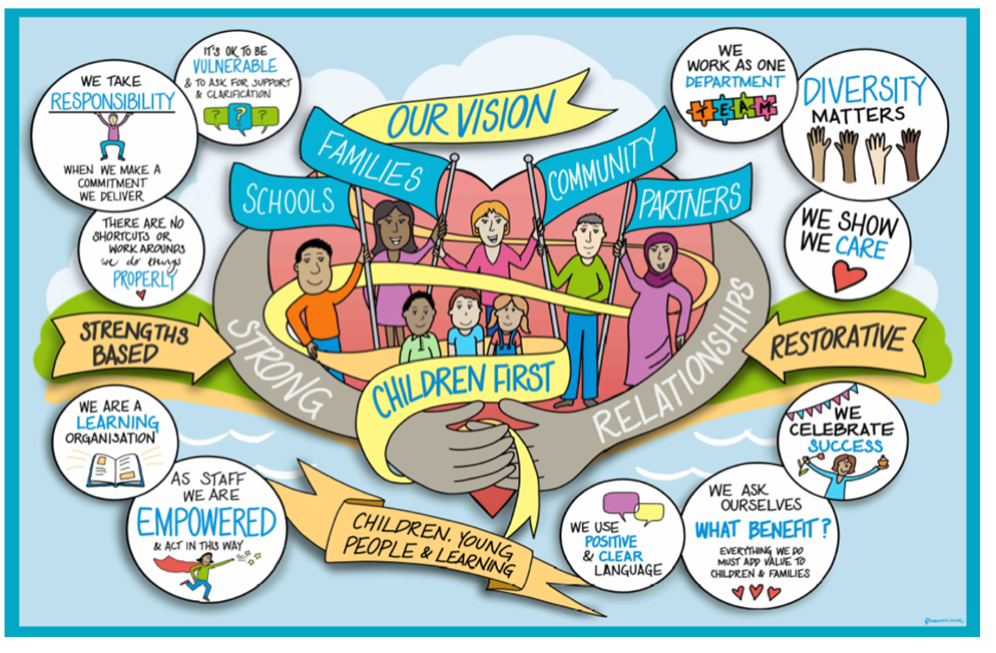

Review / Contacts / References
Document title: | Practice Guidance: Regulation 24 Temporary Connected Persons Fostering Guidance - process pre-approval and where approval is not given.
Date approved: | 28/07/23
Approving body: | Policy & Practice Steering Group
Last review date: | 20/06/23
Revision history: | Version 2
Next review date:
Document owner: | Louise Fox, Head of Service, Assessment and Family Safeguarding
Lead contact / author: | Louise Fox, Head of Service, Assessment and Family Safeguarding
Contents
1. Introduction 3
2. Pre-regulation 24 approval/referral to Fostering team for viability assessment 3
3. Next steps where regulation 24 approval is not granted 3
4. Children who are placed with carers with reg 24 temporary approval and undergoing assessment 4
5. Role of Fostering Team 4

1. Introduction
Please note – this guidance should be referred to alongside:
- Connected carers guidance connected-carers-guidance.pdf (proceduresonline.com)
- Family and friends care policy f_f_care_policy.pdf (proceduresonline.com)
- Protocol for urgent viability assessments West Sussex Practice Guidance (proceduresonline.com)

2. Pre-regulation 24 approval/referral to Fostering team for viability assessment
- Any child open to children’s social care who moves into the care of a family member or friend to be immediately bought to the attention of the service manager and a case discussion held within 2 working days to establish if this may come under the auspices of a sec 20 arrangement.
- Preliminary safeguarding checks must be undertaken on the same day that the child moves into the care of the family member or friend i.e. police PNC check and local authority social care checks (where the kinship carer lives)
- Service manager to record on mosaic the placement status and rationale (i.e. private fostering, family arrangement or Sec 20)
- If the service manager considers that this falls under the auspices of CLA/Sec 20 according to case law, or if they are unsure, they will need to discuss with their head of service and seek legal advice within 24 hours regarding the placement status and parental consent, and gain head of service agreement to the child being looked after. Head of service to record this decision on mosaic.
- If the child becomes looked after, then the process for referral to the fostering team for a viability assessment should start immediately. The placement needs to be regulated within 7 working days of the point the child was accommodated and therefore if there is any delay then the unlawful placement form needs to be completed to include a risk assessment and safety plan and signed off by the head of service and assistant director.
- If the child already has a CRO by virtue of being on a CP plan, they should be informed that the child has been accommodated.

3. Next steps where regulation 24 approval is not granted
- If at any stage during the assessment process, serious safeguarding concerns arise, then the allocated social worker for the child and their manager must be immediately notified and take safeguarding action.
- If the viability assessment is completed and is negative, a meeting must be convened within 2 working days, between the social work team and the fostering team to include the team managers and service managers from each team to see if a resolution can be reached that would allow the assessment to be positive. If either team wishes for the assessment to progress to ADM for a decision following a negative viability assessment this must happen.
- If the decision is not to proceed to ADM or the ADM concludes a negative outcome, the service manager must meet with the head of service within one day to decide on the way forward. This meeting may include legal services to provide advice, and members of the social work team and fostering team.
- If the decision is made to progress with the child remaining looked after in the placement, then the unregistered placement forms must be completed and sent to the head of service and assistant director to approve, within 2 working days.
- The CRO must be kept informed of decision making and their views added to mosaic.

4. Children who are placed with carers with reg 24 temporary approval and undergoing assessment
- A midway meeting should be held at the midpoint of the assessment (i.e. 6 weeks after date that reg 24 started including if it was backdated) with the friends and family assessor, F & F team manager, child’s social worker and team manager.
- If there are any concerns at the 6 week point or at any point in the process that the assessment will not be completed within the 12 weeks following approval or there are any concerns that the assessment might not be positive/ the carers may not be approved at fostering panel, then the assessing social worker must inform the fostering service manager and the social work team and a meeting must be convened to be chaired by the service manager for the child, to be attended by the service manager for fostering, the assessing social worker & their manager, the child’s social worker and their manager, and the solicitor with conduct for the case where appropriate.
- That meeting should decide the following:
  - What are the issues of concern and can they be addressed to allay the concerns; what actions need to be taken to address this? Is the child safe in this placement or should we be seeking a change of placement?
  - If the child is safe but there remain concerns that the approval will go out of time or will not meet the regulations, should we be seeking another arrangement or order or will this need oversight from the head of service and assistant director as an unlawful placement. In this case the unlawful placement form needs to be completed to include a risk assessment and safety plan and signed off by the head of service and assistant director for the social work team. The assistant director will put a case note onto mosaic and the form uploaded.
- The meeting should be minuted and a management oversight placed onto the system by the service manager; any change to care plan needs to be discussed and approved by the head of service and a management case note placed onto mosaic.
- The CRO should be informed of the concerns and outcome and their views added to mosaic.

5. Role of Fostering Team
- The fostering team are responsible for completing all viability assessments and special guardianship/connected persons assessments. The child’s allocated social worker will complete the child’s needs sections of those assessments.
- The fostering manager responsible for the assessment will on week 1 and 7 of a Reg 24 Connected Persons Assessment (CPA) being allocated team managers to complete and save to Mosaic as Supervision Record titled ‘Connected Persons Assessment Management Oversight’.

