Practice Guidance
Using Pre-Meeting Reports for Statutory Meetings as an Updating Child and Young Person Assessment
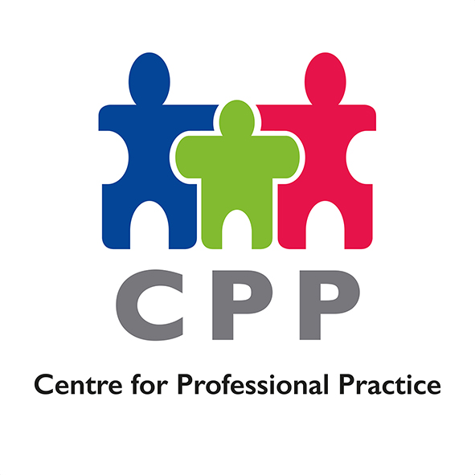
Title: | Practice Guidance – Using Pre-Meeting Reports for Statutory Meetings as an Updating Child and Young Person Assessment
Effective From: | 10th January 2023
Practice Note: | For children already subject to Child Protection Plans, the Pre-Meeting Report for the Child Protection Review Conference can be completed in place of an updating Child and Young Person’s Assessment. This means there will be one document to complete, and this will count as an updating assessment of the child’s needs.  For children placed in our care, the Pre-Meeting Report for the Child in Care Review can be completed in place of an updating Child and Young Person’s Assessment. This means there will be one document to complete, and this will count as an updating assessment of the child’s needs.  The Child and Young Person’s Assessment form will still be available to complete in situations where the assessment may be needed, for example, if there is a significant change in a child’s circumstances.
Author: | Senior Leadership Team  Children’s Services, Dudley Council
Authorised by: | Senior Leadership Team
Date: | 4th January 2023
Reference Number: | 01/2023/CPP

