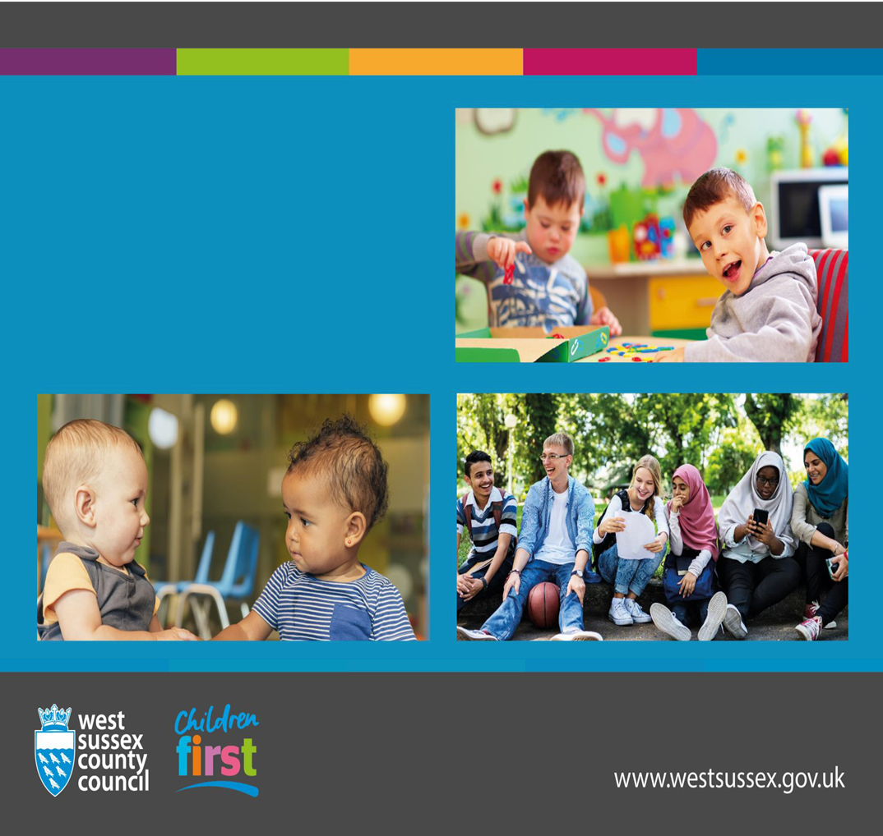
Child in Need Policy for Disabled Children
September 2021
West Sussex County Council
Children Young People and Learning

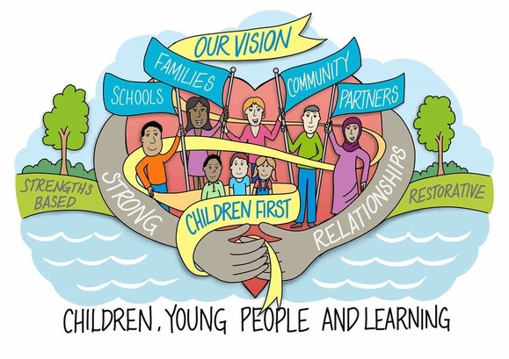

The West Sussex approach puts the child first. We work with children, families, communities, our partners and schools in a restorative, strengths-based way. Strong relationships are at the heart of what we do.

Title: Child in Need Policy for Disabled Children
Author: Justin Colman, Head of Service Children with Disabilities in West Sussex
Responsible Assistant Director: Jenny Boyd
Current Status: Draft
Date: September 2021
Review date: September 2022

Contents Table

1 | INTRODUCTION
1.1 | Purpose of the policy
1.2 | General duties to children in need
1.3 | General principles
1.4 | Relevant legislation and guidance
2 | DEFINITIONS
2.1 | Child in Need
2.2 | Warwickshire Judgement
2.3 | Roles
3 | PROCEDURES
3.1 | Referral
3.2 | Assessment
3.3 | Planning and Review - Choice
3.4 | Step across
3.5 | Planning and Review - Child Disability Teams
3.6 | Supervision and management oversight
3.7 | Case summaries and chronologies
3.8 | Decision-making
3.9 | My Plan

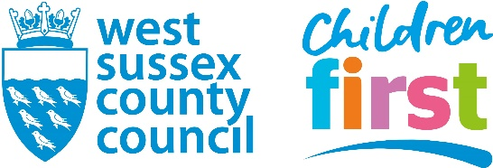

Child in Need Policy for Disabled Children
September 2021

1. INTRODUCTION

1.1 Purpose
The purpose of this policy is to set out the procedures that should be applied when working with disabled children in West Sussex. The scope of this policy will include the different levels of statutory intervention that may be appropriate when there is a disabled child in need, the rationale for making those decisions, and the legal basis for doing so. It will include the following:
- Assessments of disabled children
- Visiting frequency
- Review frequency
- Step up/step down
- Supervision/Management Oversight frequency
It should be read in conjunction with the West Sussex Eligibility Criteria for Disabled Children.

1.2 General duties to children in need
The Children Act 1989 places a duty on local authorities to promote and safeguard the welfare of children in need in their area.
Section 17(1) of the Children Act 1989 states that it shall be the general duty of every local authority:
(a) to safeguard and promote the welfare of children within their area who are in need; and
(b) so far as is consistent with that duty, to promote the upbringing of such children by their families
by providing a range and level of services appropriate to those children’s needs.
1.3 General principles
Children with Disabilities Service in West Sussex will always aim to work with families to enable children to stay safely at home with their parents. There may be a range of support offered to families to prevent children coming into the care of the Authority. This may change over time as families find situations more challenging, or where the support begins to make a difference to how they cope and manage. The purpose of this policy is to reflect how the different levels of intervention offered to families may change as circumstances change. Safeguarding disabled children is central to how these decisions are made.
1.4 Relevant legislation and guidance
- Children & Families Act 2014
- Children Act 1989
- Working Together to Safeguard Children (2015)
- Chronically Sick & Disabled Persons Act 1970
- Short Breaks: Statutory guidance on how to safeguard and promote the welfare of disabled children using short breaks, published in 2010
- Short Breaks for Carers of disabled children; departmental advice for Local Authorities, published in 2011

2. DEFINITIONS

2.1 Child in Need
A child in need is defined under the Children Act 1989 as a child who is ‘unlikely to achieve or maintain a satisfactory level of health or development, or their health and development will be significantly impaired, without the provision of services; or a child who is disabled’.
Specifically, Section 17(10) states that a child shall be taken to be in need if:
(a) the child is unlikely to achieve or maintain, or to have the opportunity of achieving or maintaining, a reasonable standard of health or development without the provision of services by a local authority under Part III of the Children Act 1989;
(b) the child’s health or development is likely to be significantly impaired, or further impaired, without the provision of such services; or
(c) the child is disabled.
2.2 Warwickshire Judgement
Following the Warwickshire judgment, local authorities are permitted to decide that some ‘disabled’ children with lesser needs will be assessed at least at first under the Common Assessment Framework – for example through an ‘Early Help’ assessment.

Disabled children with more complex needs should be assessed by social workers. It is up to each local authority to decide where to ‘draw the line’ as to when a child’s needs means that the assessment should be carried out by a social worker.

2.3 Roles

In West Sussex Children with Disabilities Service there are both qualified social workers and child & family workers (CFWs) who work across the service. The role of a CFW includes some specialist interventions around sleep or behaviour, for example, as well as being the allocated worker in the Choice Team.

Choice was developed in 2015, co-produced with parents and carers, and works with lower level children who are very settled with a care package that is meeting their assessed needs. Their parents are managing well and there is no need for ongoing support from a qualified social worker.

The CFWs are allocated to children in the Choice Team and families access their support on an ad hoc basis during the year as they require it. The CFWs will do targeted pieces of work around behaviour support plans, sleep plans, or a range of other short term and targeted pieces of work. They are managed by either a qualified senior social worker or the team manager in Choice. They do not hold any of the statutory child in need cases. Child & Family Assessments in Choice are undertaken on an annual basis jointly by qualified social workers and CFWs.

Some authorities may refer to these cases as ‘case managed’ or ‘review only cases’.

Social workers in the rest of the Children with Disabilities Teams hold all of the statutory child in need cases with either a 4 weekly or a 12 weekly visiting frequency, which is set out below. There are also CFWs in these teams who support the allocated social workers with targeted interventions.

3. PROCEDURES

3.1 Referral
The Children with Disabilities Service (CWD) has a funded FTE post in the Multi Agency Safeguarding Hub (MASH) who screens referrals and offers advice and information to families and professionals at the point of referral. Referrals that involve any level of concerns around parenting or where there are safeguarding concerns, and which meet the eligibility criteria for an assessment by the CWD Service will be passed to one of the main CWD Teams, two teams in the North and two teams in the South. Where the request is for an assessment of eligibility for short breaks (including a personal budget) that are above the level available through the Local Authority’s targeted short breaks offer, they may be passed to the Choice team for an assessment. No safeguarding concerns nor worries around parenting will have been identified at the screening stage if the assessment is passed to Choice.
3.2 Assessment
Assessments will be allocated to the relevant social work team based on geographical area or to a social worker in Choice for the lower level requests for assessments where short breaks support is being explored and regarded as the key family need. Children should be seen within 10 working days of the initial contact though managers will have the discretion to request these to be sooner, depending on the presenting need. Assessments will be completed in most cases within 20 working days and reviewed after 8-10 working days by a team manager. Assessments that are more complex may be given longer to complete and up to the maximum statutory period of 45 working days, though this ought to be the exception.
West Sussex has developed the ‘My Plan’ tool which serves as the assessment, planning and review tool for disabled children and young people up until the age of 18 and beyond. Adult Transitions have also adopted this tool. The ‘My Plan’ follows a person-centred approach to assessment, planning and review and is embedded within the Child & Family Assessment workstep on Mosaic. This plan will follow the disabled child or young person through CIN, CP and CLA processes and is also used across the Choice Team, and aims to reduce the need for families to keep telling their stories. The intention is that there should be only one plan for a disabled child or young person, that follows them and is used to track progress and improved outcomes.
3.3 Planning and Review - Choice
Following assessments in Choice that do not identify any further role for a social worker, for example where the family can meet the needs of their disabled child/ren with a small personal budget or low level agency support package, cases will remain within Choice and be allocated to a child & family worker (CFW) for any ongoing targeted piece of work (eg around sleep or behaviour).
For children where no ongoing support is needed beyond the setting up of the personal budget and support to recruit a personal assistant (PA), they will remain allocated to their CFW who will carry out a visit to the family home (or to see the child at another setting) within six months of the completed Child & Family Assessment to make sure that families are continuing to manage well with this level of support. They will update the ‘My Plan’ following this visit to reflect any changes. They will also contact families by telephone every three months to check in with them. (This could be a ‘virtual’ visit given that we know that many disabled children have enjoyed these virtual visits during the Covid-19 pandemic).
An annual assessment of needs will be undertaken of all children in Choice jointly by the allocated CFW and a social worker. The CFA will be updated collaboratively but with the allocated social worker leading this assessment. Once again, if there is no further role for a social worker following the updating assessment, the case will remain allocated to the CFW who will undertake a six month visit to review progress and update the My Plan; an annual assessment of needs will again be completed along with 3-monthly check in calls. This cycle would continue with the allocated CFW remaining the named point of contact for families who are able to contact them for support as and when needed.
For example:
January 2021-Updated CFA following joint visit by CFW and SW (Mosaic CFA workstep with ‘My Plan’)
April 2021 - 3-monthly check in phone call by CFW (case note)
July 2021 – 6-monthly visit by CFW to see child (Mosaic ‘Choice CIN’ visit workstep and update ‘My Plan’)
October 2021-3 monthly check in phone call by CFW (case note)
January 2022 - Updated CFA following joint visit by CFW and SW (Mosaic CFA workstep with ‘My Plan’)

3.4 Step across
Safeguarding concerns on an open case in Choice will be addressed in the first instance by the qualified social workers in Choice. Where a Section 47 Investigation does not lead to any further action, the case will remain in Choice. Where there is a safeguarding concern in Choice that requires ongoing statutory involvement, either ongoing child in need planning or child protection planning, cases will step across to one of the CWD Teams. Likewise, children that have become settled in the main CWD Teams may also step across to the Choice Team where the assessment indicates that the family can now manage without any need for ongoing social worker involvement. They will be allocated back to a child & family worker in Choice.

3.5 Planning and Review - Child Disability Teams
There are four Child Disability Teams, two in the North and two in the South. Social workers in those teams carry out the full range of statutory work, including assessment work, Child in Need, Child Protection, Looked After Children, PLO and court work.
It is recognised that all disabled children are by law children in need; however, it is also equally recognised that not all disabled children require the same level of intervention. As such the following two categories of children in need are defined in West Sussex with different visiting and review requirements at the discretion of team managers:

- Child in Need-CIN – This is the statutory CIN work where there are parenting or safeguarding issues (not meeting CP threshold) that have been identified following assessment. Visits take place at least 4-weekly and reviews take place within 10 working days of an assessment being signed off, and then on a 3-monthly basis thereafter. It would apply to children who are stepping down from a Child Protection Plan. The same threshold here would apply to children in other parts of the service who are the subject of Child in Need Plans.

- Complex Disability – A reduced level of visiting and reviews may be agreed at the discretion of the team manager where there are no longer any parenting issues and the plan is working well; however, there does need to be some ongoing social work involvement and multi-agency co-ordination. It may be that there are particular complexities of the disabled child, their circumstances or their care package – e.g. children with complex health needs, receiving overnight respite away from their home (but not Looked After), or known to Continuing Health Care (CHC), but where there are no parenting concerns. There will be many families where we know that the challenges they face caring for their disabled child will mean that they need ongoing social work involvement, albeit at a lower level.

Visiting will be set at minimum 3-monthly, and reviews on a 6-monthly basis. Discretion may be applied if bringing either of these forward, depending on need and circumstances. Children attending regular respite need to be seen at the particular setting at least on a 6-monthly basis in accordance with short breaks guidance.

Visting and review summary:

Level of Need | Visiting frequency | Review frequency
Statutory CIN | Minimum 4-weekly | Within 10 days of CFA or step down from CP, then 3- monthly minimum thereafter plus annual CFA
Complex Disability | Minimum 3- monthly | Minimum 6- monthly plus annual CFA
Choice (or ‘Review Only’ Children) | 6-monthly visit by CFW, 3-monthly phone call check in | 6-monthly plus annual CFA

NB: Child Protection Visits and Looked After Visits are in line with the rest of the service

3.6 Supervision and management oversight
The expectation for case supervision and management oversight recording for the different cohorts of disabled children in need in West Sussex is as follows:
Level of Need | Visiting requirement | Supervision frequency | Management Oversight frequency
Statutory CIN | 4-weekly | 8-weekly | 8-weekly
Complex Disability | 3-monthly | 3-monthly | 3-monthly
Choice | 6-monthly with a 3-monthly phone call check in (or virtual visit) | 3-monthly | 3-monthly

NB: Supervision for disabled children subject to CP plans will be 4-weekly in line with the rest of Children’s Social Care and 8-weekly for Children Looked After.
The same standard template for Supervision should be used for all of the children in the service.
For children who are subject to 3-monthly or 6-monthly visiting, it is acceptable for the team manager or social worker to record without using a template if the child has not been seen since the previous supervision, or where there has been very little involvement with the family since the last supervision. A clear note should still be recorded that sets out that there have been no concerns and to timetable the next full supervision.
3.7 Case summaries and chronologies
The expectations around updating case summaries and chronologies is as follows:
Level of need | Case summary | Chronology
Statutory CIN (4-weekly visiting) | 3-monthly | 3-monthly
Complex Disability (3- monthly visiting) | 3-monthly | 6-monthly*
Choice | 3-monthly | 6-monthly*

*The rationale for having 6-monthly updates on impact chronologies is that sometimes little has happened within a 3 month period some many of the children in these cohorts. Case summaries remain 3-monthly because they serve as a useful check-in point to be thinking about whether circumstances have changed or not.
3.8 Decision-Making
Children may move between the 3 categories depending on identified needs and at the discretion of the team manager. Service managers will regularly sample work to ensure there is consistency in approach across the service.
Prompts for social worker and manager to consider when deciding on the appropriate level of intervention:
- Are there ongoing parenting issues that require support and intervention? (Statutory CIN)
- Are parents worried about their disabled child and concerned about reduction in support levels?
- Will things deteriorate for the disabled child or their family if we reduce the level of visiting and review? (Remain statutory CIN)
- Is there support from our multi-agency partners for any reduction in our own support?
- Are you clear about the impact of our intervention and on outcomes for the disabled child? Is this evidenced on the case records?
- Are there particular complexities that mean some ongoing social work intervention will benefit the disabled child and their family? (Complex Disability)
- Is this a family that manages their disabled child’s care very well with the support package provided, and things are settled and stable? (Choice)
- Have you recorded this decision on the child’s record with a clear rationale?
3.9 My Plan
This policy should be read in conjunction with the ‘Guidance for completing updating CFAs in the Disability Social Work Teams’ (hyperlink).
The ‘My Plan’ is the single assessment, planning and review tool for disabled children and young people up to the age of 18. It is also being used now within the Lifelong Service for young adults who move into the Transitions Team.
The ‘My Plan’ will be used across all parts of the service for all reviews, including during Looked After Reviews and for Child Protection Conferences. Some more development work is underway to ensure a consistent and smooth workflow.
The ‘My Plan’ will be used for reviews and also for updating assessments. When an updating assessment (CFA) is triggered, the ‘My Plan’ is then opened up within the CFA workstep on Mosaic and it pulls through the last ‘My Plan’ that was updated at a previous review meeting.

