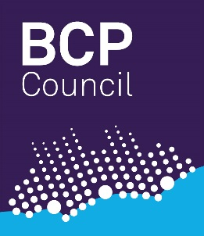

Your Housing Options and Choices

Your Housing Options and Choices
If you are 16 or 17 and assessed as needing somewhere to live there are some options and choices to make, and we will work with you to understand your needs. We will advise on what we think will best meet your needs.
The options may include:
- becoming ‘looked after’ (under section 20 of the children’s act)
- having a plan of support as a ‘child in need’ (housing services under Part 7 of the 1996 Act. In rare circumstances you may be offered accommodation under section 17 of the 1989 Act).
Please makes sure you talk about this with a Social Worker and an Independent Advocate at Coram Voice 0808 800 5792 help@coramvoice.org.uk to understand the options before making any decisions.

What help will I get if I am ‘looked after’?
BCP Childrens Services will provide you with somewhere to live which meets your assessed needs. For example, it could be:
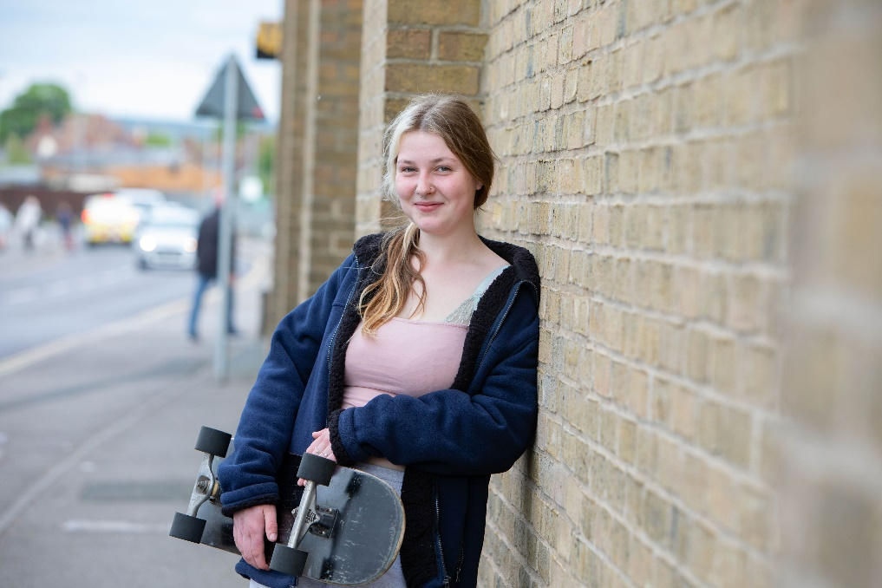
- With foster carers
- In supported housing
Childrens Services will be responsible for looking after you and supporting you in partnership with your existing support network. A Social Worker will be allocated to support you.
Together you will make a Pathway Plan which will detail arrangements for where you will live and what other support you need as a range of agencies may be able to help you. As part of your Pathway plan you can get help with:
Images from Centre for Homelessness Impact photo library ResourceSpace
- Housing issues and where you call home
- Education, employment, and training
- Money and budgeting
- Health and wellbeing
- Independent living skills
- Support in maintaining relationships with people closest to you
- Any other advice and support
Whilst you are 16 or 17 and looked after by Childrens Services, you may also:
- Have any rent or accommodation costs paid for you.
- Receive a weekly allowance or pocket money.
- Be invited to regular meetings and reviews together with the services who are supporting you to check you are getting all the help you need. These are chaired by an Independent Reviewing Officer (IRO).
Once you have been in care for 13 weeks or more without a break you have the right to leaving care services until the age of 25 years. This includes a personal Leaving Care Advisor (PA) and financial support to meet education, training, or employment needs.
Please see our ‘local offer for care leavers’ for more information on how care leavers are supported.

What help will I get if I do not become ‘looked after’?

Help from Housing

BCP Council’s Housing Options Service will help to ensure you are provided with accommodation which meets your needs to prevent you from being homeless.

A Housing Options Officer will work with you to carry out an assessment to identify your support and accommodation needs and develop a Personal Housing Plan. This will lay out a plan of the things that you, your Housing Options Officer and any other support agencies are expected to do to make sure you can get access to suitable accommodation.

If needed you will also get help and advice with:

Claiming benefits to pay your rent and living expenses

Money & budgeting advice

Independent living skills

Finding your own accommodation when you are ready to live independently.

Your Personal Housing Plan will also include steps and actions that you might need to take to help yourself. It is important that you cooperate with these steps.

The type of longer term accommodation that could be available to you will depend on your circumstances, but could be one of the following:

Supported accommodation

Private rented accommodation

Social housing

If you are homeless, the Housing Options Service may make you an offer of accommodation to resolve your housing need. This offer will have been assessed as suitable by your Housing Options Officer, and will be available for at least 6 months. It is important that you understand that refusing an accommodation offer could mean that you are not entitled to any further offers of accommodation.
You will have the right to request a review of any offer of accommodation that you do not think is suitable for you, and you are encouraged to talk to an Independent Advocate at Coram Voice 0808 800 5792 help@coramvoice.org.uk for further help before you refuse any offer.

Help from Childrens Services as a Child in Need
You will also be entitled to help from BCP Childrens Services who will support you in partnership with your wider support network and with other agencies who may be able to help you.
A Social Worker will work with you and your Housing Options Officer to support you and create a plan based on what you need, which will describe who will be able to support you and how.
You may get additional help with:
- Housing issues and where you call home
- Education, employment and training
- Money and budgeting
- Health and wellbeing
- Support in maintaining relationships with the people closest to you
- Other advice and support as needed
- You may get some financial support from Children’s Services until you receive your own benefits.
This support is available until you reach your 18th birthday.

