Northamptonshire Children’s Trust (NCT) Procedures Manual:
Practitioner Guidance Notes

- Introduction

The Northamptonshire Children’s Trust (NCT) Procedures Manual covers all areas of core Children’s Social Care business. The Manual is subject to ongoing review, change and development in order to ensure its content reflects current legislation and best practice.

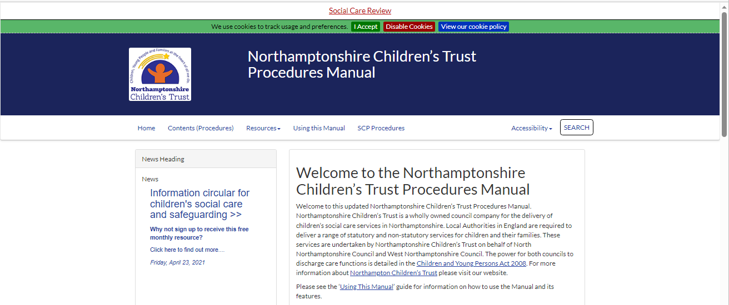

Figure 1. NCT Procedures Manual Homepage

Our aim is to ensure the Manual is:

- Comprehensive – Procedures cover the full range of children’s social care processes;

- Compliant – Procedures are compliant with legislation and statutory guidance;

- Consistent – Procedures reflect local practice and do not contradict each other.

The Manual is supplemented by the Local Resources which is accessible from the Manual’s Home page. The Manual, together with the Local Resources, aim to be a ‘one-stop-shop’ for all matters related to Children’s Social Care day to day practice.

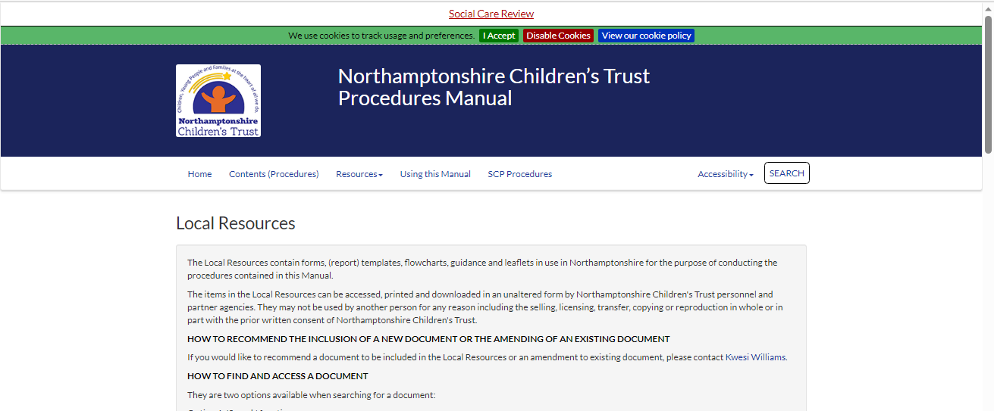

Figure 2. NCT Local Resources Page

- Accessing the Manual

The Manual is accessible from:

- the Northamptonshire Children’s Trust home page

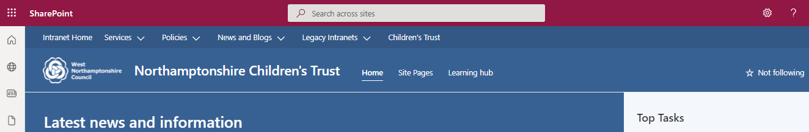

Scroll down and click here 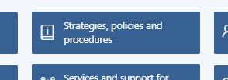, or

- the ‘Start/Windows’ menu

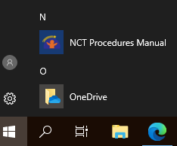

The Manual is publicly available via most internet browsers – making it accessible from mobile devices e.g. laptops, mobile phones and tablets.

- Using the Manual

Home (Welcome Page): All sections of the Manual using the links located under the title bar.

Contents: This is an important link as this is where the procedures (referred to in the Manual as ‘Chapters’ are accessed). The only exceptions to this are procedures that have been recently developed or amended – see Local Resources > New and Amended Procedures.

Top Tip – Searching, when searching through the Contents page, use the Ctrl + F function to search for specific words or terms.

Resources: The manual is crammed full of additional resources that you may find useful. These include the:

- Glossary – This is a live online glossary, containing key definitions for social care practitioners. It's a free resource powered and kept up to date by tri.x;

- Local Resources – The Local Resources contain forms, (report) templates, flowcharts, guidance and leaflets in use in Northamptonshire for the purpose of undertaking the procedures contained in the Manual;

- Contacts – This resource is designed to help you find the contact details for key National agencies and organisations. It’s kept up to date by tri.x;

- Regulatory Framework – Links to relevant Regulations and Acts;

- KCSIE – Link to the Keeping Children Safe in Education Statutory Guidance with additional notes on revisions made to the guidance.

Using the Manual: This section provides guidance on how to use the Manual. It includes information on amendments, printing Manual content and mobile/tablet compatibility.

SCP Procedures: The Northamptonshire Safeguarding Children’s Partnership Manual. This Manual has a Using this Manual section which I also suggest you go through if you have not done so already.

Accessibility: Click here to change the font size to turn it to high visibility.

Search: This facility is similar to that of an internet search engine. It includes helpful search tips to help yield better results. The Procedures section of the Manual can be searched independently from the Local Resources.

Six additional tabs are located on the Manual’s home (welcome) page, which link to two of sections already mentioned (i.e. Contents and Local Resources).

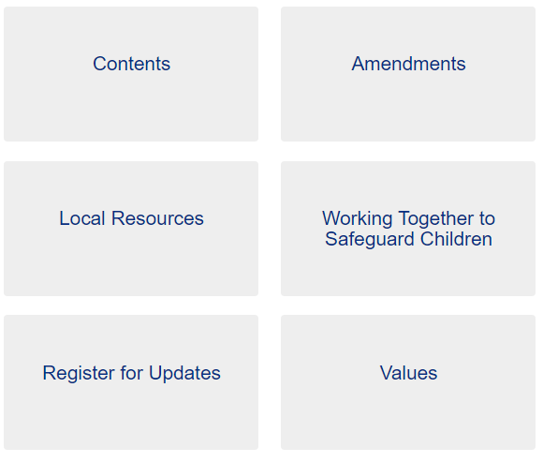
Figure 3. NCT Procedures Manual Home (Welcome) page tabs

The other four tabs are detailed below:

Amendments: A summary of the latest amendments made to the Manual is provided. An Archive of earlier changes made to the manual is also available;

Working Together to Safeguard Children: A web-enabled version of the Working Together to Safeguard Children (2018) guidance is available. It has been produced to facilitate navigation of the document;

Register for Updates: Once registered, users will be notified of Manual updates.

ACTION: Register for manual updates by clicking on ‘Register for Alerts’ and submitting your details;

Values: This section sets out the overarching values and principles that underpin all Northamptonshire Children’s Trust procedures.

- Chapter (Procedure) Structure

At the start of most chapters, a ‘Scope Box’ is included. It details information about the chapter and may provide links to other relevant chapters and related (statutory) guidance.

Chapters often include a hyperlinked contents list. By clicking on the hyperlink, you can skip to that section of the chapter. Other hyperlinked text in a chapter may include keywords, other relevant chapters or useful documents and resources.

Top Tip – Searching, when searching through a chapter, use the Ctrl + F function to search for specific words or terms.

- Potential Gaps in Manual Content

If after a thorough search of the Manual you think there is a potential gap in its content, you should;

1. Discuss the matter with your Team/Practice Manager, who will decide if the matter should be brought to the attention of the Policy and Procedures Officer.

2. Email the Policy and Procedures Officer, stating the procedure(s) in question and providing as much information as possible regarding the potential gap.

For further guidance regarding the maintenance of Manual content see the ‘Northamptonshire Children’s Trust Procedures Manual Maintenance Practice Guidance’

