Display Screen Equipment Risk Assessment
Service: |  |  | Section: |  |  |  |  | Location/building/homeworker
DSE type: |  |  |  |  | Date of assessment: |  |  |  | Review Date:
Name of User |  |  |  |  |  | Approx. height: |  | Dominant Hand |  | Left Right Ambidextrous
Task Description:

Please note, when completing the checklist if answers are: Yes - no action is required No - Add recommendation into action plan at end of assessment
The Chair | Yes/No | Things to consider | 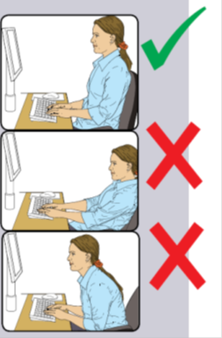  Good seating position.  Most gas cylinders in chairs usually carry up to a max 19 stone/120kg. Otherwise a different type of cylinder is required. The chair also needs to be wide enough.
1. Does the chair allow freedom of movement for the user?
2. Is the chair stable and have sufficient but not excessive friction with the flooring?
3. Does the user find their chair comfortable?
4. Is the user familiar with all the available adjustments on the chair? |  | You should adjust your chair so that your elbows are at a right angle to the desk with your shoulders relaxed.  Once adjusted your feet should be flat on the floor or on a footrest, with your knees slightly lower than your hips.  Keep your telephone, mouse and keyboard close to you to avoid over-reaching.
5. Is the height of the seat adjustable?
6. Is the seat back rest adjustable?
7. Does the seat slide? (if applicable)
8. Does the chair swivel?
9. Does the chair have five castors?
10. Is the chair adjusted correctly so that:
(a) Small of back supported by backrest?
(b) Forearms are in a suitable position?
(c) Feet flat on floor or on a footrest?
11. Can the user comfortably reach all the equipment and papers they need to use?

 | Yes/No | Considerations | Height and distance  Head position
Screen
1. Screen(s) set at the correct height? |  | Your eyes should be level with the top of the screen slightly looking down onto the working area.  When sat in your normal working position put your arm out in front of you the screen should be on or close to your fingertips.  If you look at the keyboard to type you should place your screen lower to avoid large ‘nodding’ movements between the screen and the keyboard, make sure you keep your head aligned avoid leaning forward as this places pressure down your neck, shoulders and spine.
2. Screen(s) set at a suitable distance from the user?
3. Screen(s) adjustable to meet user's needs?
4. Are the characters easy to read, clear, stable and free from flicker?
5. Screen(s) free from glare and reflections?
6. Can brightness and contrast levels be controlled?
7. Does the user know how to adjust the brightness and contrast controls?
8. Is the screen clean?
9. If you are a spectacles wearer, are the lenses single vision?

Keyboard | Yes/No | Considerations | 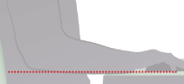  Arms level and space for resting hands/wrists
1. Is the keyboard separate from the display screen? |  | Keep the keyboard close to you with enough room to rest your wrists in-between keying.  Poor technique includes:  Wrists bent  Hitting the keys too hard  Note: you do not have to be a touch typist to have a good technique.  Try moving along your desk or putting your keyboard flat.  Are you using a standard keyboard, with a number pad on the right, or a smaller portable keyboard?
2. Can the keyboard be tilted?
3. Is there space to rest hands in front of the keyboard when not keying?
4. Are keyboard characters easy to read?
5. Is the keyboard layout appropriate to the task?
6. Does the user have suitable keyboard technique?
7. Have measure been taken to eliminate glare or distracting reflections from keyboard of worktop?
8. Is a full size keyboard used?

Mouse | Yes/No | Considerations | 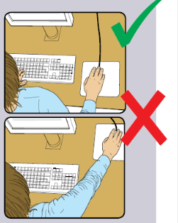
1. Is there space in front of the mouse to allow hands to rest in-between use? |  | Keep your mouse close to you so you are not over reaching.  Keep your wrist level and try not to grip, rest your fingers on the mouse.  If you are left handed you may want to use a mouse for your left hand.  If you have problems with your wrists/ fingers ensure your posture is correct first. You may need to seek further advice from H&S risk management
2. Is the mouse suitable for the user in terms of size, type, comfort and task?
3. Is the mouse positioned close to the user?
4. Is a mouse mat and wrist support used if appropriate?
5. Are you aware of keyboard shortcuts that can be used rather than the mouse? If applicable?

 |  |  | 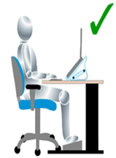
Laptop Computers (Additional Questions) | Yes/No | Considerations
 |  | When working with a laptop within the home or at work, you must get in the best position possible and remember your posture, being hunched over the laptop may lead to musculoskeletal problem in the long term. Consider a laptop stand for prolonged use.
1. Is a docking station used?
2. Is a normal sized keyboard used?
3. Is a laptop stand used to raise screen to eye level?
4. Is a suitable detached mouse used?
5. If you are required to carry your laptop with you is a suitable bag used?
6. Is the user aware of health and safety risks from using laptop computers?

Mobile Technology (Additional Questions) | Yes/No | Considerations
Using this kind of technology can cause strain in your fingers, thumbs, wrists and up your arm to you elbow.
Try to only use for short time periods.
When it is practical to do so, it is preferable to send long e mails when you can use a computer and sit more comfortably.
1. Do you frequently use mobile technology as part of work? E.g. PDA, tablet, mobile phone for keyboard use e.g. blackberry
2. Is the use of mobile technology used for long periods of time?
3. Are effective mechanical aids used to hold mobile technology used to reduce the need to manually hold the device during use?
4. Is the equipment (and accessories) appropriate for the task?
5. Is the screen easy to read, and free from glare and reflection?
6. Is the equipment used whilst walking?
7. Is the equipment used whilst in a vehicle?
8. Do you use mobile technology for leisure?
9. Is the use aware of the risks from using mobile technology?

 |  |  | 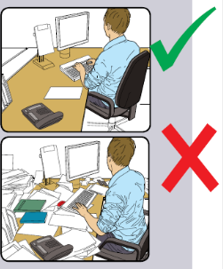
Workspace | Yes/No | Considerations
1. Is the work surface large enough to allow a flexible arrangement of the screen, keyboard, documents and related equipment? |  | Items regularly used should be close to the user e.g. telephone to prevent over reaching.  Document holders and footrests are available on request, leave blank if you don’t require one for your work.  Keep your workspace tidy in order to be able to use it effectively.
2. Is there adequate space around the workstation for the user to find a comfortable and safe position?
3. Is there sufficient clearance for thighs, knees, lower legs and feet under the work surface and between the sides of the furniture?
4. Is a document holder available and used if appropriate?
5. Is a footrest available and used if appropriate?
6. Have you made the best use of the workstation space?
7. Is the workstation and equipment subject to regular cleaning?

Workstation Environment | Yes/No | Considerations
 |  | When working with a laptop within the home or at work, you must get in the best position possible and remember your posture, being hunched over the laptop may lead to musculoskeletal problem in the long term. Consider a laptop stand for prolonged use.
- Is the temperature and humidity comfortable for the user?
- Are sources of noise reduced to a level that is acceptable?
- Have any trip hazards associated with cable management or fire hazards associated with coiled cables/socket outlets been effectively controlled?
4. Are curtains or blinds fitted where necessary used to eliminate glare?
5. Are lighting levels adequate to allow all tasks to be performed safely and without discomfort at the workstation?

DSE User | Yes/No | Considerations
1. Are you free from any physical discomfort? |  | Does the user have any medical conditions which could affect the use of their Workstation & equipment?  Short, frequent breaks are more beneficial than occasional, longer breaks, e.g. a 5-10 minute break after 50-60 minutes continuous work is better than a 15-20 minute break every 2 hours.
2. Are you free from any other symptoms that may be associated with using the workstation?
3. Have you been given information on his/her entitlement to eye and eyesight testing?
4. Do you take regular breaks away from the screen?
5. Is driving a large part of your job role?

Actions | Yes/No | Considerations
1. Have all relevant health issues been addressed in this assessment?
2. Is advice needed from an occupational health adviser?
3. Have all measures identified in the last assessment been actioned?

Comments
ABOUT YOUR HEALTH - Give brief details of any pain/discomfort associated with your DSE workstation or work

Consider points below:
Which part(s) of the body is/are affected? (e.g. right shoulder, left thumb) | What type of pain/discomfort? (e.g. numbness, tingling, impaired grip, sight difficulties)
When did this start? | How long have you been in your current role?
If part-time, what hours and days do you work? | Have you taken any time off work due to these problems?
Do you wear spectacles? | What medical advice have you sought and when? (e.g. GP, consultant)
What changes have you made to reduce the problems? | What specific recommendations have been made from your medical practitioner?

ACTION PLAN
Action |  |  | Priority - High/ Medium/Low |  |  | By Whom  (name) |  |  | Date for Action

DSE User's Details

Name: |  | Date:

Assessor's Details

Name: |  | Date:

Manager's Details

Name: |  | Date:

