How to use Mind Of My Own

A short guide for
CHILD PROTECTION

©Mind Of My Own Ltd 2021 1

Contents

All about Mind Of My Own 3

One App
- Preparing for meetings 4
- Understand the child’s wellbeing 5
- Sharing good news 6
- Sorting problems 6

Express
- All about me & My Education 10
- My Health & My Life 11

©Mind Of My Own Ltd 2021 2

Why should I use Mind Of My Own?

1. Mind Of My Own apps will save you time. You’ll receive a pdf of the child’s views, wishes and feelings which you can upload to their file

2. Receiving Mind Of My Own statements from children and young people ensures you have evidenced the voice of the child

How do I sign up or log in to my practitioners account?

Open your web browser (Google Chrome or Internet Explorer) and go to space.mindofmyown.org.uk

Why do I need a practitioners account?

1. To use Mind Of My Own with young people you work with
2. To familiarise yourself with the apps (using the ‘Test Profile’)
3. To create an Express account for a child or young person

When should I use Mind Of My Own?

1. Preparing for meetings

✓ Child Protection Conferences
✓ Statutory Visits
✓ Assessments
✓ Any other meeting or review

2. Direct Work

✓ Understanding lived experience
✓ Journey mapping through care
✓ Understanding risk & resilience
✓ Identifying safeguarding risks

Who can I use Mind Of My Own with?

Any child or young person you work with, any time you work with them

©Mind Of My Own Ltd 2021 3

Preparing for meetings

What is this for? When is this used?

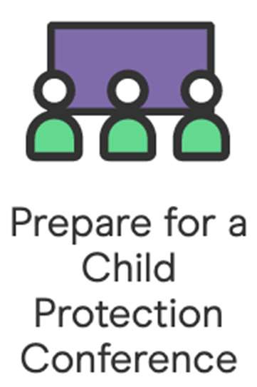• Prepares every young person for their child protection
conference

• Gives you a clear understanding of what the child wants to talk about during the meeting, allowing you to focus on what
matters to them

✓ Child Protection
Conferences

✓ Direct work sessions

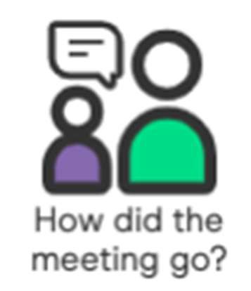• Gives young people the opportunity to feedback on how the meeting went from their perspective

✓ After all meetings

©Mind Of My Own Ltd 2021 4

Understand the child’s wellbeing

What is this for? When is this used?

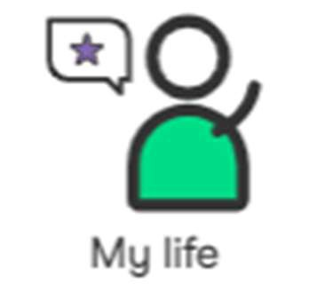• Allows young people to reflect on their current life situation

• Gives the worker an opportunity to see into the corners of their life you may not
see otherwise
✓ Encourage individual use anytime

✓ Social work visits

✓ Assessments &
investigations

✓ Meetings & reviews

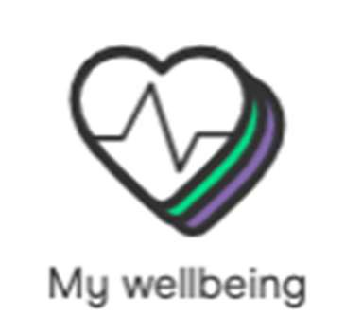• Understanding the child’s lived experience, allowing you to mitigate against risks

• Identify key risk and resilience indicators, giving a unique insight into the
child’s wellbeing

✓ Encourage individual use anytime

✓ Social work visits

✓ Assessments &
investigations

✓ Meetings & reviews

©Mind Of My Own Ltd 2021 5
Sharing good news and sorting problems

What is this for? When is this used?

• Can be used as part of life story work to capture events in the child’s own words

• Young people asked us to put this in the app. They wanted a specific place to talk about things that are
going well.

✓ Encourage individual use anytime

✓ After planned events

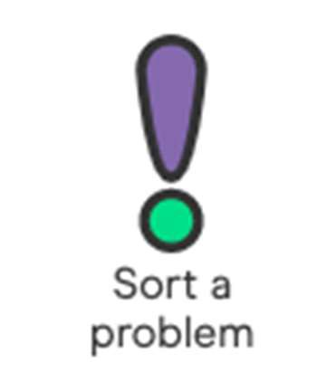• Solve issues at the earliest stage possible

• Often the change is small and easy for the worker to action, but the effect for the
child can be huge

✓ Encourage individual use anytime

✓ Formal complaints

✓ Raising concerns

©Mind Of My Own Ltd 2021 6
Using Express in direct work

What is this for? When is this used?

• Gives an overview of a young person’s likes and dislikes

• Develops a one page profile so the child does not keep having to tell their story over and over again
✓ One page profiles

✓ Before health checks

✓ Assessments

✓ Statutory visits

✓ All other meetings and reviews

• Understanding the child’s learning preferences and the academic support they need

• Understanding how they feel at school and to embed the child’s voice into
education planning
✓ Education, health and care plans

✓ Education planning

✓ Assessments

✓ Statutory visits

✓ All other meetings and reviews

©Mind Of My Own Ltd 2021 7
Using Express in direct work

What is this for? When is this used?

• Understanding how the child feels about their health and visits to health care professionals

• Explore any worries the child has about their health and understand their behaviours better

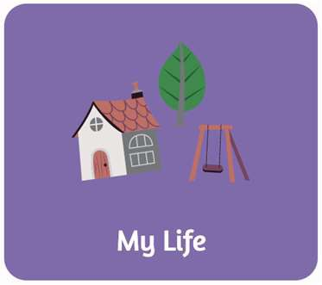• Exploring different aspects of a child’s life and the relationships they have

• Identifying safe- guarding concerns including where they feel safe or not and whether they have a
trusted adult

✓ Before health checks

✓ Assessments

✓ Statutory visits

✓ All other meetings and reviews

✓ Before health checks

✓ Assessments

✓ Statutory visits

✓ All other meetings and reviews

©Mind Of My Own Ltd 2021 8

