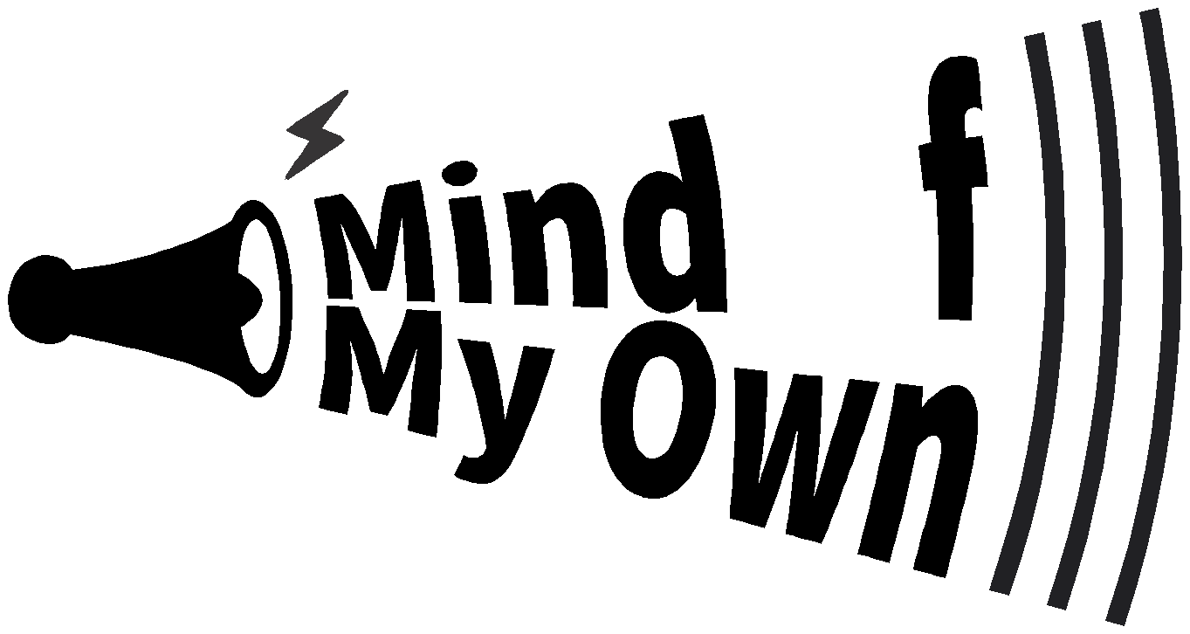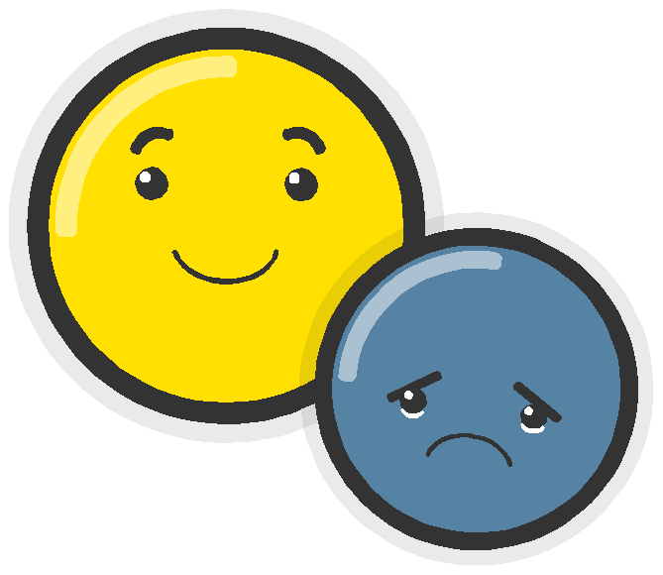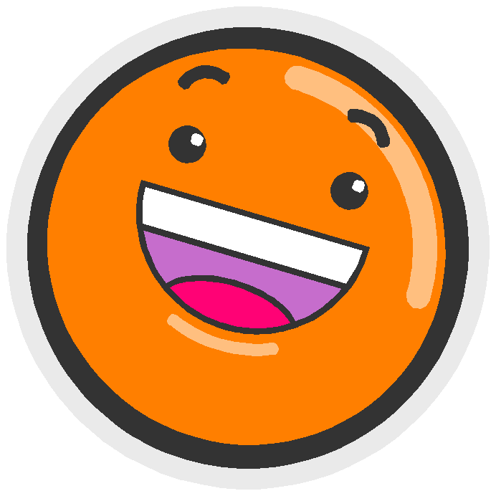A guide to

For anyone working with children and young people

Introduction to the Mind Of My Own Apps

support@mindofmyown.org.uk www.mindofmyown.org.uk
@MindOfMyOwnApp
1
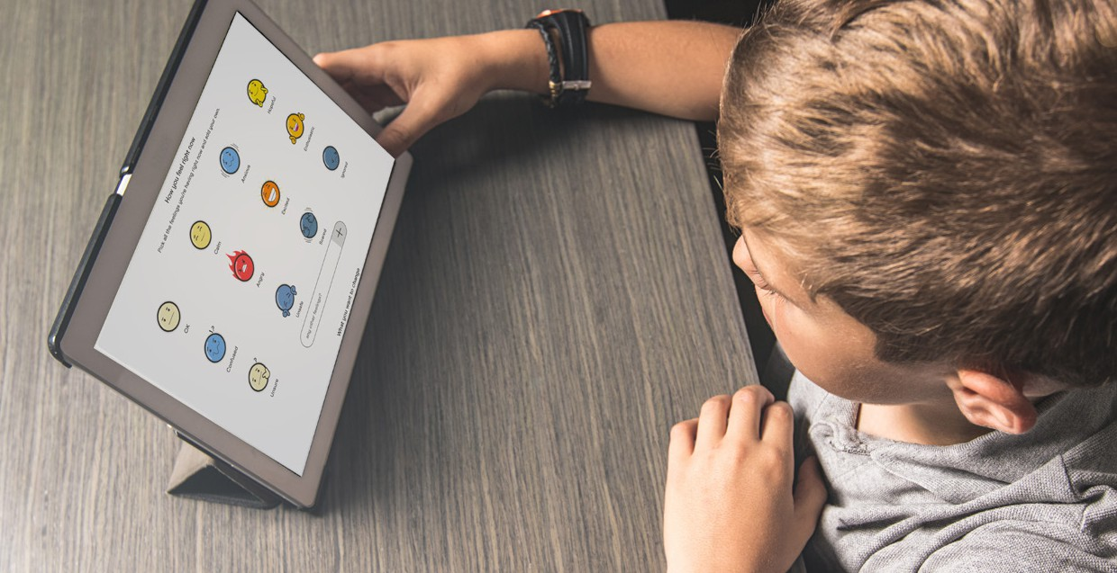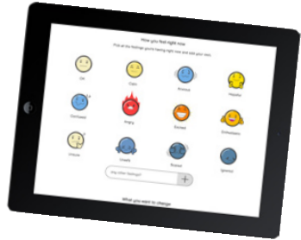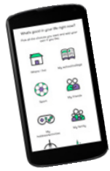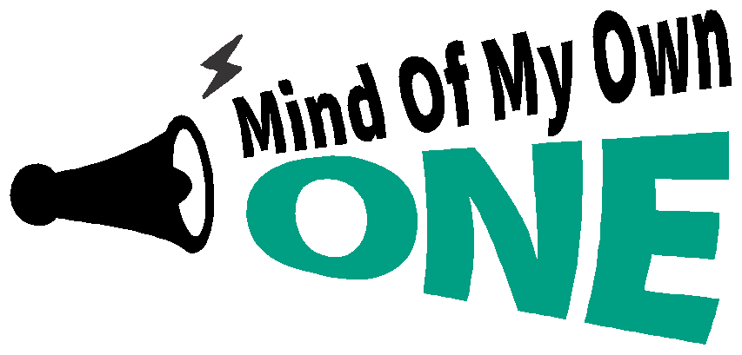

What does One app do?

One app helps children and young people communicate their views with workers. Young people can create their own account on One app, which can be used on any device.

This means that young people can use the app to say how they are feeling and what they need, in a way that suits them.

One app enables young people to be more actively involved in their lives and is an accessible and empowering way to tell their workers about things
that are important to them.

2
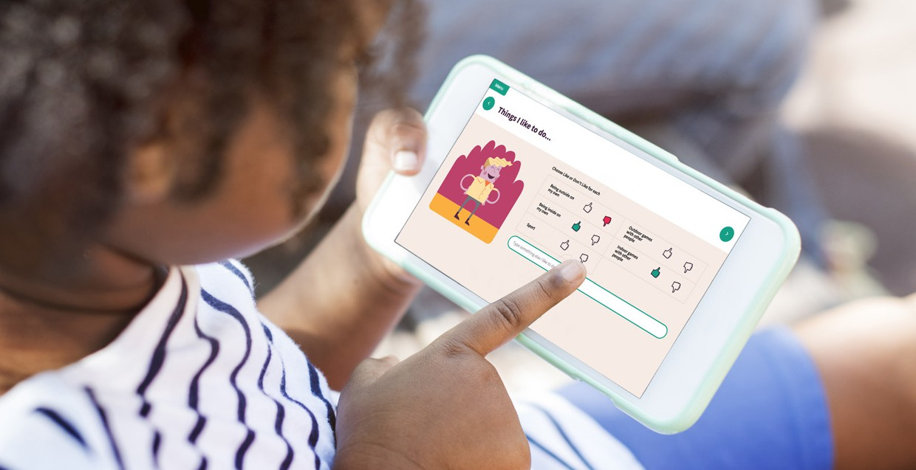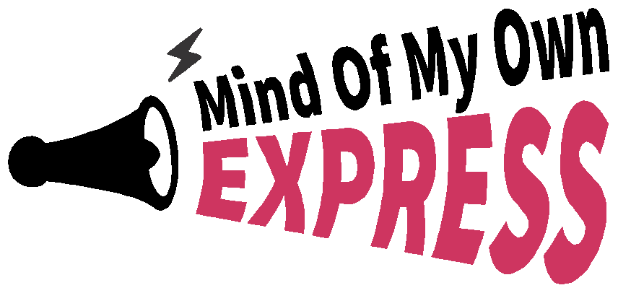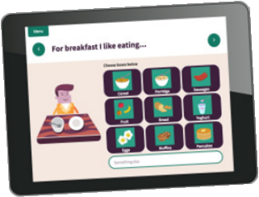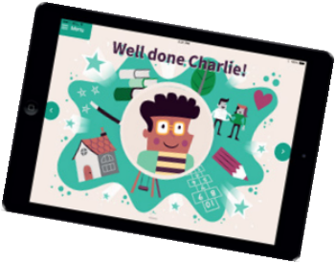

What does Express do?

Express is a co-designed, innovative and user-friendly app that helps young children and those with additional needs to express their views, wishes and feelings.

It helps you reach those children who may otherwise struggle to communicate their views to you.

Express is an accessible app, designed to be used by children alongside a worker.

You can access Express through your worker account.

3
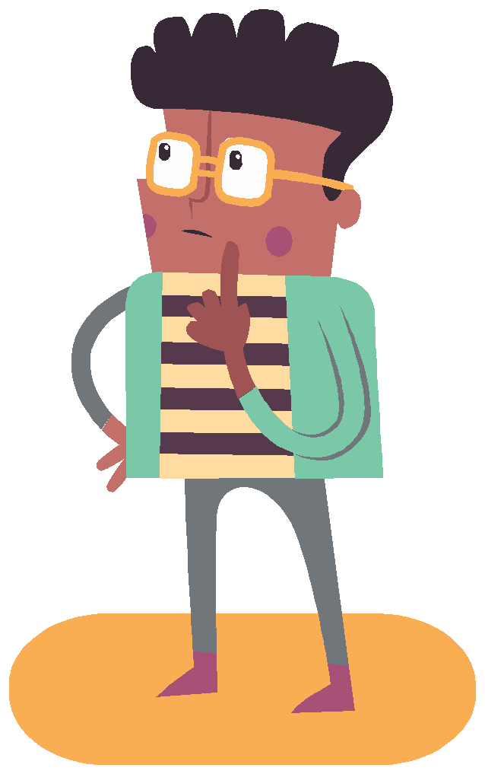How Mind of My Own works

You can access the One app and your Worker account through a web browser on any device with an internet connection.

Young people can also download the One app on to Android and
Apple devices.

Mind Of My Own needs an internet connection to work. You can use either WiFi or mobile data.

If you would like to use Mind Of My Own on a tablet or computer and there is no wifi available where you are, most phones can use their mobile data signal to create WiFi (tethering/hotspotting).

• Go to space.mindofmyown.org.uk

• Click ‘Sign up’, enter your details and wait for your account to be approved by your Service admin

• After approval you will receive an email with the steps you need to complete in order for your account to be activated

• When working with a young person, sign in to your practitioners account and create a profile for them. Through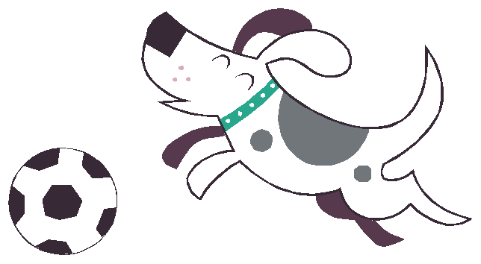 this profile you can enable the young person to access both One app and Express.
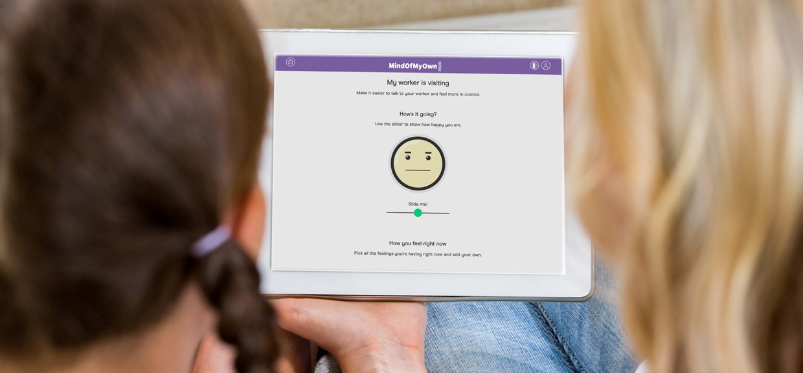

Practitioners account and One app

Using your practitioners account is a great way to introduce One app to a young person. After using it once with you, encourage them to sign up for their own account so that they will be in control of where, when and how they use the app to have their say.

Practioner account and Express

Express can be accessed through a worker’s account. Use it with children who are too young to be able to use the One app, or those with additional needs. Log in to your worker account and select the child’s profile, then click the Express button.

Privacy

We take young people’s privacy very seriously and are fully GDPR compliant. We need certain information from the young people for the apps to work, including email and date of birth.

These are stored securely and never shared with anyone. We will provide a privacy pack to help you explain privacy to those children who may struggle to understand the implications of sharing information.
Email addresses

In order to have their own account, young people need their own email address. This can be their personal or a school email. If they don’t have an email and are unable to get one, you can use your practitioners account instead.

Give young people the control to have their say. Start by co-using One app for real on your worker account, then encourage them to sign up for their own account.

Remember that if young people have their own accounts they will be able to use One app much more freely and share their views with you even when you are not there.

For more info visit www.mindofmyown.org.uk If you have questions or feedback, email us on support@mindofmyown.org.uk

Mind Of My Own
Phone: 03300 579 575
Watson House, 54 Baker St, Marylebone, London, W1U 7EX

