Missing, Slavery, Exploitation and Trafficking (MSET)
Exploitation Framework for children, transitions and adults, including the Screening Tool , Assessment Tool, Safeguarding and Disruption, and Review

Exploitation flowchart
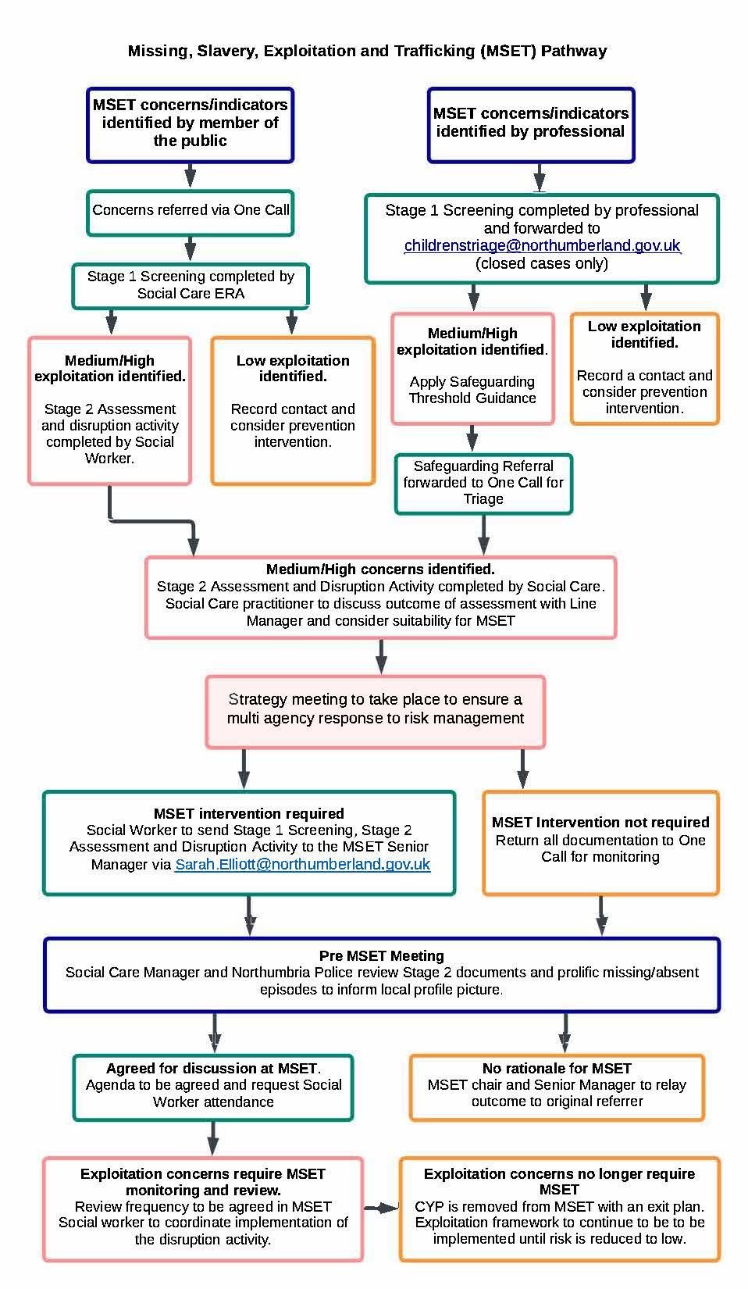
Appendix 1
Stage 2 Assessment
(Please complete for Initial or New referrals)

Name (Including alias) |  | Age
Address |  | Ethnicity
Gender |  | Sexuality
LAC Status
Learning Disability/SEND |  | CYPS Diagnosis
Language |  | Religion
Nationality |  | Immigration Status
Parent/Carer |  | Parent/Carer DOB
Date of most recent care team/core group/strategy meeting |  | Members of Care Team

Genogram (Please ‘print screen' this from the Atom tab on ICS)

Scoring Matrix – Strength and Vulnerability indicators
Note: If support is required, please see guidance document.

Missing
Score | Indicator | Concerns
0 | No staying out late or missing episodes. Individuals whereabouts are regularly known and well managed
1 | Some concerns regarding late return home and/or missing episodes
2 | Significant concerns regarding late return home and/or missing episodes
3 | Direct evidence regarding late return home and missing episodes which are associated with exploitation.

Individual’s Presentation
Score | Indicator | Concerns
0 | No concerns regarding recent changes in the individual’s physical, emotional or behavioural presentation which raise a concern. The individual’s presentation and development is healthy and positively supported.
1 | Some concerns regarding recent changes in the individual’s physical, emotional or behavioural presentation.
2 | Significant concerns regarding recent changes in the individual’s physical, emotional or behavioural presentation.
3 | Direct evidence between concerns regarding recent changes in the individual’s physical, emotional or behavioural presentation associated with exploitation

Gangs/Organised Crime
Score | Indicator | Concerns
0 | No concerns regarding the individual’s association with gangs, gang fights or gang membership. The individual has positive networks which promote a positive and safe lifestyle.
1 | Some concerns regarding the individual’s association with gangs, gang fights or gang membership.
2 | Significant concerns regarding the individual’s association with gangs, gang fights or gang membership.
3 | Direct evidence of the individual’s association with gangs, gang fights or gang membership being associated with exploitation

Social Media
Score | Indicator | Concerns
0 | No concerns relating to the individual’s use of the internet or social media. The individual use of social media promotes opportunity for safe communications and is well supervised.
1 | Some concerns relating to the individual’s use of the internet or social media
2 | Significant concerns relating to the individual’s use of the internet or social media
3 | Direct evidence the individual’s use of  the internet and social media is associated with exploitation

Family/Peer Relationships
Score | Indicator | Concerns
0 | No concerns regarding the quality and nature of family and personal relationships. Family and personal relationships promote healthy wellbeing/development.
1 | Some concerns regarding the quality and nature of family and personal relationships.
2 | Significant concerns regarding the quality and nature of family and personal relationships.
3 | Direct evidence family and personal relationships either fail to ensure the individual is protected from exploitation or contributes to exploitation.

Physical/Sexual/Mental Health
Score | Indicator | Concerns
0 | No concerns regarding the individual’s physical/sexual/mental health and awareness. The individual is healthy and engages in appropriate self care.
1 | Some concerns regarding the individual’s physical/sexual/mental health and awareness.
2 | Significant concerns regarding the individual’s physical/sexual/mental health and awareness.
3 | Direct evidence that the individual’s physical/sexual/mental health and awareness is associated with exploitation.

Drug and Alcohol
Score | Indicator | Concerns
0 | No concerns regarding drug and/or alcohol use. The individual is aware of law and safe limits and applies knowledge to stay safe.
1 | Some concerns regarding drug and/or alcohol use.
2 | Significant concern regarding drug and/or alcohol use.
3 | Direct evidence that the individual’s drug and/or alcohol use is associated with exploitation.

Education/Training/Employment Attendance, Punctuality and Attainment
Score | Indicator | Concerns
0 | No ETE attendance, punctuality or attainment concerns. The individual makes use of ETE opportunities to provide structure and opportunities to achieve.
1 | Some ETE attendance, punctuality or attainment concerns
2 | Significant ETE attendance, punctuality or attainment concerns
3 | Direct evidence that the individual’s ETE attendance, punctuality or attainment is associated with exploitation

Homeless or Accommodation Stability and Suitability
Score | Indicator | Concerns
0 | No homeless or accommodation stability and/or suitability concerns. The individual has a safe, secure and stable place to reside.
1 | Some accommodation stability and/or suitability concerns.
2 | Significant accommodation stability and/or suitability concerns.
3 | Direct evidence accommodation stability and/or suitability is associated with exploitation.

Trafficking
Trafficking is the crime of moving people for the purpose of exploitation. NB: this can be within the UK.
Score | Indicator | Concerns
0 | No concerns relating to trafficking. The individual is in control, aware of the risks and makes positive choices to ensure safety.
1 | Some concerns relating trafficking
2 | Significant concerns relating to trafficking
3 | Direct evidence the individual/young person is being trafficked

Financial Independence and Security
Score | Indicator | Concerns
0 | No financial independence or security concerns. The individual has financial control (or appropriate financial support where needed e.g from family) and money is managed money well.
1 | Some financial independence or security concerns.
2 | Significant financial independence or security concerns.
3 | Direct evidence a lack of financial independence and/or security is associated with SE

Engagement with services
Score | Indicator | Concerns
0 | Engaged with a number of services best placed to meet their needs.
1 | Some engagement with services
2 | Sporadic engagement with services, reluctant to accept risk and unable to make changes
3 | Lack of engagement or refusal to engage with services.

Overall Matrix Score (Children) |  | Level | Low (0-14) | Med (15- 25) | High (26 - 36)

Professional Judgment

Individual’s Views

Parents/Cares Views

Diversity Issues Which May Increase Vulnerability (include the relevance of age, gender, sexuality, religion, disability and any other individual needs e.g. mental capacity for 16+, learning needs, emotional maturity, social care history/status, etc.)

Gaps in information and Action Required (consider what is unknown, are there any concerns about the accuracy of information? Does the young person’s account match the evidence? Provide known information about perpetrators/locations/vehicles and any gaps in this information, consider actions needed to obtain this information)

Analysis of Strengths and Identified Vulnerability (consider strengths and concerns as evidenced within the Scoring Matrix, Give regard to the impact of the individuals history and impact upon keeping safe e.g. LAC, parental neglect, history of abuse etc. Ensure consideration is given to any diversity issues and the impact upon safeguarding e.g mental capacity, learning disability, emotional maturity etc. Include views and acknowledge the impact of any gaps).

What are the worries

What is working well

DISRUPTION PLAN

Indicator of strength/  concern requiring a response. | Safeguarding and Disruption Activity | Who by | When by | Achieved ✓

Transition Planning (if applicable consider transition into adulthood/change of school or educational establishment/accommodation/move between service providers etc)

Social worker discussion with Team Manager | Tick
Discussed and agreed this young person requires support from MSET
Discussed and plan sufficient to manage identified risks (not to send to MSET)

IF THE OUTCOME IS MSET- PLEASE SEND TO sarah.elliott@northumberland.gov.uk

