Missing, Slavery, Exploitation and Trafficking (MSET)
Exploitation Framework for children, transitions and adults, including the Screening Tool, Assessment Tool, Safeguarding and Disruption, and Review

This process replaces the CSE risk assessment tool and the Vulnerability Checklist and Risk Management Group framework

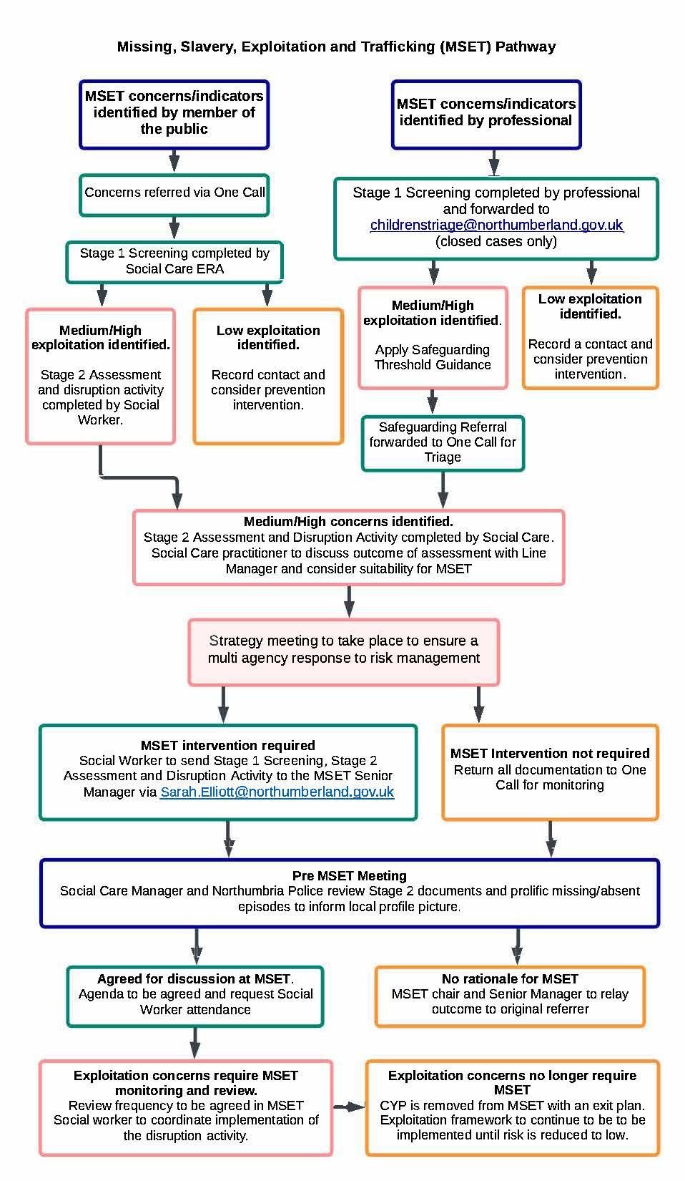
Exploitation Flowchart

↧

↓

Stage 1 Screening Tool
→

Name (Including alias) |  | Age
Address |  | Ethnicity
Gender |  | Sexuality
Learning Disability/SEND |  | CYPS Diagnosis
Language |  | Religion
Nationality |  | Immigration Status
Parent/Carer |  | Parent/Carer DOB
Date of most recent care team/core group/strategy meeting |  | Members of Care Team

Practitioner Completing the Screening |  | Completion Date
Organisation

Exploitation Type (please tick all which apply) | √
Sexual Exploitation
Modern Day Slavery
Criminal Exploitation
Other

Vulnerability Indicators (please tick all which apply) | √
Missing
Changes to the individuals’ physical, emotional or behavioural presentation
Gang Association/Organised Crime
Concerning associates/relationships with others, particularly those where there are existing CSE/SE and/or Trafficking, offending or vulnerabilities.
Concerns about the use of social media/internet
Concerns that the individuals behaviour, actions, activities exposes them to harm
Concerns regarding the quality and/or breakdown of family/personal relationships
Concerns regarding the individual’s physical/sexual/mental health/capacity
Concerns regarding drug and alcohol use
Education/Training/Employment attendance and/or punctuality concerns
Homeless or concerns that accommodation is unsuitable or unstable
Trafficking
Concerns regarding financial independence and/security
Sex Work (adults only)
Learning Difficulty/Disability
Individual’s Views about exploitation and self-identified strengths/protective factors

Parents/Carers Views about exploitation and identified strengths/protective factors

Diversity (include the relevance of age, gender, sexuality, religion, disability and any individual needs which might impact upon the effectiveness of safeguarding e.g emotional maturity, mental capacity for 16+, learning needs etc)

Summary of Exploitation concern (consider vulnerability indicators of vulnerability, diversity and individual views and self identified strengths/protective factors)

What are the worries

Complicating Factors

What is working well

Professional Judgement of Exploitation (Note: Children Under 13 cannot be assessed as low. Children under 16 who have not demonstrated Gillick Competence cannot be assessed as low. Individuals who have been assessed as lacking Mental Capacity (MCA 2005) associated with exploitation cannot be assessed as low risk) | √
Low
Medium
High

Safeguarding and Disruption Action
Action Required | Achieved  √ | Outcome
Discuss Screening with your Line Manager .
Consider Safeguarding Guidance
Report crimes/intelligence to Northumbria Police where applicable i.e.
- Call 999 if the crime is happening now.
- Call 101 for all other reported crimes.

Email intelligence to :-
forceintelligence@northumbria.pnn.police.uk

