Permanence Planning Meeting
Practice Guidance
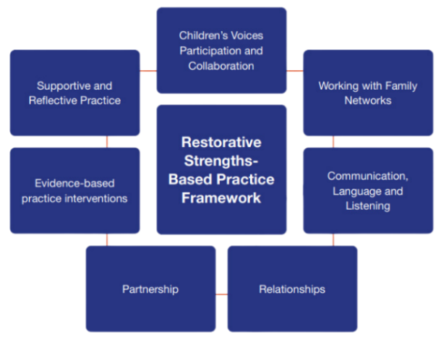
Permanency planning is based on the philosophy that all children have the right to a safe, secure and stable home where they feel loved and have a sense of belonging. A fundamental part of Dudley’s Restorative Strengths-Based Practice Framework is understanding that the relationships children and young people have with their birth families and networks have significance and meaning for them, including those absent and dysfunctional relationships. As such, having strong, healthy and ‘life-long’ relationships are fundamental to building a child’s resilience and sense of permanence, and are key to them achieving positive outcomes, wellbeing and attainment.
Child Permanence Planning Meetings consider all plans for permanence. The purpose of the meeting is to:
- prevent drift and delay to achieve permanence at the earliest opportunity.
- ensure that a clear work plan is agreed with appropriate review points.
- ensure all avenues and options for permanence are discussed, explored and assessed to frontload or avoid delay in proceedings.
The meeting should initially be held within 10 working days of child coming into care/identified as requiring permanence, and at least every six weeks until permanence is achieved. This will ensure that children and young people’s needs are fully explored with appropriate decision making reached to optimise permanence options.
The meeting will be chaired by the Team Manager and attended by: -
- the child’s social worker,
- permanence advisor,
- fostering,
- representative from Adoption@heart
and where appropriate, representatives from the Virtual School and Dudley Lighthouse Links.
The meeting should consider and agree a work plan that:
- From the outset adopts a parallel planning approach, which frontloads assessment and interventions.

- Identifies the child’s views, wishes and feelings. Best practice to capture this would be to: -
  - Work directly with the child, alone where appropriate, to capture their views wishes and feelings.
  - Observe behaviour and responses and be open to non-verbal communication.
  - Listen to the children with the intent to understand and be sensitive to the child’s changing circumstances, development and unique communication needs.
  - Co-produce plans with children, focusing on achieving good outcomes with them in a way that helps them understand their story and experiences.
  - Support children to find the people in their family or network who will keep them safe and help them and/or their families to make changes.

- Identify any assessments required within agreed timescales for review and completion.

- Review of the family genogram to ensure all friends and family have been explored and identified for consideration of viable support and / or alternative care.
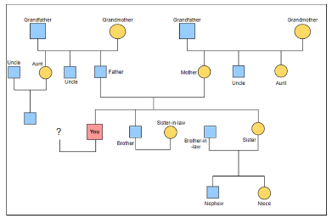
  - It is important to work alongside children and families, understanding the nature and context of their relationships and family stories through the use of tools such as chronologies and cultural genograms. It is essential that families have an accurate and up-to-date cultural genogram.

- Consideration of the individual needs of the child, sibling relationships and family time plan.

- Agreement of dates for the completion of assessments and any additional work to inform the final care plan.
Further information on the Child Permanence Strategy can be found on Dudley’s online procedures:
https://dudleychildcare.proceduresonline.com/g_perm_plan.html
Permanence Planning Meeting Flowchart
Clock starts
Child is already in care subject to Care Order/Placement Order/S20, and settled in care but permanence has not yet been achieved
Child comes into care or, if not a Child in Care, is identified as requiring permanence (e.g. pre-birth; younger sibling of child in care and children in pre-proceedings, where option to remain in parents’ network is unlikely). A draft care plan is to be completed.

Social worker arranges and Team Manager chairs the first Permanence planning meeting and records in LCS (Form: Permanence plan)
prior to 1st child in care review, and before subsequent reviews.
To attend:
PPM Chair – Team Manager
Child’s Social Worker
Foster Carer/ provider
Fostering SW Family finder - not every child will require one

A parallel plan is still a permanence plan

Within 10 working days

Social Worker updates Care Plan within the pre-meeting report; clearly setting out permanence plan within it
5 Working days
following PPM

Within 20 working days
Initial Child in Care review meeting takes place and ratifies care plan
Significant changes to permanence plan- PPM to be reconvened and IRO to be notified
Every 6 weeks following initial PPM
Permanence Planning Meeting
5 Working days
following PPM
Social Worker updates Care Plan and notifies IRO to consider if an earlier child in care review is required than initially planned
3 months after initial review then every 6 months
Subsequent child in care review meetings take place and ratifies care plan
PPMs continue on 6 weekly review cycle

NO
Has permanence been achieved?
YES
Continuing review of permanence plan

Where a child/young person remains subject to child in care reviews, all subsequent review meetings should review the progress and validity of the Permanence Plan, as detailed below:

Continue to review the plan for the child/young person within child in care review meetings

Updated Child and Young Person Assessment to be completed as part of the pre-meeting report.

PPMs continue on 6 weekly review cycle
Change in permanence plan is identified
Plan for the child/young person remains the same

Permanence planning meeting to be held

